Two-Movies

path_one = "~/OneDrive - MNSCU/myGithub/Unsupervised_Learning/Movie-Script-Unsupervised-Learning-Methods-Analyses/One_movie"  
dir_1 = DirSource(paste(path_one, sep=""), encoding = "UTF-8")  
corpus_1 = Corpus(dir_1)  
head(summary(corpus_1))

## Length Class Mode  
## A-Few-Good-Men.txt 2 PlainTextDocument list

path_second = "~/OneDrive - MNSCU/myGithub/Unsupervised_Learning/Movie-Script-Unsupervised-Learning-Methods-Analyses/Second_movie"  
dir_2 = DirSource(paste(path_second, sep=""), encoding = "UTF-8")  
corpus_2 = Corpus(dir_2)  
head(summary(corpus_2))

## Length Class Mode  
## A-Prayer-Before-Dawn.txt 2 PlainTextDocument list

ndocs <- length(corpus_1)  
# ignore extremely rare words i.e. terms that appear in less then 1% of the documents  
minTermFreq <- ndocs * 0.05  
# ignore overly common words i.e. terms that appear in more than 50% of the documents  
maxTermFreq <- ndocs * .5  
dtm_1 = DocumentTermMatrix(corpus_1,  
 control = list(  
 stopwords = ("en"),   
 wordLengths=c(5, 15),  
 removePunctuation = T,  
 removeNumbers = T  
 #stemming = T,  
 #removeWords("bateman"),  
 #bounds = list(global = c(minTermFreq, maxTermFreq))  
 ))

ndocs <- length(corpus_2)  
# ignore extremely rare words i.e. terms that appear in less then 1% of the documents  
minTermFreq <- ndocs * 0.05  
# ignore overly common words i.e. terms that appear in more than 50% of the documents  
maxTermFreq <- ndocs * .5  
dtm_2 = DocumentTermMatrix(corpus_2,  
 control = list(  
 stopwords = ("end"),   
 wordLengths=c(5, 15),  
 removePunctuation = T,  
 removeNumbers = T  
 #stemming = T,  
 #removeWords("bateman"),  
 #bounds = list(global = c(minTermFreq, maxTermFreq))  
 ))

### Two movies

tdm_1 = t(dtm_1)  
tdm_2 = t(dtm_2)  
#Removing sparse terms  
tdm_no_sparse_1 = removeSparseTerms(tdm_1, sparse = .99)  
tdm.mat_1 <- as.matrix(tdm_no_sparse_1)  
tdm_no_sparse_2 = removeSparseTerms(tdm_2, sparse = .99)  
tdm.mat_2 <- as.matrix(tdm_no_sparse_2)

#First 20 most frequent words for Move#1  
word.freq_1 = sort(rowSums(tdm.mat_1), decreasing = T)  
barplot(word.freq_1[1:20], cex.names = .8)

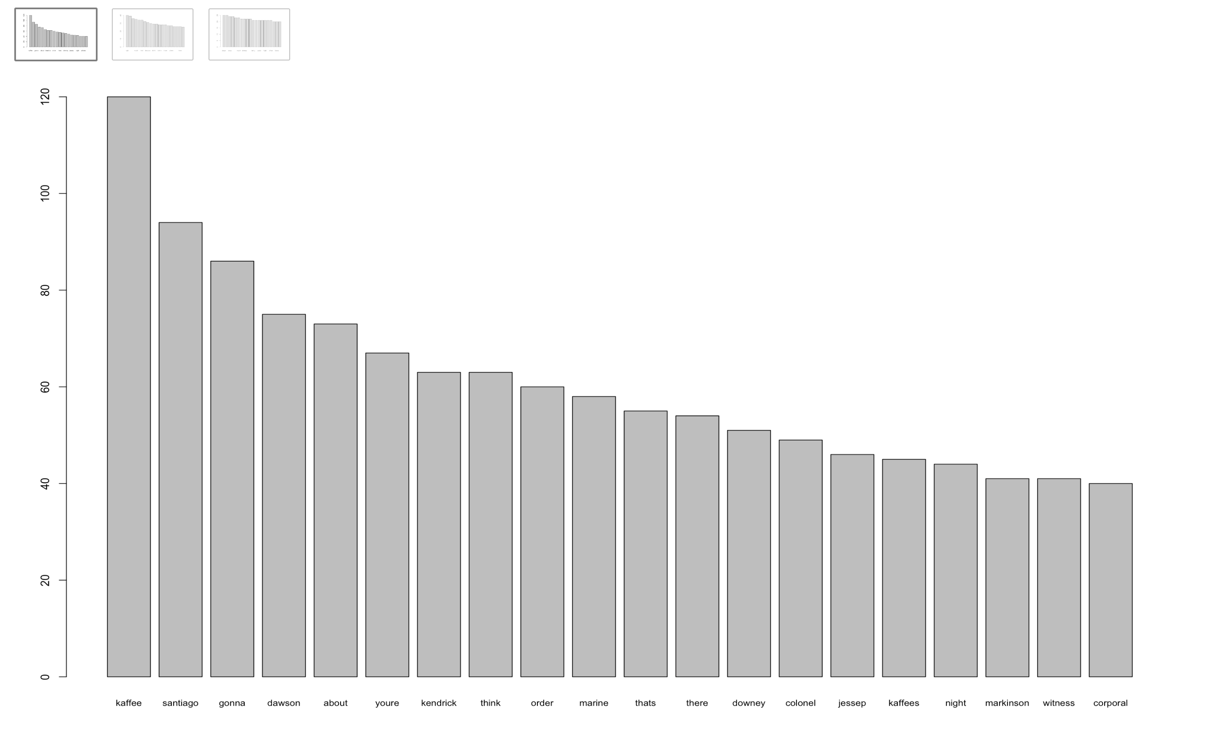

#Next 20 most frequent words  
barplot(word.freq_1[21:40], cex.names = .8)

#Next 20 most frequent words  
barplot(word.freq_1[41:60], cex.names = .8)

dim(tdm.mat_1)

## [1] 2376 1

#Word Cloud for Movie#1  
#wordcloud(words = names(word.freq_1[4:2376]), freq = word.freq_check, min.freq = 100, col = rainbow(1000), max.words = 50)

Move#1 A Few Good Men

#First 20 most frequent words for Movie#2  
word.freq_2 = sort(rowSums(tdm.mat_2), decreasing = T)  
barplot(word.freq_2[4:20], cex.names = .8)

#Next 20 most frequent words  
barplot(word.freq_2[21:40], cex.names = .8)

#Next 20 most frequent words  
barplot(word.freq_2[41:60], cex.names = .8)

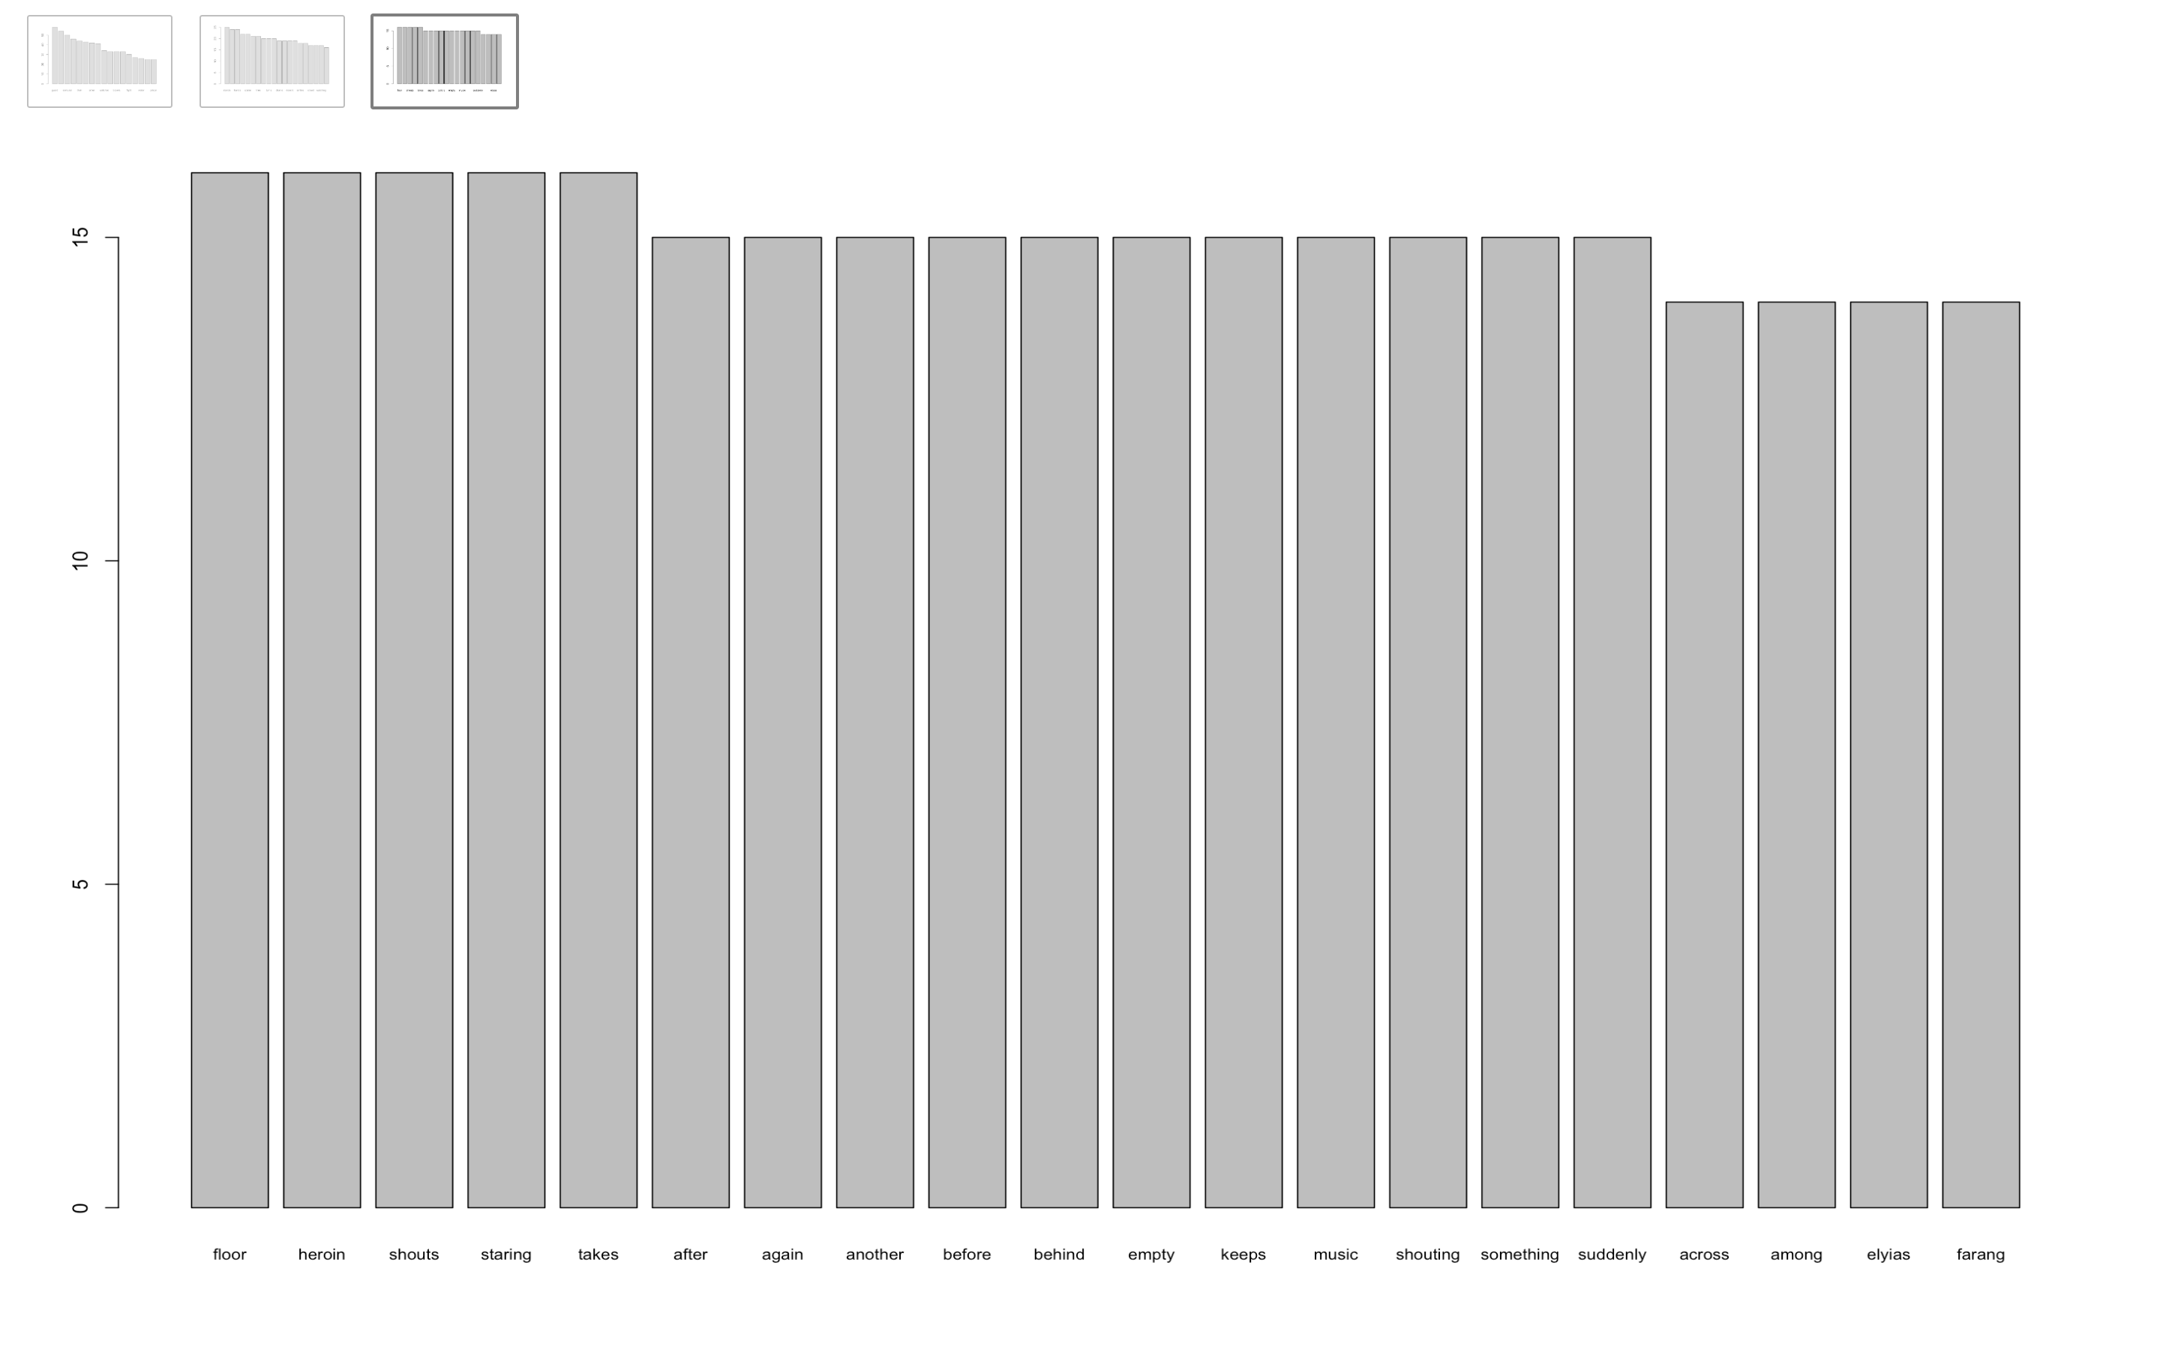

dim(tdm.mat_2)

## [1] 2544 1

#Word Cloud for Movie#2  
#wordcloud(words = names(word.freq_2[4:2544]), freq = word.freq_check, min.freq = 100, col = rainbow(1000), max.words = 50)

Movie #2 A Prayer Before Dawn

