Snack Bar Analysis

Will Sheehan

24/12/2021

library(readxl)  
library(ggplot2)  
library(tidyverse)  
library(janitor) #for cleaning col names  
SB_data <- read_excel("~/Downloads/SB data.xlsx")  
summary(SB_data)

## Order ID Financial Status Purchase Time   
## Length:624 Length:624 Min. :2021-07-30 12:16:47   
## Class :character Class :character 1st Qu.:2021-08-03 20:42:26   
## Mode :character Mode :character Median :2021-08-10 20:57:12   
## Mean :2021-08-17 16:17:53   
## 3rd Qu.:2021-08-19 20:31:27   
## Max. :2021-09-25 16:03:03   
## NA's :2   
## Currency Subtotal Taxes Total   
## Length:624 Min. : 0.220 Min. :0.0300 Min. : 0.250   
## Class :character 1st Qu.: 2.210 1st Qu.:0.2900 1st Qu.: 2.500   
## Mode :character Median : 3.100 Median :0.4000 Median : 3.500   
## Mean : 3.632 Mean :0.4718 Mean : 4.104   
## 3rd Qu.: 4.870 3rd Qu.:0.6300 3rd Qu.: 5.500   
## Max. :15.920 Max. :2.0700 Max. :17.990   
##   
## Quantity Product Price Payment Method   
## Min. :1.000 Length:624 Min. :0.220 Length:624   
## 1st Qu.:1.000 Class :character 1st Qu.:1.770 Class :character   
## Median :1.000 Mode :character Median :2.210 Mode :character   
## Mean :1.194 Mean :2.361   
## 3rd Qu.:1.000 3rd Qu.:3.100   
## Max. :5.000 Max. :3.310   
##

ggplot(SB_data, aes(Quantity, Product))+  
 geom_point()

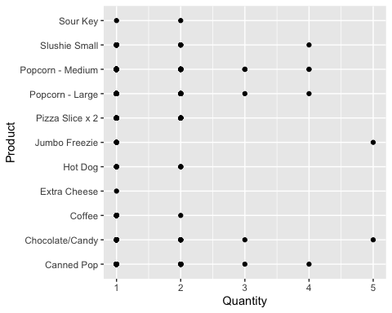

### This chart is useful when paired with the “Number of Orders Where Each Item was Purchased” chart

* While the previous chart displays the amount of orders containing any given item, this chart displays the quantities each item is most frequently purchased in (per single order). By pairing the two, we can see the need to have a very strong supply of popcorn, pop, freezies, sour keys and slushies.
* Popcorn, freezies, pop and chocolate/candy are often bought in higher numbers This information should be factored into the restocking process

p1 <- ggplot(SB_data, aes(purchase_time, product))+  
 geom_point() + labs(x = "Date", y = "Product Purchased")  
p1

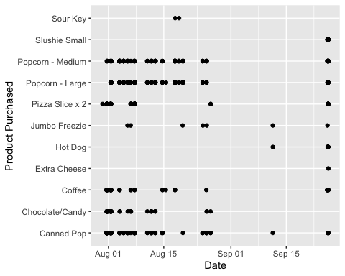

### This chart displays the items purchased over time

* The month of August was very busy, with most items being ordered frequently
* Hot dogs and slushies were not popular in August. This could be due to a lack of stock or a failure to have the item prepared
* It is possible that this data would simply align with the hours of operation, thus rendering this chart obsolete

### Condiderations:

* This data will be heavily influenced by when the SB is open/ when events are happening
* This data is pulled from a range of time that was drastically skewed due to the pandemic, and therefore not a completely accurate representation of overall SB performance