TURA
Offline-First Bus Travel WebSocket App
Build blueprint • agent prompts • architecture • features • testing plan
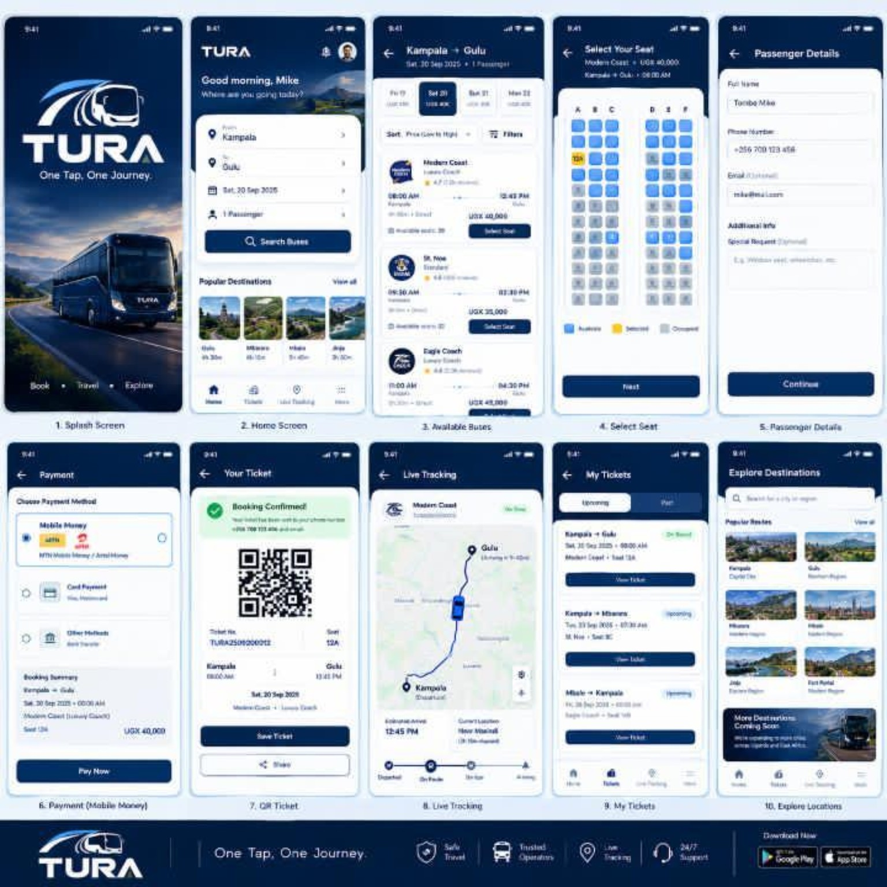
Reference UI supplied for the TURA concept.

1. Executive brief
TURA is an offline-first bus-booking and operations system. The first version should run locally without Mobile Money APIs, while keeping a clean integration boundary so MTN/Airtel payments can be connected later. The browser UI is HTML5/CSS/JavaScript, the backend is Python, and WebSockets carry live seat, trip, tracking, driver, ticket and SOS events.
The practical target for today is a polished working prototype, not a production payment deployment.
Area | Today’s prototype | Later integration
Customer | Search → seat → mock payment → QR ticket → trip tracking | Real payment providers
Operator | Trips, fleet/routes, revenue, settlements, charts | Bank/MoMo settlement feeds
Driver/conductor | QR scan/validate, passenger list, trip status, SOS | Device camera + live dispatch
Offline | SQLite/local cache + service worker + signed QR | Sync server / multi-device conflict handling
Language | English + Luganda-ready labels | Full translated content

2. Non-negotiable product rules
- Do not hard-code payment-provider logic into booking logic. Use a PaymentProvider interface and a mock provider now.
- Seats are server-authoritative when connected; offline reservations use short-lived local locks and sync with conflict detection.
- Tickets must be tamper-evident. Use a signed payload or HMAC in the prototype; never trust QR text alone.
- Every important mutation gets an event/audit record: booking, payment, ticket issue, validation, luggage, SOS and settlement.
- Never expose secrets in frontend JavaScript, QR codes, or logs.
- Use configuration for fares, luggage price, insurance price, commissions and fees. The UI must calculate from config.
- Make all payment and booking operations idempotent (safe to retry without creating duplicates).
- The app must remain usable when the network disappears. Show a clear Offline/Online indicator.

3. Recommended stack
Layer | Choice | Reason
Frontend | HTML5 + CSS + vanilla JS | Fast, offline-friendly, no heavy build system required
Backend | FastAPI | Excellent WebSocket support, typed APIs, async-friendly
Realtime | FastAPI WebSockets | Seat updates, tracking, SOS, driver alerts
Database | SQLite | Perfect for a local prototype; easy backup
ORM/data | SQLModel or SQLAlchemy | Clean models and migrations later
Validation | Pydantic | Typed request/event validation
QR | Python QR library + browser scanner | Ticket/luggage validation
Maps | Offline SVG/map mock first | Avoid map API dependency today
Charts | Plain SVG/Canvas | No network dependency
Offline | Service Worker + Cache API + IndexedDB | PWA-style offline behavior
Testing | pytest + WebSocket/API tests | Protect business rules

Recommendation: choose FastAPI rather than Flask for this project because WebSockets are a first-class requirement. Flask can work with an extension, but FastAPI keeps the realtime architecture cleaner.

7. Suggested project structure
tura/
├── app/
│ ├── main.py
│ ├── config.py
│ ├── db/
│ │ ├── session.py
│ │ └── models.py
│ ├── api/
│ │ ├── auth.py
│ │ ├── bookings.py
│ │ ├── trips.py
│ │ ├── payments.py
│ │ ├── tickets.py
│ │ ├── luggage.py
│ │ ├── sos.py
│ │ └── reports.py
│ ├── realtime/
│ │ ├── manager.py
│ │ └── events.py
│ ├── services/
│ │ ├── booking_service.py
│ │ ├── payment_service.py
│ │ ├── ticket_service.py
│ │ ├── luggage_service.py
│ │ ├── tracking_service.py
│ │ └── sos_service.py
│ └── security/
│ └── signing.py
├── frontend/
│ ├── index.html
│ ├── assets/
│ ├── css/
│ ├── js/
│ ├── pages/
│ └── sw.js
├── tests/
├── data/
├── scripts/
├── .env.example
├── requirements.txt
└── README.md

9. Core data model
Entity | Important fields
User | id, role, name, phone, language, status
Bus | id, plate, operator, capacity, status
Route | id, origin, destination, stops, distance
Trip | id, bus_id, route_id, departure, status, active
Seat | id, bus_id, label, row, column, status
Booking | id, user_id, trip_id, seat_id, status, idempotency_key
Payment | id, booking_id, provider, amount, status, provider_ref
Ticket | id, booking_id, signed_payload, issued_at, expires_at, status
Luggage | id, booking_id, tag_id, fee, status
TrackingPoint | id, trip_id, lat/lng or map position, timestamp
SOS | id, user_id, trip_id, type, reason, location, status
AuditEvent | id, actor, event_type, entity_id, timestamp, metadata
Settlement | id, trip_id, gross, fees, net, provider, status

10. WebSocket design
Use WebSockets for state that users need to see change immediately. REST can remain the source for normal CRUD operations.
Event | Sender | Consumers | Purpose
seat.locked | Booking service | Customer/operator | Temporarily reserve a seat
seat.released | Booking service | Customer/operator | Release expired/failed lock
ticket.validated | Driver app | Operator | Record successful validation
trip.position | Driver/tracker | Customer/operator | Update vehicle position
trip.eta | Tracking service | Customer | Show estimated arrival
sos.created | Customer | Driver/operator | Create internal emergency alert
sos.acknowledged | Driver/operator | Customer/operator | Confirm alert receipt
luggage.scanned | Driver | Operator | Track luggage handoff/lookup
sync.completed | Sync service | Device | Report offline queue synchronization

11. Peak features for adding also
- Offline-first PWA: App shell loads without internet; queued actions sync later.
- Signed QR tickets: Stops simple screenshot/text forgery. Add expiry and cancellation checks.
- Offline validation cache: Driver can validate recently issued tickets using a local signed-ticket cache.
- Seat conflict protection: Short seat locks plus WebSocket updates prevent two customers taking the same seat.
- Idempotent payments: Retries do not create duplicate tickets or charges.
- Luggage chain of custody: Every scan changes status: registered → loaded → received/claimed/lost.
- Trip replay: Operator can replay tracking points for a completed trip.
- Operations audit log: Who did what, when, and to which booking/ticket.
- Configurable fee engine: Fare, luggage, insurance and commission values can change without rewriting business logic.
- USSD-ready service boundary: Later add USSD as another client of the same booking/payment services.
- Luganda-ready i18n: Keep labels in translation dictionaries rather than hard-coding text.
- Feature flags: Turn experimental features on/off without deleting code.
- Health dashboard: Show database, WebSocket, sync queue and device status.
- Backup/restore: One-click SQLite backup for the prototype.

12. Offline architecture
- Service Worker caches the application shell.
- IndexedDB stores the user's local ticket cache, trip cache, seat state snapshot, and pending sync queue.
- SQLite remains the local backend database when the Python server is running.
- Every queued mutation gets a client_operation_id so retries are idempotent.
- When connectivity returns, sync operations are sent in order where ordering matters.
- Server returns accepted/conflict/rejected for each queued operation.
- Never silently overwrite a newer booking/seat state during sync.
- Show users exactly whether data is live, cached, pending, or stale.

13. QR security model
A prototype QR should carry a compact signed token, not sensitive personal information. A practical payload is ticket_id + trip_id + seat_id + issued_at + expires_at + version + signature. The driver app verifies the signature locally using a verification key or appropriate shared secret design. The UI then looks up non-sensitive details from the local cache/database. For production, move toward asymmetric signing so verification keys can be distributed without giving every device the ability to issue tickets.

14. SOS model
Mode | Prototype behavior | Production boundary
Private operational SOS | Create alert visible to TURA control/driver roles; store reason and location. | Integrate approved emergency/authority channels only after legal/technical validation.
Broader passenger alert | Notify configured TURA users/devices, but mark police notification as disabled. | Connect only to approved notification infrastructure.

Do not simulate a real police dispatch as if it happened. The prototype should clearly say 'Demo/Local alert'.

15. Test checklist before calling it done
- Customer can search a route and see available trips.
- Customer can select a seat and see the seat ID.
- Second customer cannot successfully book the same seat.
- Mock payment success creates exactly one booking and one ticket.
- Retrying the same operation does not duplicate the booking.
- Expired ticket is rejected and expiry is displayed.
- Valid ticket is accepted offline when the required verification/cache data exists.
- Invalid signature is rejected.
- Luggage tag can be registered and scanned.
- Trip tracking events appear without page refresh.
- SOS creates the correct internal event type and reason.
- Offline mode is visible and queued changes synchronize after reconnection.
- Operator dashboard updates after booking/payment/ticket events.
- Application survives a WebSocket disconnect and reconnects cleanly.
- No secrets appear in frontend source or QR payload.

16. Build order for today
1. Create FastAPI project and SQLite database.
2. Create role model and seed demo users.
3. Create Bus, Route, Trip, Seat and Booking models.
4. Implement search and seat-selection REST endpoints.
5. Implement WebSocket connection manager and seat events.
6. Implement mock payment provider + idempotency.
7. Implement ticket signing, QR generation and validation.
8. Build customer screens with the TURA dark visual system.
9. Build operator dashboard and charts.
10. Build driver/conductor validation and trip screens.
11. Add service worker, IndexedDB cache and offline queue.
12. Add tracking simulator.
13. Add SOS and luggage events.
14. Run tests, then do a complete manual flow.

17. Definition of done
The prototype is done when a user can complete a full local journey from search to seat selection to mock payment to QR ticket, a driver can validate that ticket, the operator can see the trip/revenue state, and tracking/SOS/luggage events can move through WebSockets — including a controlled offline demonstration.

TURA — One Tap, One Journey.

