**BAB II**

**PERANCANGAN SISTEM**

* 1. **Alur Sistem**

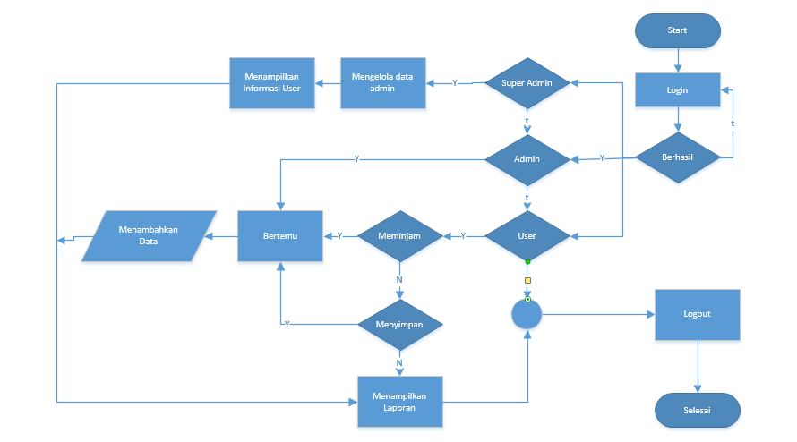

* 1. **Conceptual Data Model (CDM)**

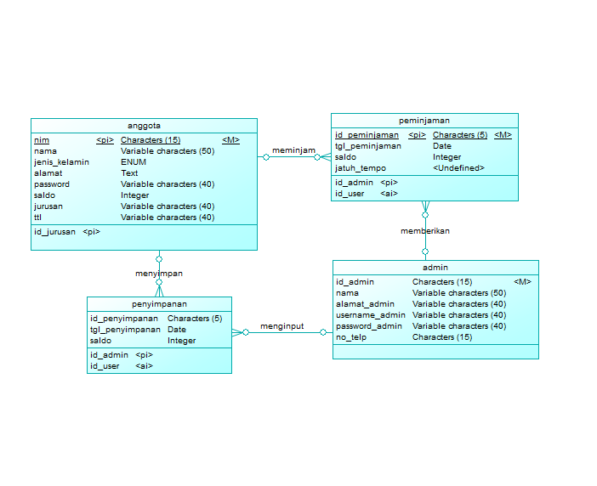

* 1. **Spesifikasi Data**

Nama Databases : koperasi_simpan_pinjam

Nama Tabel : anggota

Primary Key : nim

|  |  |  |  |
| --- | --- | --- | --- |
| **Field** | **Type** | **Size** | **Keterangan** |
| nim | Characters | 15 | Kode user |
| nama | Varchar | 50 | Nama |
| jenis_kelamin | ENUM | (‘L’,’P’) | Jenis kelamin |
| alamat | Text | **-** | Alamat user |
| ttl | Varchar | 40 | Tanggal Lahir user |
| password | Varchar | 40 | Passoword user |
| jurusan | Varchar | 40 | Jurusan user |
| saldo | integer | **-** | Saldo user |

Nama Databases : koperasi_simpan_pinjam

Nama Tabel : penyimpanan

Primary Key : id_penyimpanan

|  |  |  |  |
| --- | --- | --- | --- |
| **Field** | **Type** | **Size** | **Keterangan** |
| id_penyimpanan | Characters | 5 | Kode Id penyimpanan |
| tgl_penyimpanan | Date | - | Tanggal penyimpanan |
| saldo | Integer | - | Saldo penyimpanan |
| jatuh_tempo | Integer | - | Tanggal jatuh tempo penyimpanan |
| Id_admin | character | 15 | Id Admin |
| nim | character | 15 | Id user |

Nama Databases : koperasi_simpan_pinjam

Nama Tabel : peminjaman

Primary Key : id_peminjaman

|  |  |  |  |
| --- | --- | --- | --- |
| **Field** | **Type** | **Size** | **Keterangan** |
| id_peminjaman | Characters | 5 | Kode Id peminjaman |
| tgl_peminjaman | Date | - | Tanggal peminjaman |
| saldo | Integer | - | Saldo peminjaman |
| Id_admin | Character | 15 | Id Admin |
| Nim | Character | 15 | Id user |

Nama Databases : koperasi_simpan_pinjam

Nama Tabel : admin

Primary Key : id_admin

|  |  |  |  |
| --- | --- | --- | --- |
| **Field** | **Type** | **Size** | **Keterangan** |
| id_admin | Characters | 15 | Kode Id admin |
| nama_admin | Varchar | 50 | Nama admin |
| alamat_admin | Varchar | 40 | Alamat admin |
| username_admin | Varchar | 40 | Username admin |
| password_admin | Varchar | 40 | Password admin |
| No_telp | character | 15 | Telefon admin |