App Storage Activity

William Ogura

Rasmussen College

Author Note

This paper is being submitted on April 22, 2017, for Chintan Thakkar’s COP4683C Section 01 Apple iOS Cloud Integration course.

App Storage Activity

Here is the screen where data is input:

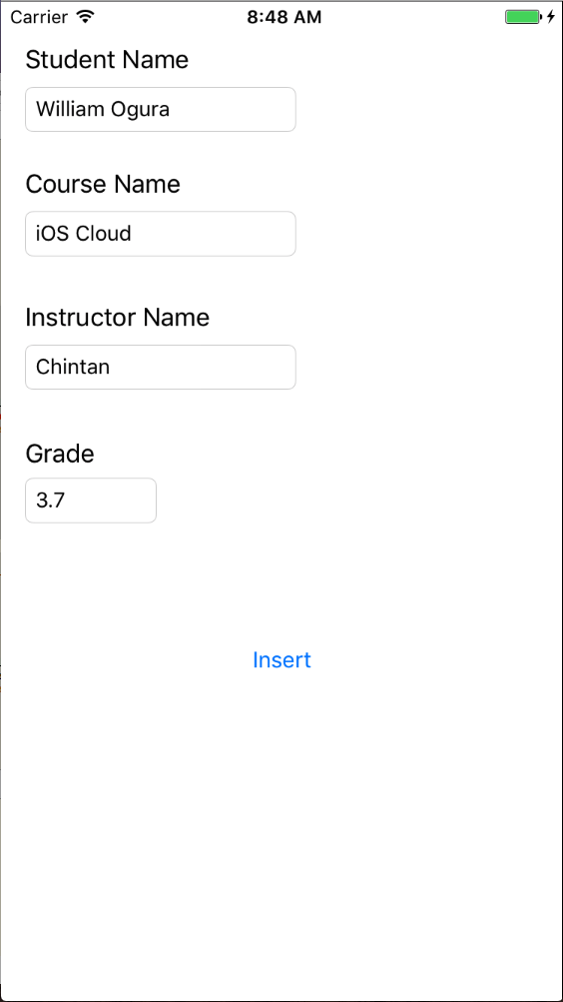

When the data is inserted, a StudentRecord object is created and initialized with the data from the related text fields. This Class is passed to the dataHandler.saveRecord() function. Then the data is saved in the database. Then the view handler calls the dataHandler.printAllRecords() where the result appears in the debug window :

