My Project Consists of Three tabs: Notes, Bookmarks, and Reminders. The icons do not match the tab names, as I had to use system icons. The Database is a SQLite DB with 6 tables, three individual and three group tables, one set corresponding to each section type.

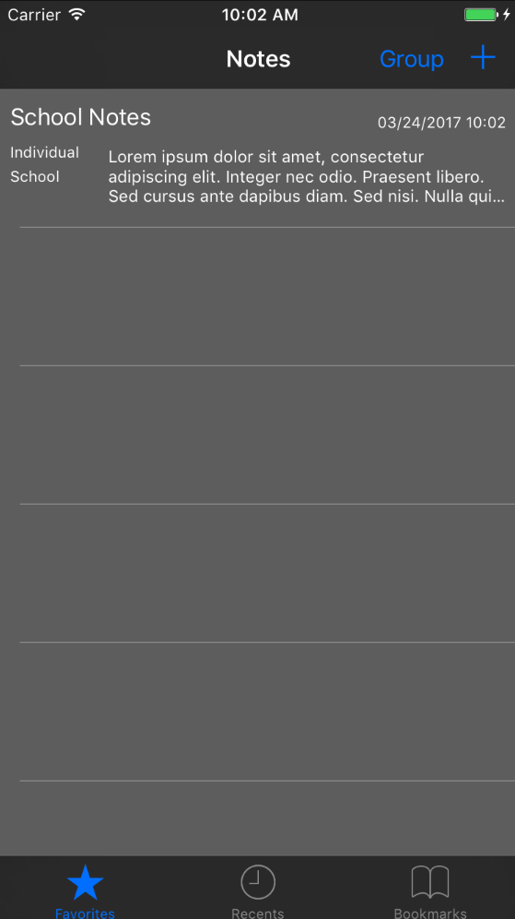

Notes will appear in a table cell and include an excerpt of the note, date when note was made, and a note group type and note type. Notes can be sorted by Group, Individual, Group, or all.

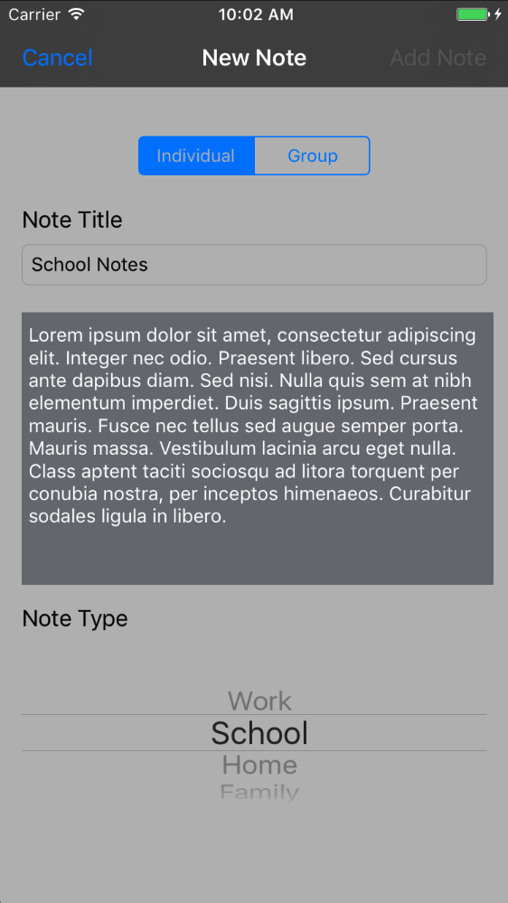

Reminders work much the same as the To Do list:

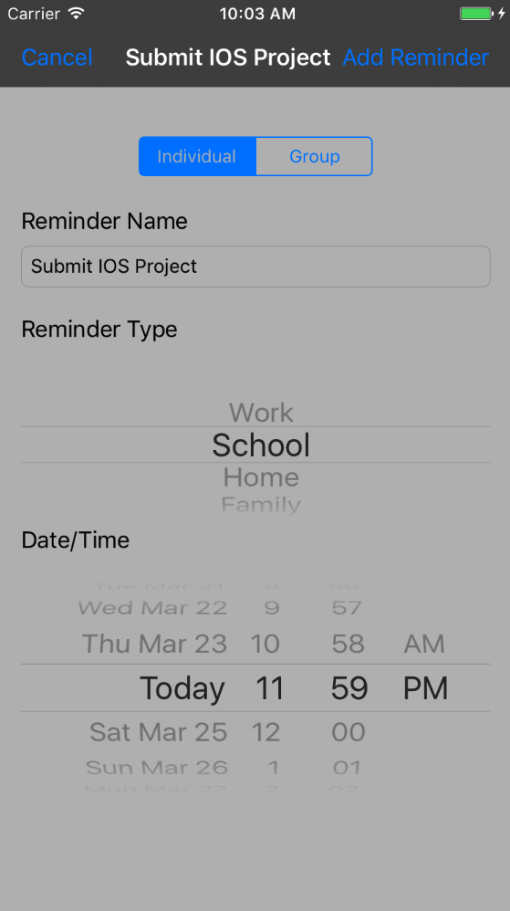

Reminders can be sorted by group and Today’s reminders.

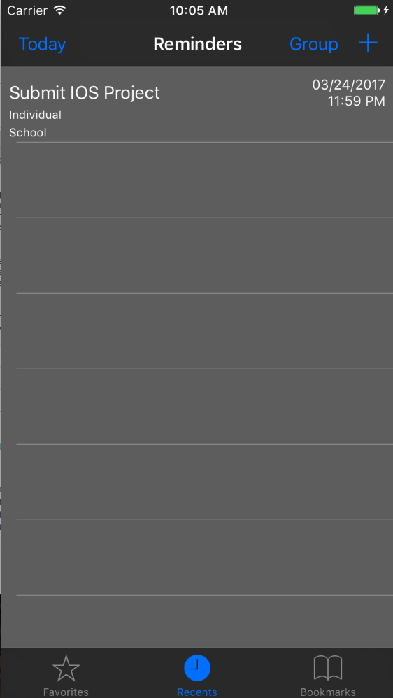

Finally, Bookmarks are saved URLs that open Safari when the corresponding table cell button is pressed:

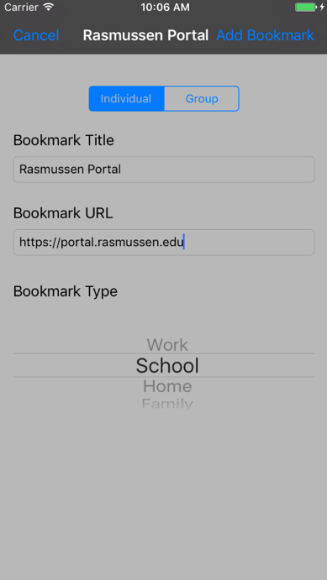

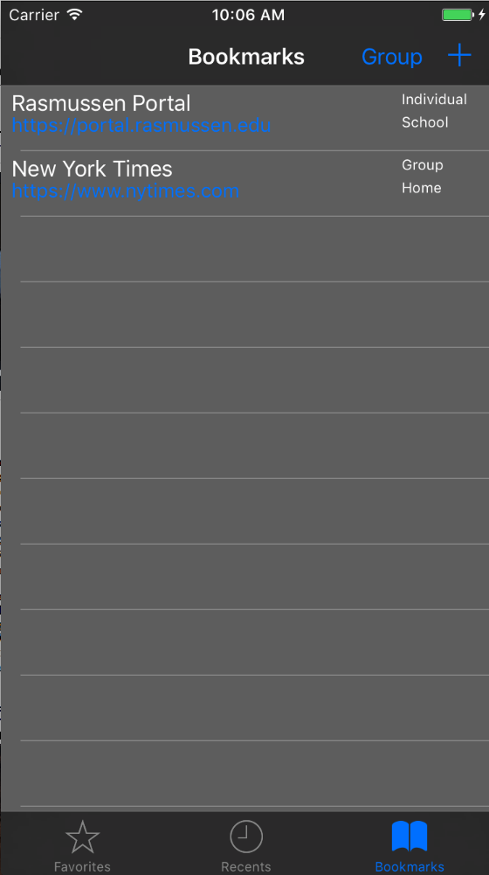

When the blue button is pressed, Safari opens the appropriate web page:

