Course Project Interface

William Ogura

Rasmussen College

Author Note

This paper is being submitted on April 15, 2017, for Chintan Thakkar’s COP4683C Section 01 Apple iOS Cloud Integration course.

Course Project Interface

Screen 1:

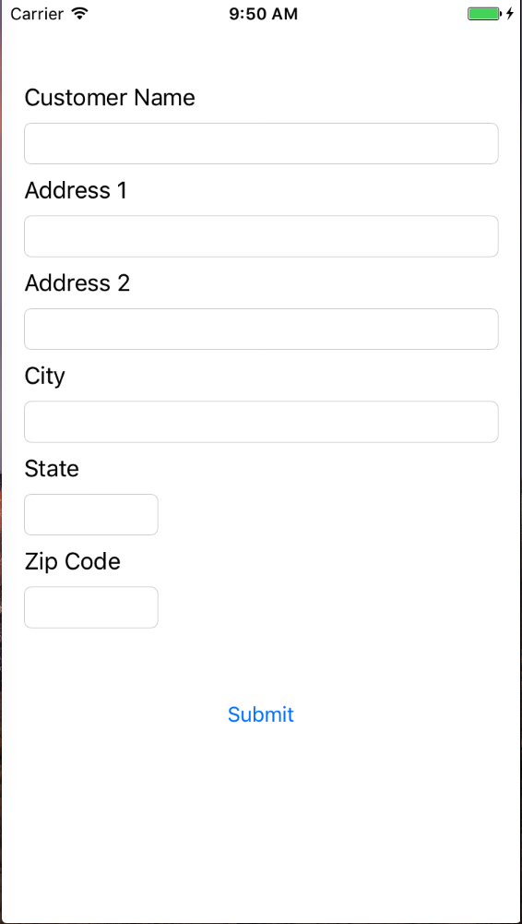

Screen 2:

