Course Project Testing

William Ogura

Rasmussen College

Author Note

This paper is being submitted on May 12, 2017, for Chintan Thakkar’s COP4683C Section 01 Apple iOS Cloud Integration course.

Course Project Testing

1. Verify Functionality of Navigation
   1. Recent Tab should display table view
   2. Search Tab should display Search Form
   3. Add button (+) located on table view should display Add Customer Form
2. Results of Test
   1. Recent Tab correctly displays table view:

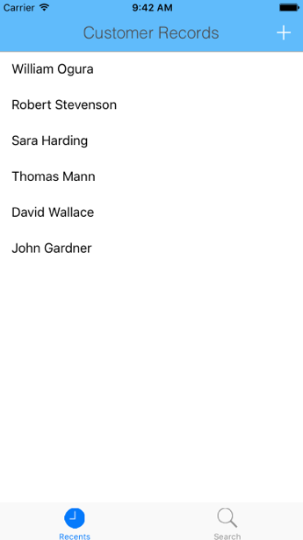

* 1. Search Tab correctly displays Search Form:

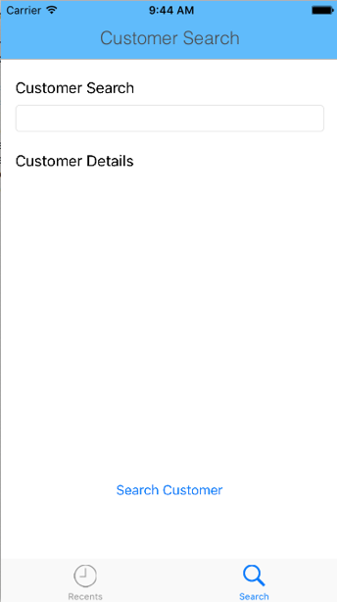

* 1. Add buttons correctly displays Add Customer Form:

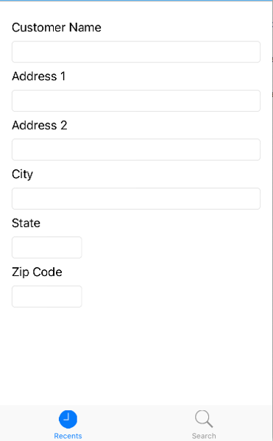

* 1. Test Results: **Pass**

1. Recents Table View Correctly loads recent customers from Azure
   1. Azure Connection is completed
   2. Table Structure of Azure is identical to expected table structure
   3. Results are in Table View accurately reflect the Azure results
   4. Pull-Down to refresh functions correctly
2. Results of Tests
   1. Azure Connection is made and fetch is called:

var error : NSError? = nil

do {

try self.fetchedResultController.performFetch()

} catch let error1 as NSError {

error = error1

print("Unresolved error \(error), \(error?.userInfo)")

abort()

}

Connection is correctly made as output console does not display error message upon load

* 1. Table structure of Azure is identical. As no error messages appear when refresh is called upon load of table view.
  2. Results of table view accurately reflect Azure results.
     1. Azure records: 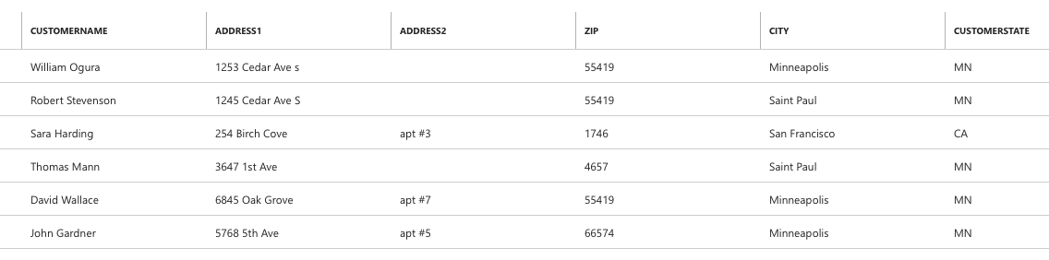
     2. App Table View Results:

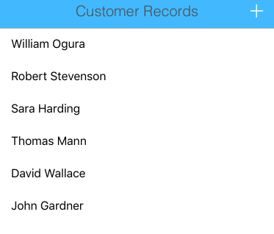

* 1. Test Results: **Pass**

1. Verify Creation of New Customer record
   1. Customer creation form must correctly receive customer input for the following: Customer Name, Address1, Address2, City, State, Zip and Submit Button
   2. Upon Save of record, Recent Table View should update results
   3. Azure Database Table should contain new Customer Record
2. Results of Tests
   1. Customer Creation form correctly receives the expected input: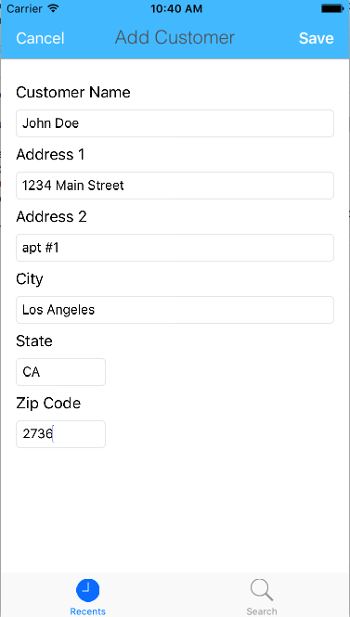
   2. The saved record correctly displyas in the Recent Table View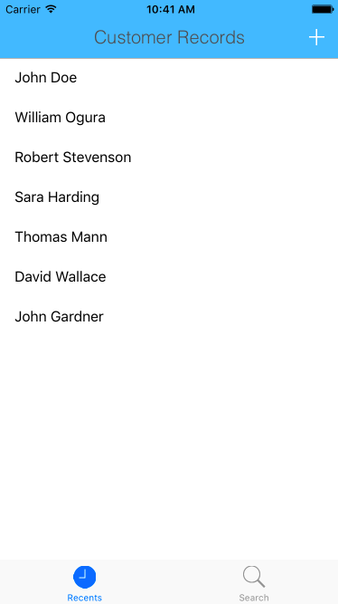
   3. The Azure Database Correctly updates with the new recordScreen%20Shot%202017-05-12%20at%2010.42.56%20AM.png
   4. Test Result: **Pass**
3. Search View functions correctlyf
   1. Search View accepts Customer Name as Input
   2. Search Correctly retrieves Customer Record when existing Customer Name is input
   3. When non-existing customer name is input, no results returned
4. Results of Tests
   1. Search View accepts Customer Name:

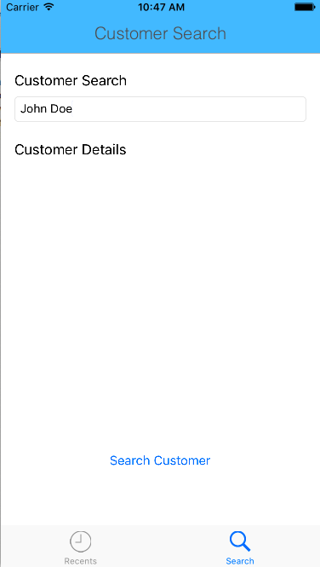

* 1. When Existing customer is input, the correct record is retrieved:
  2. When non-existing customer name is input, no record is retrieved: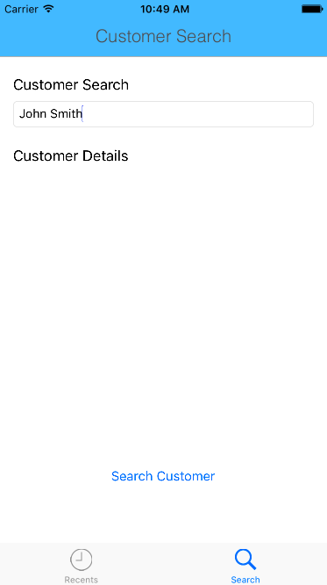
  3. Test Result: **Pass**