Woodland Bubble Game Template

Modes

Puzzle - rows falls if you miss. (1 miss on 1 stage and 2 misses on next stages)

Arcade – rows falls during the time.

Project structure:

* Animations
* Prefabs and Resources
* Scenes
* Scripts
* Textures

All textures you can find in Textures folder.

Admob

Interstitial ads shows after game over.

Open Scenes/menu and find Admob object. In inspector paste your ad unit id.

Replace Plugins folder into Assets. Should be Assets/Plugins.

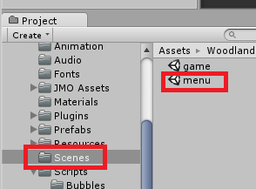

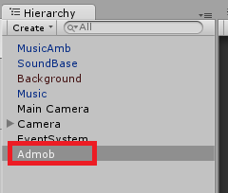

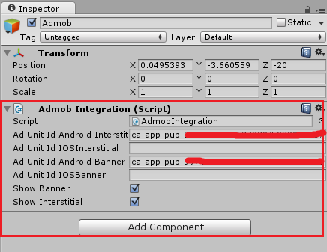

**Run the project on IOS**

Download new Google Mobile Ads SDK

https://developers.google.com/mobile-ads-sdk/download#downloadios

To build and run on iOS, click **File -> Build Settings**, select the iOS platform, then **Switch Platform**, then **Build**. This will export an XCode project. You'll need to do the following before you can run it:

1. From the Xcode project navigator, right-click on the project, and choose Add Files To "".
2. Navigate to and select **GoogleMobileAds.framework**.
3. Set **Enable Modules (C and Objective-C)** to **Yes** in **Build Settings**.

IF YOU GOT ERRORS TRY TO UPDATE THE PLUGIN:

https://github.com/googleads/googleads-mobile-plugins/releases