----------------------------------------------------------------------------------
Optional: Aliases in Your Start-up Shell
----------------------------------------------------------------------------------

alias phy='cd PHY480'

----------------------------------------------------------------------------------
Nan's and Inf's
----------------------------------------------------------------------------------

Pretty sure that 0.*(1./0.) will be nan (result is -nan)

----------------------------------------------------------------------------------
Bound States by Matrix Diagonalization in Coordinate Representation
----------------------------------------------------------------------------------

1. We can verify by plugging in our test values into the equations shown in the for loop

Enter maximum radius (Rmax): 1
Enter the number of steps (N): 20
eigenvalue 1 = 9.919925e+00
eigenvalue 2 = 3.923497e+01

Enter maximum radius (Rmax): 2
Enter the number of steps (N): 20
eigenvalue 1 = 2.740537e+00
eigenvalue 2 = 1.011051e+01

Enter maximum radius (Rmax): 2
Enter the number of steps (N): 30
eigenvalue 1 = 2.743379e+00
eigenvalue 2 = 1.015543e+01

Enter maximum radius (Rmax): 3
Enter the number of steps (N): 40
eigenvalue 1 = 1.683822e+00
eigenvalue 2 = 5.110384e+00

Enter maximum radius (Rmax): 4
Enter the number of steps (N): 40
eigenvalue 1 = 1.512700e+00
eigenvalue 2 = 3.775453e+00

2. Plot name: eigen_tridiagonal.png

u(0) should be 0

3. u approaches 0 after Rmax reaches 6, so Rmax = 6

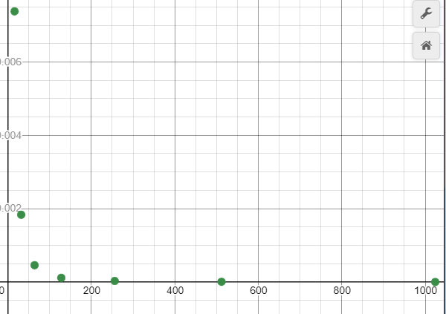

As N increases, the relative error decreases exponential.

5. This follows, because the second derivative would be an equation for a straight line.

Bound States from Diagonalizing the Hamiltonian in a Basis

1.. Bound state energies: -3.8733, -14.5248

3. I believe that the first eigenvalue given is the most accurate one.

4. It seems that the square well is more accurate, I believe that is just because the computer is better at handling that form mathematically.

5.

