**Patterns of sound localization/lateralization under bone conduction due to wave interference**

**Demo Codes of the Theoretical Model**

--------------------------------------------------------------------

**Descriptions**

* **model_symmetrical.m** is the demo code for the theoretical model (assuming that the skull is perfectly symmetrical.
* **model_universal.m** is the demo code for general cases
* All the demo codes follow the GNU GPL license.

**Usage**

* The codes were developed and tested in MATLAB v2023a environment. But earlier versions may also be Okay.
* Users can adjust the parameters interactively, and the contour pattern would refresh in real-time.
* For ‘model_symmetrical.m’, only the parameter T (or TA, trans-cranial attenuation) is adjustable, users can adjust its amplitude and phase by:
  + Drag the corresponding slide bar
  + Click the arrows besides the slide bar
  + Direct edit the values

The number shown in the bottom of the `TA` panel gives the complex value of the T value (please refer to the following figure).

* For ‘model_universal.m’, four parameters are adjustable, namely, the transfer functions HLL, HRR, HLR, and HRL.

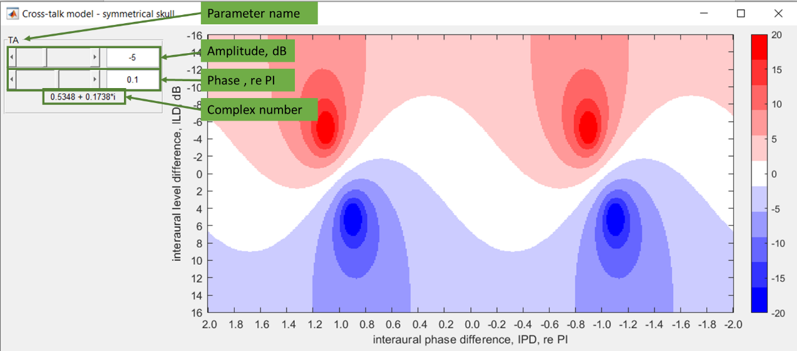

Figure: Demonstration of using the graphical interface