How to get multiple tables into PowerPivot without establishing a new connection each time.

Step 1:

- Set up the connection using the ODBC by clicking on From Other Sources and Selecting Others(OLEDB/ODBC)

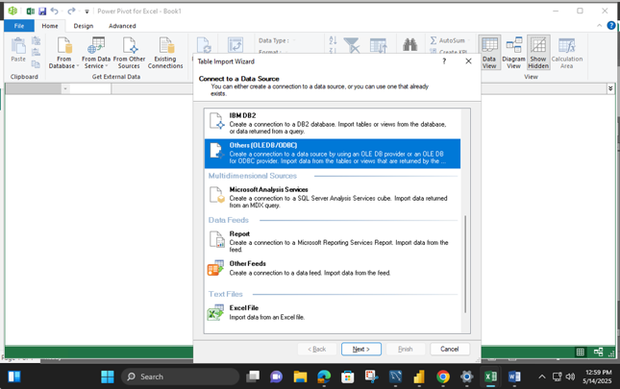

- Give a name to the connection and build it
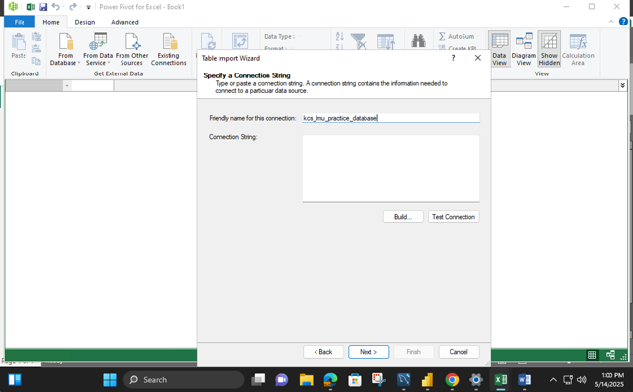

- Make sure to select the Provider first
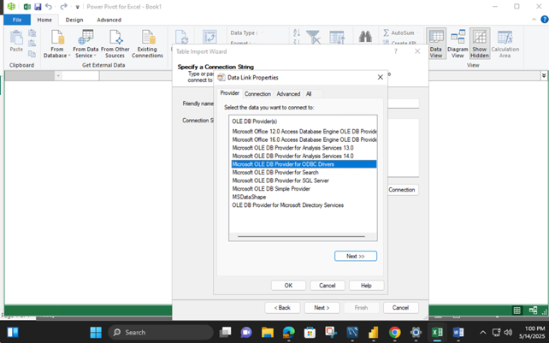

- Then select the DSN (must be a System DSN)
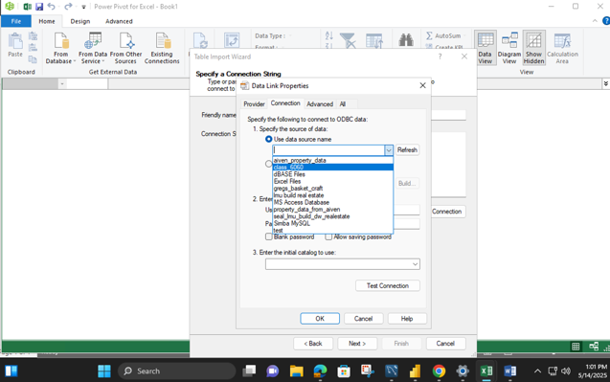

- Write a query to get the table that you want from the database. Do not select the first item, it does not work with MySQL.
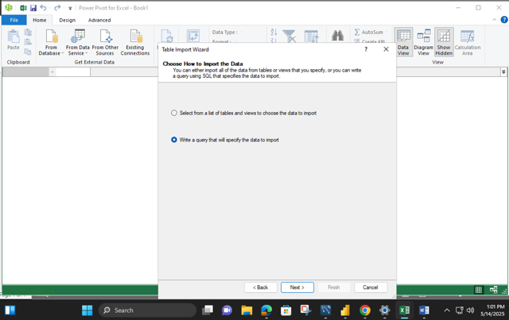

- Here is the query to get the car data. Note that I have appended the name of the database in front of the table to ensure that correct table is extracted (and it is a good idea because it prevents the accidental no selection of database)
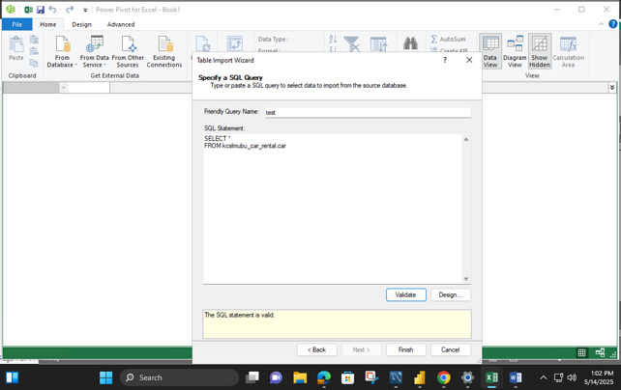

Step 2. Now you can get the other tables as well using the established connection.

- For the next table, click on Existing Connection instead of From Other Sources and
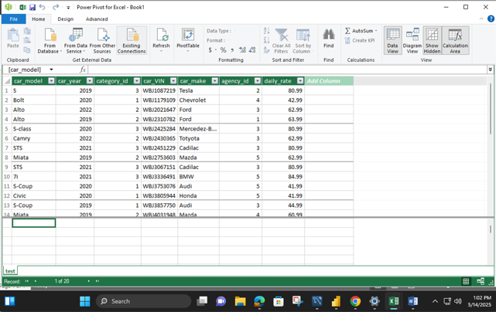

- Select the connection and click on Open
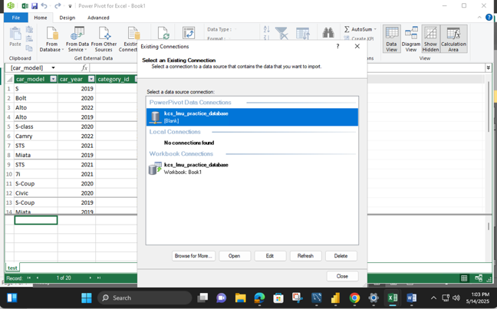

- And you are back to the Query window to get the next table!
