Enterprise Proposal

Prompt-Guided Dashboard
Personalization Platform

End-to-End KPI Management with Databricks + Claude AI

From raw data to personalized dashboards.
Configuration through conversation, not menus.

April 2026
Version 1.0

1. Executive Summary
This proposal describes an end-to-end platform that transforms how organizations define, validate, and visualize Key Performance Indicators (KPIs). The system combines Databricks as the data and semantic backbone with Claude AI as the natural-language interface, enabling users across the organization to go from raw data to personalized, governed dashboards through conversation.

The core insight: KPI management today is fragmented. Data engineers write SQL, analysts copy it into BI tools, business users request changes through tickets, and nobody is confident the number on the dashboard matches the agreed-upon definition. This platform unifies the entire lifecycle into a single system with a conversational interface at every layer.

What This Platform Does
1. Ingests and catalogs raw data in Databricks Unity Catalog
2. Lets any user define new KPIs through natural language (Claude generates the SQL)
3. Validates KPI logic automatically (schema, type, range, semantic, consistency checks)
4. Registers validated KPIs in a versioned semantic layer
5. Renders personalized dashboards driven by user priorities expressed in plain English
6. Continuously tests KPI health and alerts on drift or breakage

Figure 1: Conversational dashboard onboarding — the user describes their role and priorities in natural language
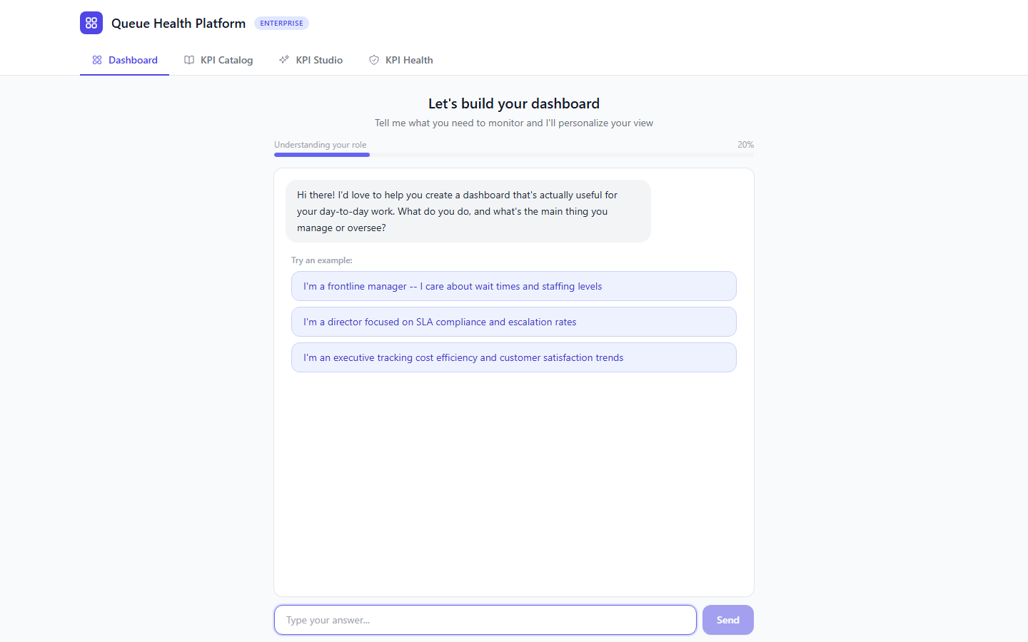

2. Problem Statement
Enterprise KPI management suffers from three systemic failures:

Fragmented Ownership
KPI definitions live in SQL scripts, BI tool configs, spreadsheets, and tribal knowledge. When a metric like "average wait time" appears on three dashboards, there is no guarantee all three compute it the same way. Schema changes break dashboards silently. New team members cannot discover what metrics exist or what they mean.

High Friction to Change
A business user who needs a new metric must file a request, wait for a data engineer to write the SQL, wait for review, wait for deployment to the BI tool, then verify it shows what they expected. This cycle takes days to weeks. The result is that teams either live with wrong metrics or build shadow analytics in spreadsheets.

No Validation Feedback Loop
Once a KPI is deployed, there is no systematic way to verify it continues to return correct results. Data drift, schema migrations, upstream ETL changes, and business logic updates can silently corrupt metrics. Teams discover problems when an executive questions a number in a quarterly review.

3. Solution Architecture
The platform is organized into three layers, each with clear responsibilities. Data flows upward from raw storage through a governed semantic layer to personalized dashboards.

3.1 Architecture Overview

Layer | Components | Responsibility
Layer 3: Presentation | React Frontend, Dashboard Chat, Onboarding Flow | Personalized visualization driven by DashboardConfig objects. Users describe priorities in natural language; Claude selects and arranges KPIs from the registry.
Layer 2: Orchestration | Express API, Claude AI Integration, KPI Authoring UI | Routes requests between frontend, Databricks, and Claude. Manages KPI authoring workflows, validation pipelines, and config persistence.
Layer 1: Data & Semantic | Databricks Unity Catalog, Delta Tables, SQL Warehouse, KPI Registry | Source of truth for all data and KPI definitions. Handles storage, compute, access control, and the semantic layer.

3.2 The KPI Registry (Semantic Layer)
The KPI Registry is a set of governed Delta tables in Unity Catalog that serve as the single source of truth for every metric in the organization. A KPI is not a label or a number — it is a versioned SQL expression with metadata, ownership, and validation status.

Registry Schema: kpi_registry.definitions
Column | Type | Description
kpi_id | STRING | Unique identifier (e.g., avg_wait_time). Immutable after creation.
version | INT | Auto-incrementing version number. Each edit creates a new version.
display_name | STRING | Human-readable name shown on dashboards.
description | STRING | Business-readable explanation of what this KPI measures and why.
unit | STRING | Unit of measurement (minutes, percent, dollars, count, ratio, score).
direction | STRING | lower-is-better or higher-is-better. Drives threshold color logic.
sql_logic | STRING | The executable SQL expression that computes this KPI.
source_tables | ARRAY<STRING> | Unity Catalog table references used in sql_logic.
grain | STRING | Aggregation level: hourly, daily, weekly, per-entity.
dimensions | ARRAY<STRING> | Columns this KPI can be broken down by (e.g., make, model, region).
default_thresholds | STRUCT | Default green/yellow/red boundaries based on historical distribution.
materialization | STRING | live (query on demand) or scheduled (pre-computed on a cron).
owner | STRING | User or team who created/maintains this KPI.
status | STRING | Lifecycle state: draft, validating, validated, published, deprecated.

Registry Schema: kpi_registry.test_assertions
Column | Type | Description
assertion_id | STRING | Unique identifier for this test.
kpi_id | STRING | Foreign key to the KPI being tested.
assertion_type | STRING | Type: range_check, not_null, freshness, row_count, custom_sql.
assertion_sql | STRING | SQL that returns true (pass) or false (fail).
severity | STRING | warn or fail. Fail blocks publication; warn alerts but allows.
last_result | STRING | pass, warn, or fail.

3.3 KPI Lifecycle States
Every KPI moves through a governed lifecycle. The status field controls what operations are allowed and where the KPI is visible.

Status | Who Can See It | What Happens
draft | Author only | KPI has been defined but not yet validated. SQL may not execute correctly.
validating | Author only | Automated validation pipeline is running (8 stages).
validated | Author + reviewers | All validation checks passed. Ready for review and promotion.
published | Everyone | KPI is live in the registry. Users can add it to their dashboards.
deprecated | Everyone (read-only) | KPI still visible on existing dashboards but cannot be added to new ones.

4. KPI Catalog Browser
The KPI Catalog provides a searchable, browsable view of all registered KPIs in the semantic layer. Users can filter by lifecycle status, search by name, description, or tag, and drill into any KPI to inspect its SQL logic, test health, and version history.

Figure 2: KPI Catalog — browsable registry with status filters, search, test status indicators, and tags
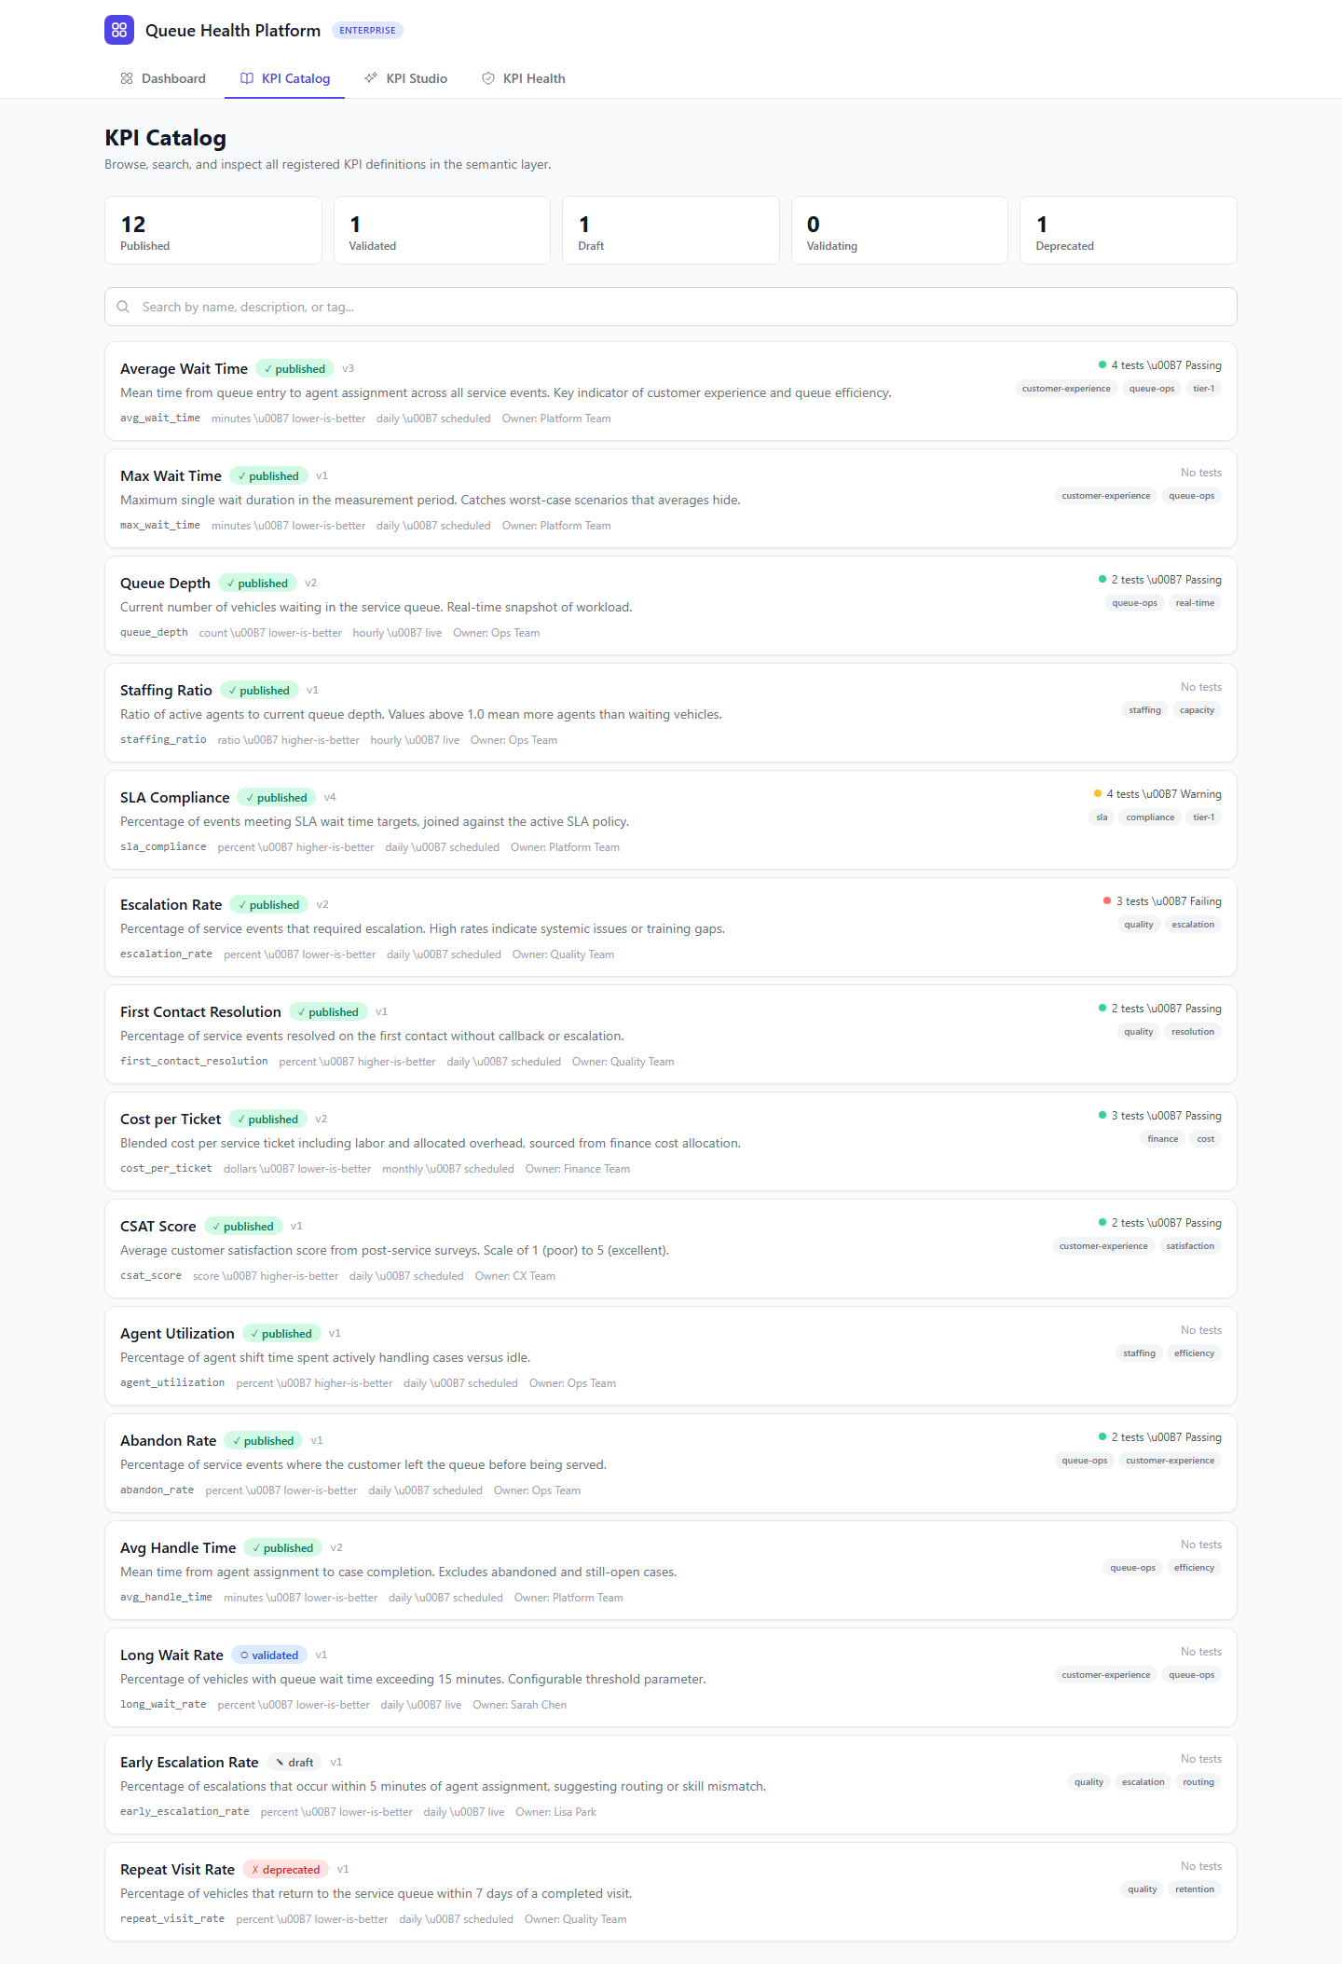

4.1 KPI Detail View
Clicking any KPI opens a detail panel with three tabs: SQL Logic (the actual computation), Tests (assertion results), and Versions (change history with audit trail).

Figure 3: KPI Detail — SQL Logic tab showing the executable query, metadata, source tables, and thresholds
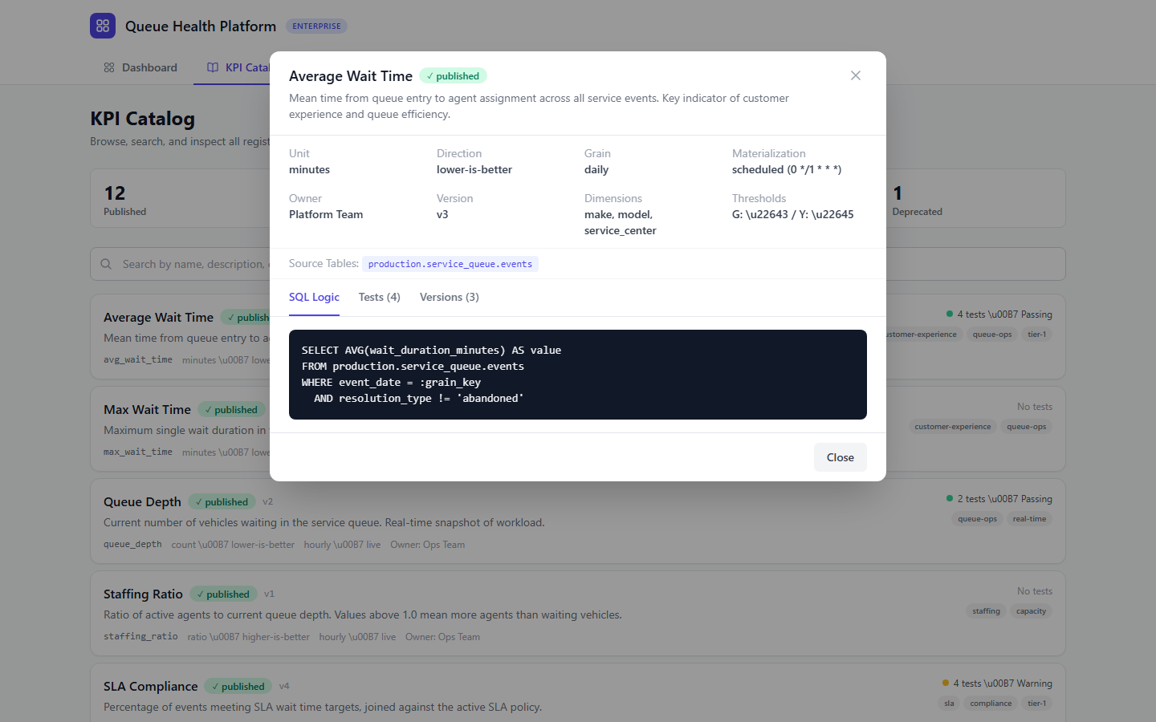
Figure 4: KPI Detail — Tests tab showing assertion results with pass/warn/fail status
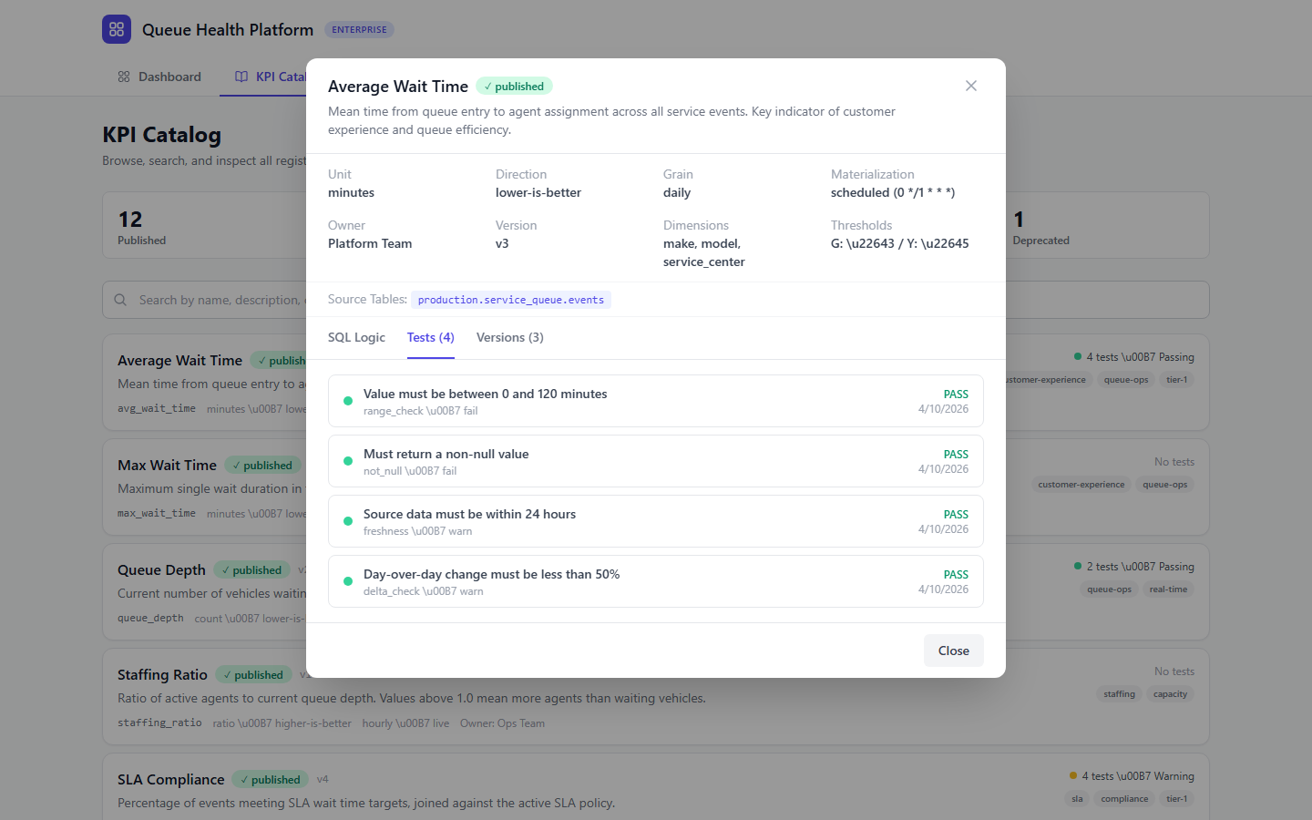
Figure 5: KPI Detail — Versions tab showing the full change history with audit trail
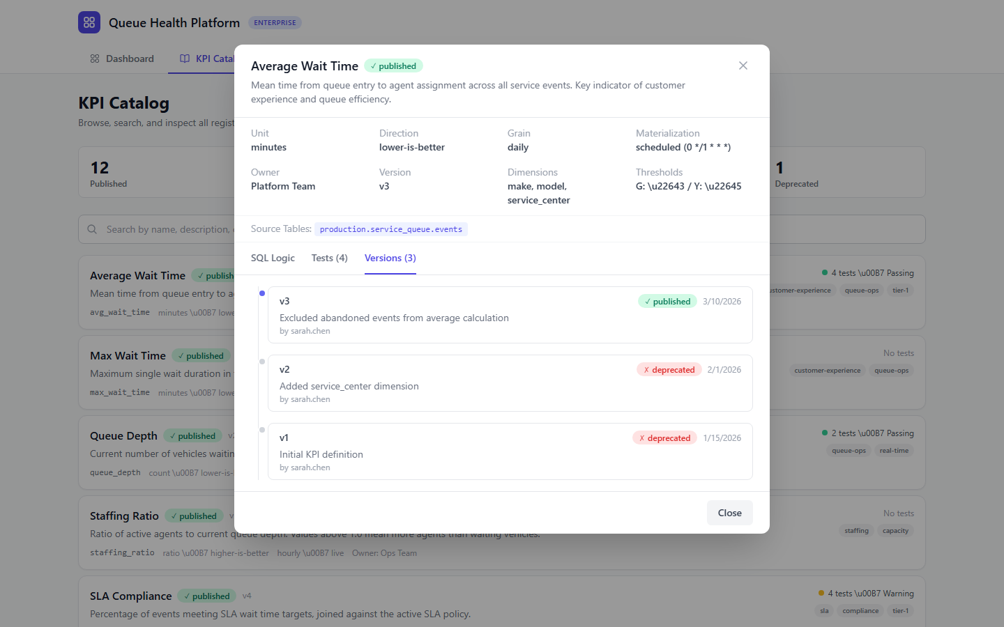

5. KPI Authoring Through Conversation
The authoring flow is the core differentiator. Any user in the organization can define a new KPI by describing what they want to measure in plain English. Claude handles the translation to SQL, and the validation pipeline ensures correctness before the KPI reaches production dashboards.

5.1 The Authoring Studio
The KPI Authoring Studio is a three-panel interface: a Unity Catalog schema explorer on the left, a conversational chat in the center, and a candidate preview with validation pipeline on the right.

Figure 6: KPI Studio — Schema Explorer showing Unity Catalog tables and column metadata
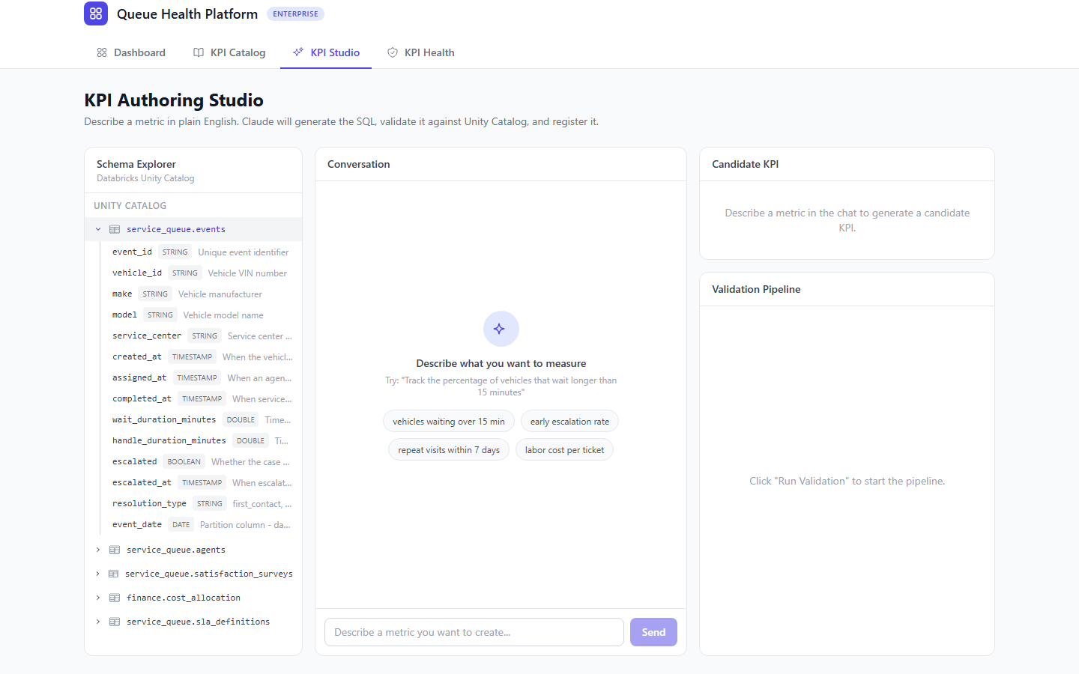

5.2 Conversational KPI Creation
The user describes what they want to measure in natural language. Claude examines the available schema metadata and generates a complete KPI definition: SQL logic, unit, direction, grain, dimensions, and default thresholds.

Figure 7: KPI Studio — Claude generates a candidate KPI from natural language, with SQL preview and metadata
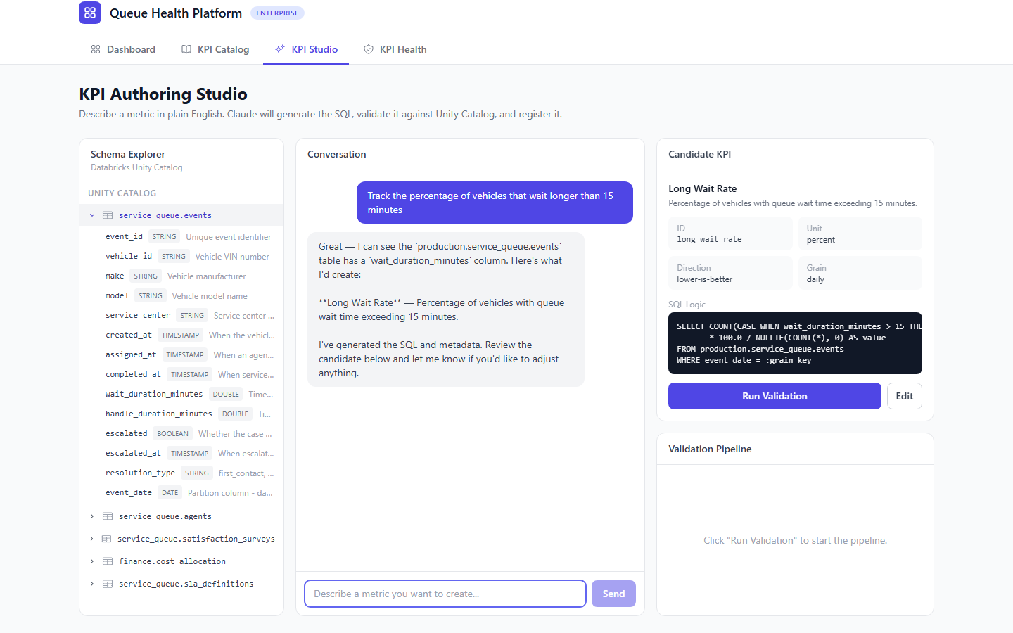

5.3 Automated Validation Pipeline
Once a candidate is generated, the user triggers the 8-stage validation pipeline. Each stage runs against Databricks and reports pass/warn/fail in real time.

Figure 8: KPI Studio — Validation pipeline results showing all 8 stages (schema, execution, type, range, null, freshness, semantic, consistency)
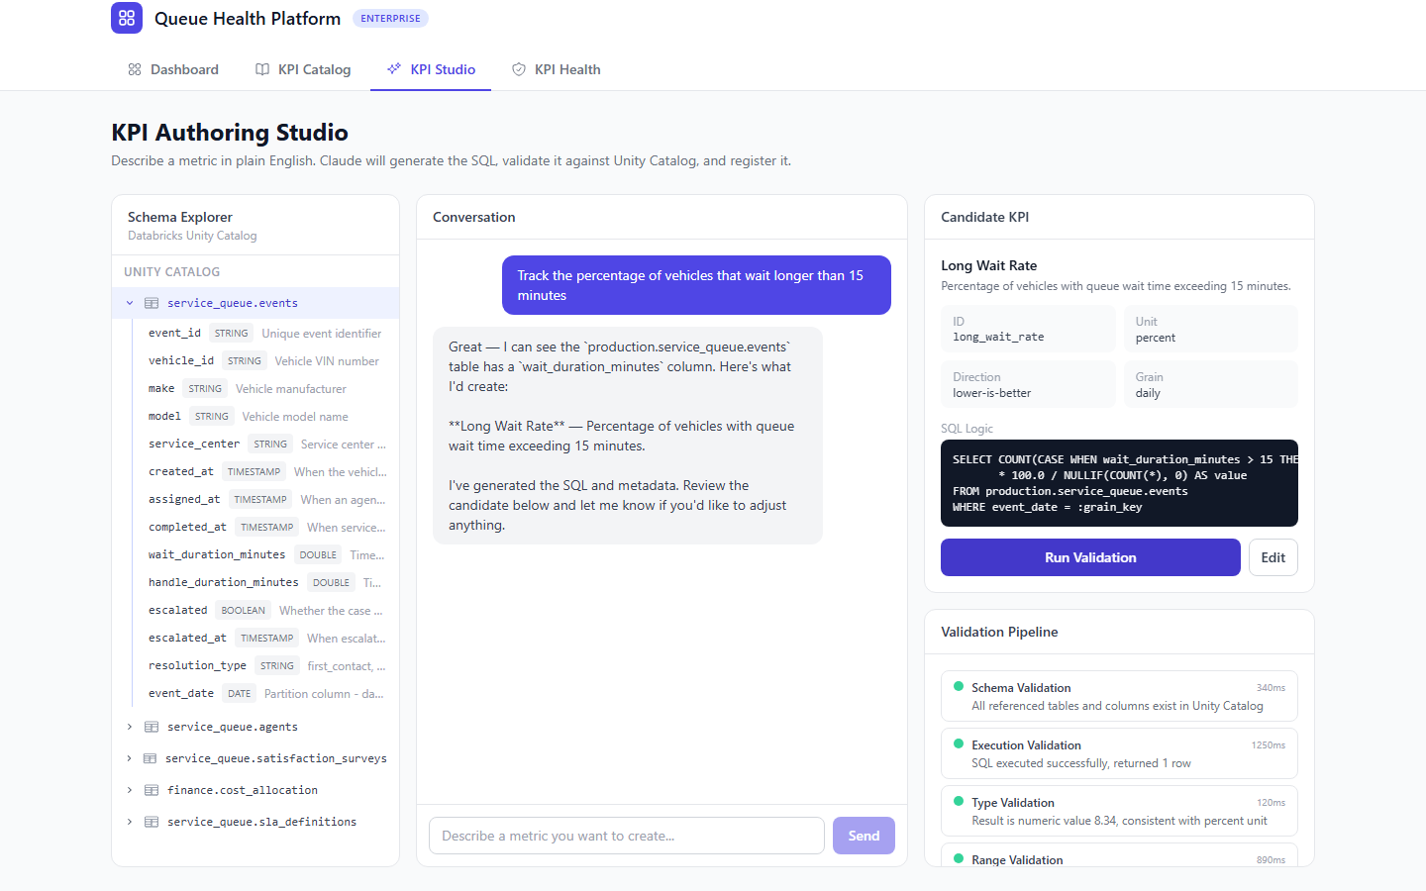

5.4 The Authoring Flow

- User describes the metric they need in natural language via the KPI Studio.
- System sends the request to Claude along with Unity Catalog metadata (table names, column names and types, column descriptions, sample values).
- Claude generates a candidate KPI definition: display name, description, SQL logic, unit, direction, grain, dimensions, and default thresholds.
- System presents the candidate to the user with a sample query result and proposed metadata.
- User can accept, edit, or ask Claude to revise through follow-up conversation.
- On acceptance, the KPI enters the validation pipeline (draft → validating).
- Validation results are shown to the user. If all checks pass, the KPI moves to validated and can be promoted to published.

5.5 Handling KPIs That Don't Exist Yet
When a user is in the dashboard chat and asks for a metric that doesn't exist in the registry, the system recognizes the gap and offers to create it via the authoring flow. This creates a flywheel: every question the system can't answer makes the system smarter by producing a new governed KPI.

6. KPI Versioning
Every edit to a KPI's definition creates a new version. The previous version is preserved immutably. This provides a complete audit trail and enables safe rollbacks.

6.1 What Gets Versioned
- SQL logic (the computation itself)
- Display name and description
- Thresholds (green/yellow/red boundaries)
- Dimensions and grain
- Materialization strategy and schedule

The kpi_id remains stable across versions. Dashboards reference the kpi_id, not a specific version. By default, dashboards always use the latest published version.

6.2 Version Lifecycle
- User edits a published KPI (via the authoring UI or dashboard chat).
- System creates a new row with version = previous + 1 and status = draft.
- The new version goes through the full validation pipeline.
- Once validated and published, the new version becomes active.
- The previous version's status changes to deprecated.
- If the new version causes issues, an admin can roll back by re-publishing the previous version.

7. KPI Validation Pipeline
Validation is the critical gate between "someone wrote SQL" and "the organization trusts this number." The pipeline runs automatically when a KPI enters the validating state.

7.1 Validation Stages

Stage | What It Checks | How It Works
Schema Validation | Do referenced tables and columns exist? | Parse sql_logic, validate against Unity Catalog metadata.
Execution Validation | Does the SQL actually run? | Execute against the SQL Warehouse with LIMIT 100.
Type Validation | Does the result type match the unit? | A percent KPI should return 0–100. A count should be non-negative.
Range Validation | Are the values plausible? | Check results against reasonable range and data distribution (p5, p50, p95).
Null/Empty Validation | Is there data? | Check that the SQL returns at least one non-null row.
Freshness Validation | Is the source data current? | Check max timestamp of source tables against configured threshold.
Semantic Validation | Does the SQL match the description? | Claude reviews the SQL against the stated description.
Consistency Validation | Is this a duplicate? | Claude compares against existing published KPIs.

8. Ongoing KPI Testing
Validation runs once during authoring. Testing runs continuously to catch breakage after deployment. Every published KPI has test assertions that execute daily via Databricks Jobs.

Figure 9: KPI Health Monitor — overall health banner with aggregate test results across all published KPIs
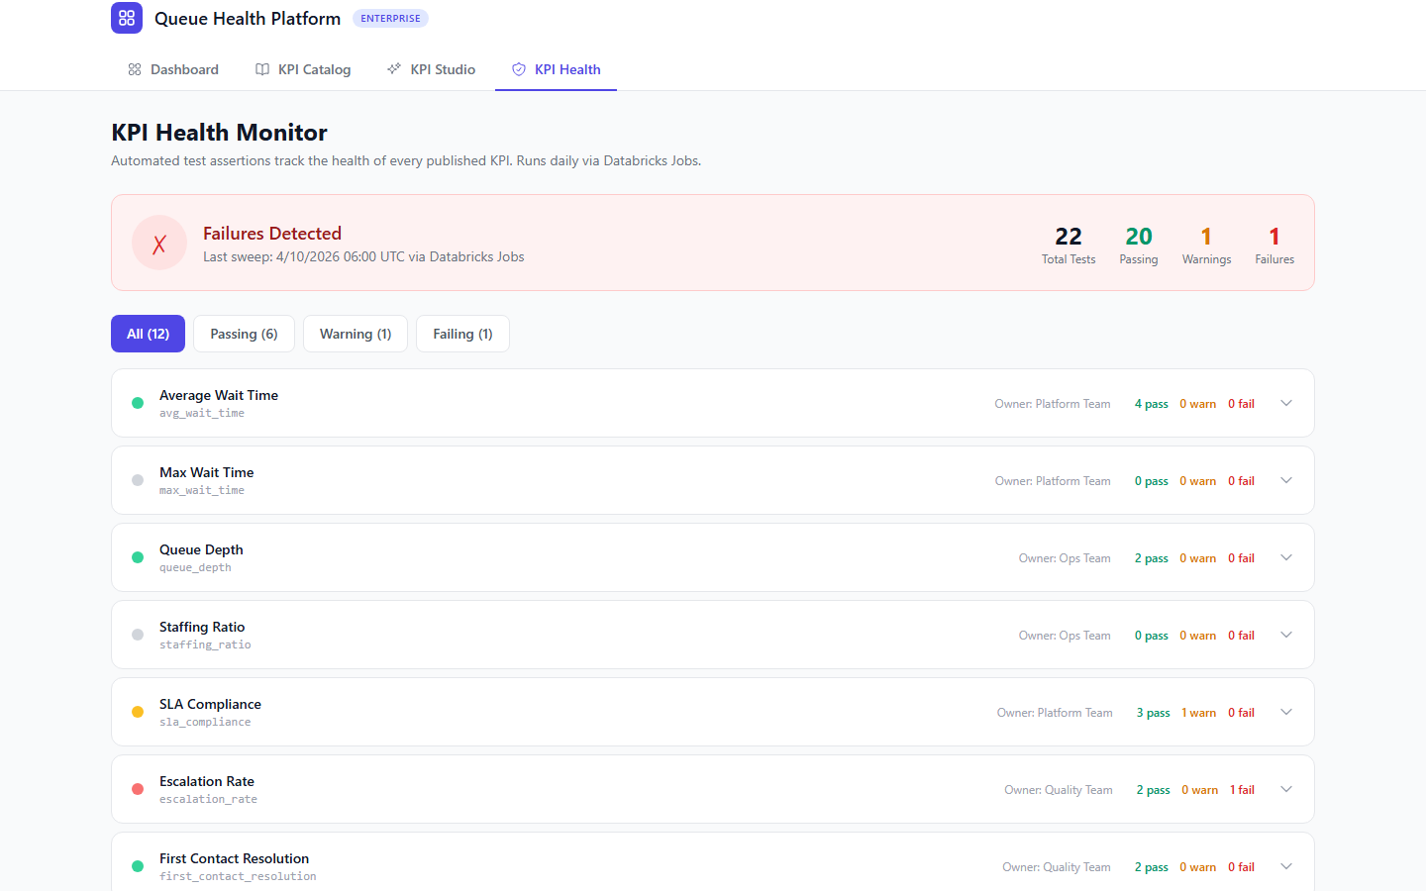
Figure 10: KPI Health — expanded view showing individual test assertions with type icons and pass/warn/fail results
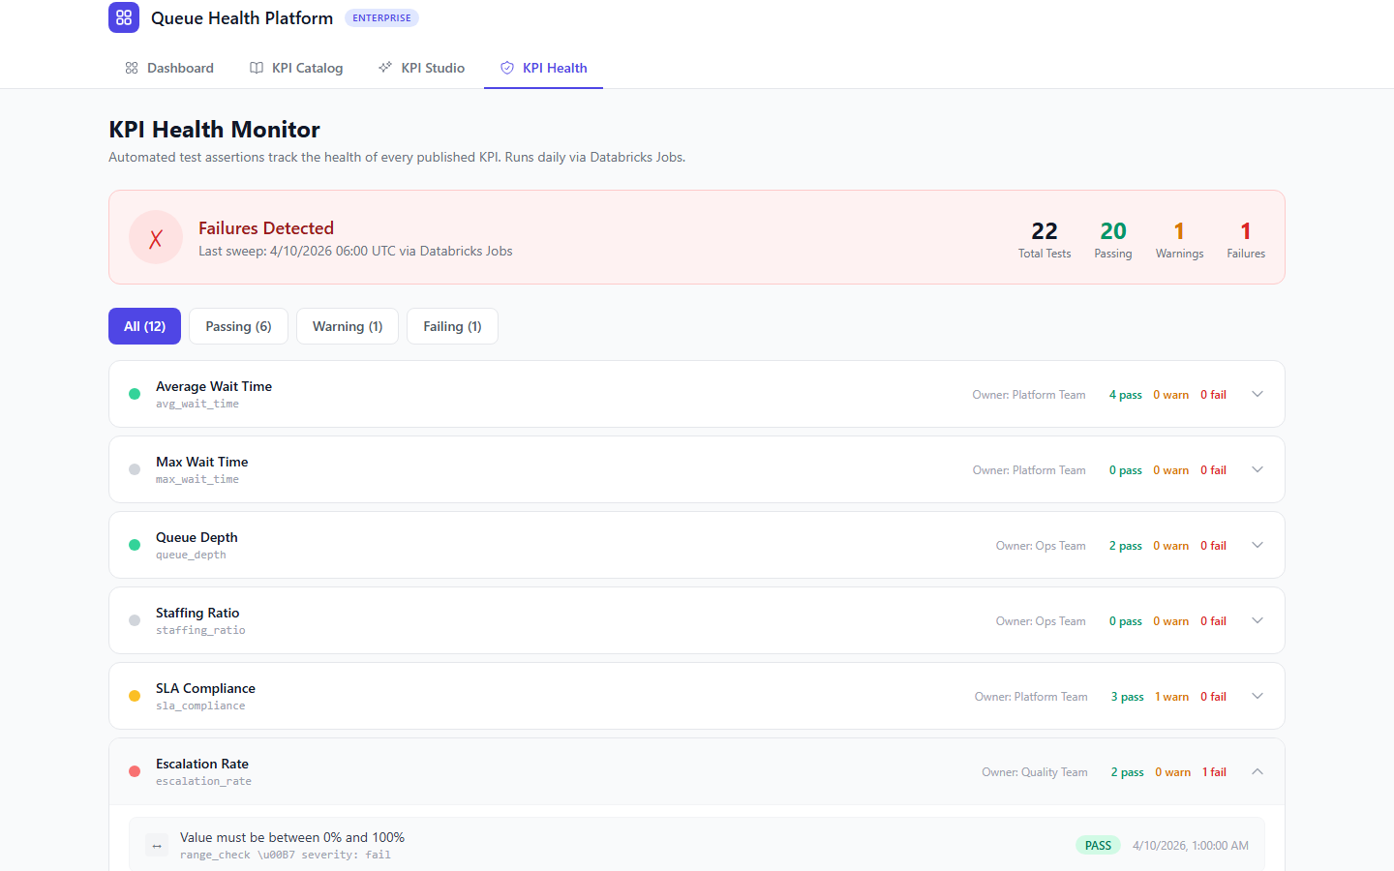

8.1 Assertion Types
Type | Example | Auto-Generated?
range_check | Value must be between 0 and 100 (for percent KPIs) | Yes
not_null | Result must not be NULL for the current grain period | Yes
freshness | Source table must have data within the last 24 hours | Yes
row_count | Query must return at least 1 row | Yes
delta_check | Value must not change more than 50% day-over-day | No (user/Claude adds)
custom_sql | Any arbitrary SQL assertion that returns true/false | No (user/Claude adds)

8.2 Test Execution
- A Databricks Job runs on a configurable schedule (default: daily).
- For each published KPI, it executes all associated assertions.
- Results are written to a test_results table with timestamps.
- Failures trigger notifications (email, Slack, or webhook).
- Persistent failures (3+ consecutive) automatically flag the KPI on dashboards.

9. Materialization Strategy
Each KPI declares whether it runs live (computed on demand) or is materialized (pre-computed on a schedule). The choice depends on query cost, data freshness requirements, and acceptable dashboard latency.

Strategy | When to Use | Tradeoffs
Live | Low-latency source data, simple SQL, small result sets | Always fresh. Higher per-request compute cost.
Scheduled | Expensive joins, large aggregations, executive dashboards | Low dashboard latency. Freshness limited by schedule.

10. Databricks Integration Details

10.1 Unity Catalog as the Backbone
- Data discovery: The authoring flow queries catalog metadata (INFORMATION_SCHEMA) to show Claude what tables and columns are available.
- Access control: Before sending catalog metadata to Claude, the system filters to only tables/columns the user has SELECT access to.
- Lineage: Unity Catalog tracks which tables a KPI reads from. When an upstream table changes, affected KPIs trigger re-validation.

10.2 SQL Warehouse Usage
- Shared SQL Warehouse for validation and test execution (serverless for cost efficiency)
- Per-user or per-group warehouses for live dashboard queries (isolates compute)
- Query tags on all KPI-related queries for cost attribution

10.3 Databricks Jobs for Scheduling
- One job per materialized KPI, scheduled via the cron expression in the registry
- One shared job for the daily test assertion sweep
- Job failures surface through Databricks alerting plus the platform's notification layer

11. Dashboard Integration
The existing prompt-guided dashboard system connects to the KPI Registry with minimal changes:

Component | Current (Demo) | Enterprise
Metric Registry | Hardcoded array (12 metrics) | Dynamic query: kpi_registry.definitions WHERE status = 'published'
Interpret Prompt | Static metric table | Dynamically injected from registry
Data Fetching | Random walk generator | Databricks SQL queries using KPI sql_logic
Filter Values | Hardcoded arrays | SELECT DISTINCT from dimension columns
Config Storage | In-memory Map | Persistent table or external DB
Thresholds | Hardcoded defaults | From registry (informed by data distribution)

12. Implementation Phases

Phase 1: Foundation (Weeks 1–2)
- Create kpi_registry catalog and Delta tables in Unity Catalog.
- Build Databricks SQL connector service in the Express backend.
- Implement catalog metadata retrieval.
- Seed registry with the 12 existing demo metrics.
- Swap dashboard data fetching from mockData.ts to live Databricks queries.

Phase 2: KPI Authoring (Weeks 3–4)
- Design Claude prompt for KPI authoring (catalog-aware SQL generation).
- Build the KPI Authoring Studio UI.
- Implement the authoring API route.
- Build the candidate review and edit interface.
- Implement KPI persistence to the registry.

Phase 3: Validation Pipeline (Weeks 5–6)
- Build the 8-stage validation pipeline.
- Implement Claude-based semantic and consistency validation.
- Build the validation results UI.
- Implement auto-generated test assertions.
- Build the test assertion editor UI.

Phase 4: Versioning & Materialization (Weeks 7–8)
- Implement KPI versioning (edit flow, version history, rollback).
- Build the materialization job runner (Databricks Jobs).
- Implement the scheduled test sweep job.
- Build the KPI Catalog Browser UI.
- Integrate "KPI doesn't exist" detection in dashboard chat.

Phase 5: Hardening & Governance (Weeks 9–10)
- Integrate Unity Catalog ACLs into the authoring flow.
- Add cost monitoring and query tagging.
- Implement notification pipelines for test failures.
- End-to-end testing across the full KPI lifecycle.
- Performance optimization (query caching, materialization tuning).

13. Open Design Decisions

Decision | Options | Recommendation
Parameterized KPIs | Allow :parameter syntax in SQL for reusable KPIs | Yes — enables variants without duplication
Approval workflow | Self-service publish vs. reviewer approval | Start self-service, add approval gates later
Dashboard version pinning | Always latest vs. pin to specific version | Default to latest; offer pinning for compliance
Cross-org sharing | Team-scoped vs. globally visible | Globally visible, governed by Unity Catalog ACLs
Backfill depth | How far back to recompute on version change | Configurable per KPI, default 90 days

14. Success Criteria

The platform is successful when:

- A non-technical business user can define a new KPI in under 10 minutes through conversation, without writing SQL manually.
- Every KPI on every dashboard traces back to a single versioned SQL definition in the registry.
- KPI breakage from upstream schema changes is detected within 24 hours automatically.
- The time from "I need a new metric" to "it's on my dashboard" drops from days/weeks to minutes.
- KPI duplication across teams is reduced — consistency validation catches near-duplicates.
- Dashboard load times remain under 3 seconds for dashboards with up to 12 KPIs.

