Report

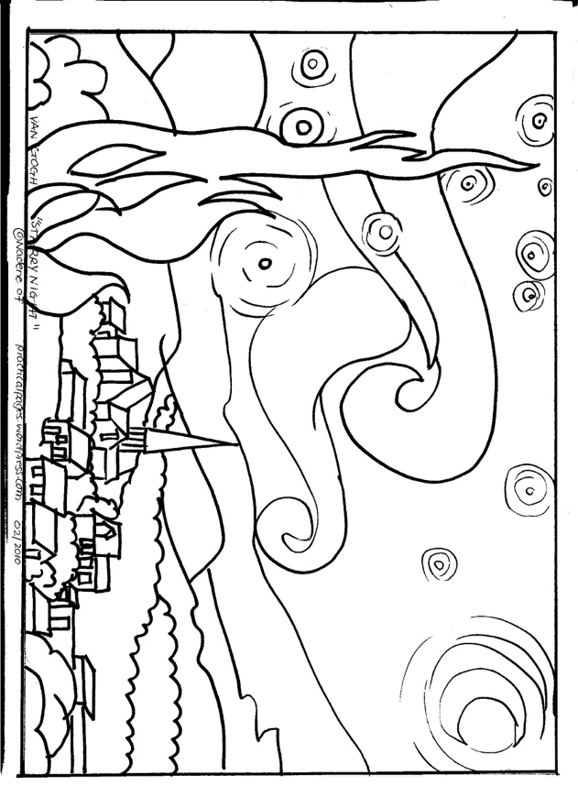I was tasked in developing and program that could visualize data for a user with an interactive element for added user interaction. I looked at various artists and projects for an idea I could base my project on. I ended up visualizing a world map and having the user select what city they would like to know the time zone of and when the city is selected it will be highlighted on the map. The 3 artists/projects that inspired me are as follows.

1. **Van Gogh** *“Starry Night”*

I really like the style of art used for this piece as it’s a very simplistic design just containing black lines with a black background. I feel that this works very well as there isn’t too much going on in the piece so you cannot be distracted easily unlike some other pieces of art which are very complex and have many colours. And I feel with a world map using an image that consists of lines would be very effective and suits the needs of the program.

1. **Michael Thompsett** *“Musical Instruments Of The World Map****”***

This was the piece of art that heavily influenced me to think about basing my visulisation on a world map. As I liked how he had brought music and a map together to create this piece of art so I started to think of ways I could incorperate a world map into my program.

1. 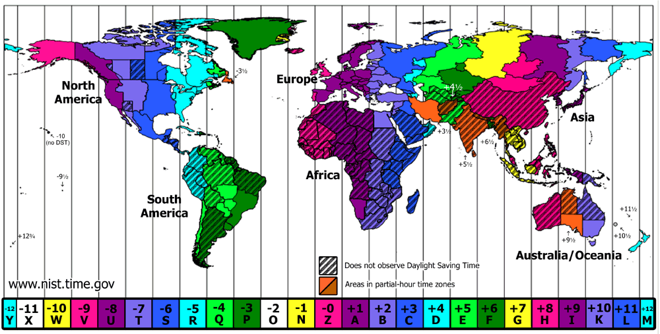The third isnt techinally an artist but I saw this image and liked the way how the designer has used different colours to differentiate between the different timezones that are in the world and its created an image that is visually appealing and still represents all the data effectively.

After looking at these 3 images in particular I decided I would be using the base image for my project a world map and I would have the user select what city and then it would show you on the map where the city was on the map and then also display to the user what time zone the place selected used. If I had had more time on my project I would have made it a world map with various locations around the world as opposed to what I have made which is a map of Europe with only a few cities, but when creating the program certain coordinates wouldn’t come back with any results and only the country in Europe would return any data for me to use. Another issue I encountered was that when the internet browser window is not in full screen the select button moves around and isn’t in the correct place but when the window is in full screen then button is in its correct place