**Department of Informatics**

**Cover Sheet for Coursework**

Module Code: CO3098

Assignment: Coursework 1: XML Schema, XSLT and XML Parsing

Surname (in CAPITALS): PECK

First name (in CAPITALS): WILLIAM

CFS ID: 159029051

I understand that this is a piece of coursework. I confirm that I handed in a signed Declaration of Academic Honesty Form (available at <https://campus.cs.le.ac.uk/ForStudents/plagiarism/>) and that am fully aware of the statements contained therein.

Date: 23rd October 2016

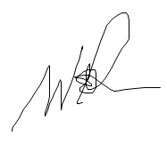

Signature: