Reproducible_report

Will Pitchers

25 August 2015

This is an R Markdown document. Markdown is a simple formatting syntax for authoring HTML, PDF, and MS Word documents. For more details on using R Markdown see <http://rmarkdown.rstudio.com>.

When you click the **Knit** button a document will be generated that includes both content as well as the output of any embedded R code chunks within the document. You can embed an R code chunk like this:

summary(cars)

## speed dist   
## Min. : 4.0 Min. : 2.00   
## 1st Qu.:12.0 1st Qu.: 26.00   
## Median :15.0 Median : 36.00   
## Mean :15.4 Mean : 42.98   
## 3rd Qu.:19.0 3rd Qu.: 56.00   
## Max. :25.0 Max. :120.00

You can also embed plots, for example:

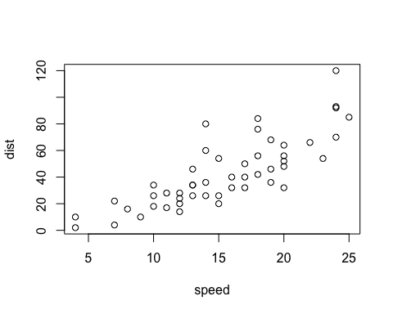

Note that the echo = FALSE parameter was added to the code chunk to prevent printing of the R code that generated the plot.

* So maybe I have lists of things:
* thing 1
* thing 2
* tacos
* Ned Niederlander

...and maybe there are tables involved:

|  |  |
| --- | --- |
| name | legs |
| thing 1 | 4 |
| thing 2 | 4 |
| tacos | 0 |
| Ned Niederlander | 2 |

library(ggplot2)  
  
min( diamonds$price )

## [1] 326

qplot( carat, price, data=diamonds, color=cut )

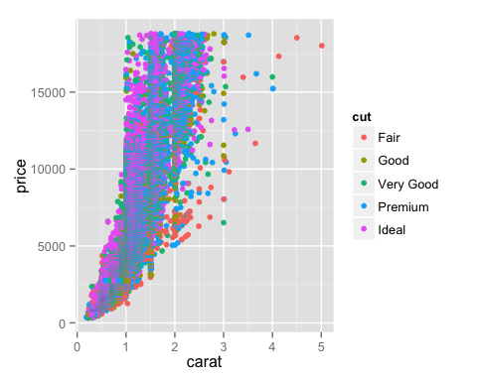

have you seen how expensive the diamonds are!??! the most expensive ones cost *$18823 FFS!*