**TAP-XXX PIEZO LEVEL DETECTOR**

The TAP-XXX piezoelectric sensor is designed to be firmly affixed under the printing bed of an FDM (Fused Deposition Modeling) printer so as to detect the contact of the printing nozzle with the bed. It requires only connection to a power supply, and to the Z minimum port normally found on the control board of a 3D printer. It requires no physical modification of the printer itself, and indeed may function satisfactorily if not attached to the printer bed directly, but anywhere that will transmit rapid impulses to the sensor, such as the extruder. The novel design of the TAP-XXX sensor disc makes it insensitive to high frequency vibration and motor noise, both mechanical and electrical. Modification of the firmware used to control the printer generally requires only a reduction of the probing speed, and setting the firmware to zero the probe X, Y, and Z axis offsets for fixed probe nozzle contact detection.

The TAP-XXX will work with any bed material and nozzle, and is not subject to variations in material, temperature, offset, conductivity, or reflectivity, as is common with inductive, capacitive, optical, magnetic, acoustic, or mechanical switch probing. Because it uses the nozzle contact with the bed, and is sensitive only to low rate *changes in acceleration*, it is extremely accurate and repeatable.

Unlike other piezo sensors, the TAP-XXX piezo level detector is designed to react only to instantaneous changes in acceleration, referred to physically as jerk (j, meters/second3). Response to acceleration (a, meters/second2) is minimized via electrical low pass filtering, and most particularly by physical mass loading and, optionally, viscous damping of the piezoelectric sensor disc.

The mass loading is of critical importance, as it is the primary means for preventing the piezo disc from responding to inputs that are not “instantaneous” in relation to its design filter functions.

The piezoelectric sensor is a brass disc, with piezoelectric ceramic bonded to its center. The entire piezoelectric sensor is generally about 0.6mm thick, with the brass substrate representing approximately half of the total thickness. While the diameter is not critical, a larger diameter has a lower mechanical resonance frequency, and is more suitable in this application. Piezo discs are polarized during manufacture, and it is important to verify that the initial electrical response of the disc is positive going with respect to the common circuit ground when given a mechanical impulse in the intended direction. The XXX term in the TAP-XXX name refers to the diameter of the piezo disc in mm times 10.

The brass is solderable, and the ceramic is coated with silver, allowing judicious soldering of wire leads to its surface. However, suitable discs are available with wire leads applied by the manufacturer. The Murata leaded BB series is recommended for reasons of manufacturing repeatability, temperature stability, and ease of installation during assembly of the TAP-XXX.

The output of the piezo disc is input rate and displacement dependent, and may easily exceed 90 volts peak if the disc is subject to sufficient and rapid flexure. In my design, this response is clipped via back-to-back silicon switching diodes, and attenuated by a 100K ohm direct shunt load and a parallel 0.1 uF shunt capacitor. In parallel with the 30000 pF disc capacitance (for a 35mm disc), a low pass filter of about 80 milliseconds, (12.5 Hz) is obtained. A second pole is provided by the nominally 10 pF sample and hold capacitor inherent in the microprocessor ADC (Analog to Digital Convertor) input, and the 10K ohm series input resistor. An output from the piezoelectric disc of about 20 millivolts is all that is required for stable TAP-XXX operation, and the sensitivity is configured via software. Connector pads for a three pin serial programming connector are available on the printed circuit board, although pogo pin programming is preferred, and pads are included for same, for size and cost constraints.

The microprocessor is a Picaxe 08M2, in an 8 pin SOIC (Small Outline Integrated Circuit) package, based on the Microchip 12F1840. It receives a nominal 5.0 volt supply from a standard 7805 linear voltage regulator, capable of input from 7 to 35 VDC (Volts Direct Current). The 7805 is in a SOT-223 package, and is thermally and electrically ground coupled to both sides of the printed circuit board through generous plated through-hole vias to top and bottom ground planes. The regulator input is decoupled with a 0.22 uF ceramic capacitor, and the output is decoupled with a 1.0 uF ceramic capacitor. The Picaxe 08M2 is also closely decoupled with a 0.001 uF ceramic capacitor. No electrolytic capacitors are used to enhance the longevity of the assembly. All capacitors are generously voltage derated, and of 0603 SMD (Surface Mount Device) form factor, as are all of the other discrete surface mount devices. The 7805 regulator was chosen for its low output noise and excellent ripple rejection. Low drop out regulators are not suitable, due to their high feedback gain, output noise, and low ripple rejection. The output of the regulator is indicated with a high efficiency green LED (Light Emitting Diode), current limited to about 0.25 mA (milliAmperes) by a series 10K resistor. The entire worst case load on the regulator is less than 12 mA, including its own quiescent current, so that the regulator dissipates 0.24 watts maximum with a 25 volt input. The entire assembly is capable of operation at +85 Celsius ambient indefinitely, in still air. Thermally, the piezoelectric ceramic is the limiting component.

The Picaxe 08M2 is initialized to run at an internal clock rate of 32 MHz (MegaHertz). The 10 bit ADC of the Picaxe uses the internal 1.024 volt buffer amplifier output and circuit ground as references, giving a sensitivity of 1.0 millivolt per count, with the ADC input disconnected from its digital functions; i.e., it is an input only. The Picaxe receives conditioned ADC input from the piezo disc, and provides an 80 millisecond output pulse to a high efficiency red LED, current limited to about 0.25 mA via a series 10K ohm resistor on the LED drive output pin. This is strictly to provide visual indication of sensor actuation upon a positive going leading edge signal from the piezo disc.

Simultaneously, a separate Picaxe pin is switched from an active low output state, i.e., current sinking, to a high impedance input state, i.e., an open collector, for 80 milliseconds. This is to replicate the action of a normally closed mechanical switch, in which the input to the associated printer microprocessor Z minimum pin is pulled up to the logic supply voltage via a nominal 4.7K ohm pull-up resistor on the printer controller board. The Picaxe pulls the printer controller microprocessor input low, and allows it to go high via the pull-up when actuated (switch open, or high impedance upon nozzle contact with the printer bed). Note that this Picaxe pin will function with any standard logic level input, from 1.8 to 5 volts, as it functions only as a FET (Field Effect Transistor) closed switch to common ground when low. The output pin can safely sink up to 25mA, although pull-up resistor limiting to less than 10 mA will ensure both standard Transistor-Transistor-Logic (TTL) and Schmitt trigger logic levels. Note also that attempting to switch external voltages greater than the +5V supply of the Picaxe may “phantom drive” the entire Picaxe through the output pin, and is not permitted.

It is critical that the piezo disc be edge constrained, i.e., fastened only at its periphery within its housing, and have an appreciable mass adhered to the center of the piezoelectric ceramic of the disc. A non-magnetic 316 or 304 stainless steel sphere of 0.5 inch diameter, bonded with J-B Weld epoxy to the center of the disc, is recommended for ROHS (Reduction of Hazardous Substances). Otherwise, a .50 caliber lead ball is ideal, in terms of density, cost, and acoustic damping. Tungsten, tungsten carbide, depleted uranium, gold, copper, brass, bismuth, non-crystalline neutronium, or any other non-magnetic material of high density is acceptable. A small flat spot is machined, cast, or ground onto the sphere to enhance adhesion and provide stability during adhesive cure. Keeping the adhesion area small, with the mass and overhung moment large, is critical to sensitivity and jerk response.

A sphere with a minor flat of about 2 mm diameter is ideal, although other shapes are suitable. Obviously, a magnetic mass will render the disc sensitive to external magnetic fields, which may be of interest, but is not within the scope of this purpose.

The mass, of roughly 10 grams (an order of magnitude greater than that of the piezoelectric ceramic itself), provides inertia to the entire disc, which dampens response to acceleration while enhancing the response of the disc to jerk. Because the TAP-XXX responds only to *changes* in acceleration, thermal drift of the piezo disc is not an issue. When installed under a heated bed, it is only necessary to allow the TAP-XXX to thermally stabilize (red LED off), before starting the probing process. The circuit board and disc mount are vented to prevent distortion of the piezo disc from air expansion or contraction during temperature changes. The vent must not be obstructed. Again, the TAP-XXX may be mounted anywhere on the printer that will reliably transmit nozzle contact impulses. It is not necessary that it be mounted in contact with the printer bed, although doing so will result in much greater sensitivity and repeatability.

Additionally, the disc may be vibration damped with a thermally stable viscous material, such as silicone grease, applied during assembly between its major brass surface and its housing. This prevents resonant vibration of the disc after it has received a mechanical impulse, although this technique reduces overall sensitivity. Because the mechanical low pass response is lower in frequency than the response time of the open collector output of the circuit, viscous damping is generally not required.

Existing piezoelectric probe designs firmly clamp the entire disc surface with various levers, springs, pads, and other fixtures, in an attempt to mechanically deform the disc to yield a piezoelectric response. Doing so yields a device which is basically a contact microphone or accelerometer, responsive to sources of acoustic noise, vibration, and acceleration. My design has no moving parts or special fixturing requirements, and responds only to *changes* in acceleration, for example the slight tap of a 3D printer nozzle on its printing bed, and is very insensitive to higher frequency audio and vibration input such as motion of the printer motors and the like. A very low nozzle contact speed of 10 millimeters per second is more than sufficient for reliable sensing of nozzle contact on the printer bed, as bed jerk on the order of nanometers/second3 is all that is required. There is a direct trade-off between probing speed (time spent probing), accuracy, and repeatability. Lower probing speeds allow the printer more time to respond to the TAP-XXX signal, so there is less effect from continuation of Z axis motion due to mechanical mass and motor inertia, and unnecessary microsteps after nozzle contact.

Invoking input pin interrupt capabilities on the printer controller via firmware, when available, can result in an order of magnitude decrease in the response time of the motor control function, further enhancing repeatability and accuracy.

This design is capable of nanometer resolution, and picometer repeatability. Few mechanisms are capable of the delicacy required to test this nozzle contact sensor. A typical g-code M48 test will only report the capability of the stepper resolution, with an effective sigma much less than that of the stepper resolution, and ultimately limited by the associated mathematics processor floating point capability and the algorithms utilized for statistical analysis.

With the TAP-XXX affixed under the bed of a delta style printer with 5 micron mechanical resolution (0.9 degree steppers, 1/16 stepping, 16 tooth drive gears, and 2 mm pitch Gates belts, running Marlin 2.0.7.2 on a 32 bit ARM controller board at 72 MHz), repetitive Marlin firmware M48 probe tests will generally report a standard deviation of 0.000000 millimeters, with a worst case of 0.002 millimeters (two microns) during severely changing thermal conditions, i.e.; during bed warm-up.

It should be noted that due to an internal flaw in the C++ code that Marlin (up to Rev 2,0.9.1) uses for motion control, there can be as many as 2 microsteps of motion AFTER the printer controller has received a Z axis contact signal, even if the Marlin interrupt function is enabled. This “carry-on” motion is averaged into the standard deviation result, and leads to erroneous data. This will affect repeatability, calibration, and bed leveling.

An effective method to “absorb” this error is to mount the bed on “O” rings, or another compliant material, so that it is capable of complying with the extraneous motor steps. Only a few microns of compliance are required, but the bed should be able to mechanically respond under Z axis pressure, while remaining immobile during actual printing, during which X and Y axis forces are extremely low. Note that this is NOT to enhance response of the piezo sensor, but to address an inherent flaw in the Marlin motion routines.

Mechanically, the TAP-XXX is assembled within a housing printed from PLA, ABS, PETG, PC, or any other material suited to the intended environment. Even PLA is useable under a heated bed if there is a high temperature thermal spacer adhered between the bed and the TAP-XXX.

The piezo disc is gently abraded with fine aluminum oxide grit, applied with a Paasch etching gun, at three equidistant points on the periphery of its rear surface, and also at the center of the front ceramic. This is to promote adhesion, and care must be taken not to interrupt the conductive silver applied to the surface of the piezoelectric ceramic. Without abrasive surface treatment, the silver metallization of the ceramic will not adhere reliably to most epoxies or cyanoacrylates.

A small dab of J-B Weld high temperature epoxy is then applied at three equidistant points to the stepped ridge at the bottom of the housing, and the disc is placed onto the adhesive. The stepped ridge prevents the surface of the disc from contacting the surface of the housing, and it is important that the disc be glued in three equidistant spots and not continuously around the periphery, so that air has access to the cavity under the disc for expansion and contraction during temperature changes.

During assembly, a dab of silicone grease may be applied to the center of the rear surface of the disc to act as a viscous damper, although this is generally not required, nor recommended.

With the disc in place, a centering fixture is used to gently press the disc into the adhesive, and to align the mass ball, with a small dab of adhesive applied to its flat, with the center of the piezo disc. The alignment fixture is removed, and the assembly is cured at 60 Celsius until the adhesive has completely hardened.

The leads from the piezo disc may then be soldered to the through-hole pads of the printed circuit board, with careful attention to proper directional response polarity, and the board adhered in place with J-B Weld, taking care that the leads do not contact the mass ball.

I have measured no difference in performance between a 41 mm and 35 mm diameter piezo disc (TAP-410 and TAP-350 respectively), and smaller discs also work well. However, the 35mm disc housing fits within the size constraint of a standard NEMA 17 motor mount, and also allows for a reasonably sized printed circuit board, which can be manually assembled, given a steady hand and good vision (or a magnifier). At the same time, the standardized mounting footprint provides an easy method of attaching the TAP-XXX to the extruder of a printer, if so desired. My 35mm housing printer files allow for either through hole or brass inserts for 4-40 or 3 mm screws, with proper screw head clearance. My preferred method is to simply adhere the TAP-XXX to the underside of the heated bed with J-B Weld epoxy, which is rated for continuous service at 260 Celsius.

The TAP-XXX must never be dropped onto a hard surface. Doing so may dislodge the mass ball, and will almost certainly induce voltages into the ADC input of the microprocessor greater than those that the clipping functions are designed to deal with.

The Picaxe 08M2 microprocessor is available from Revolution Education in the United Kingdom, and was chosen due to the excellent support available from them, and prior experience with their products in commercial devices. Although it costs a few pennies more than the base Microchip 12F1840, it includes on-chip bootstrap firmware, and can be easily re-programmed with a simple three wire serial interface from any USB (Universal Serial Bus) port for users who may wish to modify the operating code. An extensive development environment is available at no charge from Revolution Education, and the programming hardware consists of a simple USB adapter cable (AXE-027), available at very little cost.

The required serial interface circuit is built into the TAP-XXX printed circuit board, along with the pogo-pin contact points for the programming interface, so that no programming connector need be installed on the TAP-XXX board itself.

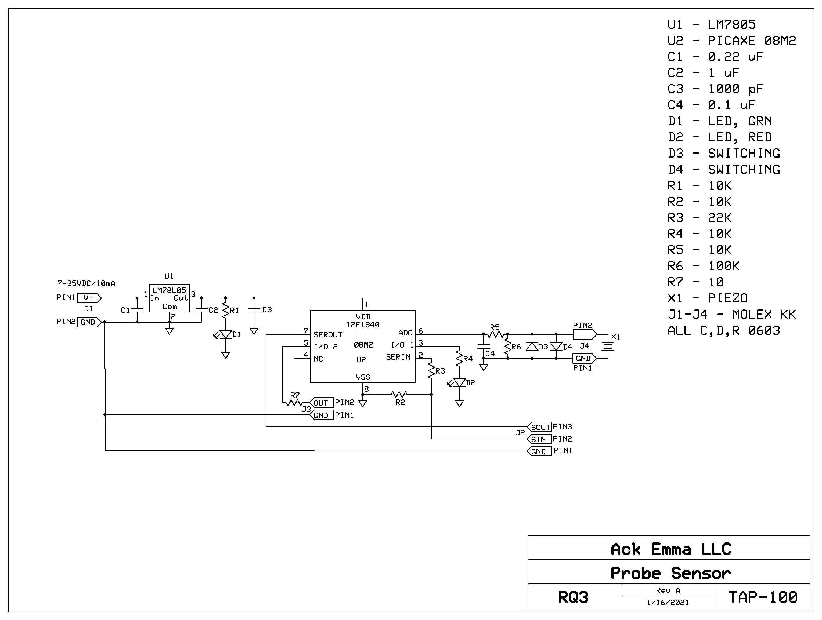

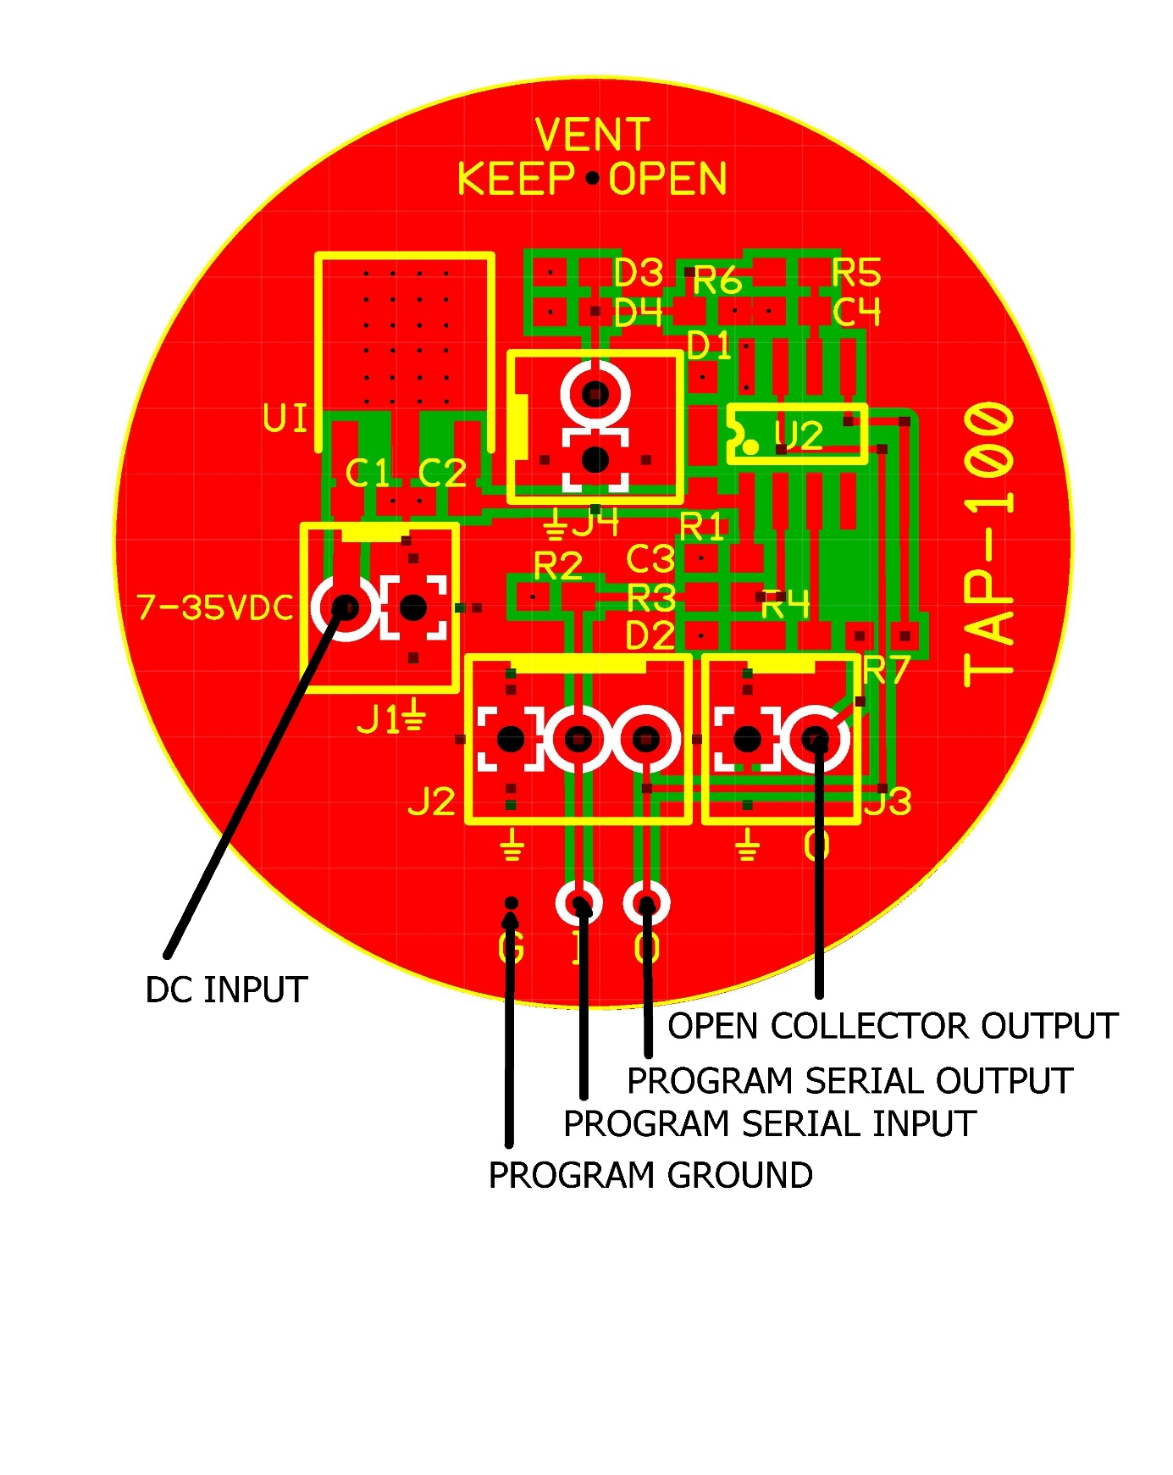

J1 – 7 to 35 VDC Input Header – J1 Pin 2 is common ground

J2 – Programming Input Header, omitted, with parallel POGO inputs – J2 Pin 1 is common ground

J3 – Open Collector Output Header – J3 Pin 1 is common ground

J4 – Piezo Input Header, omitted – J4 Pin 1 is common ground

All connectors are gold flashed 0.1 inch Molex KK

**PRINTED CIRCUIT BOARD CONNECTORS**

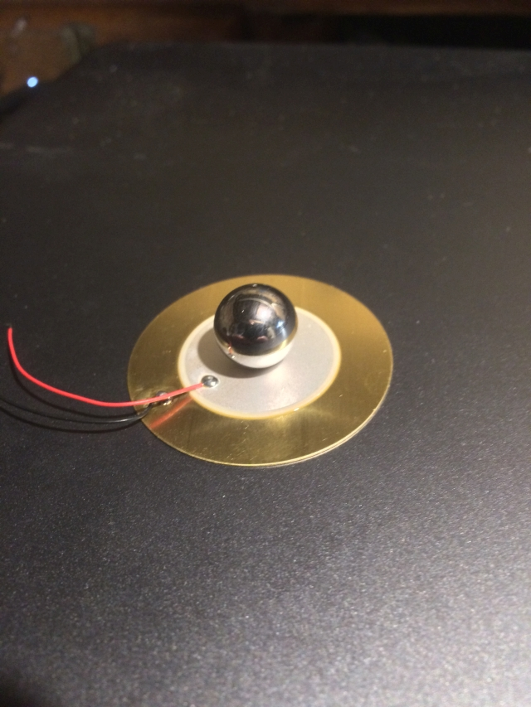

**MASS MODIFIED MURATA 41mm PIEZOELECTRIC DISC – 0.5” DIAMETER 316 SS BALL**

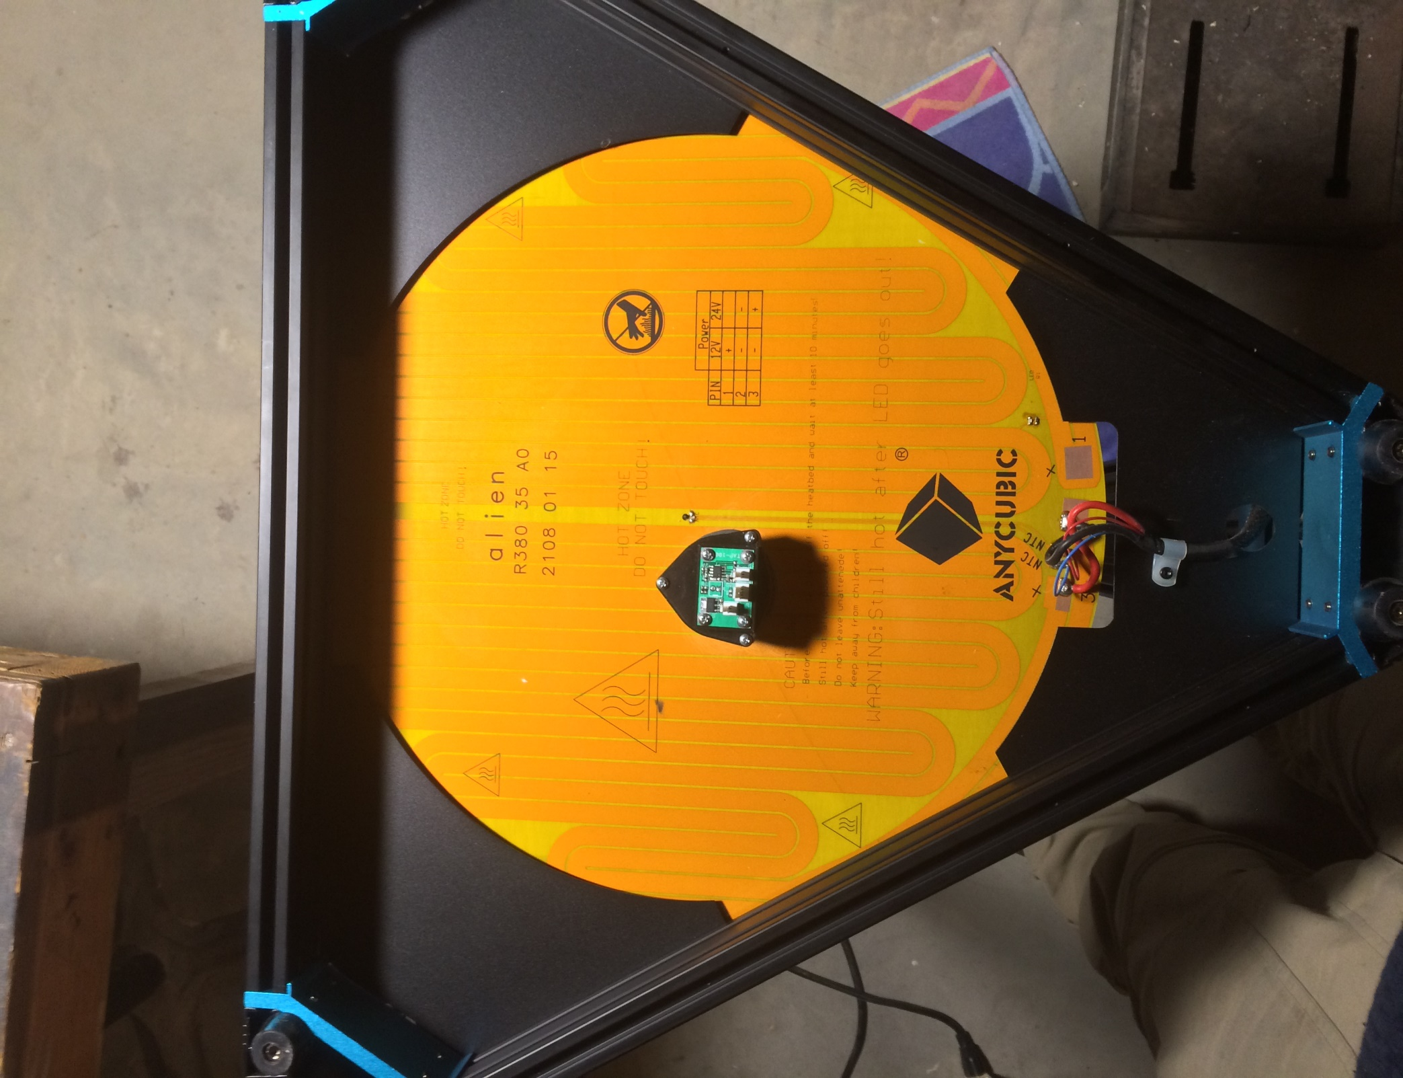

**41mm SENSOR MOUNTED UNDER HEATED DELTA BED**

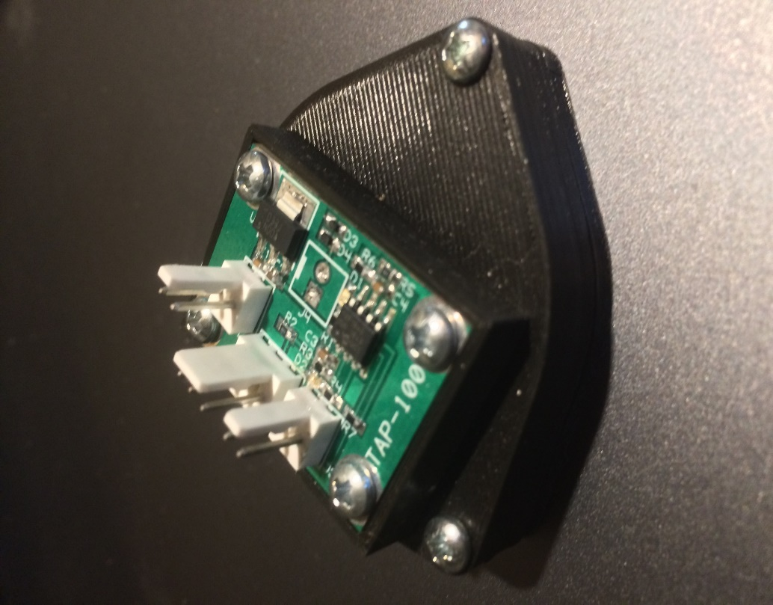

**41mm TAP-410 PIEZO NOZZLE CONTACT SENSOR**

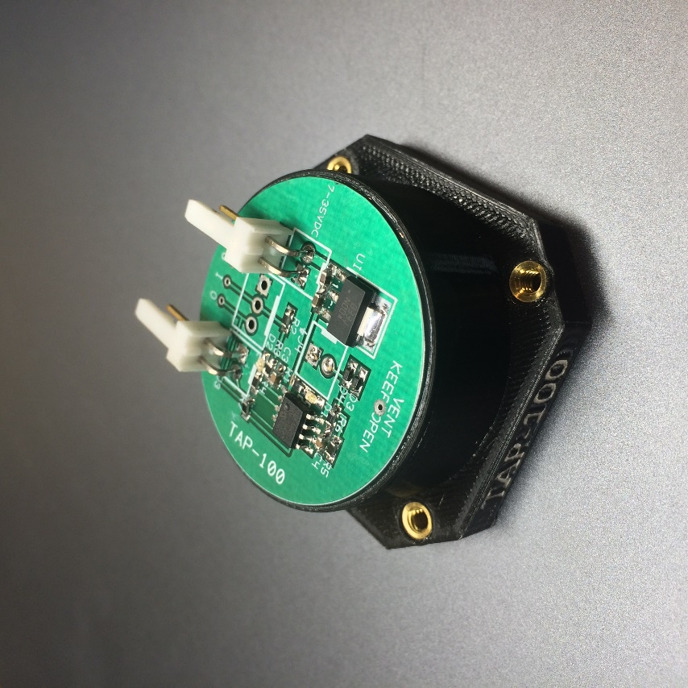

**35mm TAP-350 PIEZO NOZZLE CONTACT SENSOR – NEMA 17 MOUNT**

**PICAXE BASIC CODE**

01 #REM

02 Piezoelectric bed leveling sensor using piezo disc

03 with jerk mass. Output acts like normally closed

04 microswitch, actively pulled low when not actuated,

05 and tri-stated when actuated to allow printer microprocessor

06 to pull output high via 4K7 ohm resistor on controller board.

07 1/21/21 by RQ3 / Ack Emma LLC

08 #ENDREM

09

10 #Picaxe 08M2

11 #no_data

12 #no_end

13

14 symbol LED=C.4 ;LED drive pin

15 symbol OUT=C.2 ;open collector output

16 symbol PIEZO=C.1 ;sensor ADC input pin

17 symbol DELAY=**80**\***8** ;output pulse width, milliseconds*8

18 symbol TRIGGER=**24** ;sensitivity (millivolts),0-1023(max-min),nom.24

19

20 init:

21 setfreq M32 ;run at 32 MHz

22 pullup **%01000** ;apply pull-up to unused pin 4 (C.3)

23 adcsetup=**%00010** ;make C.1 ADC input

24 adcconfig **%011** ;use internal reference and circuit ground

25 fvrsetup FVR4096 ;step references per Microchip errata sheet

26 fvrsetup FVR2048

27 fvrsetup FVR1024 ;use internal 1.024 volt reference

28 pause **1000** ;settling time

29

30 main:

31 do while w0<TRIGGER ;loop ADC while piezo output is less than trigger

32 readadc10 PIEZO,w0 ;read the ADC

33 loop

34 input OUT ;tri-state output pin to allow external pull-up

35 high LED ;turn on LED

36 w0=**0** ;re-set ADC value

37 pause DELAY ;wait for bounce settling

38 low LED,OUT ;re-set outputs active low

39 goto main