SYSTEM INTEGRATION AND ARCHITECTURE
FINAL PROJECT REQUIREMENTS
Implementation Checklist: System Diagrams
System Title
SmartFine: A Student Fines Monitoring and Management System
Diagrams in this document
- Figure 1. Use Case Diagram (System Users)
- Figure 2. System Flow Diagram (Swimlanes and Pools)
- Figure 3. Entity Relationship Diagram (ERD)
- Figure 4. System Flowchart
- Figure 5. Network Diagram (Network Flow)
Prepared by: ______________________________________
Course and section: ______________________________
Date submitted: _________________________________

About the System
SmartFine: A Student Fines Monitoring and Management System (SmartFine) is a mobile and web application that helps a school record, track and settle student fines. Fines Officers record fines (with optional evidence photos), Students see their fines and pay them with GCash or at the cashier, and Administrators manage accounts, fines, payments, refunds and the system itself.
The mobile and web app is built with Expo and React Native. It talks to a Node.js and Express server that stores its data in a SQLite database. Payments by GCash go through PayMongo, one-time codes are sent by email, and the server is reached from outside the school through an ngrok tunnel.
Security features shown in the diagrams: login by username or email with a lockout after three wrong passwords and a CAPTCHA after a lockout; one-time codes (OTP) for first sign-in, forgotten passwords and email changes; server-side sessions that end after 15 minutes without activity; role-based access; a Log Trail of security and administrator actions; validation and cleaning of all input; and encrypted daily backups with restore.

Names used in every diagram
All five diagrams use the same names. The terms are listed here so the documentation stays consistent.
Term | Meaning
Student | A person with a student account who is fined and who pays fines.
Fines Officer | A staff account that records fines (and may cancel its own unpaid fines).
Administrator | A staff account that manages everything, including accounts, payments, refunds, settings, backups and the Log Trail.
Staff Member | Groups the Fines Officer and the Administrator (the functions they share).
SmartFine System | The app and the server together, shown as one participant.
Fine | A penalty recorded against a student for a violation type, with an amount in pesos.
Violation type | A named kind of violation with its amount (for example, a school rule).
Evidence photo | A photo attached to a fine (up to 3), shown to the student, officer and administrator.
Payment | Money received for a fine, either by GCash (through PayMongo) or in cash at the cashier.
Refund | Money returned to the student for a paid fine, approved by an Administrator.
OTP | A 6-digit one-time code sent by email (expires, limited tries, used once).
Session | A signed-in period kept on the server; ends at logout, after 15 minutes idle, or when the account changes.
Log Trail | The read-only record of who did what, when, in which module, from which IP address, and the result.
PayMongo | The external GCash payment gateway.
Email Service | Gmail (SMTP), which sends the one-time codes.
ngrok | The secure tunnel that gives the server a public HTTPS address.

1. Use Case Diagram (System Users)
The Use Case Diagram shows who uses SmartFine (the actors) and what each actor can do (the use cases). It uses standard UML use case notation: stick figures for actors, ovals for use cases, a rectangle for the system boundary, a hollow triangle for generalization, and dashed arrows for «include» and «extend».

Actors
Actor | Type | What the actor does
Student | Primary | Views own fines and evidence photos, pays with GCash or requests cash payment, requests refunds, shows own QR code.
Fines Officer | Primary | Scans or searches for a student, records fines with evidence photos, views recorded fines, cancels own unpaid fines.
Administrator | Primary | Does all staff functions, and manages accounts (lock, unlock, roles, import), fines, cash payments, refunds, reports, fine types, settings, the Log Trail, backups, restore and system reset.
System User | Abstract (generalization) | The functions every signed-in person has: log in, log out, reset or change password, change email, view notifications.
Staff Member | Abstract (generalization) | The functions shared by Fines Officers and Administrators: scan or search for a student, record a fine, view recorded fines.
PayMongo | Secondary (external system) | The GCash payment gateway. Processes GCash payments and refunds.
Email Service | Secondary (external system) | Gmail (SMTP). Sends one-time codes by email.

Relationships between use cases
- Generalization: Student and Staff Member inherit from System User; Fines Officer and Administrator inherit from Staff Member. A child actor can do everything its parent can.
- «include» (always used): Pay Fine with GCash includes Process GCash Payment; Record Fine includes Select Violation Type; Approve or Decline Refund includes Process GCash Refund; Restore Data from Backup includes Create Safety Backup First; Verify Email with One-Time Code, Reset Forgotten Password and Change Email Address include Send One-Time Code by Email.
- «extend» (optional): Verify Email with One-Time Code (first sign-in) and Solve CAPTCHA (after lockouts) extend Log In; Attach Evidence Photos extends Record Fine.
- Every function except Log In and Reset Forgotten Password needs a signed-in, active account. The server checks this on every request.

Checklist coverage
- All system users (actors) are identified, including the two external systems.
- Relationships between actors and functions are shown with solid lines; primary and secondary actors are both included.
- Standard UML use case notation is used.
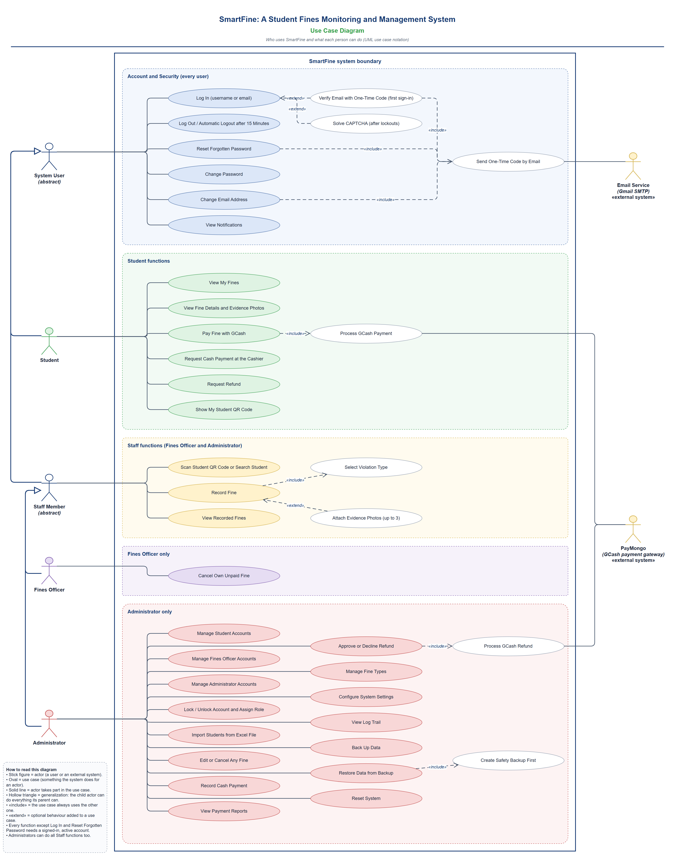
Figure 1. Use Case Diagram (System Users)

2. System Flow Diagram (Swimlanes and Pools)
The System Flow Diagram follows one fine through SmartFine, from the moment a Fines Officer records it to payment and the optional refund. Each participant has its own lane. The school and the SmartFine System share one pool; PayMongo is an external organization, so it is a separate pool, and the messages between the pools are drawn as dashed arrows.

Lanes and pools
Lane or pool | Role in the process
Fines Officer | Finds the student and records the fine.
Administrator (cashier) | Receives cash at the cashier, records it, and approves or declines refunds.
SmartFine System | Validates and saves data, sends notices, creates PayMongo checkouts, checks webhooks, updates reports and the Log Trail.
Student | Views the fine, chooses how to pay, and may ask for a refund.
PayMongo (separate pool) | Takes the GCash payment and the refund, and sends signed webhooks back.

Sequence of activities
- Start. The Fines Officer scans the student's QR code or searches for the student.
- The SmartFine System shows the student's details and unpaid fines.
- The Fines Officer selects the violation type, adds remarks and optional evidence photos.
- The System validates the input, saves the fine as UNPAID, records it in the Log Trail and notifies the Student, the Officer and the Administrators.
- The Student views the fine details and evidence photos and chooses to pay at the cashier or with GCash.
- Cash: the Student requests cash payment; the System creates a pending request and notifies the Administrators; the Administrator receives the cash and records the payment; the System marks the fine PAID.
- GCash: the Student taps Pay with GCash; the System creates a PayMongo checkout; the Student pays; PayMongo sends a signed webhook; the System checks it, records the payment and marks the fine PAID.
- The System sends payment notices to the Student and Officer and updates the reports and the Log Trail.
- If no refund is needed the process ends: End: fine settled.
- Refund (optional): the Student requests a refund with a reason; the System creates the request and notifies the Administrators; the Administrator approves or declines it.
- Declined: the Student is notified (End: refund declined). Approved: the refund is sent through PayMongo for GCash, or the Administrator returns the cash; the System marks the refund done, cancels the fine and notifies the Student (End: refund completed).

Checklist coverage
- Each user and system component has its own lane; PayMongo is a separate pool.
- The sequence of activities, interactions and handoffs between participants is shown.
- The start point and the three end points are clearly marked.
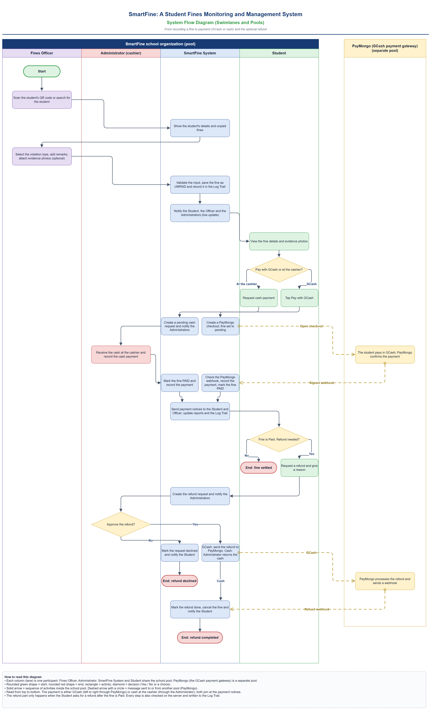
Figure 2. System Flow Diagram (Swimlanes and Pools)

3. Entity Relationship Diagram (ERD)
The ERD shows the SmartFine database. It was drawn from the real database (SQLite) and uses crow's foot notation: a bar means exactly one, a circle means zero or optional, and a crow's foot means many. Every table is an entity, every column is an attribute, and each line is labelled with its relationship.
PK marks the primary key, FK a foreign key (with the table it points to) and UQ a column whose value must be unique.

Entities
Entity (table) | What it stores
users | Every account: name, unique username and email, hashed password, role (ADMIN, FINES_OFFICER or STUDENT), account status, verification and lockout fields.
students | The student profile of an account: student number, grade level, section, QR token.
fines_officers | The officer profile of an account: employee number and assigned area.
violation_types | The kinds of violations with their code, name and amount.
fines | Each fine: reference, student, violation type, who recorded and who cancelled it, amount, status, dates.
fine_evidence | Evidence photos attached to a fine (file name, type, size, who added or removed it).
payments | Each payment for a fine: reference, method (CASH or GCASH), status, gateway references, who confirmed it.
payment_events | The history of each payment (events, including PayMongo webhooks).
refunds | Refund requests and their review, status and gateway data.
notifications | In-app notices for each user, optionally about a fine or a payment.
student_fine_reads | Which fines a student has opened (the linking table of a many-to-many relationship).
user_sessions | Server-side sessions: start, last activity, expiry, IP address, device, how it ended.
otp_challenges | One-time code requests for first sign-in and email change (the code itself is stored only as a hash).
password_reset_codes | Password reset code records.
audit_logs | The Log Trail: who did what, when, module, IP address and result. Entries cannot be edited or deleted.
system_settings | School name, academic year and system name (a single row).

Relationships
Between | Type | Foreign key
users – students | 1 : 1 | students.user_id → users.id
users – fines_officers | 1 : 1 | fines_officers.user_id → users.id
users – fines | 1 : N | fines.student_id, recorded_by and cancelled_by → users.id
violation_types – fines | 1 : N | fines.violation_type_id → violation_types.id
fines – fine_evidence | 1 : N | fine_evidence.fine_id → fines.id
fines – payments | 1 : N | payments.fine_id → fines.id
students – payments | 1 : N | payments.student_id → students.id
payments – payment_events | 1 : N | payment_events.payment_id → payments.id
payments – refunds | 1 : N | refunds.payment_id → payments.id (one open refund per payment)
fines – refunds | 1 : N | refunds.fine_id → fines.id
users – notifications | 1 : N | notifications.user_id → users.id
fines – notifications | 0..1 : N | notifications.related_fine_id → fines.id (optional)
users – user_sessions, otp_challenges, password_reset_codes | 1 : N | user_id → users.id in each table
users – audit_logs | 0..1 : N | audit_logs.user_id → users.id (cleared, not deleted, if the account is removed)
users – fines (many to many) | M : N | resolved by student_fine_reads (student_id, fine_id)
Columns that record who did an action (for example confirmed_by, uploaded_by, reviewed_by, actor_user_id) are also foreign keys to users.id. They are marked FK → users on the diagram without a separate line, to keep it readable.

How the structure supports the system
System requirement | Tables that support it
Accounts, unique usernames and emails, roles, lock and unlock | users (UNIQUE username and email, role and account_status checks)
One-time codes and password reset | otp_challenges, password_reset_codes
Sessions, 15-minute inactivity logout, logout in all tabs | user_sessions
Fines, violation types and evidence photos | fines, violation_types, fine_evidence
Payments by GCash or cash, and refunds | payments, payment_events, refunds
Notifications and live updates | notifications, student_fine_reads
Log Trail with IP address and result | audit_logs
School settings | system_settings
Backups are encrypted files on the server, not tables, so they do not appear in the ERD. Money is stored in centavos (whole numbers).
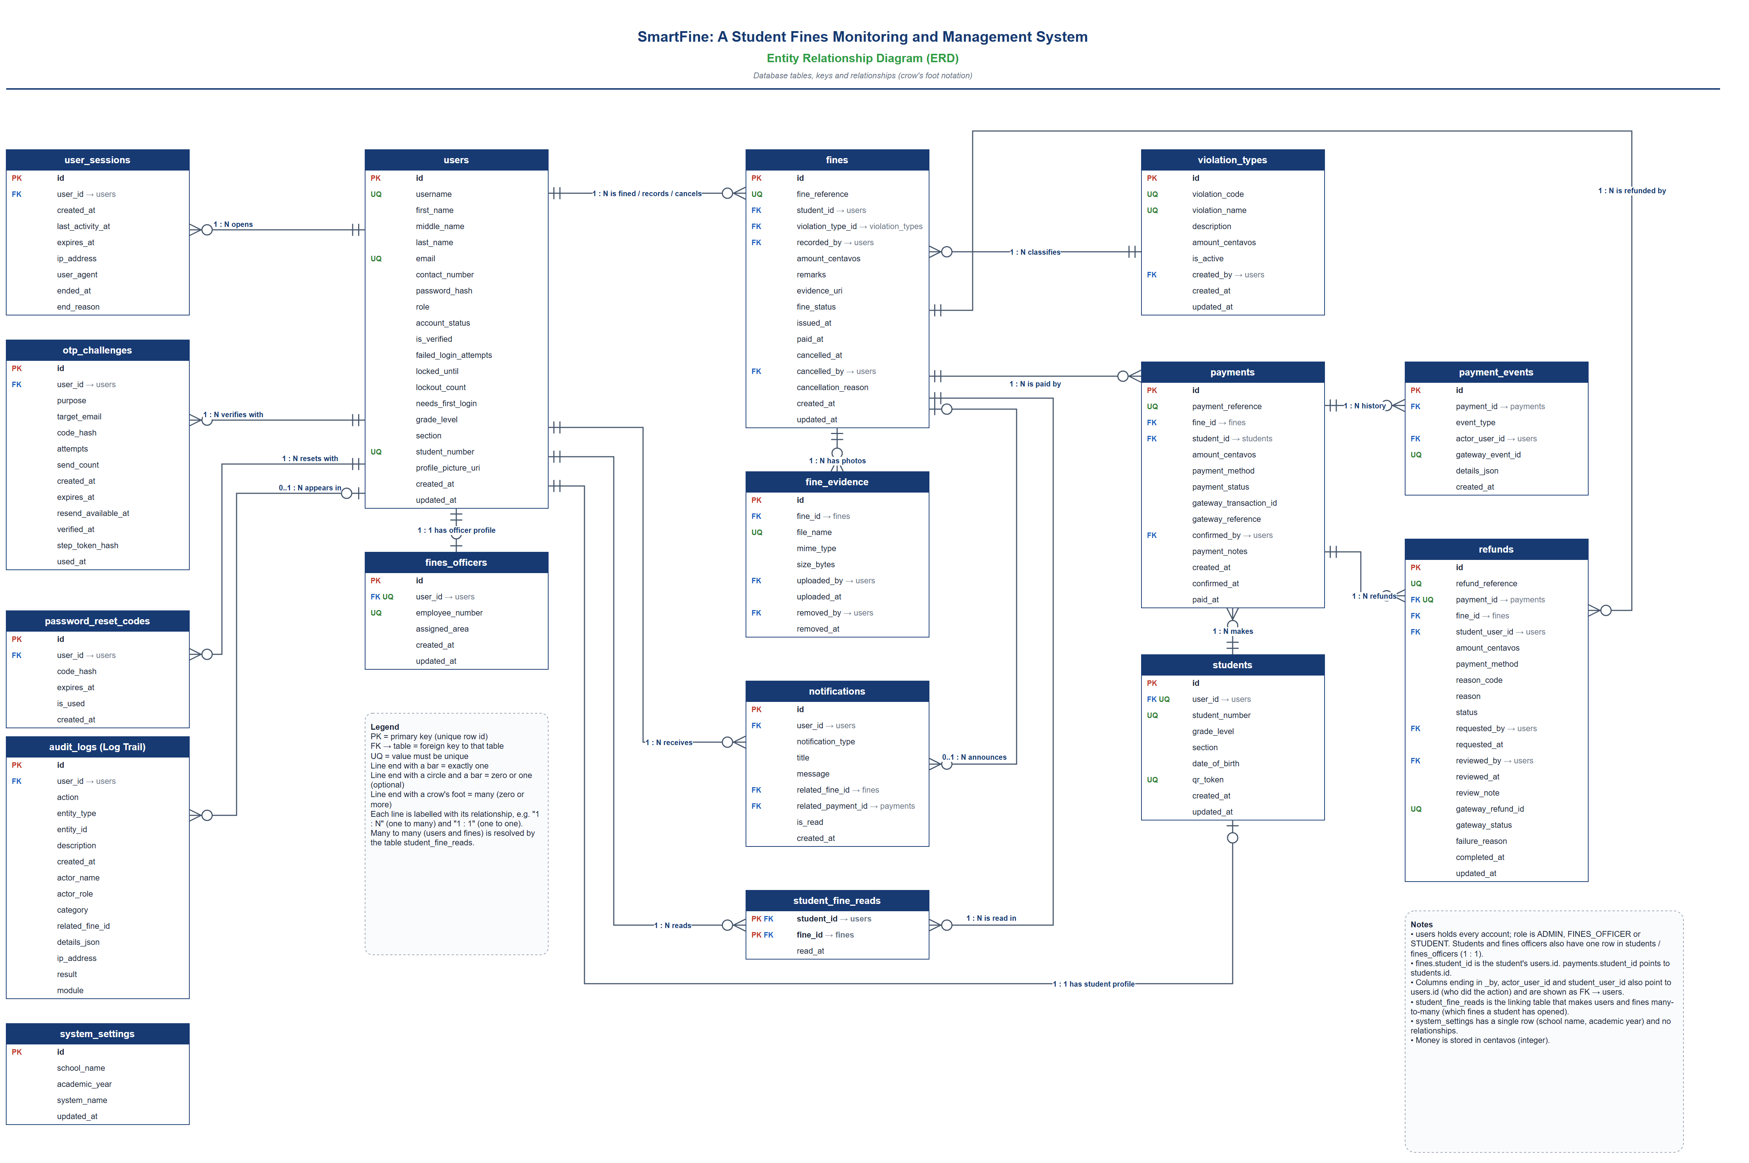
Figure 3. Entity Relationship Diagram (ERD)

4. System Flowchart
The System Flowchart shows the complete workflow of SmartFine from input to output, using standard flowchart symbols. It has three sections: A (sign in and verification), B (what each role does) and C (how every request is checked, saved and recorded).

Symbols
Symbol | Meaning
Rounded rectangle | Start or End
Rectangle | A process (an action the system or user takes)
Parallelogram | Input or output (data entered or shown)
Diamond | A decision with Yes and No paths
Rectangle with double side lines | A group of steps (the screens a role uses)
Cylinder | A data store (the dashed arrow means read and write)
Circle with a letter | Continue at the circle with the same letter (A = back to sign in, B = back to the user's dashboard)

Section A: sign in and verification
- The user enters a username or email and a password; the required fields are checked on the client and again on the server.
- Decisions: account found, ACTIVE and not locked; CAPTCHA required after a lockout and answered correctly; password matches the bcrypt hash. The third wrong password in a row locks the account for 1, then 5, then 15 minutes.
- A first sign-in sends a 6-digit one-time code by email (10 minutes, 5 tries, used once) and the user chooses their own password. A server session and signed token are then created, LOGIN_SUCCESS is logged, and the role opens the right dashboard.

Section B: using SmartFine
- Student: view fines, details and evidence photos; pay with GCash or request cash payment; request a refund; show the QR code; read notifications.
- Fines Officer: scan or search for a student; choose the violation type, remarks and evidence photos; record the fine; cancel own unpaid fines; view recorded fines.
- Administrator: manage accounts (lock, roles, import); manage fines, cash payments, refunds and fine types; configure settings; view the Log Trail; back up and restore data; reset the system.

Section C: every request
- The server checks the session (under 15 minutes idle), the account (ACTIVE) and the role. Failures are refused and logged (AUTO_LOGOUT or ACCESS_DENIED).
- Input is validated and cleaned (invalid input shows a safe error message), then saved with a parameterized query in SQLite and recorded in the Log Trail.
- Live-update and in-app notices are sent (Socket.IO) and the updated screen, receipt or report is shown, until the user logs out or is idle for 15 minutes, which ends the server session.
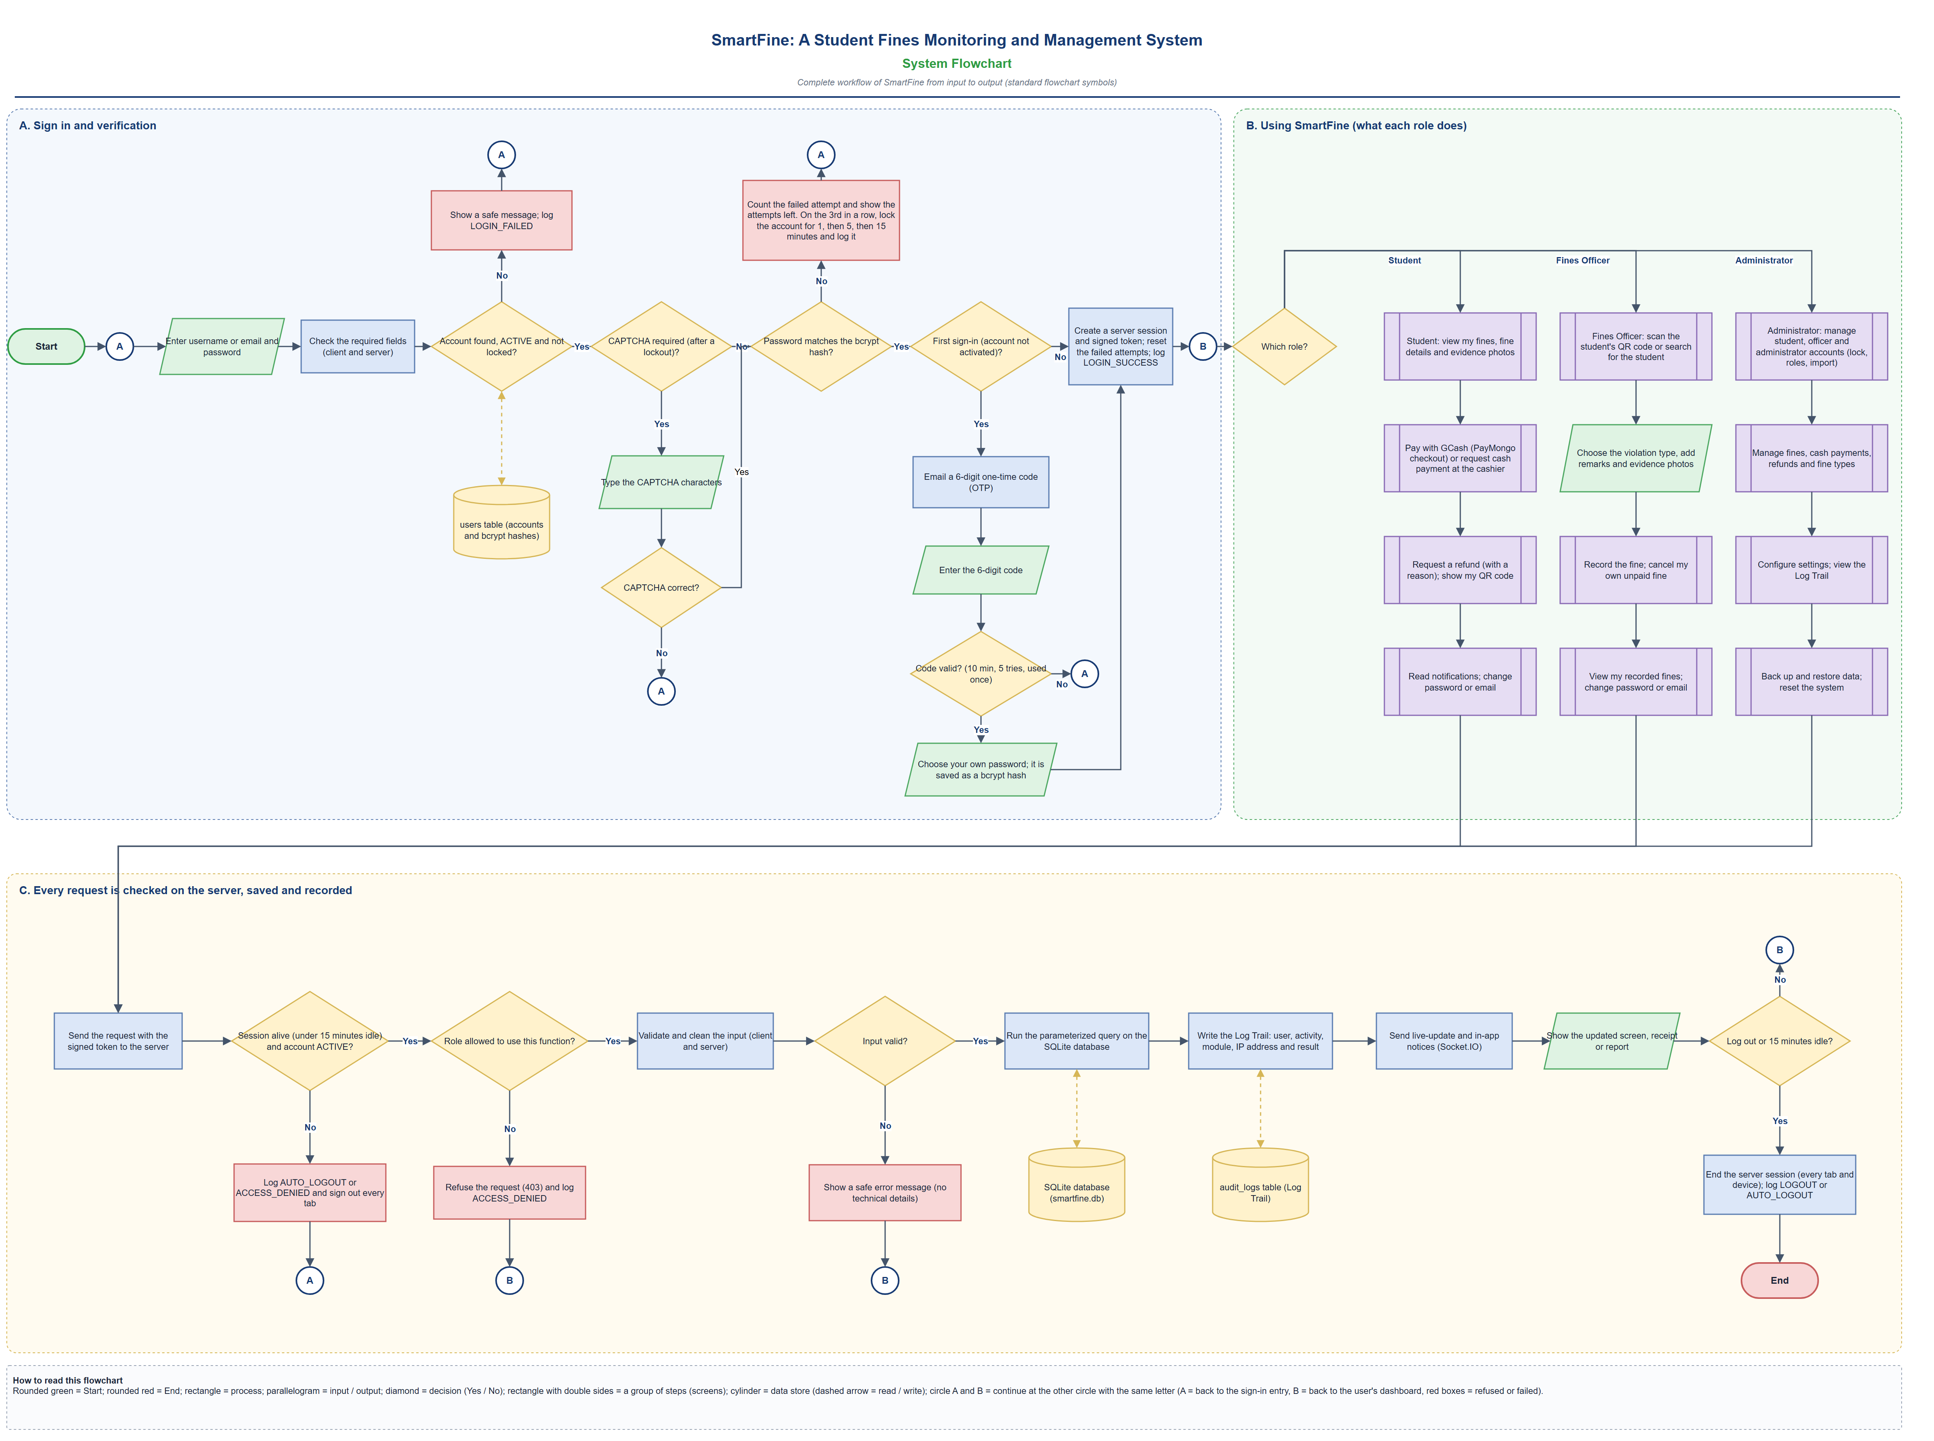
Figure 4. System Flowchart

5. Network Diagram (Network Flow)
The Network Diagram shows the devices, servers and network equipment that make up SmartFine, how they are connected, and how data flows between them. Each link is labelled with the protocol it uses.

Components
Component | Role
Student's phone, Fines Officer's phone | Run the SmartFine app (Android app or Expo Go) and connect over mobile data or Wi-Fi.
Administrator's computer | Runs the SmartFine web app in a browser.
Internet | Carries all traffic between the users, the public services and the school.
ngrok tunnel service | Gives the server a public HTTPS address; forwards requests through an encrypted tunnel that the server opens outward.
Firewall | Protects the school network.
Router and Wi-Fi access point | Connects the school network to the Internet.
Network switch | Connects the server computer and the office computer on the school network.
SmartFine server computer | Runs the Node.js and Express API (port 3000), Socket.IO live updates and the ngrok agent.
SQLite database | Stores all records (smartfine.db).
Uploads folder | Stores profile pictures and evidence photos (served only through signed links).
Backups folder | Stores encrypted (AES-256) daily database backups.
Office computer | An Administrator's computer on the school network.
PayMongo | External GCash payment gateway.
Email service | Gmail (SMTP), which sends the one-time codes.

Communication paths
Link | Protocol | What travels
Phones and browser ↔ Internet | HTTPS 443 and WSS | App requests and answers; live updates (Socket.IO).
Internet ↔ ngrok | HTTPS 443 / WSS | The same traffic, to SmartFine's public address.
ngrok ↔ Firewall ↔ Router ↔ Switch ↔ Server | Encrypted tunnel, then LAN | Requests reach the server through the tunnel the server opened outward.
Server ↔ SQLite, uploads, backups | Local files | Parameterized SQL, photos and encrypted backups.
Server ↔ PayMongo (through the Internet) | HTTPS | GCash checkouts and refund requests; signed webhooks come back through ngrok.
Server → Email service (through the Internet) | SMTP over TLS (587) | One-time codes.

Data flow: a student pays a fine with GCash
- The student's phone sends an HTTPS request (and keeps a WSS connection for live updates) over the Internet to SmartFine's public ngrok address.
- The Internet delivers the request to ngrok's public HTTPS endpoint.
- ngrok forwards it through its encrypted tunnel, past the firewall and router, to the SmartFine server.
- The server checks the session and role, reads and writes the SQLite database, stores photos and encrypted backups on its own disk, and records the Log Trail.
- The server asks PayMongo (HTTPS) for a GCash checkout; the student pays on PayMongo's page.
- PayMongo sends a signed webhook back through the Internet and the same tunnel; the server verifies it, marks the fine PAID and pushes a live update to the phone.

Checklist coverage
- All relevant components are shown: servers, workstations, routers, switches, firewall, databases and external services.
- The connections and data flow between components are shown, and every device and communication path is labelled.
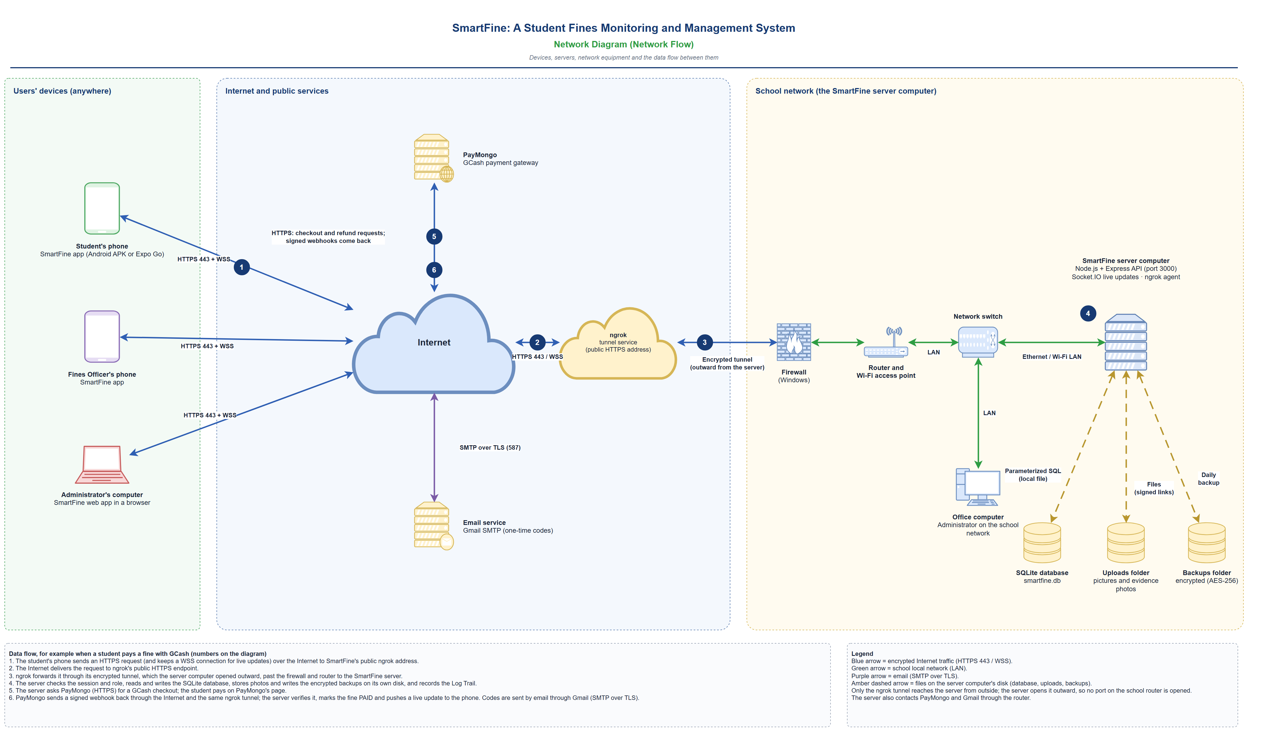
Figure 5. Network Diagram (Network Flow)

Checklist Summary
Each requirement in the Implementation Checklist and where this document meets it.
Requirement | Diagram | How it is met
Identify all system users (actors) | Figure 1 | Student, Fines Officer, Administrator, plus the abstract System User and Staff Member.
Show relationships between actors and use cases | Figure 1 | Solid association lines, generalization, «include» and «extend».
Primary and secondary actors | Figure 1 | PayMongo and the Email Service are secondary actors.
Standard UML use case notation | Figure 1 | Actors, ovals, system boundary and UML arrows.
Swimlanes and pools; each participant in its own lane | Figure 2 | Four lanes in the school pool; PayMongo in a separate pool.
Sequence, interactions and handoffs | Figure 2 | Numbered steps and dashed message flows between pools.
Start and end points | Figure 2 | One Start and three End points.
ERD with entities, attributes, primary and foreign keys | Figure 3 | 16 tables with every column; PK, FK and UQ marked.
Relationships labelled 1:1, 1:N, M:N | Figure 3 | Crow's foot ends and a label on each line; M:N through student_fine_reads.
Database supports all system requirements | Figure 3 | See the table "How the structure supports the system".
System flowchart with standard symbols | Figure 4 | Terminators, processes, decisions, input/output, data stores, connectors.
Complete workflow from input to output | Figure 4 | Sign in, role functions, request checks, saving, logging and logout.
Logic and sequence of operations | Figure 4 | Yes/No decisions on every check; failed paths return to a connector.
Network diagram with all relevant components | Figure 5 | Phones, computers, Internet, ngrok, firewall, router, switch, server, database, PayMongo, email.
Connections, data flow and labelled paths | Figure 5 | Protocol on every link and six numbered data-flow steps.
Same names and terms; titles, labels and notes | All | Shared term list in "About the System"; every diagram has a title, labels and a notes box.

