Weekly Overhead Report Update

**Process Description:** This process involves navigating through network folders, copying and renaming an Excel report file, and then updating the data within the Excel file using the SAP EPM Solutions add-in. The process specifically focuses on updating 'Engineering Pool (Pool 2)' and 'Field Engineering (Pool 3)' data by adjusting the week-ending date and refreshing the workbook.

## 1.0 Navigate to Report Folder

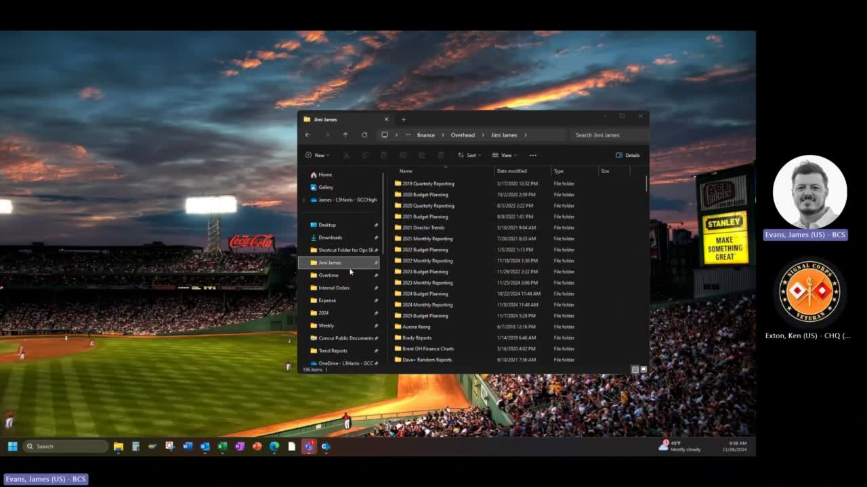

* 1.1 Navigate to the 'Expense' folder. (Timestamp: 00:09)

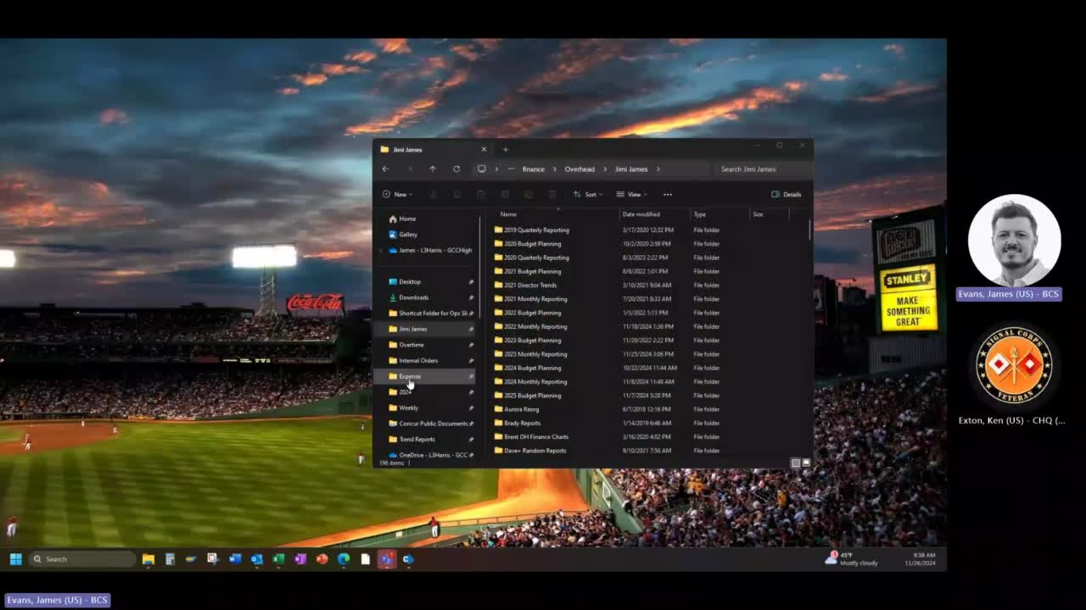

* 1.2 Navigate into the 'Engineering' subfolder. (Timestamp: 00:13)

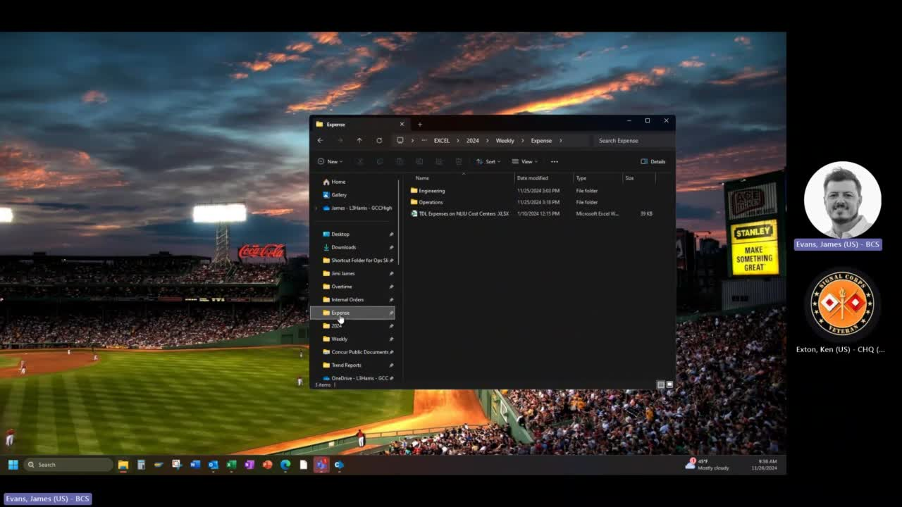

## 2.0 Copy and Rename Report File

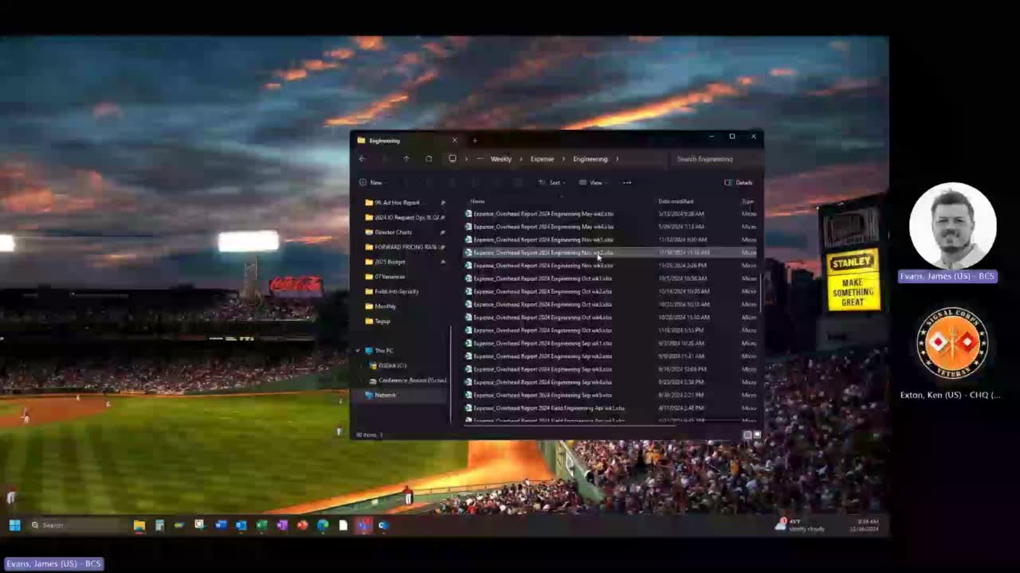

* 2.1 Copy the file named 'Expense_Overhead Report 2024 Engineering Nov v4.xlsm'. (Timestamp: 00:40)



* 2.2 Rename the copied file to 'Expense_Overhead Report 2024 Field Engineering Sep v4.xlsm - Copy - Week3 R1.xlsm'. (Timestamp: 00:57)



## 3.0 Update Report in Excel

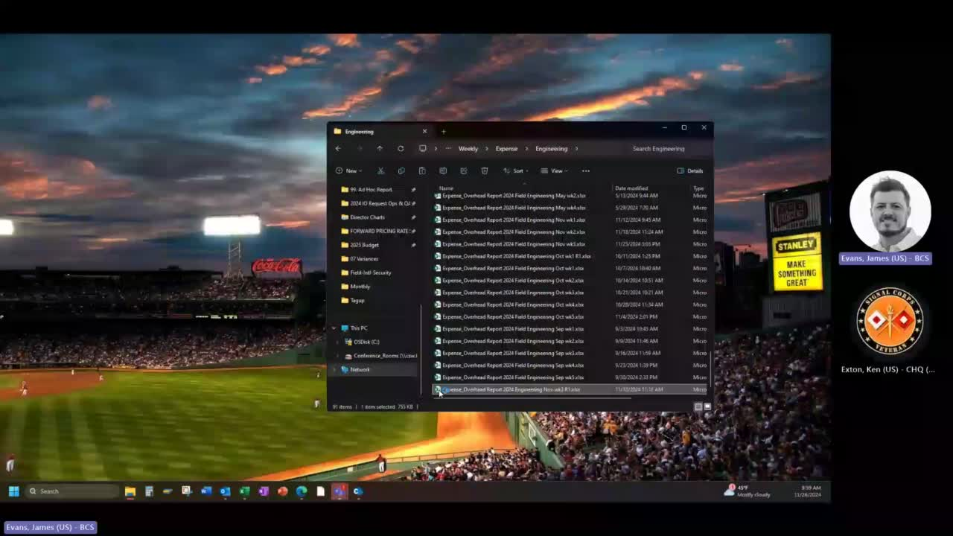

* 3.1 Open the renamed Excel file 'Expense_Overhead Report 2024 Field Engineering Sep v4.xlsm - Copy - Week3 R1.xlsm'. (Timestamp: 01:20)



* 3.2 Change the 'Week Ending' date in the Excel file to '11/02/2024'. (Timestamp: 01:52)

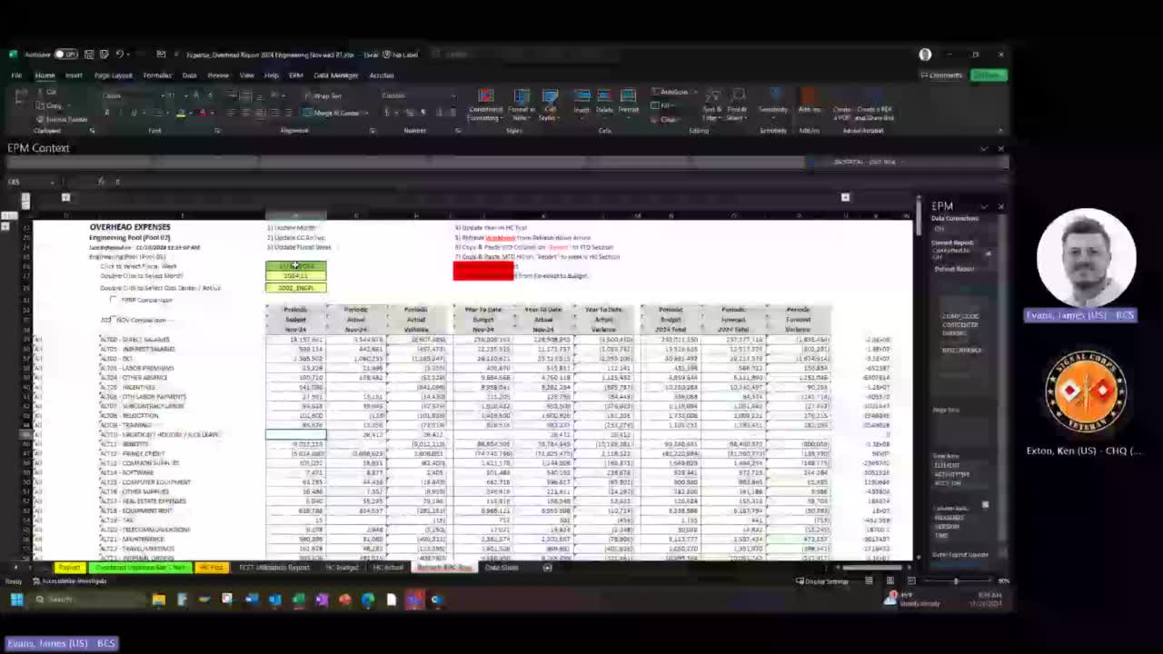

* 3.3 Click on 'EPM' tab then 'Refresh Workbook' to update data. (Timestamp: 01:57)

