Introduction
The Application to be developed is a school system designed to allow the creation and taking of student tests. The development process will involve putting these features into place and developping on top of the existing application for a school system that was developed in the first assignment. Some examples of how I will expand on the first version of the application are; adapting to an sql Database, upgrading the login system to allow password input and allowing teachers to view results in a separate view. As well as this, I will clear up any existing bugs with the exsiting system to make it more stable to use.

Application Functionalities
The application has to have a login system, that can be used by both teachers and suduents. They should be able to login with a username and password that they have, and that will bring them to the home view. The home view will have buttons that only appear for certain user types.
For a student, they will be able to see the Take Tests button. This will allow them to click and view the tests that they have for the class that they are in. Upon clicking on one of the listed tests, they will be prompted to input some specific details, such as a first name, last name and date of birth. After submitting these details they can take the test questions and see the results that they have, how many they got correct and how many they got incorrect.
For a teacher, they will be able to see a create tests button and a review tests button. For the create tests button, they can create a new test with as many questions as they want. They will be able to add questions of specific types, name the question title and set the answer/s. For the case of a Text answer, the answer will be the text that the teacher types in. For the multiple choice question, the teacher will be able to input up to 4 answers and select which answers will be correct.
The teacher also has the opportunity to click the view tests button on their homepage. This allows them to access the results of any student for any test. This also allows for them to look at each question that the student answers and which ones they got right and which they got wrong.

Application Design and OO

The following diagrams are the class design and process design diagrams which will demonstrate in visual form how the software will work, and how the data structure looks. There are some details such as locally used variables in process classes that are not detailed in the class design diagram. This is because the class design diagram is mainly aimed to show the sql table layout for my database solution.

Class Design Diagram
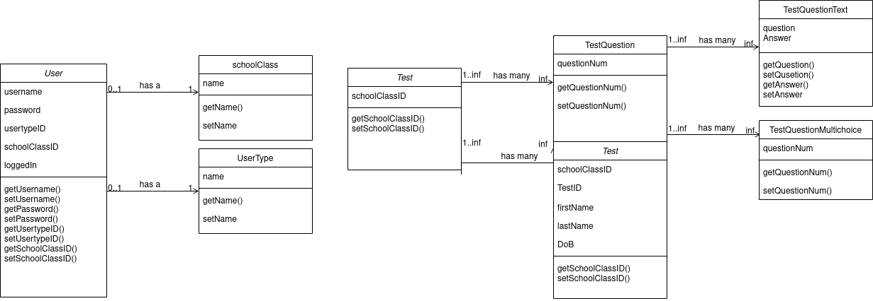
As you can see in the class diagram, we have mainly two sets of interconnecting data structures. The first of these is the User.
The user class is used for the login system. It contains everything you would need to allow for a user login, such as a username, password, and loggedin boolean to see who the currently logged in user is.
It has a connected school Class ID that lets it connect a user to a specific class. This allows for the taketests test list to only show the tests that apply to the specific user. A teacher does not have a class ID, so the class ID does not apply and is not used when a teacher is logged in.
It also has a usertype. The user types that are set up are currently Teacher and student. This is an important class to have because it allows the teachers and students to be shown differing home views, while still being able to login from the same place.

Process Design Diagram
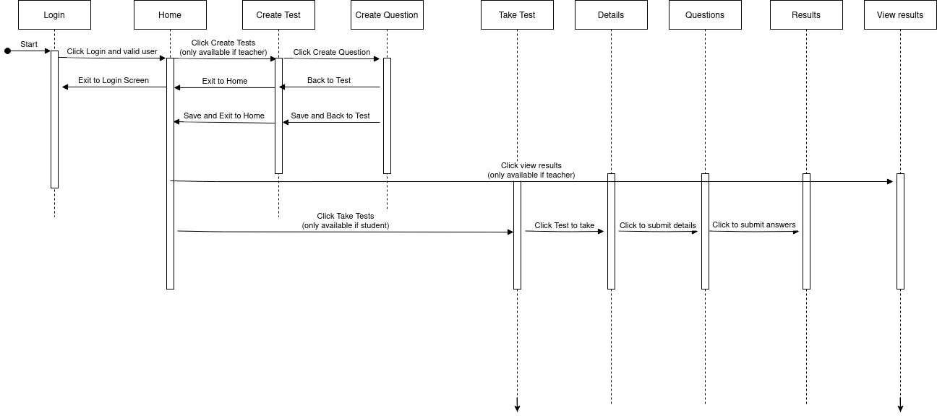
This is my Process Design Diagram. It details how the user would interact with the software and it does not outline specific functions within processes, but focuses more on the communications between systems in the projects.
To put it simply, the user will login, then enter their username and password. If they are a student they will be shown a home page with a take tests button. If they click take tests they will be able to take a test, enter details, questions and finally get their results. The teacher is able to click create test, which allows them to create a test for a specific class. They also can click view tests that allow them to view the results of each test and each student.

Discussion of Role of OO
Because I am using an Object Oriented Programming solution, I am able to easily simplify live data storage in an easier and more convient way than otherwise possible. Because each object stores my required variables, such as a user having username and password, it makes it easier to manage the level of variables that I am using, and where I should be accessing them. Because of this, I have effectively simplified the development process and reduced the chance for errors over accidental usage of variable names in multiple places.
An example of how Object Oriented Programming has helped and been useful within my software is through polymorphism. The example I am refering to for polymorphism is the TestQuestion class that has two subclasses TestQuestionText and TestQuestionMultichoice. These two subclasses needed to be extrapolated from TestQuestion because of the differing ways that the answer/s need to be stored. However because fields such as the question number or question text are consistent between each of the TestQuestionText and TestQuestionMultichoice.

