Predicting Total Enrollment at U.S. Higher Education Institutions Using Multiple Linear Regression
Will Sanderfer, wsanderfer@bellarmine.edu
Taylor Dunkle, tdunkle@bellarmine.edu
ABSTRACT
We used the 2013 IPEDS dataset of 1,534 U.S. higher education institutions to build a multiple linear regression model that predicts total enrollment. The target variable is heavily right-skewed, so we took the log of enrollment before fitting any models. We tested two different feature sets (one with just numeric variables and one that also included two categorical variables) on two train/test splits, for four experiments total. Our best model used six numeric predictors plus Control of Institution and Highest Degree Offered with a 70/30 split. It got an R² of 0.78 on the held-out test data. The Highest Degree Offered variable turned out to matter the most. Taking the log of the target, leaving out any variables that would leak the answer, and adding the two categorical variables were the three things that helped our model the most.
1. INTRODUCTION
The Integrated Postsecondary Education Data System (IPEDS) is the main source of data on colleges and universities in the United States. Every school that takes part in federal student aid programs has to report data to IPEDS every year, so the dataset ends up being a pretty complete picture of higher education. The 2013 version we used has 1,534 institutions and 145 variables covering admissions, enrollment, tuition, financial aid, graduation rates, and other institutional characteristics.
Our target variable is Total Enrollment, which is just the number of students enrolled at a given school. This is a regression problem because the target is a continuous number. We picked this target because enrollment is probably the single biggest operational number for a university. It drives revenue, staffing, and how big a campus needs to be. Understanding what actually predicts enrollment is useful both for people running a college and for students trying to understand what kind of school they are looking at.
2. BACKGROUND
IPEDS has been collected by the National Center for Education Statistics since 1986. Policymakers, researchers, and tools like the College Navigator use it. Variables are grouped by which survey they came from: IC2013 for institutional characteristics and admissions, HD2013 for header data like location and control, SFA1213 for financial aid, and EF2013 for enrollment. The data is self-reported by each institution under federal reporting rules, so completeness is usually high. The main gap is that SAT and ACT scores are missing for schools that do not require test scores.
Most of the research that uses IPEDS focuses on specific questions, like graduation rate gaps by race and income, how tuition affects enrollment, or return on investment for different majors. Predicting total enrollment is not something people study very often on its own, but it works well as a practice problem for multiple linear regression. The dataset has lots of possible predictors, the target is continuous, and there are some obvious data leakage traps that we had to watch out for.
3. EXPLORATORY ANALYSIS
The dataset has 1,534 rows and 145 columns. The columns are a mix of numeric variables (like Applicants total and Tuition and fees), categorical variables (like Control of institution and Highest degree offered), and identifier columns (ID number, Name). Two rows were missing the target variable, so we dropped those. Table 1 lists the data types of the variables we considered as predictors.
Table 1: Data Types of Candidate Predictor Variables
Variable Name | Data Type
Applicants total | Numeric (float)
Admissions total | Numeric (float)
Percent admitted - total | Numeric (float)
Admissions yield - total | Numeric (float)
SAT Math 75th percentile score | Numeric (float)
ACT Composite 75th percentile score | Numeric (float)
Tuition and fees, 2013-14 | Numeric (float)
Graduation rate - Bachelor degree within 6 years, total | Numeric (float)
Percent of freshmen receiving any financial aid | Numeric (float)
Percent of freshmen receiving Pell grants | Numeric (float)
Highest degree offered | Categorical (string)
Control of institution | Categorical (string)
Total enrollment (target) | Numeric (float)
3.1 Target Distribution
The biggest thing we noticed about the target is how skewed it is. The skewness is 2.49, which is very high. Enrollment goes from 66 students at the smallest school up to 77,338 at the biggest, with a median of only 3,127. Most schools are small and then there are a few giant universities way out in the tail. If we tried to fit a linear model on the raw target, the error on those few huge schools would dominate everything else. Taking log1p of the target drops the skewness to 0.07, which is basically normal. From that point on, every model we built used log(enrollment) as the target.
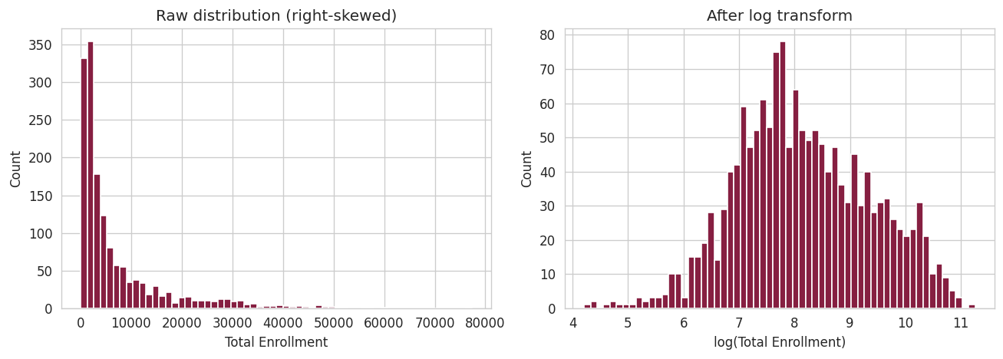
Figure 1: Total Enrollment distribution before (left) and after (right) log transform
3.2 Missing Values
Most of our predictors had few missing values. The two exceptions were SAT Math 75th percentile (352 missing, about 22.9%) and ACT Composite 75th percentile (335 missing, about 21.8%). Those are missing because a lot of schools do not require SAT or ACT scores to apply. The Applicants and Admissions columns are also missing for about 10% of institutions, mostly community colleges with open admissions. We used complete-case analysis in each experiment instead of imputing the missing values. Filling in SAT scores for schools that do not require them would just make up data, and the model would treat those made-up numbers as real.
3.3 Relationships Among Predictors
Figure 2 shows the correlation matrix for our numeric predictors along with log(Total Enrollment). The strongest positive correlations with log enrollment are Admissions total (0.73) and Applicants total (0.67), which makes sense because bigger schools admit more people. Selectivity variables like SAT Math 75p, ACT 75p, and the 6-year graduation rate are moderately positive. The percent of students getting financial aid (-0.38) and the percent getting Pell grants (-0.28) are negative. Schools with more financially needy students tend to be smaller. The matrix also shows some pretty strong multicollinearity. SAT Math 75p and ACT 75p correlate at 0.91, and SAT Math 75p and Pell % correlate at -0.75. We only kept one predictor from each of those pairs when we built Feature Set B.
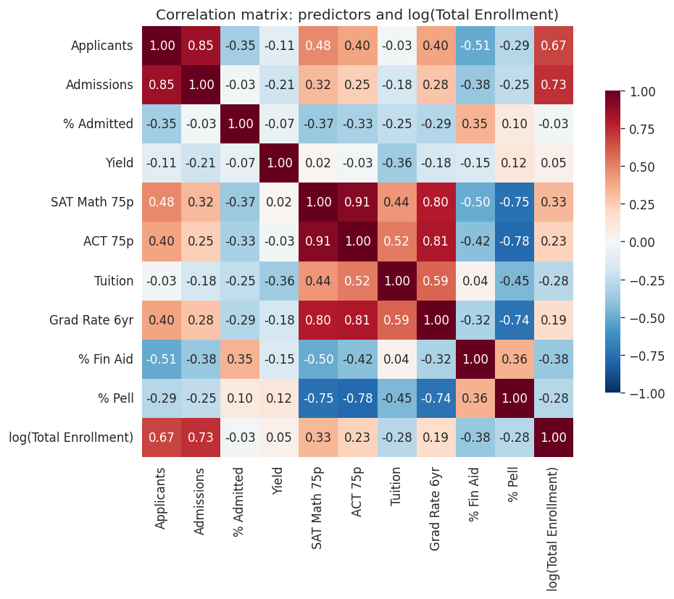
Figure 2: Correlation matrix of candidate numeric predictors and log(Total Enrollment)
3.4 Categorical Variables
Figure 3 shows enrollment distributions by Control of Institution (Public, Private not-for-profit, Private for-profit) and by Highest Degree Offered. Public schools have a much higher median enrollment than private schools. Doctoral and research universities are about 10x bigger than bachelor-only schools on average. Both of these variables tell us something about enrollment that you cannot get from any single numeric column, which is why we added them to Feature Set B.
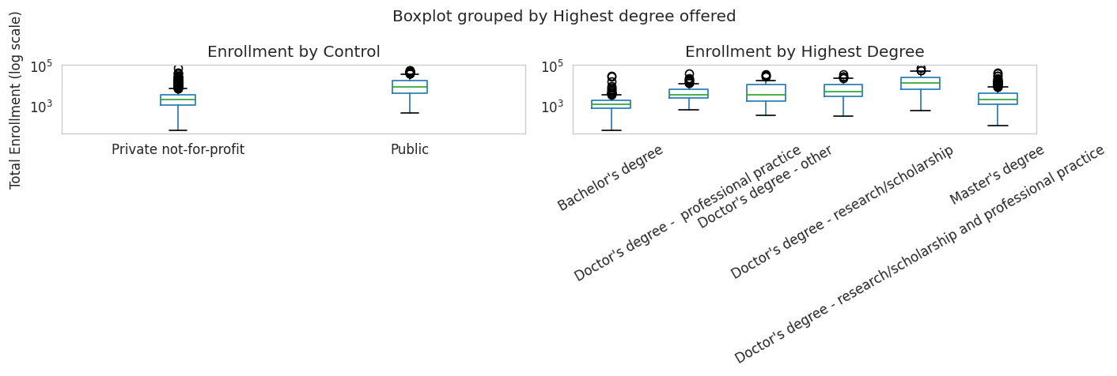
Figure 3: Enrollment (log scale) by Control of Institution and Highest Degree Offered
4. METHODS
4.1 Data Preparation
We kept our data prep steps simple on purpose, so that we could actually tell which modeling choices (feature set, train/test split) were making a difference and not confuse it with complicated preprocessing. Our steps were:
- Drop the 2 rows with missing target values.
- Apply log1p to the target to normalize it.
- For each experiment, drop any rows missing one of the chosen predictors (complete-case).
- One-hot encode categorical predictors with drop_first=True so we do not fall into the dummy variable trap.
- After splitting into train and test, fit StandardScaler on only the training data and apply it to both. Standardizing does not change the predictions of OLS, but it does make the coefficient sizes comparable to each other.
One important choice was leaving out any variable that would leak the answer. Undergraduate enrollment, graduate enrollment, full-time enrollment, and part-time enrollment would all give us a fake-perfect model because they are basically the pieces that add up to the target. We also left out Admissions total, because it is just Applicants total multiplied by Percent admitted. Keeping all three would have been redundant.
4.2 Experimental Design
We ran four experiments by crossing two feature sets with two different train/test splits. Feature Set A is a small numeric baseline. Feature Set B adds two more numeric variables plus two categorical variables for institutional type. Every experiment used random_state=42 so that anyone running our notebook would get the same results.
Table 2: Experiment Parameters
Experiment | Feature Set | Predictors | Train/Test Split
1 | A | 4 numeric | 80 / 20
2 | A | 4 numeric | 70 / 30
3 | B | 6 numeric + 2 categorical | 80 / 20
4 | B | 6 numeric + 2 categorical | 70 / 30
Feature Set A includes Applicants total, Percent admitted, Tuition and fees 2013-14, and 6-year Graduation rate. Feature Set B adds SAT Math 75th percentile score, Percent receiving Pell grants, Control of institution (one-hot), and Highest Degree Offered (one-hot).
4.3 Tools Used
We did all the analysis in Python 3.11 on a Windows 11 computer using a regular scientific Python setup. The libraries we used were Pandas 2.1 for data manipulation, NumPy 1.26 for arrays, Matplotlib 3.8 and Seaborn 0.13 for the plots, and Scikit-learn 1.4 for the train/test split, StandardScaler, and linear regression. We picked Python because Scikit-learn has a consistent API across different models and because Pandas handles the IPEDS file (which has both numeric and categorical columns, plus missing values) without much setup code. The notebook should run end-to-end in any standard Anaconda install.
5. RESULTS
5.1 Accuracy Measures
For each experiment, we reported R² on both the training set and the test set, plus RMSE on the test set in two different units. We show RMSE in log units (what the model actually optimized) and in student counts (back-transformed from the log predictions so the numbers are interpretable). We also included MAE on the student scale because RMSE gets inflated by a handful of massive universities where small log errors turn into huge student-count errors.
Table 3: Experimental Results
Exp. | N train | N test | # Feat. | R² train | R² test | RMSE (log) | RMSE (students) | MAE (students)
1 | 1,093 | 274 | 4 | 0.586 | 0.588 | 0.698 | 64,469 | 9,950
2 | 956 | 411 | 4 | 0.577 | 0.613 | 0.693 | 45,819 | 7,032
3 | 942 | 236 | 12 | 0.795 | 0.776 | 0.538 | 8,046 | 3,243
4 | 824 | 354 | 12 | 0.795 | 0.780 | 0.538 | 11,892 | 3,678
The RMSE numbers for Feature Set A look huge in student units (64,469 for Exp 1 and 45,819 for Exp 2) because when the R² on the log scale is only about 0.59, the biggest schools end up with large log errors, and those errors blow up when we exponentiate back to student counts. That is why we mostly compared models using R² test and RMSE (log) rather than the student-scale numbers.
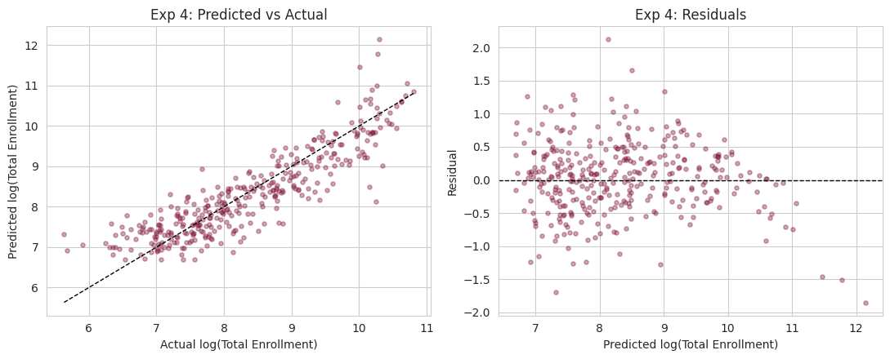
Figure 4: Predicted vs. actual (left) and residuals (right) for the best model (Experiment 4)
5.2 Discussion of Results
Feature Set B was clearly better than Feature Set A. The test R² jumped from around 0.59 to around 0.78. Almost all of that gain came from the two categorical variables. Highest Degree Offered by itself captures something that no numeric variable can pick up: research-doctoral universities are about 10x bigger than bachelor-only schools on average, and that is a category difference, not a continuous one. When we looked at the standardized coefficients from Experiment 4, the dummy for Doctor's degree (research/scholarship and professional practice) was the biggest at 0.59, followed by Applicants total at 0.44 and the Public control dummy at 0.38.
The 80/20 vs 70/30 split barely made any difference. Within each feature set, the test R² only moved by less than 0.01 when we changed the split. With about 1,300 rows of usable data, this is what we would expect. It was also a good sanity check. If our best result had been really sensitive to which rows ended up in the test set, we would have worried it was just a lucky split.
The predicted vs. actual plot shows that most of the points are close to the diagonal line across most of the enrollment range. There is more scatter at the top end where the biggest universities are, and the model tends to under-predict those. The residual plot also shows a slight fan shape, meaning the residuals get bigger as the predicted value gets bigger. That tells us the log-linear relationship does not quite hold for the largest schools.
5.3 Problems Encountered
The first issue we ran into was dumb but it still took us a while to find. The target column is actually named "Total enrollment" with two spaces between the words, not one. Our first few runs of the code were silently throwing KeyErrors until we printed the full column list and spotted the extra space. A bigger issue was multicollinearity. SAT Math 75p and ACT Composite 75p correlate at 0.91, so keeping both in the same model inflates standard errors without really adding predictive power. We ended up only using SAT Math 75p in Feature Set B. The 6-year graduation rate also correlates with the selectivity variables at around 0.80, so we only kept it in Feature Set A. The last issue was deciding what to do with the missing SAT and ACT values. Complete-case analysis was the cleanest option, but it also cut our usable sample for Feature Set B by about 25%.
5.4 Limitations
Linear regression assumes a log-linear relationship between the predictors and the target, and the residuals show this is not completely true at the tails. A tree-based model like Random Forest or Gradient Boosting would probably do a better job, especially on the biggest schools. Our model also assumes the same relationship holds for public and private schools and for doctoral and bachelor-only schools. Adding interaction terms, or fitting separate models by institution type, might show that the dynamics are actually different in each group. Because we used complete-case analysis for Feature Set B, our best model really only applies to schools that report SAT scores. Open-admission institutions are outside what our model can predict well.
5.5 Improvements / Future Work
The obvious next thing to try is a Random Forest and a Gradient Boosting regressor on the same feature set, and then compare them to our linear baseline. After that, it would be interesting to pull in multiple years of IPEDS data and model enrollment growth instead of the enrollment level, which would help us answer a different question: what kinds of schools are gaining students over time. Another thing worth trying is adding interaction terms like Control x Highest Degree, so a single linear model can capture different dynamics for public vs. private schools without losing the interpretability that made us pick linear regression in the first place.
6. CONCLUSION
Using only publicly available variables from the 2013 IPEDS dataset and a plain OLS regression with a log-transformed target, we ended up with a model that explains about 78% of the variance in total enrollment on the test set. The biggest predictor is not a numeric measure of size. It is Highest Degree Offered. Research doctoral universities are just fundamentally bigger than undergraduate-only schools, and that category difference drives most of the signal. Application volume and public vs. private control come next. The model is simple, easy to interpret, and not very sensitive to how we split the data. The main weaknesses are the usual ones for linear regression: a little bit of heteroscedasticity in the residuals and under-prediction for the very biggest schools. The clearest next step is to try a tree-based model and see how much it improves on these weak spots.
REFERENCES
National Center for Education Statistics. (2013). Integrated Postsecondary Education Data System (IPEDS). U.S. Department of Education. https://nces.ed.gov/ipeds/
Pedregosa, F., et al. (2011). Scikit-learn: Machine Learning in Python. Journal of Machine Learning Research, 12, 2825 to 2830.
McKinney, W. (2010). Data Structures for Statistical Computing in Python. Proceedings of the 9th Python in Science Conference, 56 to 61.
Hunter, J. D. (2007). Matplotlib: A 2D Graphics Environment. Computing in Science & Engineering, 9(3), 90 to 95.
Waskom, M. (2021). seaborn: statistical data visualization. Journal of Open Source Software, 6(60), 3021.

