**Problem 1A: Script code vim p1_sh.sh**

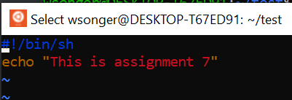

**Problem 1A: Script output sh p1_sh.sh**

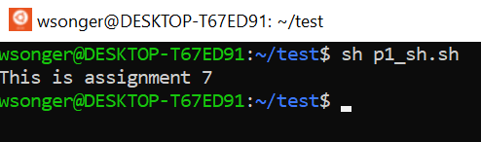

**Problem 1B: Script code vim P1_bash.bash**

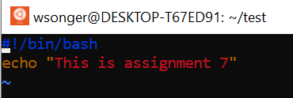

**Problem 1B: Script Output bash P1_bash.bash**

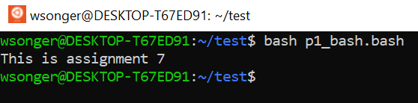

**Problem 2 Script Code**

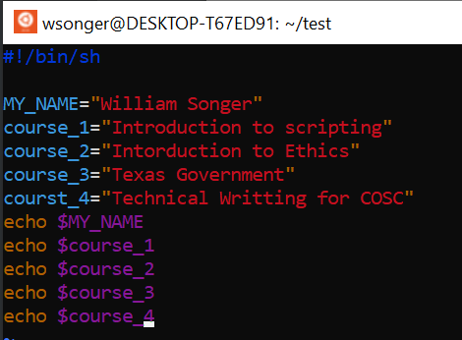

**Problem 2 Script output:**

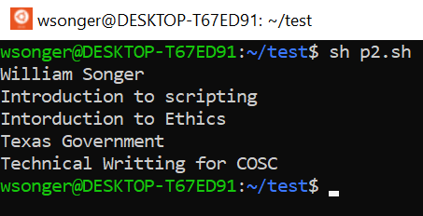

**Problem 3 Script Code**

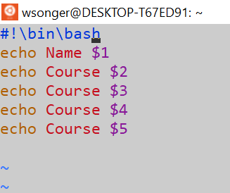

**Problem 3 Script Output**

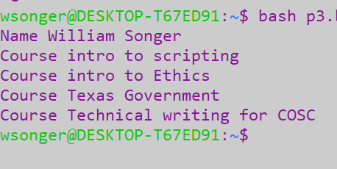

**Problem 4 Script Code**

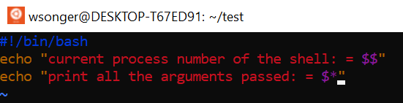

**Problem 4 Program output:**

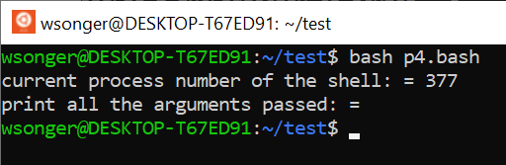

**Problem 5 Script Code**

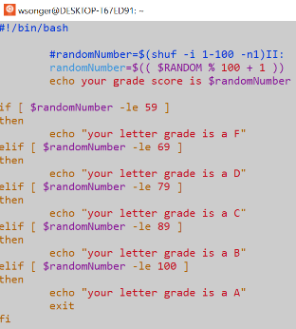

**Problem 4 Program output:**

