**Environment Setup**

**System:**

* **Ubuntu 14.04.5 LTS**

**Software and packages:**

* **Node JS v6**
  + Install: nvm install v6
  + Setting: nvm alias default v6
  + Check Version: node -v
* **Truffle: most popular development framework for Ethereum**
  + Install: nmp install –g truffle
* **Ganache Cli: Fast Ethereum RPC client for testing and development**
  + Install: npm install -g ganache-cli
  + Run: ganache-cli
* **SHA-256 / SHA-224 hash function for JavaScript**
  + Install: npm install js-sha256
* **Cryptographic JS functions for web3js and solidity**
  + Install: npm install eth-crypto –save
* **ECIES encrypt/decrypt library for Ethereum**
  + Install: npm install eth-ecies
* **(Optional) MetaMask for Chrome/FireFox**
  + Link: https://metamask.io

**Installation for TaskOwner (Or using MetaMask):**

1. Download base solution code from the BitBucket of blockTEST.net
2. In Ubuntu, open a terminal, and go to the directory of the base solution (say ‘MedHack’ here)
   1. 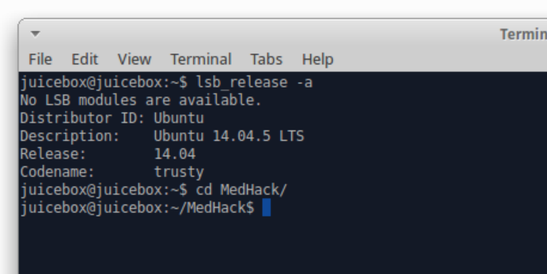
3. Run Ethereum client (or testRPC **ganache-cli** in this example), make sure the port is **8545** (Otherwise, update port in MedHack/truffle.js)
   1. 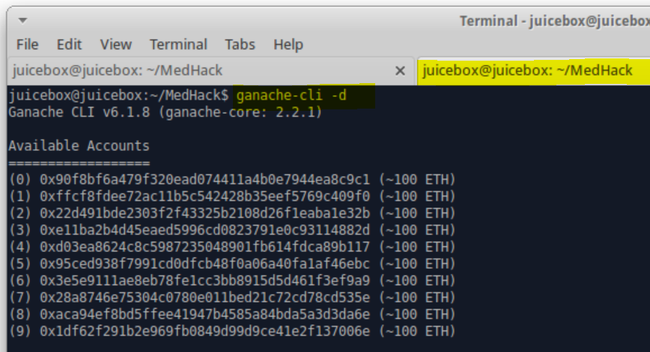
   2. 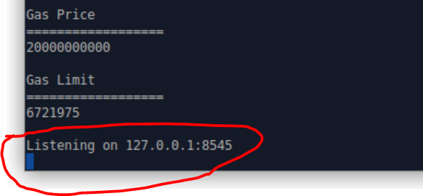
4. In ‘MedHack’ directory, run “truffle compile” and then “truffle migrate”
   1. 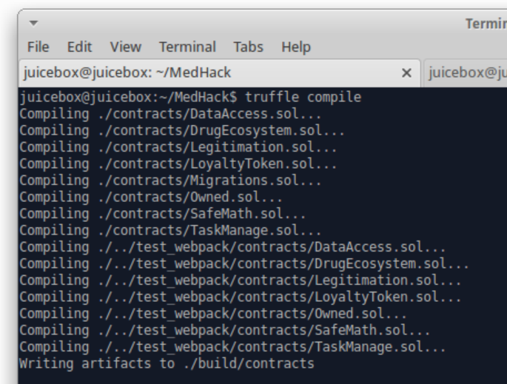
   2. 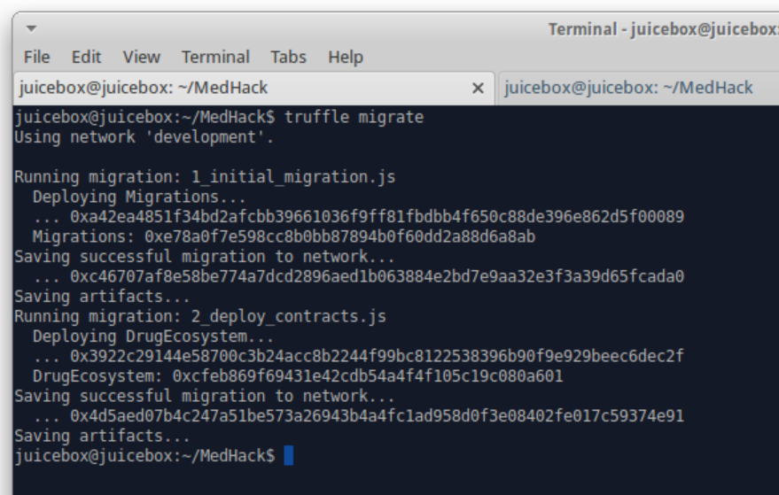
5. In ‘MedHack’ directory , open another tab in the terminal, run “npm run dev”
   1. 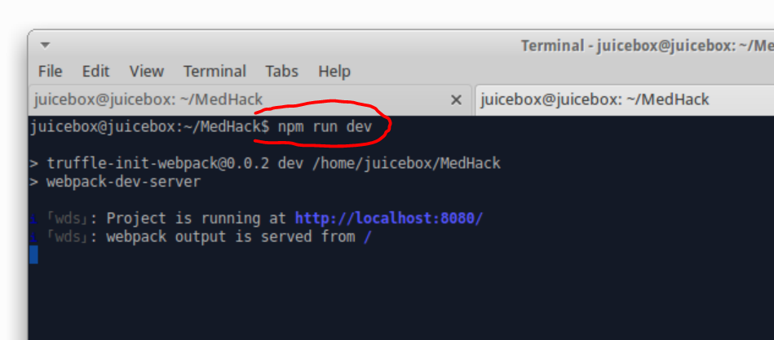
6. Open browser such as Chrome, type url “localhost:8080”
   1. 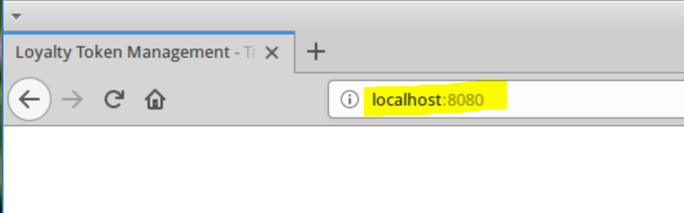
7. For the first time usage, wait a few minutes for code intiation, and it is ready
   1. 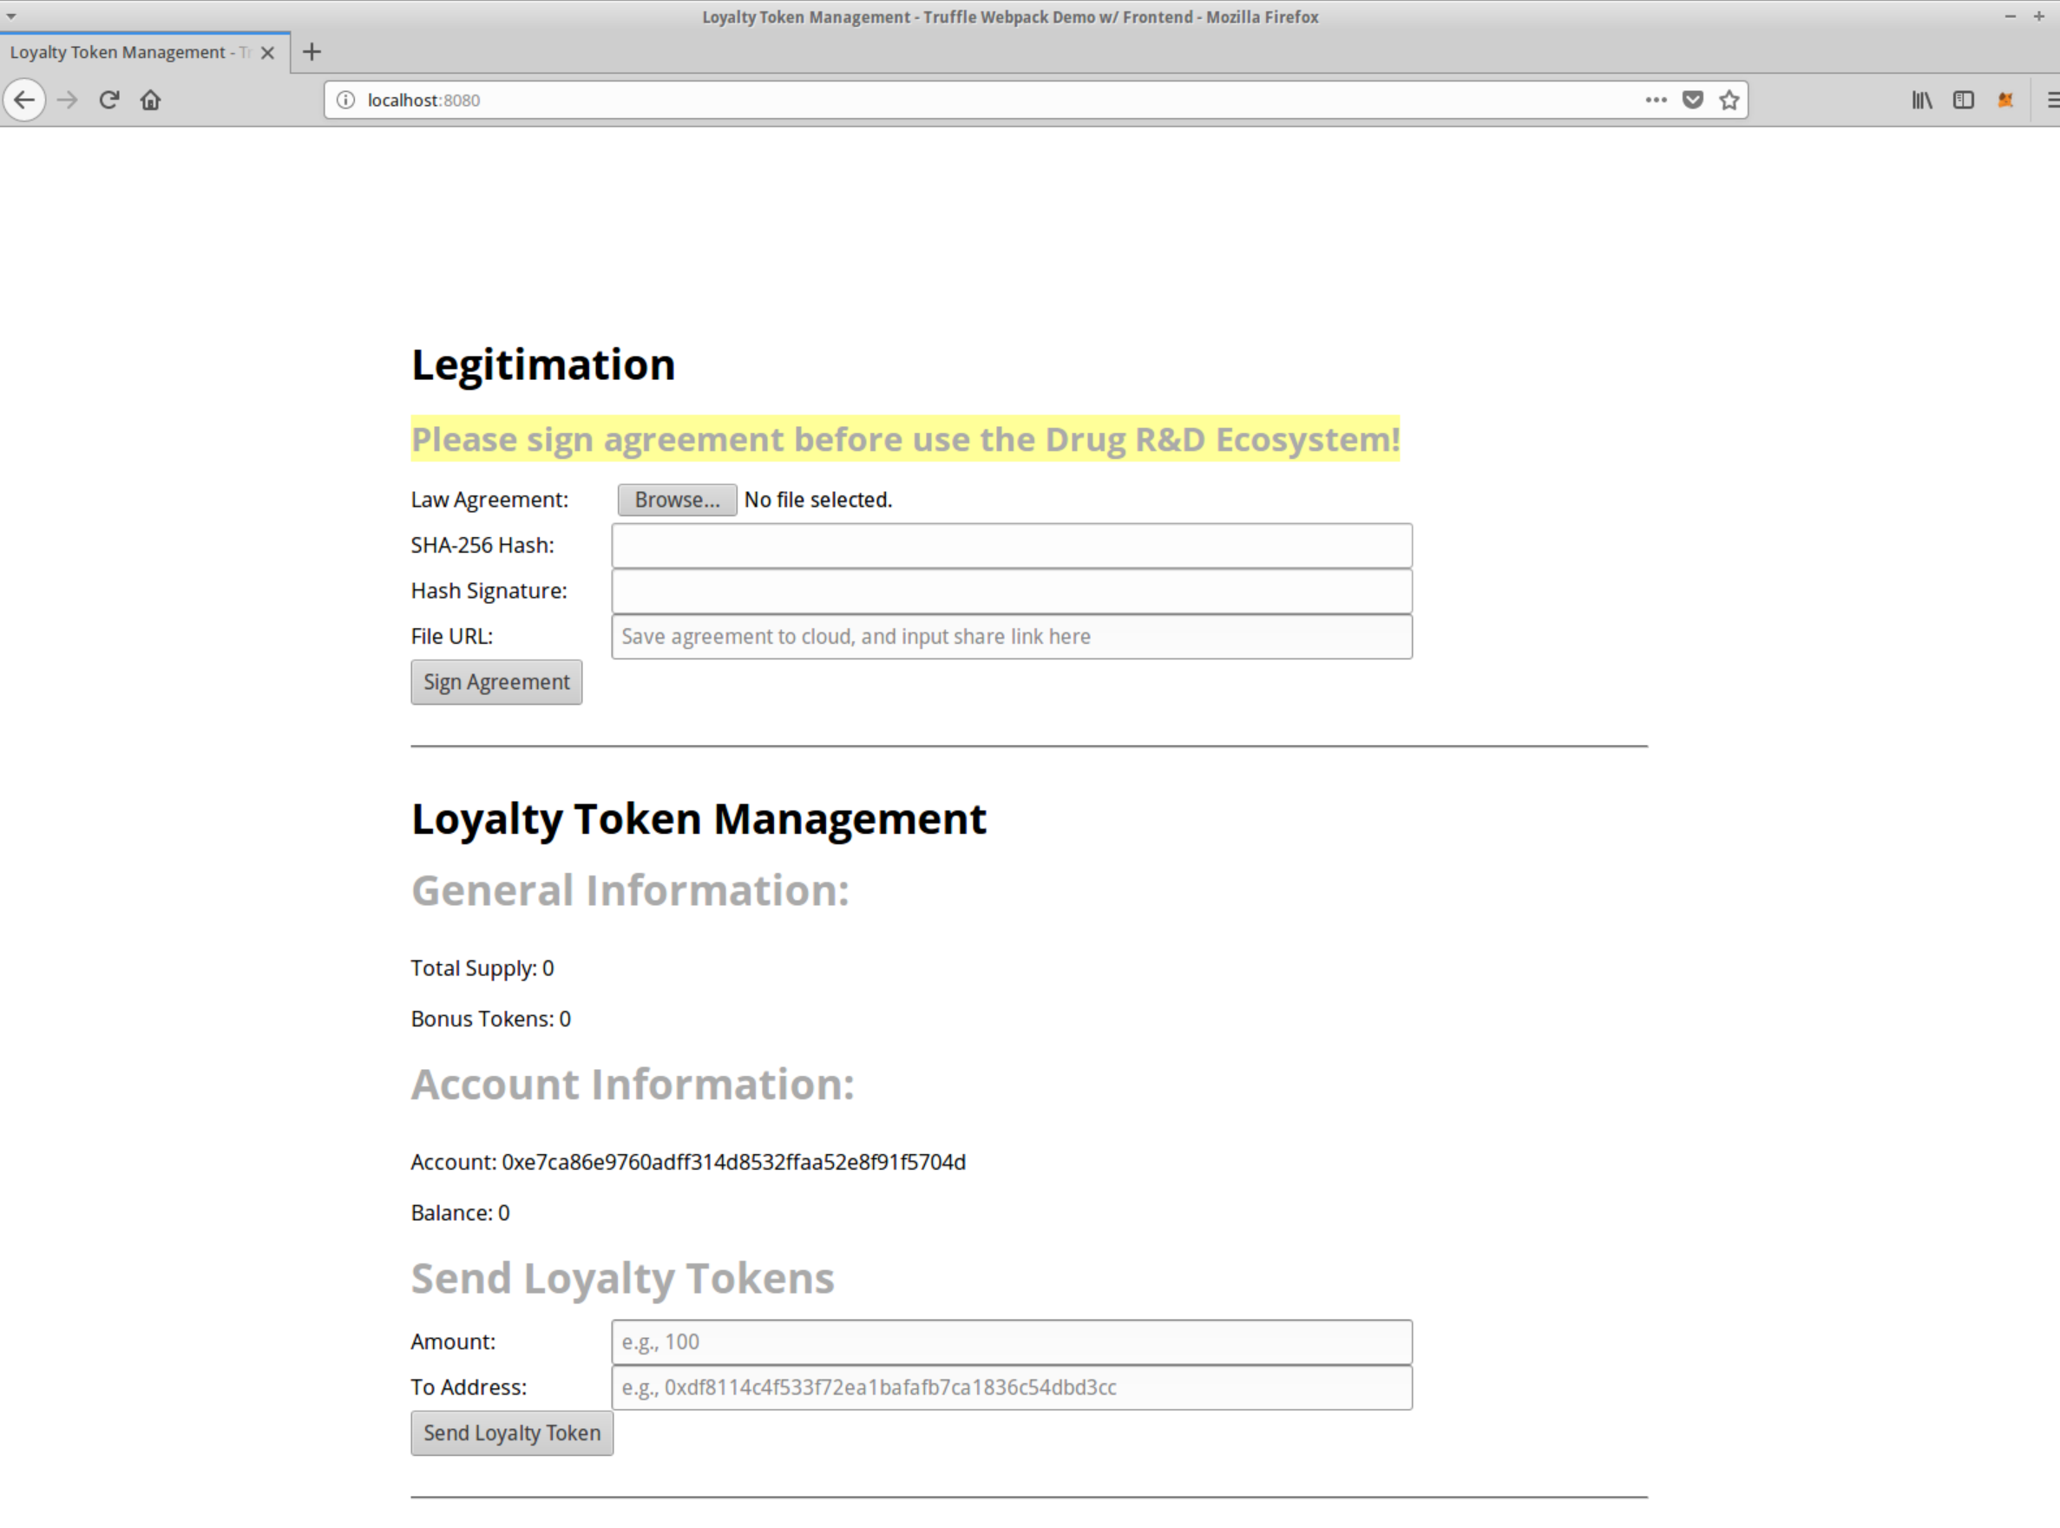
8. Switch the role between TaskOwner and Player by choosing different Ethereum account in MetaMask
   1. 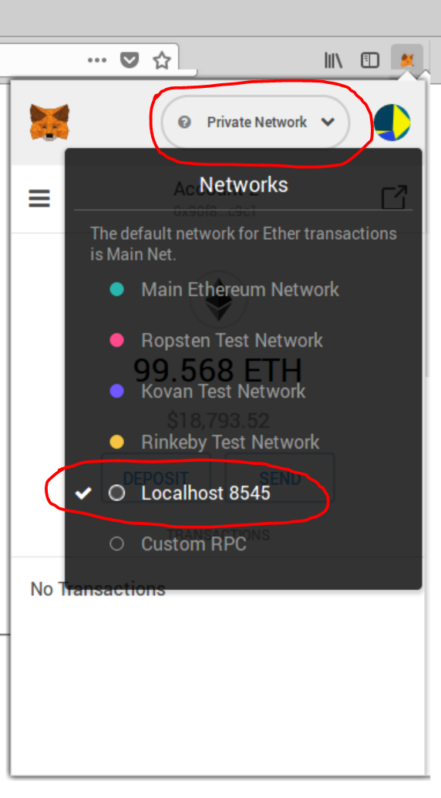 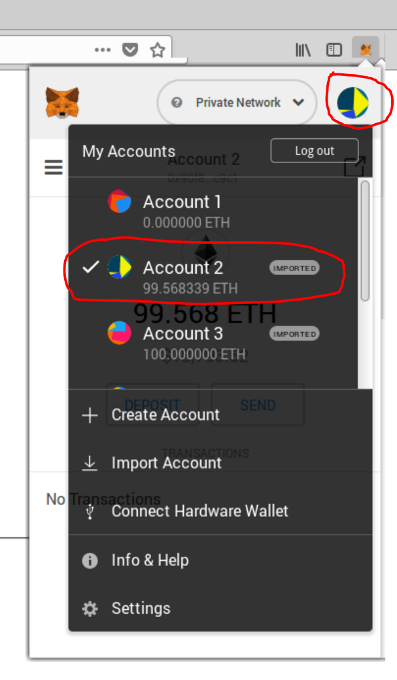

**Installation for Player:**

1. Follow steps 1-3 in TaskOwner
2. Copy “build” folder of ‘MedHack’ in TaskOwner machine to Player machine
3. Follow steps 5-8 in TaskOwner