Volumetric Reproducibility: Basal Ganglia
Will Tackett
April 10th, 2020

Figure 1 - Box plot showing the absolute value of an ROI's percent volume change between 'passive' acquisitions subtracted from the absolute value of an ROI’s percent volume change between ‘active’ acquisitions. That is, active scans’ abs(% volume change) – passive scans’ abs(% volume change) for a given region. Negative data points represent measurements where passive scans showed a greater volume change than active scans. Percent volume change is calculated as 2*(A1-A2)/(A1+A2)
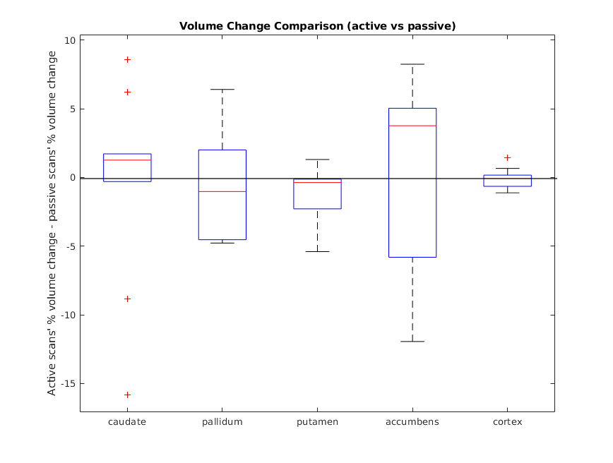

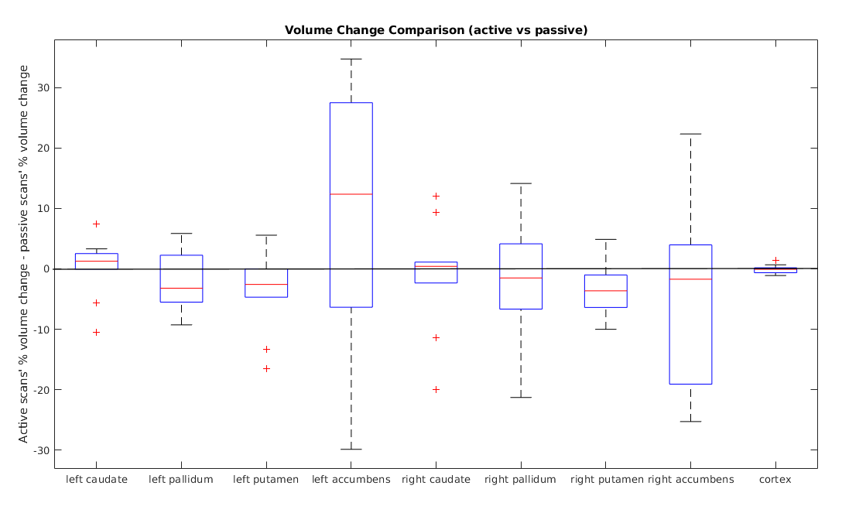
Figure 2 - Active scans’ abs(% volume change) – passive scans’ abs(% volume change) for a given region. Negative data points represent measurements where passive scans showed a greater volume change than active scans.

ROI Name  Table 1 – Results of a paired, two-sided Wilcoxon signed rank test for the null hypothesis that x – y comes from a distribution with zero median, where x is absolute value of the percent change in volume between active acquisitions and y is the absolute value of the percent change in volume between passive acquisitions. | p-value
Caudate | 0.492
Pallidum | 0.625
Putamen | 0.084
Accumbens | 0.695
Left Caudate | 0.432
Left Pallidum | 0.232
Left Putamen | 0.160
Left Accumbens | 0.193
Right Caudate | 0.846
Right Pallidum | 0.695
Right Putamen | 0.105
Right Accumbens | 0.492
Cortex | 0.770

Updated Figure 3 from last analysis:

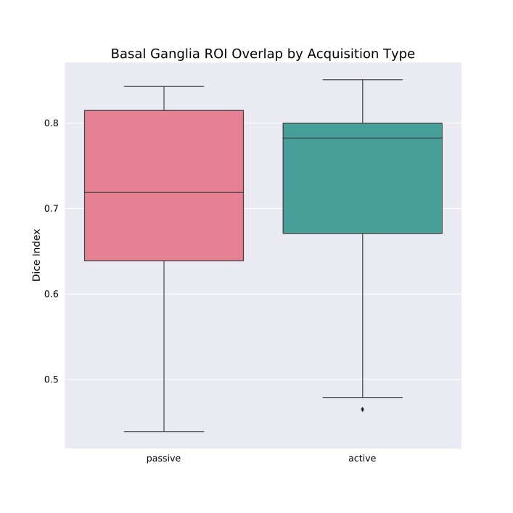
Including pilot_08 and pilot_5 and restricted to basal ganglia.Figure 3: Dice Index for every Freesurfer ROI averaged per subject, compared across
Figure 3: Dice Index for basal ganglia ROI averaged per subject, compared across acquisition types.

