<http://www.porkbeinspired.com/recipes/ginger-soy-and-sherry-soaked-pork-steak/>

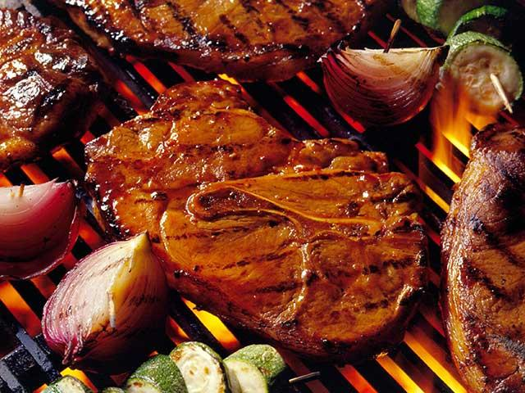

**Used for top background parallax image**

**https://www.flickr.com/photos/mypubliclands/24936183702**

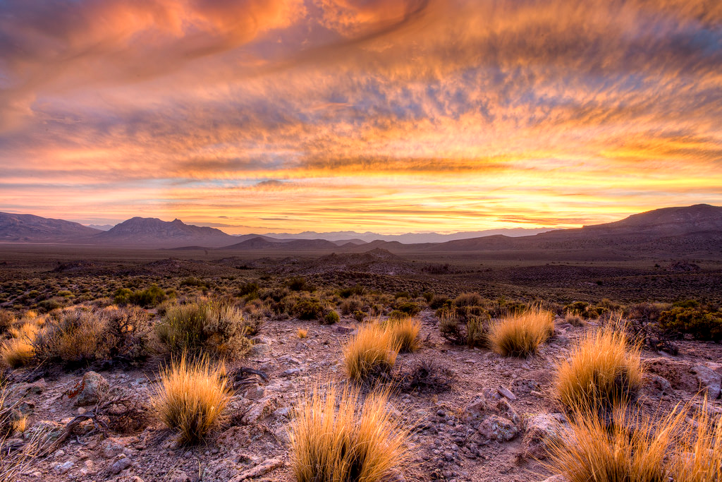

[**https://pixabay.com/en/t-bone-steak-meat-grill-866600/**](https://pixabay.com/en/t-bone-steak-meat-grill-866600/*)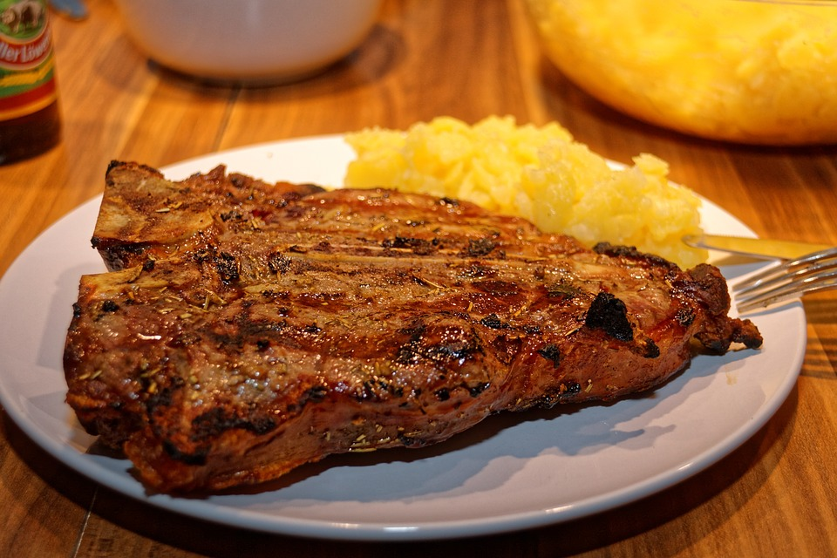

[**https://en.wikipedia.org/wiki/Strip_steak#/media/File:StripSteak.jpg**](https://en.wikipedia.org/wiki/Strip_steak#/media/File:StripSteak.jpg)

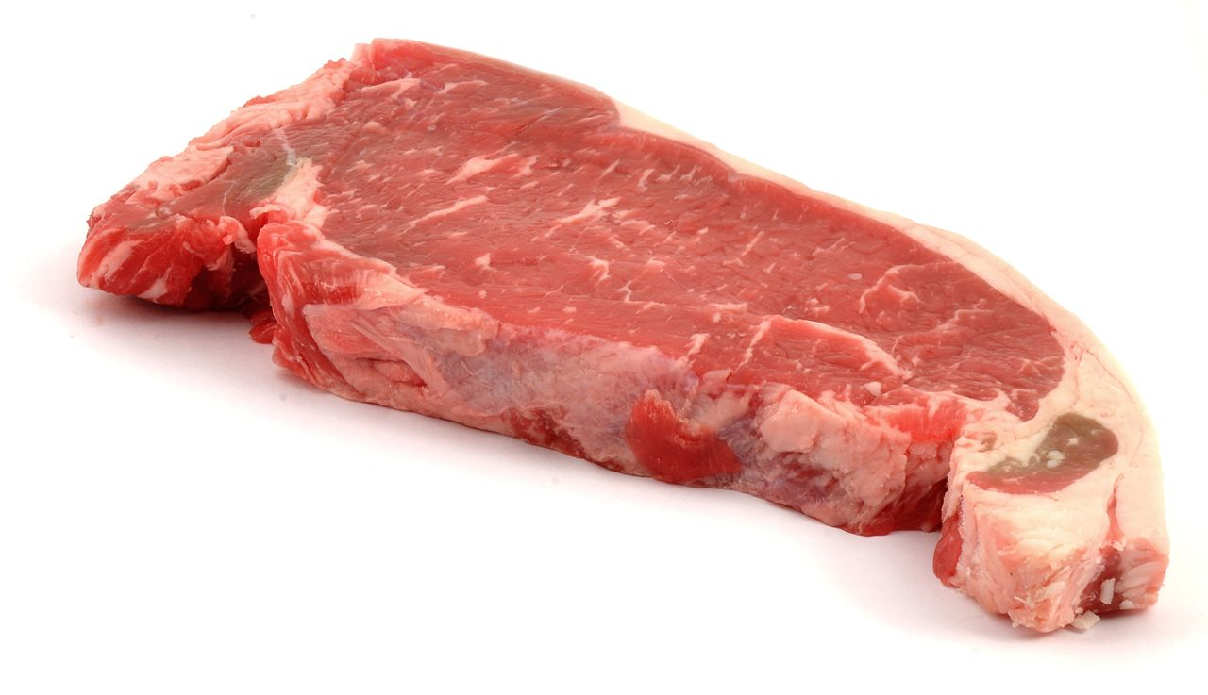

**By Ɱ - Own work, CC BY-SA 3.0,** [**https://commons.wikimedia.org/w/index.php?curid=32270556**](https://commons.wikimedia.org/w/index.php?curid=32270556)

[**https://en.wikipedia.org/wiki/T-bone_steak#/media/File:T-bone-raw-MCB.jpg**](https://en.wikipedia.org/wiki/T-bone_steak#/media/File:T-bone-raw-MCB.jpg)

**By MCB at English Wikipedia, CC BY-SA 2.5, https://commons.wikimedia.org/w/index.php?curid=25331286**

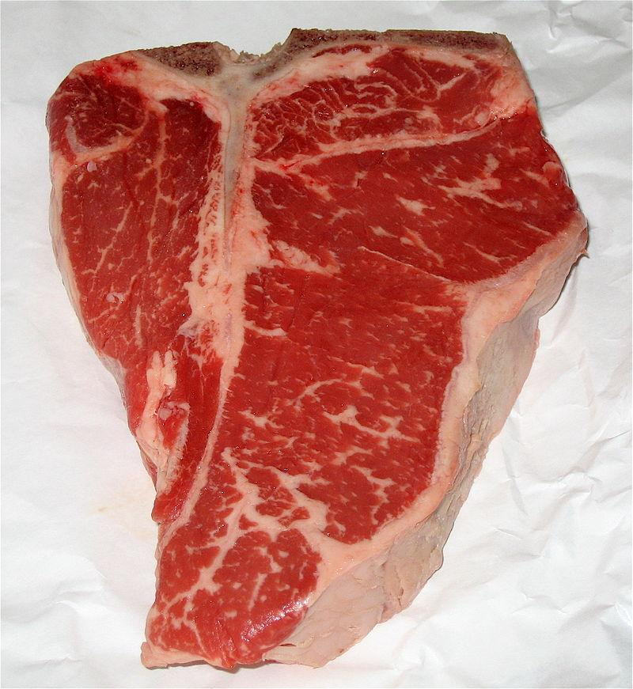

[**https://www.flickr.com/photos/alexik/3313248278/in/photostream/**](https://www.flickr.com/photos/alexik/3313248278/in/photostream/)

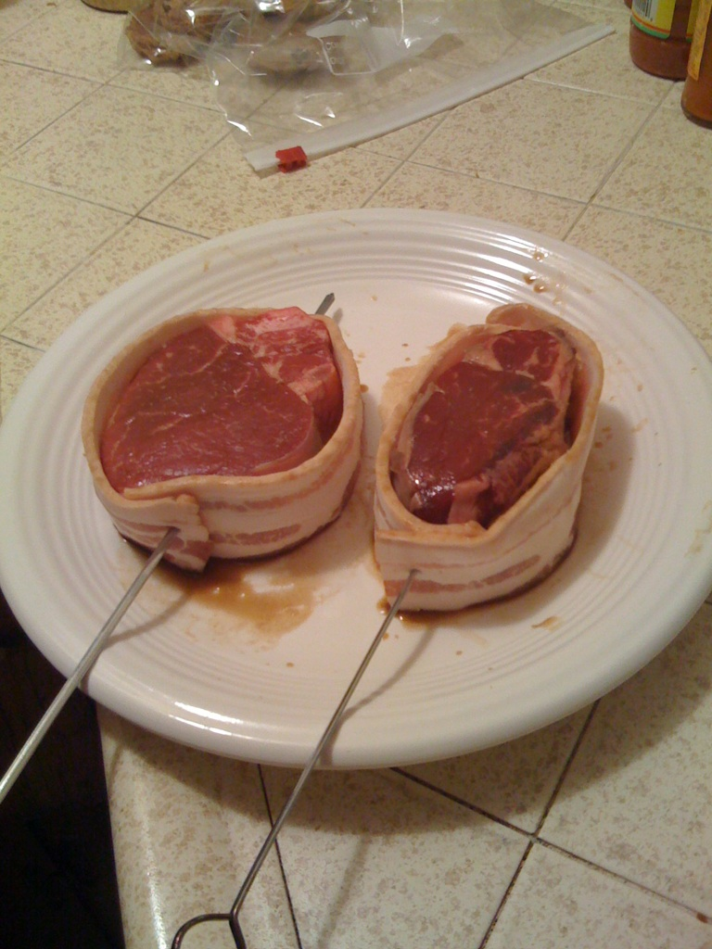

[**https://en.wikipedia.org/wiki/File:Strip-steak-MCB-MaggieO.jpg**](https://en.wikipedia.org/wiki/File:Strip-steak-MCB-MaggieO.jpg)

