Install Pycharm

Outline:

1. Download Pycharm Community version

2. Install Pycharm community version

**1. Download Pycharm community version**

**(step.1) Open your browser, and navigate to link below, and click “Download”**

<https://www.jetbrains.com/pycharm/>



**(step.2) click download.**

Upon completing the download, save it on c:\software, and double click to finish the installation process

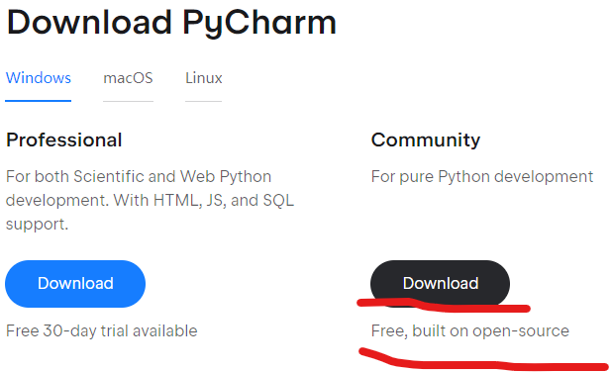

**(step.3) click “windows” key, type in “pycharm”, on the right side, you can see Pycharm as below, click it and start Pycharm**

