Install Python Environment

**Outline:**

1. Download Python 3.9.7 for Windows

2. Install Python

3. Verify the installation

4. Print “Hello World” in command prompt

5. Print “Hello World” by running helloworld.py

**1. Download Python for Windows**

1.1 Download python at:

(a)

<https://www.python.org/downloads/>

<https://www.python.org/downloads/release/python-397/>

note: make sure you download 3.9.* version for Windows if your computer has Windows installed

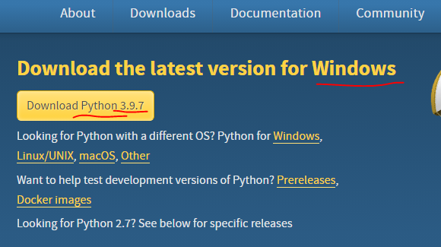

(b) if you find it is too slow to download Python at link above, try other links below:

Step.1 click link below to go to the page as below, and click “3.9.7/” and navigate to the corresponding directory.

<http://npm.taobao.org/mirrors/python/>

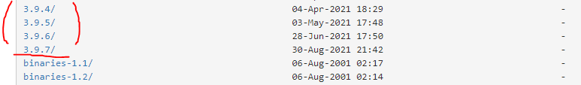

Step.2 Find “python-3.9.7.exe”, and click it to initialize the download

Note: (1) follow the instruction carefully so that you download the right version for your computer (2) upon finishing the download, save the installer somewhere, e.g., d:\software, in case you need it in future.

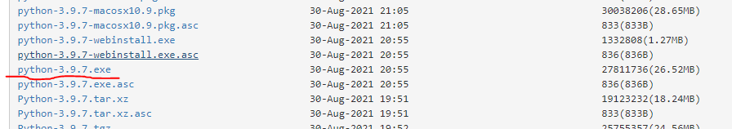

**2 Install Python**

2.1 double click the installer and you will see the screenshot below, make sure tick on the “Add Python 3.9 to PATH”

Click “Customize installation” to navigate to next screen.

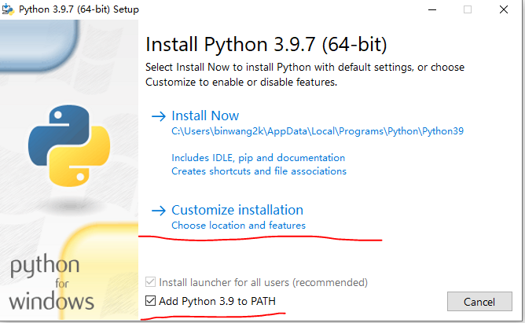

2.2 Tick on “Install for all users”, click “install” and go through the rest of installation

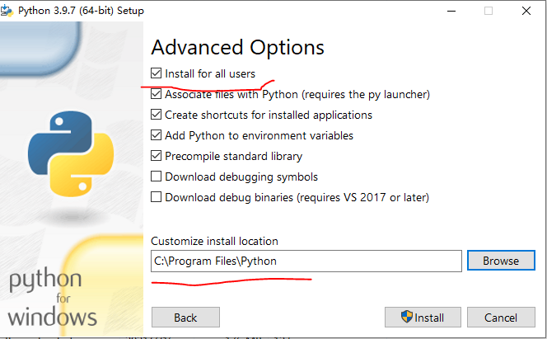

**3. Verify installation**

3.1 press Windows Key+R to open Windows Run, type in “cmd” and enter to open Command Prompt

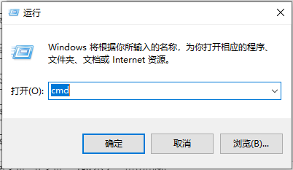

3.2 Type “python” and enter, if the command is executed properly and similar information is shown as the screenshot below, it means it works.

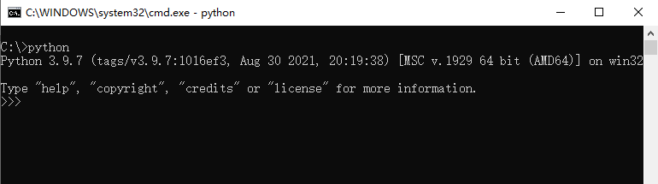

Otherwise, i.e. Python environment is not installed successfully, check your installation according to tutorial above, or check the “environment variables”. It is very important to tick on the checkbox for “Add Python 3.9 to PATH” in 2.1.

You can refer to 3.3 on how to configure environment variable for Python.



3.3 how to configure enironment variable

(a) <https://www.tutorialspoint.com/python/python_environment.htm>

**4. Print Hello wolrd**

(1) open cmd, and type python and press enter key



(2) type: print(“Hello World”), press enter key, and you would see the output below.

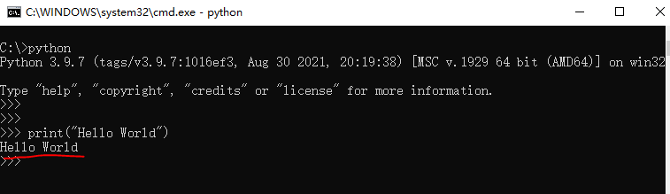

**5. Print Hello World by running file: helloworld.py**

(1) create a txt file (note: it must be a txt file) and change extension name to “py”, file name should be: helloworld.py

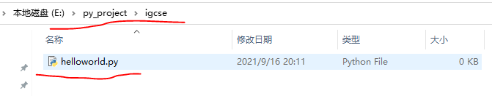

(2) use notepad to open it and type in: print(“Hello World”), save the file

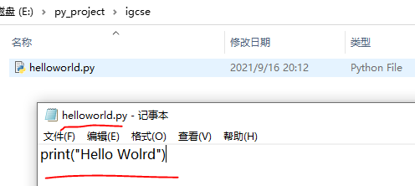

(3) open command prompt, and navigate to directory where helloworld.py is located:

e:\py_project\igcse. Type: python helloworld.py, and press enter

