GAME CONCEPT & VERTICAL SLICE BLUEPRINT
JOE MOWER HORROR
Working title: The Back Nine
The course closes at dusk. Joe does not.
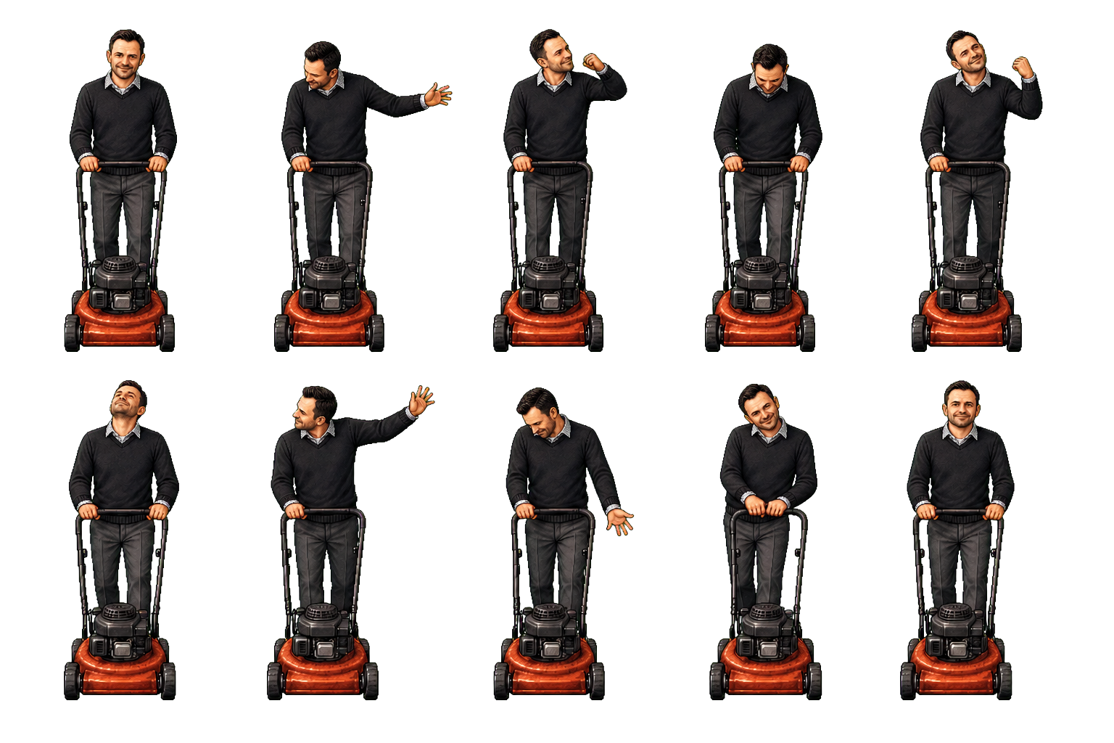
FIRST-PERSON 2.5D PIXEL HORROR | DESIGN STATUS: CONCEPT

1. Project vision
Logline: Trapped on a golf course after closing, the player must cross nine increasingly hostile holes while Joe, an unnervingly dedicated groundskeeper, removes hiding places with his mower and hunts every disturbance.
Field | Working definition
Genre | First-person survival horror with stealth, pursuit, environmental manipulation, and deadpan comedy.
Format | Low-resolution 3D course geometry with high-detail billboard sprites and nearest-neighbor presentation.
Player fantasy | Outthink an apparently chaotic pursuer by reading the course, controlling sound, and exploiting momentum.
Target session | A 2-3 hour first campaign; 10-20 minute replayable hole scenarios.
Primary antagonist | Joe, a mower-driven groundskeeper whose erratic animation conceals learnable behavior.
Recommended engine | Godot for a lightweight 3D world, billboard sprites, data-driven AI, and rapid vertical-slice iteration.

Experience goals
- Sustain anticipation longer than direct pursuit.
- Make every chase alter the course by permanently cutting cover.
- Let players survive through observation and improvisation rather than combat.
- Use absurd golf-course normality to release tension without making Joe harmless.
- Create streamer-readable situations with clear cause, consequence, and recovery.

Design pillars
Readable chaos. Joe looks erratic, but head, hand, engine, and posture cues reveal his actual state.
The course remembers. Mowing, opened shortcuts, activated sprinklers, and displaced props persist during a run.
Sound is gameplay. The mower engine, grass movement, golf impacts, and PA system are navigation and deception tools.
Comedy stays diegetic. The course behaves professionally and politely while something impossible is happening.
Short pursuit, long dread. Chases are intense and decisive; anticipation, investigation, and aftermath occupy more time.

2. Recommended game format
Use a first-person 2.5D presentation: low-poly golf-course geometry and pixelated textures rendered at 320x180 or 640x360 internal resolution, with Joe displayed as a detailed animated billboard. Joe's tendency to face the player becomes uncanny rather than technically limiting.

Art-direction rules
- Keep the course readable: open sightlines, clear silhouettes, and selective fog instead of uniform darkness.
- Render Joe at greater detail than the environment so he feels distressingly real inside a crude simulation.
- Animate Joe at 8-12 FPS while the camera remains smooth.
- Use sickly fairway greens, desaturated twilight blues, sand beige, deep tree-line blacks, and mower orange-red.
- Show persistent mowing strips, bent grass, sprinkler particles, and fog layers as gameplay information.
- Avoid heavy VHS overlays that obscure hazards, interaction points, or Joe's telegraphs.

Core loop
- Enter a new hole and identify the exit condition.
- Read the terrain, mower sound, and available tools.
- Complete two or three noisy objectives while managing concealment.
- Redirect or evade Joe as he permanently changes the route.
- Attempt an optional golf challenge for an upgrade or story fragment.
- Reach the next tee, maintenance passage, or clubhouse checkpoint.
Pacing target: Approximately 70 percent anticipation and navigation, 20 percent active pursuit, and 10 percent recovery, comedy, and narrative discovery.

3. Joe behavior system
Joe should not be truly random. His animation is theatrical noise layered over a deterministic state machine. Players who study him gain meaningful predictive power.
State | Visible or audible cue | Joe's behavior | Player response
Mowing | Steady engine and two-hand grip | Follows a mowing route and removes tall grass. | Stay hidden, reroute, or exploit his predictable line.
Listening | Engine idles; head snaps toward a sound | Stops advancing and samples recent noise events. | Freeze, move under ambient noise, or create a second distraction.
Investigating | Uneven throttle and slow head tracking | Moves toward disturbed grass, impacts, or activated devices. | Leave before he reaches the source; prepare a sharp-turn escape.
Watching | Motionless at long range, directly facing player | Builds dread and blocks a route without immediate attack. | Break line of sight and question whether he truly saw you.
Charging | Head lowers, grip stabilizes, engine pitch rises | Accelerates rapidly in a straight line. | Commit to a late lateral dodge around solid terrain.
Unstable pursuit | One arm releases; shoulders and head jerk | Swerves and corrects course unpredictably within limits. | Use trees, signs, bunker lips, and narrow route changes.
Silent search | Engine cuts out; mower remains unattended | Joe searches on foot or repositions out of sight. | Treat silence as danger; use grass movement and environmental audio.
Course correction | Distant restart or impossible engine angle | Uses a shortcut or previous player route to regain pressure. | Avoid repeating the same escape path.

Animation-to-behavior language
- Both hands steady: a straight, committed movement is coming.
- One hand off the mower: expect wobble, a turn, or a delayed correction.
- Head snaps toward a location: Joe registered a sound there.
- Head lowered: acceleration or direct pursuit is imminent.
- Head tilted while stationary: Joe is listening, not merely idling.
- Sudden normal posture: use as a rare prelude to a dangerous phase transition.

4. Player and course mechanics

Player verbs
Walk, crouch, sprint. Movement changes noise, visibility, and stamina.
Hide in rough. Tall grass conceals but slows movement and records disturbance.
Throw golf balls. Creates discrete sound events that can redirect Joe.
Strike objects. A club can ring signs, pipes, bells, or balls; it is not a primary weapon.
Operate sprinklers. Masks audio, reveals silhouettes, and makes hard surfaces slick.
Drive a golf cart. Fast, loud, fuel-limited traversal with awkward handling.
Use maintenance access. Keys and switches open sheds, tunnels, and shortcuts.
Attempt golf shots. Optional high-noise challenges grant upgrades and narrative rewards.

Terrain rules
Terrain | Player effect | Joe effect
Fairway | Fast, exposed movement and clear sightlines. | High mower speed and reliable charges.
Tall rough | Concealment, noise, and reduced speed. | Can be permanently removed by mowing.
Bunker | Slow movement with highly visible footprints. | Mower loses momentum or must route around.
Pond or stream | Hard boundary, reflection cue, and forced detour. | Constrains approach angles.
Tree line | Line-of-sight break and sharp-turn protection. | Creates collision risk during a charge.
Cart path | Fast walking and driving but little cover. | Supports aggressive course correction.
Maintenance area | Tools, keys, fuel, and temporary shelter. | High-value investigation destination.

Persistent course state
- Mowed grass remains removed for the rest of the run.
- Opened gates and maintenance shortcuts remain available.
- Activated sprinklers cycle on timers instead of resetting immediately.
- Moved carts, rakes, signs, and barriers remain where the player leaves them.
- Joe becomes faster on routes he has already cleared.

5. Suspense, horror, drama, and comedy

Tension cycle
- Unease: evidence of Joe appears before he does.
- Uncertainty: location, route, or intention is unclear.
- Recognition: an animation or sound reveals his state.
- Pursuit: the player commits to a terrain-based escape.
- Escape: the player reaches temporary safety or redirects Joe.
- Release: a mundane golf-course detail creates a brief laugh.
- Complication: the next objective removes certainty or cover.

Audio direction
- Use the mower as the primary musical instrument: idle, load, acceleration, distance filtering, occlusion, restart, and mechanical failure.
- Make engine silence more threatening than constant volume.
- Allow hills, trees, sheds, and fog zones to distort perceived direction.
- Use sprinklers, insects, wind, and public-address announcements as masking layers.
- Reserve conventional music for title, safe-room, revelation, and endgame beats.
- Give the golf cart a cheerful reverse alarm that becomes tactically dangerous.

Comedy rules
Joe never acknowledges that the situation is funny. Humor comes from inappropriate professionalism, course etiquette, machinery, and the player's desperate use of ordinary golf equipment.
- A speaker announces, 'Please allow faster groups to play through,' as Joe charges.
- Joe shouts, 'Stay on the cart path!' while cutting across the rough.
- A vending machine rejects payment during an emergency.
- A scorecard stamps failed attempts as penalties, bogeys, or disqualifications.
- Joe pauses to repair a divot, then resumes the chase without comment.

Narrative mystery
- The course has employed several groundskeepers, all listed as Joe.
- Old tournament photographs show Joe unchanged across decades.
- The player's name already appears on a weathered scorecard.
- Maintenance reports describe grass growth as an unauthorized condition.
- The clubhouse clock resets whenever the player reaches the ninth hole.

6. Nine-hole campaign progression
Hole | New mechanic | Horror or dramatic escalation | Comedy or release
1 | Basic concealment and straight mower charge | Joe is introduced at a long, readable distance. | An etiquette sign explains how to let him play through.
2 | Persistent mowing and shrinking cover | A previously safe route is gone on the return trip. | A scorecard calls hiding in rough a pace-of-play violation.
3 | Sprinklers and sound masking | Audio direction becomes unreliable during irrigation cycles. | Joe stops mid-chase to inspect a sprinkler head.
4 | Golf cart traversal | Speed becomes tempting but attracts Joe from across the course. | The cart's reverse alarm refuses to stop.
5 | Bunkers, ponds, and footprints | Joe predicts exits from visible sand tracks. | A rake must be returned to its designated place to unlock a shed.
6 | Silent search without mower | The engine stops and Joe begins appearing inside structures. | The unattended mower continues following a perfect stripe.
7 | Course geometry shifts | Paths and signs disagree with the player's map. | Every sign still insists the clubhouse is 300 yards away.
8 | False mower audio and shortcut use | Multiple engine sources pressure the player into bad routes. | The PA congratulates Joe for excellent course maintenance.
9 | Nearly all rough has been removed | The final crossing is exposed, fast, and visually simple. | The exit gate requests one final scorecard signature.

7. Vertical slice definition
Goal: Prove that listening for Joe, manipulating sound, hiding in persistent grass, and surviving a momentum-based charge are enjoyable inside one 10-15 minute hole.

Required slice content
- One fairway, one rough field, one bunker, one pond, one maintenance shed, and one tee checkpoint.
- A two-part objective: restore sprinkler pressure, then obtain the exit key.
- Golf-ball throwing, crouch, sprint, stamina, and one sprinkler control.
- Persistent grass removal and one opened maintenance shortcut.
- Joe states: mowing, listening, investigating, watching, and charging.
- One optional par-three shot with a small reward.
- One short golf-cart escape or scripted end beat.
- Functional restart, checkpoint, settings, and readable failure feedback.

Explicitly out of scope
- All nine holes, complete narrative, or final visual polish.
- Combat, weapon upgrades, or a conventional boss fight.
- Full procedural generation.
- Multiplayer or online services.
- Complex inventory crafting.
- Production-ready Joe animation in every direction.

Acceptance criteria
- A new player can explain why Joe detected them after one or two failures.
- At least two terrain-based escape choices are viable during a charge.
- Persistent mowing changes the preferred route during the same attempt.
- The mower's direction and aggression are understandable without a minimap.
- The optional golf shot creates a meaningful risk rather than a detached minigame.
- The slice produces at least one genuine scare and one unforced laugh.

8. Technical stand-up

Recommended architecture
- Godot 3D world with billboarded Joe sprites and low-resolution render scaling.
- Data-driven Joe state machine with explicit perception, navigation, and animation layers.
- Noise-event service that records source position, loudness, category, and decay.
- Persistent course-state service for grass, gates, sprinklers, props, and checkpoints.
- Course segment scenes that can be tested independently and assembled into holes.
- Animation metadata that maps behavioral states to Joe's sprite clips and telegraphs.

Directory structure
JoeMowerHorror/
README.md
docs/ project-facing documents
design/ mechanics, levels, narrative, tuning
game/ engine project and runtime source
assets/
characters/joe/ current Joe sprite package
environment/ terrain, props, foliage, structures
audio/ mower, ambience, UI, PA, scares
builds/ local packaged builds
qa/ review output and test notes
tools/ project-local content utilities

Initial asset backlog
- Joe: idle/listen, mowing patrol, charge, collision recovery, silent-search walk, distant watch, and fail-state animation.
- Course: fairway, rough, cut-grass states, bunker, pond, cart path, tree line, fog, and sprinkler particles.
- Props: mower, golf balls, club, cart, rake, flags, signs, gates, keys, valves, shed, PA speakers, and vending machine.
- Audio: six mower states, pull-start, shutdown, foot movement, grass, golf impacts, sprinklers, cart, PA, and stingers.
- UI: scorecard, interaction prompt, stamina treatment, objective list, settings, pause, and failure stamp.

9. Production plan
Phase | Duration | Primary output | Exit condition
Preproduction | 1 week | Movement test, art-scale test, Joe cue language, one graybox hole. | The camera, sprite scale, and course readability feel coherent.
Systems prototype | 2 weeks | Noise events, Joe state machine, grass concealment, mowing persistence. | Joe can detect, investigate, mow, and charge with understandable causes.
Vertical-slice content | 2 weeks | Objectives, tools, terrain interactions, golf challenge, checkpoint. | The complete 10-15 minute loop is playable.
Presentation pass | 1-2 weeks | Lighting, fog, mower audio, PA comedy, UI, failure and end beats. | The slice produces intended suspense, scare, and release beats.
Playtest and tuning | 1 week | Telemetry notes, route tuning, cue timing, difficulty options. | Most players understand detection and can recover from at least one mistake.

Primary design risks
Joe feels random instead of readable. Tie visible head, hand, posture, and throttle cues directly to state transitions.
Constant mower audio becomes tiring. Use distance, occlusion, silence, false cues, and short pursuit windows.
Billboard presentation breaks at close range. Control minimum distance, use angle variants, and trigger authored close-contact framing.
Comedy weakens the threat. Keep Joe sincere and place jokes after tension peaks or inside neutral course systems.
Grass interaction is too expensive. Use coarse gameplay cells and visual shader responses instead of simulating every blade.
Golf challenge feels disconnected. Make shots noisy, route-dependent, and tied to useful rewards.

10. Game-name ideas
Recommended working title: The Back Nine: A Joe Mower Horror Game. It is concise, ominous, golf-specific, and flexible enough to support horror without promising pure comedy.
Name | Tone | Why it works
The Back Nine | Balanced horror | Familiar golf language that also suggests a hidden or final ordeal.
Please Play Through | Deadpan horror-comedy | Sounds polite while implying that something dangerous is behind you.
Groundskeeper Joe | Character-forward | Simple, memorable, and makes Joe the franchise identity.
Rough Cut | Stylish horror | Connects tall grass, mowing, editing, and violence without being graphic.
Cart Path Only | Deadpan comedy | A mundane rule that becomes threatening when Joe enforces it.
No Mulligans | Horror-comedy | Communicates consequence and replay without naming the monster.
The Course Is Closed | Atmospheric horror | Immediately establishes trespass, isolation, and after-hours danger.
Last Mowing | Creature-feature | Directly communicates the antagonist's tool and an end-of-night event.
Cut Below Par | Pun-forward | Combines mowing and golf performance with a dark edge.
Stay on the Fairway | Threatening instruction | Works as both course advice and Joe's controlling demand.
Joe's Final Round | Character and golf | Supports a narrative campaign built around nine holes.
Tee Time with Joe | Comedy-forward | Friendly phrasing that becomes unsettling through context.
After Closing | Broad horror | Strong atmosphere but less distinctive without the subtitle or key art.
Fore! | Minimal and punchy | Recognizable warning language with strong marketing potential.
Par for the Corpse | Camp horror-comedy | Memorable and explicit, but commits the project to a sillier tone.

Name availability, trademarks, domains, and storefront conflicts have not been researched. Perform a clearance check before public announcement or commercial use.

Tagline ideas
- The course closes at dusk. Joe does not.
- Please allow faster groundskeepers to play through.
- Nine holes. One mower. No mulligans.
- Stay on the fairway.
- He keeps the course immaculate.

11. Immediate next steps
- Choose the public-facing working title and retain Joe as the antagonist name.
- Create the Godot project inside the existing game directory.
- Build a low-resolution rendering and billboard-sprite proof before producing more art.
- Graybox one hole with fairway, rough, bunker, pond, and maintenance shed.
- Implement noise events and Joe's mowing, listening, investigating, and charging states.
- Add persistent grass removal and one sprinkler interaction.
- Playtest the chase before adding narrative, comedy, or additional holes.
- Record a 60-second internal gameplay capture and evaluate readability at native resolution.
First decision: Do not begin with nine holes. Prove one memorable pursuit in one small course segment, then expand only after Joe is readable, frightening, and fun to manipulate.

