Design:

Through the whole design process, the user-experience was the foremost consideration. The user-experience (UX) is an individual’s emotions, behaviors, actions and reactions to a product or interface. What this means in the context of a software is that the user can easily recognize how to interact with the software, can easily observe the information provided and provide a level of satisfaction or enjoyment from using the software. It is important to note that the design goal of a great UX doesn’t conflict with the project’s altruistic goals as defined above. In fact, by achieving a good user-experience through design, these other goals are simultaneously achieved.

To achieve the UX goals, I drafted a very minimalist design. The idea is, the software has well-defined functionality, so the design should reflect this by incorporating only the most necessary elements without exceeding the expectations of the user. The benefit of this is less clutter, so the user is generally less confused when interacting with the interface. Other benefits include good aesthetics, an ease of scalability, and improved readability.
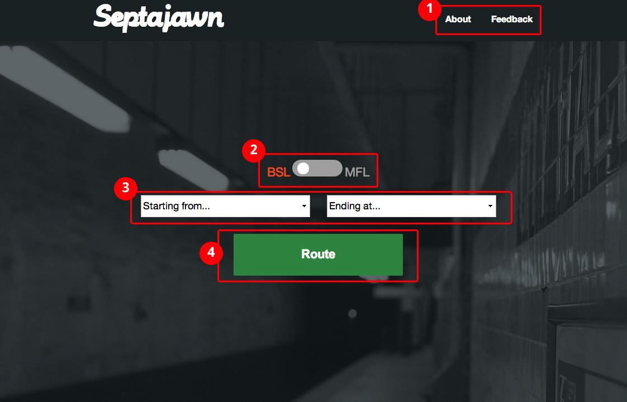

Figure 1 – The initial interface when user first uses the software. Highlighted are important design features.

When the user first visits the webpage, they are presented with an interface as seen in figure 1. The following is a breakdown on the important design features of this initial interface:

- Navigation – The website itself isn’t particularly deep with content. But aside from the actual functionality of the software, the only other necessary content are pages dedicated to providing information about the project itself and user feedback. For the best user experience, the user should be able to access any and all content through a comprehensive navigation. The convention is to include links to these pages towards the top of the page, inline with each other. By not deviating from this convention, users are familiar with the navigation and are more likely to understand what content these links contain.
- Line selection slider – SEPTA subways run on two different lines, the Broad Street line and the Market Frankford line. This input is necessary because the next input is dependant on its value. Special consideration was taken to ensure that the user is aware of what the active selection is. Binary inputs (two selections) sometimes have this issue. For example, in the instance of a music player control interface, when displaying a pause symbol on a button, does this indicate the state of the software (paused) or does it indicate that pressing the button initiates the pause function? Both cases are opposites and can cause confusion to the user. To address this potential confusion, two “active” indications were implemented. First, the slider has a white circle that acts as a handle. Whichever side the circle resides correlates to the active selection. To reinforce this idea, the “active” label changes colors from neutral gray to the color that represents the line. Broad Street line is orange; the Market Frankford is blue, as chosen by SEPTA. The labels themselves don’t spell out the full line name entirely, and instead uses the line’s abbreviation. The reason for this is because the intended audience’s assumed knowledge of the two lines and because the labels would cause issues when displaying on a small display.
- Station selections – After the user selects the appropriate line, the user naturally progress to the two following inputs, one for the station of origin, the other is the station of destination. Both lists automatically populate based on what line is selected. The user then can click the box and select their station by scrolling through the drop-down interface. This method was chosen over other selection methods such as text input for two main reasons. Firstly, by only allowing a limited array of possible selections, the data won’t need to be validated on the backend. Furthermore, despite a long list of stations, the user experience was deemed better than manually typing based on time and the number of button presses to achieve the desired input.
- Submit button – The function of the large, vibrant “Route” button should be obvious to the user, it submits the user inputs and continue from there. It is important to note that this button isn’t entirely necessary. The software can easily be configured to submit the inputs immediately after they’re both selected, which would quicken the process and eliminate the need for a user to act. However, with the button present, the user is more confident in the process, they are to select the inputs then click the button. If absent, the user may be confused with the automated process and may not be familiar with two drop downs. Additionally, allowing the user to hit a large button provides a small sense of empowerment and as a result, a good user experience. Additionally, if in the case of an accidental input, the button allows the user to correct their selections before the submission occurs. Conversely, if the form submitted with incorrect selections immediately, the user may become frustrated with the backtracking required to fix their mistake.
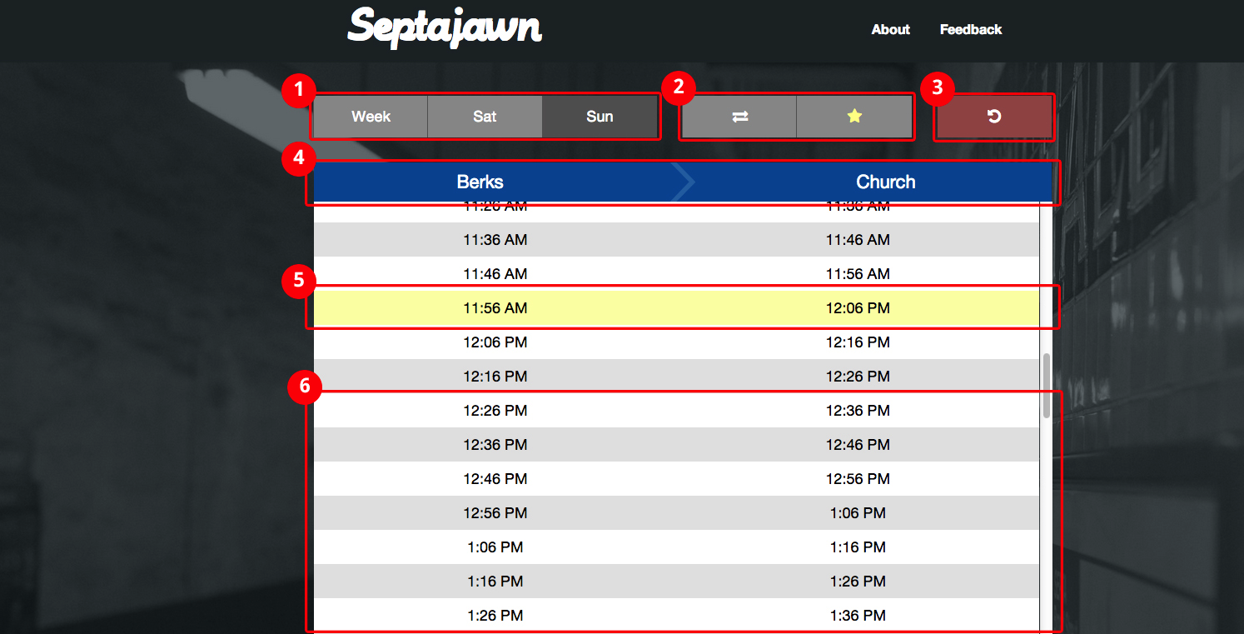
Figure 2 – The interface presented to the user after input submission. Highlighted are important design features.

After the user inputs their appropriate station selections and submits, they are presented with an interface as seen in figure 2. The following is a breakdown on the important design features of this initial interface:
- Day selection- Giving users the ability to find schedules for any day of week is important for the user experience. Many of the similar transit software focus on the current day and time and sometimes don’t even include this functionality. The three buttons correspond to the line’s three different schedules based on day of the week. The default selection is the current day. The “active” selection is denoted with a darker background color, for figure 2, it’s the Sunday button.
- Reverse and favorite – Two added features exist for the convenience of the user. The first is the reverse button, which will swap the starting and ending stations and find the appropriate schedule. This is convenient because often times the user will be making a round-trip and will need to know the reverse information. The other button is the favorites function. It will remember a special pairing of stations and automatically input them into the initial interface upon the next visit to the website. These two buttons are separated from the rest of the buttons in the toolbar because they are much different in functionality to the rest. They are the same color however as the “day” buttons with the same text color. This choice of consistency was made to prevent a saturation of clashing color to exist. However, the “favorites” button has two states, favorited and not favorited. These states are distinguished based on a yellow start and a white star respectively.
- Reset– If the user wishes to clear the generated schedules and pick start over, they can quickly press the reset button. As the only colored button in the toolbar, it suggests to the user that it is different, which it certainly is from a functional standpoint. The other buttons modify the schedule, while the reset clears it completely. Furthermore, the red background is a cue to the user to suggest some sort of reset, clearing or deletion that has become synonymous with the color.
- Schedule header – Statically positioned at the top of the schedule are the names of the origin station and the destination station. This bar is colored based on SEPTA’s preexisting color scheme—Market Frankford line is blue, Broad Street line is orange. Furthermore, the font and the font color mimic the existing physical and digital signage that exists throughout the SEPTA stations. This provides a sense of familiarity to the user, especially for seasoned riders.
- Current time highlight – When the schedule is generated, the closest scheduled departing time compared to the actual time is highlighted with a slight yellow. For many and probably most cases, this is what the user is looking for. Given the time sensitivity of catching a train, the user needs to be able to find this information immediately. Furthermore, the design calls for the software to immediately jump to this point in the table, to provide the user with this information as soon as possible.
- Schedule table- The generated table is populated with all trains corresponding to that day’s schedule. The legibility and readability of the table is improved with alternating row background colors and provide good contrast between the rows and the text.

Backend programming:
Overview:
This project is coded primarily in JavaScript. It has recently been going through a resurgence in popularity, especially with the online application developer community. The popularity is one of the advantages that JavaScript has over other web development languages. The community is large enough that troubleshooting is made much easier with the abundance of documentation, tutorials and discussion groups. From the technical perspective, JavaScript is a “full” computer programming language in every sense. While optimized for the web, it can be applied in other ways. The “full” nature of the language allows the developer to have free reign over the program, allowing for more flexibility and functionality. Though sometimes not categorized as an object-oriented language, it has strong object-oriented capabilities. Furthermore, the syntax and behavior of JavaScript has similarities to other object-oriented languages such as C and Java. Which allows for a smaller learning curve. For these reasons, JavaScript was chosen for this project.
The markup and styling will be done with standard HTML and CSS respectively. The dynamic content will be generated into HTML and injected into the Digital Object Manager (DOM) with JavaScript.

First phase:
Initially, this project was coded by hand without any planned structure or organization. Instead, it was developed freely and incorporated some “hack”-like programming, for lack of a better word. While the software worked closely to spec, there were some issues that became apparent. And though these issues could be addressed through more lines of code, the lack of structure caused workflow issues and significantly hampered progression and even maintenance of code.
An example of one such issue is when the project was initially developed, the times for all the stations were generated through a static array of numbers, the times of the first stop on the entire line. The time between stations was mostly static across the board, meaning the time between one station and another didn’t change much throughout the day. By knowing this information, arrays for each station were generated by adding the duration between two stops to the previous stop’s schedule. This can be seen in figure 3. The advantage of this method is that it quickly generated the times, usually only requiring 10ms or less. One downside of this method is that it doesn’t incorporate express trains, only local ones. Another downside is in some special instances; the time between stations differs by one or two minutes. Because the scheduling function relies on the consistency of times between stations, during these special cases, the wrong schedule is generated for that stations and cascades to subsequent stations. Even though these are special cases, the schedules are still wrong and the function fails to provide accurate information to the user. But a bigger issue is the absence of express trains, by doing this, the needs of a large chunk of users are ignored, failing the accessibility goals set.
The remedy was to create a comprehensive listing of data for all the stations instead of relying on a scheduling function. This data would reside on an external JSON (JavaScript Object Notation) file and be called and imported upon page load. The lack of organization of the code made it difficult to implement the JSON file for a number of reasons. Mostly because the JSON file turned what was a variable to be passed down through the code into an object. For many of the functions between the selection and rendering of the input, this meant rewriting all these functions to accommodate for the object. This led to much confusion and

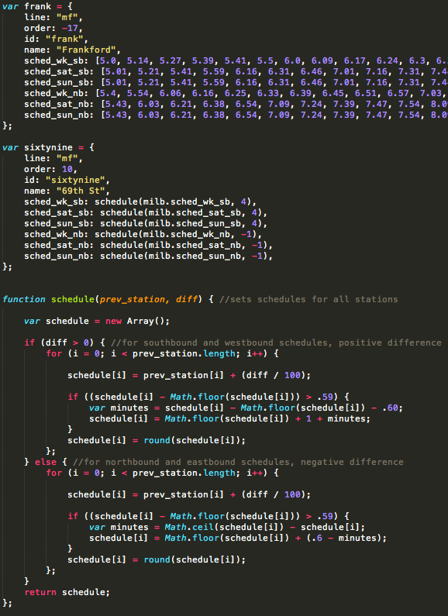
Figure 3 - The scheduling code that was originally implemented, the variable frank is the origin station, variable sixtynine is another station with the parameters that dictate how to create that station’s times. This is done through the schedule function.

Second phase:
Initially

