Paying colonization credit with forest management could accelerate the range shift of temperate trees under climate change

Willian Vieira1,2,\*, Isabelle Boulangeat3, Marie-Hélène Brice4,5,2, Robert L. Bradley1,6, Dominique Gravel1,2  
  
1 *Département de biologie, Université de Sherbrooke, Sherbrooke, Québec, Canada*  
2 *Québec Centre for Biodiversity Sciences, McGill University, Montréal, Québec, Canada*  
3 *Université Grenoble Alpes, INRAE, LESSEM, St-Martin-d’Hères, France*  
4 *Jardin botanique de Montréal, Montréal, Québec, Canada*  
5 *Institut de recherche en biologie végétale, Département de Sciences Biologiques, Université de Montréal, Montréal, Québec, Canada*  
6 *Centre d’étude de la forêt, Université du Québec à Montréal, Montréal, Québec, Canada*  
\* *corresponding author: willian.vieira@usherbrooke.ca*

The northward migration of several tree species ranges is likely to lag behind climate change due to slow demography, competitive interactions, and dispersal limitations. These will result in a colonization credit, where suitable climate envelopes are left unoccupied, and extinction debt, where tree stands persist at unsuitable climatic locations. While the underlying mechanisms explaining the delayed range shift of forest trees have been investigated, few studies have focused on how management could overcome this lag. Here we extend a forest community state model derived from the metapopulation theory and validated with over 40,000 forest inventory plots, to formulate how forest management can accelerate the response of the boreal-temperate ecotone under warming temperature. We first complete the model equations to represent how four types of forest management may affect the transitions between four forest states: Boreal, Temperate, Mixed and Regeneration. We then simulated the potential of forest management to reduce colonization credit and extinction debt using two complementary approaches to measure the resilience and range shift of the boreal-temperate ecotone in response to warming temperature. Our simulations reveal that paying the colonization credit by planting temperate trees in a stand in Regeneration or Boreal state are likely to i) reduce the return time to equilibrium, ii) increase forest resilience, and iii) move the ecotone towards colder temperatures. Surprisingly, harvesting boreal trees in stands in Boreal or Mixed state were not effective to reduce extinction debt and provide colonization opportunities for temperate trees. Our results suggest that forest management related to planting actions could help the boreal-temperate ecotone keep pace with climate change. Future experiments are required to test these theoretical expectations and make operational recommendations.

**Keywords**: Adaptive management, Assisted migration, Resilience, Range dynamics, Transient dynamics, Metapopulation, State and Transition Models

**Highlights**:

* We test the effect of sylvicultural practices in a forest model under climate change.
* We assess how planting and harvesting can increase forest resilience and range shift.
* Planting temperate trees is more efficient at increasing response rate to climate change.
* Enrichment planting boreal stands is more efficient than planting empty stands.
* Plantation increases resilience and coldward range shift to keep up with climate change.

**Running title**: Management could accelerate tree range shifts  
  
**Supporting information**: Additional supporting information can be found [here](https://willvieira.github.io/ms_STM-managed/suppInfo.pdf).  
  
**Acknowledgments**: We thank Daniel Houle for insightful discussions on the effect of forest management practices, and his comments on the early version of this manuscript. We are also grateful to Steve Vissault for helping with the implementation of the model, and to Antoine Becker Scarpitta for suggestions for improvement.  
  
**Data availability**: All the code and data used to reproduce the analysis, figure and manuscript are stored as a research compendium at <https://github.com/willvieira/ms_STM-managed>.  
  
**Funding**: This research was supported by the BIOS² NSERC CREATE program, Strategic Project Grant from the Natural Sciences and Engineering Council of Canada, and A joint Internship Grant from Mitacs and Ouranos.  
  
**Authorship**: WV, IB and DG designed the study. WV and IB developed the model. WV analyzed the simulations and wrote the first draft of the manuscript. All authors contributed substantially to revisions.  
**Conflicts of interest**: The authors declare no conflict of interest.

# Introduction

There is a growing concern about how tree species will respond to climate change, and how fast they can migrate to keep pace with climate warming. Correlative statistical models have projected large range shifts following temperature increases, such as the migration of plant species hundreds of kilometers northward by the end of this century (Malcolm et al. [2002](#ref-Malcolm2002), Mckenney et al. [2007](#ref-Mckenney2007)). While the range of short-lived mobile species may keep pace with climate change (Chen et al. [2011](#ref-Chen2011)), the range of long-lived tree species generally does not (Harsch et al. [2009](#ref-Harsch2009), Zhu et al. [2012](#ref-Zhu2012)). In fact, trees of eastern North America have shifted their range limits way bellow of the pace required to keep up with temperature increases (Boisvert-Marsh et al. [2014](#ref-BoisvertMarsh2014), [2019](#ref-BoisvertMarsh2019), Sittaro et al. [2017](#ref-Sittaro2017)). This mismatch between climate conditions and forest community composition will likely lead to maladaptation of trees to their environment, and therefore a possible loss of future forest productivity (Aitken et al. [2008](#ref-Aitken2008)). Assessing the mechanisms determining species range limits is, therefore, critical for formulating adaptive management strategies (Becknell et al. [2015](#ref-Becknell2015a)).

Range limits of forest trees are driven by colonization and extinction dynamics. The metapopulation theory predicts the boundary of a species’ range occurs where the colonization rate equals the extinction rate, wherever habitat is available (Holt and Keitt [2000](#ref-Holt2000)). Derived from this theory, Talluto et al. ([2017](#ref-Talluto2017)) quantified the colonization and extinction rates as a function of climate for 21 tree species in eastern North America and found that their distribution is out of equilibrium with the current climate. Specifically, they found a colonization credit at the leading edge of their range whereby suitable habitat is left unoccupied, and an extinction debt at the trailing edge whereby populations persist in unsuitable habitats. This equilibrium mismatch is predicted to increase in the future, as the range limits of temperate trees will barely shift northward due to their slow demography and limited dispersal rates (Vissault et al. [2020](#ref-Vissault2020)).

Forest management provides an opportunity to reduce colonization credit and extinction debt and, therefore, accelerate range shifts. Although some management practices, such as assisted migration (Peters and Darling [1985](#ref-Peters1985a)), have been proposed as a potential tool towards this end (*e.g.* Gray et al. [2011](#ref-Gray2011)), there has been extensive debate about its effectiveness with no definite conclusion (*e.g.* McLachlan et al. [2007](#ref-McLachlan2007), Ricciardi and Simberloff [2009](#ref-Ricciardi2009), Schwartz et al. [2009](#ref-Schwartz2009), Vitt et al. [2009](#ref-Vila2010)). The truth is, temperature is warming and there is an increased need to adapt forest management practices to consider future environmental conditions (Keenan [2015](#ref-Keenan2015), Ameztegui et al. [2018](#ref-Ameztegui2018)). In the boreal forest in Quebec, simulations indicate that if current management practices persist, climate change will decrease the maximum sustainable harvest yield due to the heightened frequency of fires, which prevents individuals from reaching maturity (Forestier en Chef [2020](#ref-BureauduForestierenChef2020)). Changing the current management strategies to reduce colonization credit and extinction debt can be obtained through different silvicultural approaches that trigger or modify some ecological processes. There are basically two broad categories of actions: harvesting (removing individuals) or planting trees (adding individuals). Large-scale harvesting may reduce extinction debt by removing maladapted individuals at the trailing edge, and also reduce colonization credit by reducing competitive interactions at the leading edge (Leithead et al. [2010](#ref-Leithead2010), Steenberg et al. [2013](#ref-Steenberg2013), Brice et al. [2020](#ref-Brice2020)). Similarly, stand thinning could improve the competitive ability and recruitment of certain tree species that thrive in forest gaps. Alternatively, the planting of novel species or genotypes in open areas, or enrichment planting in mature stands (which increase the population of a tree species in a stand before natural dynamics) could favor the desired successional pathways. In the next section, we will develop in detail the link between forest management and the ecological processes as we introduce the model.

In this paper, we will study how forest management can accelerate the response of the boreal-temperate ecotone to climate warming. We first extend a field-based model derived from metapopulation theory to determine how four different management practices affect the colonization and extinction processes driving tree range dynamics. Our analysis is based on an empirical model which accounts for colonization and extinction dynamics, along with competitive exclusion and invasion processes, to predict how the boreal-temperate ecotone responds to climate warming (Vissault et al. [2020](#ref-Vissault2020)). This model was initially calibrated and validated with data from over 40,000 forest inventory plots from eastern North America. We integrate the effects of plantation, enrichment planting, harvest, and thinning on the colonization and extinction dynamics of temperate deciduous and boreal conifer stands.

We then assess the theoretical effectiveness of the four management practices using two complementary approaches that quantify: (i) the transient dynamics under equilibrium and (ii) the forest range shifts on a lattice grid (Figure [1](#fig:concept)). Transient dynamics are defined as the period a forest stand takes to reach a new equilibrium after a temperature-increase (Hastings [2004](#ref-Hastings2004)). In dynamic models, equilibrium is defined as the absence of change in a state variable over time. We simulate an increase in temperature and analyze the effect of forest management in five metrics charactherizing the transient dynamics (Boulangeat et al. [2018](#ref-Boulangeat2018)). Initial resilience () and asymptotic resilience () measure the rate of change near to the initial and final equilibriums and are read as the system’s reactivity and stability, respectively. Exposure () measures the degree to which the old and new equilibrium’s states differ, and sensitivity () describes the amount of time needed to reach the new equilibrium. Cumulative amount of changes () combines all four metrics described above to quantify the total amount of state and time in which the system is out of equilibrium and therefore vulnerable. In the second approach, we implement a stochastic and spatially explicit version of the model to account for limited dispersal. We quantify how each of the management practices accelerates the range shift of the boreal-temperate ecotone in a landscape grid. Because of the lack of abundant data on forest management across a climate gradient, we could not parametrize and validade the extended model. Rather, these analyzes will serve as references to guide future empirical studies by revealing the potential effect of forest management in accelerating the response of forest to climate warming and thus contribute to the advancement of adaptive management practices.

Conceptual schema of the two approaches used to test the effect of forest management on the response of forest to temperature increases. (a) Redrawn from Boulangeat et al. (2018). The spatially implicit version of the model was used to investigate how forest management affects the transient dynamics following temperature increases. Take, for instance, a patch with environmental conditions that mainly favour boreal species, the increase in temperature due to climate change will now favour other species over the boreal ones. As a result, the boreal state occupancy at equilibrium under the new climate (B_1 at t_1) will be lower than it was before climate change (B_0 at t_0). Five metrics can describe the transient phase between the old and new equilibrium: initial resilience (-R_0), asymptotic resilience (R_{\infty}), exposure (\Delta_{state}), sensitivity (\Delta_{time}) and cumulative amount of changes (\int S(t)dt). (b) The spatially explicit version of the model was used to study the effect of forest management on the range shift of forest states following climate change (CC) while accounting for limited dispersal of trees and stochastic dynamics. The two lattice grids represent the distribution of pure boreal, mixed, pure temperate, and regeneration states along a gradient of temperature ranging from boreal dominant to temperate dominant climate conditions. The cell size of the grids in this figure was increased for visual clarity. The left and right vertical black bars indicate the range limit between boreal and mixed, and between mixed and temperate, respectively. The upper lattice shows the distribution of forest states in equilibrium with climate before the increase in temperature (initial state). The bottom lattice shows, according to Vissault et al. (2020), that after 150 years following the increase in temperature, the mixed/temperate range limit followed climate change (red arrow), but the boreal/mixed range limit did not (faded red arrow). We use this scenario to study the potential of forest management to accelerate the range shift of the boreal-temperate ecotone towards colder temperatures.

Conceptual schema of the two approaches used to test the effect of forest management on the response of forest to temperature increases. (a) Redrawn from Boulangeat et al. ([2018](#ref-Boulangeat2018)). The spatially implicit version of the model was used to investigate how forest management affects the transient dynamics following temperature increases. Take, for instance, a patch with environmental conditions that mainly favour boreal species, the increase in temperature due to climate change will now favour other species over the boreal ones. As a result, the boreal state occupancy at equilibrium under the new climate ( at ) will be lower than it was before climate change ( at ). Five metrics can describe the transient phase between the old and new equilibrium: initial resilience (), asymptotic resilience (), exposure (), sensitivity () and cumulative amount of changes (). (b) The spatially explicit version of the model was used to study the effect of forest management on the range shift of forest states following climate change (CC) while accounting for limited dispersal of trees and stochastic dynamics. The two lattice grids represent the distribution of pure boreal, mixed, pure temperate, and regeneration states along a gradient of temperature ranging from boreal dominant to temperate dominant climate conditions. The cell size of the grids in this figure was increased for visual clarity. The left and right vertical black bars indicate the range limit between boreal and mixed, and between mixed and temperate, respectively. The upper lattice shows the distribution of forest states in equilibrium with climate before the increase in temperature (initial state). The bottom lattice shows, according to Vissault et al. ([2020](#ref-Vissault2020)), that after 150 years following the increase in temperature, the mixed/temperate range limit followed climate change (red arrow), but the boreal/mixed range limit did not (faded red arrow). We use this scenario to study the potential of forest management to accelerate the range shift of the boreal-temperate ecotone towards colder temperatures.

# Modelling forest range limits and management practices

A classical model to study spatial dynamics at the regional spatial scale comes from Levins’ metapopulation theory (Levins [1969](#ref-Levins1969)). The theory is particularly suitable to describe the mosaic of forest successional stages at the landscape scale arising from natural disturbances and succession. The model describes metapopulation as a set of patches that are either occupied or empty and connected by dispersal. At this point, the model is spatially implicit, meaning that dispersal is global and all patches are connected equally. The dynamics of the metapopulation is given by individuals arriving and establishing in empty patches through the process of colonization (), and occupied patches becoming empty through the process of extinction ():

Where is the proportion of occupied patches. We can further extend this model to incorporate an environmental gradient by turning the demographic parameters ( and ) into functions of climate conditions. As a result, we can derive range limits as the set of environmental conditions where the extinction rate equals the colonization rate (Holt et al. [2005](#ref-Holt2005)). Relaxing the assumption of one single species dynamics, we can consider multiple species competing for the same patches by having both colonization and extinction parameters varying as a function of species interactions (Gravel and Massol [2020](#ref-Gravel2020)). In this multi-species setting, range limits are not only determined by climate, but also by interactions that can either reduce or expand the northward limit (Godsoe et al. [2017](#ref-Godsoe2017)). The theoretical model composed of differential equations can be made spatially explicit, meaning every patch is located on a lattice and that dispersal only occurs between neighboring patches. The spatially explicit model allows us to account for the effect of dispersal limitations when predicting the response of trees to climate warming. Our model previously parameterized for eastern North American forests is derived from this theory (Vissault et al. [2020](#ref-Vissault2020)).

Forest landscapes have been conceptualized as a dynamic mosaic of different states for a long time (Picket and White [1985](#ref-PICKETT1985)). While the formal application of Levins’ metapopulation model over a climatic gradient is recent (Talluto et al. [2017](#ref-Talluto2017)), it builds on key concepts formalized in previous forest dynamic models. Among the first ones is the description of successional dynamics with a transition probability matrix by Horn ([1971](#ref-horn1971adaptive)). Our approach described bellow is somehow very similar, with the particularity that the transition matrix is non-stationary over a climatic gradient and conditional on state occupancy. Levin and Paine ([1974](#ref-Levin1974)) followed not long after with with a model of disturbances and patch formation used to derive steady-state distributions of different patch states. Forest gap models like Jabowa were developped independently (Botkin et al. [1972](#ref-Botkin1972)) and later followed by landscape models like Landis (Mladenoff et al. [1996](#ref-Mladenoff1996)) and its climate-dependent variant Landis-II (Scheller and Mladenoff [2004](#ref-Scheller2004)). Such models, and other descendants, differ significantly in implementation, scope and details, but they all share the common feature that landscapes are composed of patches subject to disturbances (extinction) and succession (colonization, exclusion) between different states. Our motivation with the Levins’ approach was twofold : i) maintain mathematical tractability to facilitate its analysis and ii) facilitate model calibration on forest inventory data. Below we summarize the model conception and calibration to ease the reading and refer to Vissault et al. ([2020](#ref-Vissault2020)) for a detailed description and sensitivity analysis. We will then develop the integration of the four management practices in the following section.

The State and Transition Model (STM) considers three discrete forest (or occupied) states along a gradient of temperature: (B)oreal, (T)emperate, and (M)ixedwood forest states; and the (R)egeneration (or empty) state (Vissault et al. [2020](#ref-Vissault2020)). The colonization () and extinction () processes drive the transitions between empty (R) and occupied (by either B, M, or T) patches. The model describes species interaction through the mechanisms of invasion and competitive exclusion. Invasion () happens when an occupied state type of pure boreal (B) or pure temperate (T) is colonized by tree species from the opposite type, and becomes then a mixed state (M). Competitive exclusion () drives the transitions from a mixed forest state (M) to either state boreal (B) or temperate (T), depending on the competitive ability of each of forest types. The rate at which occurs each of these processes (, , , and ) is specific to the forest type and the local climatic conditions, and the resulting process is dependent on the amount of the corresponding state in the landscape (Figure [2](#fig:model) a).

The parameters describing transitions among states were calibrated using over 40,000 plots from the eastern North American forest (Vissault et al. [2020](#ref-Vissault2020)). In this study, the database incorporates data from the FIA in the United States (O’Connell et al. [2007](#ref-OConnell2007)), the Canadian provinces of Québec, Ontario, and New Brunswick (Porter [2001](#ref-Porter2001), Ontario Ministry of Natural Resources [2014](#ref-OMNR2014), Ministere des Ressources Naturelles [2016](#ref-Naturelles2016)), as well as a private forest company in Québec (Domtar). For each plot (measured between 1960 and 2010) and each census, the forest states (B, M, and T) were classified following their species composition. A stand was classified as T whenever all boreal species were absent while at least one of the following eight temperate species was present: *Prunus serotina*, *Acer rubrum*, *Acer saccharum*, *Fraxinus americana*, *Fraxinus nigra*, *Fagus grandifolia*, *Ostrya virginiana*, and *Tilia americana*. Alternatively, a stand was classified as B whenever all temperate species were absent while at least one of the following seven boreal species was present: *Picea mariana*, *Picea glauca*, *Picea rubens*, *Larix laricina*, *Pinus banksiana*, *Abies balsamea*, *Thuja occidentalis*. The stand was classified as mixedwood (M) when both boreal and temperate species were present. Therefore, T and B stands are inheritly pure compositions. The stand was classified as regeneration (R) when the total basal area was inferior to 5 m ha, irrespective of its species composition. After classifying each plot year into one of the four forest states, transitions were modelled as a function of local climate conditions, namely mean annual temperature (MAT) and total annual precipitation (TAP). Parameters of the non-linear multi-nomial models were evaluated by maximum likelihood and a simulated annealing optimization procedure. Note that this model avoids the presumption that the point data is at equilibrium since it predicts the transition between states rather than the distribution. Only permanent sampling plots with a time interval within the 5-15 year range were used in the parameterization (median time interval among plots ~5 years). Furthermore, all disturbances such as fire, drought, and outbreaks were included in the fitting of the STM; only managed plots were excluded of the analysis to assure the four transition processes were naturally induced. Part of the data not used in the calibration was used to validate the predictions of the model. The parameters of the model were validated by solving the model to equilibrium using current climate conditions and comparing the model predictions to the current forest distribution from the validation data. The accuracy of the STM in predicting each of the four states given MAT and TAP ranged from 70% to 98% (Vissault et al. [2020](#ref-Vissault2020)).

This simple State Transition Model allows one to predict the distribution of forest community composition at the continental scale. In the present study, we use the STM equations with their estimated parameters to integrate the effects of four management practices. We are aware of the theory that predicts species range limits as a process derived from their local demographic vital rates (Ara’ujo and Rozenfeld [2014](#ref-Araujo2014a), Normand et al. [2014](#ref-Normand2014)). Given that different species within the same community have different demographic rates, their response to climate change will likely generate different range shifts. However, empirical studies have had little success in establishing the link between the vital rate of tree species and their distribution (Kunstler et al. [2021](#ref-Kunstler2021), Le Squin et al. [2021](#ref-LeSquin2021)). In addition, we can expect that species within the same forest state will respond similarly to each other compared to species in other states, regardless of the demographic variance among the species of the same group. Since we are interested in exploring how forest management affects forest range limits, we chose to work beyond the species level to model general management practices at the scale of forest community composition. Therefore, we stress our study as a theoretical investigation to guide future models and experimentation towards adaptive management practices. In the next section, we detail the ecological assumptions and mathematical formulation for each management practice implemented in the model. Finally, with the extended model equations and estimated parameters, we develop our two simulation approaches to test the effect of forest management on transient dynamics and forest range shifts.

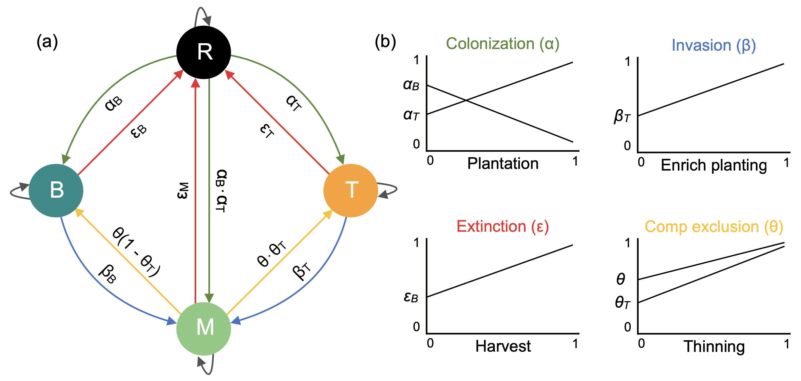

Schema of the State and Transition Model adapted from Vissault et al. ([2020](#ref-Vissault2020)). Directional arrows describe the colonization (), extinction (), invasion (), and competitive exclusion () processes driving the transition between the four forest states: (R)egeneration, (B)oreal, (T)emperate, and (M)ixedwood. The panel (b) summarises the effect of increasing the intensity of forest management in each of the four ecological processes. For instance, increasing plantation intensity will increase the rate of transition from R to T and consequently descrease the rate of change from R to B and from R to M. The values of each of the 9 specific (process x state) parameters are shown in Figure S7.

## Adapted forest management: reducing the gap between potential and actual forest distribution

Given the predictions that the distribution of the boreal-temperate ecotone may lag behind climate change (Vissault et al. [2020](#ref-Vissault2020), Talluto et al. [2017](#ref-Talluto2017)), here we define and simulate four management practices to test how they may reduce the gap between potential and realized forest distribution with climate warming. The four management practices implemented in the model are plantation and enrichment planting to potentially reduce colonization credit, and harvest and thinning to potentially reduce extinction debt. The objective of these management practices is to favor the migration of both the leading edge of temperate forest and the trailing edge of boreal forest towards colder temperatures when the climate is suitable.

### Forest management to reduce colonization credit

Colonization of temperate species beyond the leading edge of their distribution may depend on many factors such as climate conditions, competitive ability, and seed sources through dispersion. The first factor limiting the colonization of a population beyond its range is the climate. Once the climate limitation is relaxed with climate warming, species interactions such as competition for light may limit the development of regenerating individuals (e.g. Bianchi et al. [2018](#ref-Bianchi2018)). Finally, seed production is a density-dependent process that, associated with the slow migration rate of trees, contributes to the lack of colonization beyond the population range limits. In the context of managing ecological processes, some of these factors can be modified with forest management. Here we model two management practices that may operate at different spatial scales to simulate density-independent colonization: plantation (i.e. assisted migration) at the large spatial scale, and enrichment planting at the local spatial scale. Plantation occurs in regeneration states, while enrichment planting occurs in mature stands of the alternative composition (e.g. introducing temperate hardwoods in a boreal stand). Following temperature increases, plantation and enrichment planting of temperate species should overcome dispersal limitation and the lack of seed sources and may increase the range shift towards colder temperatures by colonizing stands beyond the current distribution.

#### Plantation of temperate stands

In our model, the establishment of boreal, mixedwood or temperate forest in regenerating stands depends on the colonization capacity of boreal and temperate tree species ( and ) as well as their abundance in the neighboring stands. The plantation practice is modelled as an increase in the probability of regeneration stands to become temperate forest stands . A proportion of available stands in state R is thus converted into state T at each time step. Only the remaining stands in state R () are allowed to follow the natural colonization process. Plantation thus involves an additional parameter that modifies the following probabilities:

where is the proportion of R stands that are planted per time step. Note that when , the natural dynamics occurs and when , , .

#### Enrichment planting of temperate trees on boreal stands

Invasion of temperate species into boreal stands is a function of the capacity of temperate forest trees to colonize boreal forest , and the abundance of mixed and temperate in neighboring stands. Invasion only applies to mature stands. Enrichment planting of temperate species in boreal stands is modelled as an increase in the probability of stands in state boreal to become mixedwood . Among stands in state B available to invasion, a proportion is directly converted to M. The colonization probability of temperate species establishing in boreal stands after enrichment planting adds a parameter to the model:

Where is the proportion of mature stands in state B that are enriched at each time step. Natural dynamics occurs when , while direct conversion by forest management occurs when . Note that is the proportion of stands in state B that are harvested as explained in the next section.

### Forest management to reduce extinction debt

Different ecological mechanisms can explain extinction debt caused by the delayed response of forest trees to temperature increases. Slow demographic rates along with dispersal limitations can delay the response of species to environmental changes (Dullinger et al. [2012](#ref-Dullinger2012)). These life-history traits, associated with source-sink dynamics (Schurr et al. [2012](#ref-Schurr2012)), can increase considerably the extinction debt of tree populations following temperature increases. To reduce this delayed response, unadapted species would have to disappear and therefore make room for the new species that is better adapted to the novel environmental conditions. Disturbance and competitive exclusion are two ecological processes suitable to influence the rate of extinction and, if well directed, reduce extinction debt. Here we chose harvest and thinning, which is a partial harvest within a stand, as complementary management practices that may accelerate disturbance and competitive exclusion. Harvest of stands in state B has the same effect than large spatial scale disturbances, such as fire, and transform a proportion of B stands in a R state. Similarly, removal of boreal species by selective thinning in stands of state M can increase the rate at which temperate species can competitively exclude boreal species. Both harvest and thinning are intended to open space and reduce the proportion of boreal species, and therefore increase the likelihood of temperate states to shift towards colder temperatures.

#### Harvest of boreal stands

In the natural extinction model, stands in state B turn into a regeneration state only after natural disturbances, occurring at a probability . Harvest is modelled as an increase in the probability of boreal states to become regeneration states . A proportion of mature stands in state B is converted into state R, featuring the cut of all trees. This proportion of B stands is thus excluded from following natural dynamics. Harvest thus involves an additional parameter that modifies the following probabilities:

Where is the proportion of stands in state B that are harvested at each time step. If , no B stands will be maintained, and when , only natural disturbance occurs.

#### Thinning of boreal trees in mixedwood stands

In the natural model, the transition from a mixed state M to either a pure state (B or T) is driven by the instability of the state M (), and the competitive ratio between temperate and boreal species (). It means that the higher the instability (), the higher the probability of competitive exclusion, and the winner is given the competitive ratio between temperate and boreal species (). Thinning of boreal species in M stands is modelled as an increase of the probability of M stands to become state T in two different ways ( and ). First, thinning of boreal species can be translated into an increase in the instability of M stands:

Second, selective thinning of boreal species can increase the competitive ability of temperate species:

It is unclear if we need to distinguish between the two processes. The rationale is that the proportion of M stands that are managed this way is directly converted into state T. It means that should at least be equal to . If thinning further boost the competitivity (fitness) of temperate species, then can be greater than . For a parsimonious approach, it seems reasonable to set . These modifications directly affect and :

Where is the proportion of undisturbed stands in state M where thinning is applied per time step. When , and .

## Simulation analysis

### Analysis of the transient dynamics under climate warming

We used the spatially implicit version of the STM at equilibrium with current climate conditions to test the effect of forest management on the transient dynamics following temperature increases. To do so, we simulated an increase in temperature and focused on the dynamics of the transient period of the four forest states until they reach the new steady state. Steady state was considered as being reached when the difference between two successive states prevalence was inferior to for 10 consecutive steps. Each step in the model is equal to 5 years according to the initial parameterization of the model (Vissault et al. [2020](#ref-Vissault2020)). We characterized the transient dynamics over a gradient of mean annual temperature ranging from -2.61 to 5.07 C. Note that this approach quantifies the model’s local stability for a specific location defined by climatic conditions. As a result, no spatially explicit dynamics like dispersal are considered, and the transient metrics are calculated separately for each location along the MAT gradient. This gradient corresponds to the current temperature range along with the temperate-to-boreal forest ecotone, and it is the reason we describe this gradient as “initial mean annual temperature”. This gradient can be visualized by drawing a straight line from Montreal (~45.5 N) to Chibougamau (~49.9 N), in Canada. While we simulated temperature changes, TAP was kept constant to the mean value extracted from the database (998.7 mm) because TAP has a relatively small effect on model outputs compared to MAT (Vissault et al. [2020](#ref-Vissault2020)). Temperature increased by 0.09 C at each time step for the first 20 steps (100 years) for a total increase of 1.8 C following the Representative Concentration Pathway (RCP) scenario of 4.5, and then remained constant until the model reached the steady state. As we used a linear increase of temperature to represent the boreal-temperate ecotone (ranging from -2.61 to 5.07 C) instead of a real landscape, the RCP scenarios are based on the mean global projections (IPCC [2013](#ref-IPCC2013)). We further tested the RCP8.5 scenario and observed that the increase in the disturbance intensity with warmer temperatures only shifted the reponse to higher values, but did not change the overall interpretation compared to RC4.5 (results not shown).

We characterized the transient phase after temperature increases using five different metrics from Boulangeat et al. ([2018](#ref-Boulangeat2018)). The first two metrics are the asymptotic and initial resilience as measures of local stability derived from the Jacobian Matrix at the new equilibrium (Arnoldi et al. [2016](#ref-Arnoldi2016)). was numerically calculated using the R package rootSolve (Soetaert [2009](#ref-Soetaert2009a), Soetaert and Herman [2009](#ref-Soetaert2009)). The asymptotic resilience () is the leading eigenvalue of , and quantifies the asymptotic rate of return to equilibrium after small perturbation. The more negative , the greater is the asymptotic rate of change back to the equilibrium, and therefore the greater the resilience of the system. Although the stability metrics are computed at the new equilibrium, we can derive the initial reactivity of the system to disturbance using algebra transformation of the matrix (Neubert and Caswell [1997](#ref-Neubert1997)). Initial resilience (), defined by Arnoldi et al. ([2016](#ref-Arnoldi2016)) as the inverse of initial reactivity, is the leading eigenvalue of the following matrix:

Positive values of indicate a smooth transition to the new equilibrium whereas negative values indicate reactivity, that is, an initial amplification in the opposite direction to the final equilibrium. The third metric is the exposure of the ecosystem states (), defined by the euclidean distance between initial and final state prevalence among the four states (Dawson et al. [2011](#ref-Dawson2011)). It reports the amount of change the system will experience. The fourth metric is the return time () or ecosystem sensitivity, which is estimated by the number of time steps of the transitory phase. A combination of the previous metrics, it describes how long it takes to reach the new equilibrium. The last metric is the cumulative amount of changes in the transitory phase, or ecosystem vulnerability (Boulangeat et al. [2018](#ref-Boulangeat2018)). It is defined as the sum of all changes in the states after climate warming and is obtained by the integral of the states change over time (). It combines all of the prior metrics to describe how much the system is “out-of-equilibrium” or vulnerable. These five metrics together can summarize the multidimensionality of the response of a system to external disturbances.

We used five distinct simulation scenarios: natural dynamics without forest management, 0.25% of plantation, 0.25% of enrichment planting, 1% of harvest, and 0.25% of thinning, at an annual rate. The above values were chosen to maintain a certain degree of realism. In the Canadian province of Quebec, about 1% of the forest territory is harvested annually. Of this 1% harvested, only 20 to 25% is followed by planting. To our knowledge, enrichment planting and thinning of a specific species are more complex to operate and rarely used in Quebec and should not overpass the other practices, hence we chose to analyze the same amount as the plantation. To further quantify the effect of increasing the intensity of forest management from 0 to 100% for each practice. For instance, increasing plantation to 100% () means that all regeneration stands will become T. For that, we chose two locations from the gradient of temperature in which forest management had the most effect on the metrics of transient dynamics: -1 and 0 C MAT which represents the leading and trailing edge of the ecotone.

### Analysis of the range shift under climate warming

Using the model equations with forest management, we created a spatially explicit version of the model with an artificial landscape (lattice) to account for explicit dispersal limitations and stochastic dynamics, to test the capacity of forest management to accelerate the range shift of the boreal-temperate ecotone towards colder temperatures. The landscape is composed as a regular grid of 1698 by 170 cells where each cell (approx. 300 x 300 meters) at each time step is occupied by one of the four forest states (R, B, T or M). Given the average dispersal rate for some temperate trees is in the range of 5-15 (Ribbens et al. [1994](#ref-Ribbens1994)), with maximum dispersal rates estimated in the post-glacial period reaching 260 (Feurdean et al. [2013](#ref-Feurdean2013)), our 300 m grid has sufficient distance to account for the rare long-distance dispersal events. Sensitivity analysis showed that the range shift following climate warming increased with larger grid cells (from 1 hectare to 2500 hectares), but the effect was stronger in cells larger than 100 hectares (Figure S1). While the choice of the cell size affects the absolute value of range shift, it does not affect the relative effect of the different forest management strategies. Moreover, although the smaller the cell the better we model dispersion, smaller cells are computationally expensive. Therefore, the size of 300 x 300 m (9 ha) was the best compromise between these two factors. The gradient of the landscape grid was defined using the same MAT range as in the spatially implicit model (-2.61 to 5.07 C) to represent the whole ecotone from boreal to temperate dominant forest types, with a constant TAP of 998.7 mm. The prevalence of each state at time was calculated considering the stand composition of the eight neighboring cells and the temperature and precipitation condition of the cell at time . The state of the current cell at time was then randomly drawn from the transition probabilities. The effect of climate warming on the landscape dynamics was simulated by increasing temperature of 0.09 C for each cell at each time step for the first 20 steps (100 years; RCP4.5). We further performed simulations using the RCP8.5 scenario, and the results are shown in Figure S6. The spatially explicit version of the model was bind into an R package stored on GitHub (Vieira [2020](#ref-STManaged2020)). We used the released version v2.0 of the package to run the simulations for this article.

We ran three simulations to compare the relative importance of temperature increases, forest management, and their interaction with the equilibrium distribution in future climate conditions. The intensity of the four management practices was the same as used in the first approach, and they were equally applied across the landscape. The model simulated 150 years of forest dynamics under three different scenarios: (i) only climate change, (ii) only one forest management practice, and (iii) climate change and one forest management practice at a time. These “virtual experimental treatments” allow to independently characterize their independent effects and also their interaction. These three simulation scenarios were then compared with current () and future () forest distribution at equilibrium with climate as reference points. For each simulation and reference points, we quantified the boreal and the mixed/temperate occupancy over the gradient of initial mean annual temperature (-2.61 to 5.07 C). This allowed us to visualize the response of state occupancy to each simulation. In addition, we computed the average range shift of state occupancy in mean annual temperature for each simulation, taking the initial distribution at equilibrium with climate () as the starting point. Range shift represents the shift of state occupancy relative to the initial mean annual temperature. This approach allowed us to quantify the displacement of the boreal-temperate ecotone in the grid without the need of arbritary thresholds to define the range limits of a forest type. Range shift was calculated as the difference in initial mean annual temperature between the first and final step of a simulation run for all values of state occupancy ranging from 0 and 1. We removed extreme values of state occupancy (; ) to avoid miscalculation of range shift as our approach was imprecise in these extreme locations. This filter had little effect on the median and quantiles of range shift (Figure S2). Negative values of range shift indicate a displacement of the distribution of a forest type towards colder temperatures, whereas positive values indicate a displacement towards warmer temperatures.

Finally, as the chosen time scale (150 years) and management intensity may not be large enough to detect the response of forests to temperature increases and forest management, we ran the same configuration of simulations while increasing both the time scale and the management intensity. The running time of each simulation was increased to 250, 500 and 1000 years, and management intensity for all practices increased to 2, 5, 10 and 20%. We replicated the simulations 15 times, while varying the initial landscape for each simulation. Initial landscapes were randomly generated, with the prevalence of each cell determined by the MAT value across the gradient of the lattice grid.

# Results

## Effect of forest management on transient dynamics under climate warming

We characterized the transient dynamics following an increase of 1.8 C in temperature along the boreal-temperate ecotone. Overall, all metrics peaked in two specific regions, indicating maximum resilience at the transition between boreal and mixedwood (~ -1 C), and at the transition between mixedwood and temperate dominant forest types (~ 3 C; Figure [3](#fig:num-res1) a for reference). Plantation and enrichment planting of temperate species, which simulate the payment of colonization credit, were the only two practices affecting significantly the transient dynamics following climate warming. The effect of these two practices on the transient metrics was observed only in the transitional region between boreal and mixedwood. Exposure increased with enrichment planting in the boreal region (Figure [3](#fig:num-res1) b), meaning that forest management promoted the shift of forest states to a new equilibrium. The time for the forest to reach the new equilibrium following climate warming (sensitivity) was reduced by about 40 and 80% with plantation and enrichment planting, respectively (Figure [3](#fig:num-res1) c). The cumulative state changes (Figure [3](#fig:num-res1) d) integrates the variation in both exposure, sensitivity, and resilience into a single metric, ecologically interpreted as ecosystem vulnerability. In the transition between boreal and mixedwood states, where vulnerability is at its peak, plantation and enrichment planting reduced vulnerability by 55 and 78%, respectively. In both transition regions between dominant forest types, asymptotic resilience was close to zero, meaning a weak resilience of the system due to its slow rate of change following a perturbation (Figure [3](#fig:num-res1) e). In the same locations, initial resilience was at its peak, meaning that the system is less reactive to a disturbance (Figure [3](#fig:num-res1) f). This means that the forest ecosystem has a slow reaction at the beginning and/or at the end of the transient phase (see Figure [1](#fig:concept) a for a visual interpretation). Enrichment planting was the only practice to change both resilience metrics, doubling asymptotic resilience, and reducing initial resilience by 13%. Reducing colonization credit through plantation and enrichment planting of temperate species were effective in changing the transient dynamics under temperature increases, helping forest to keep pace with climate change.

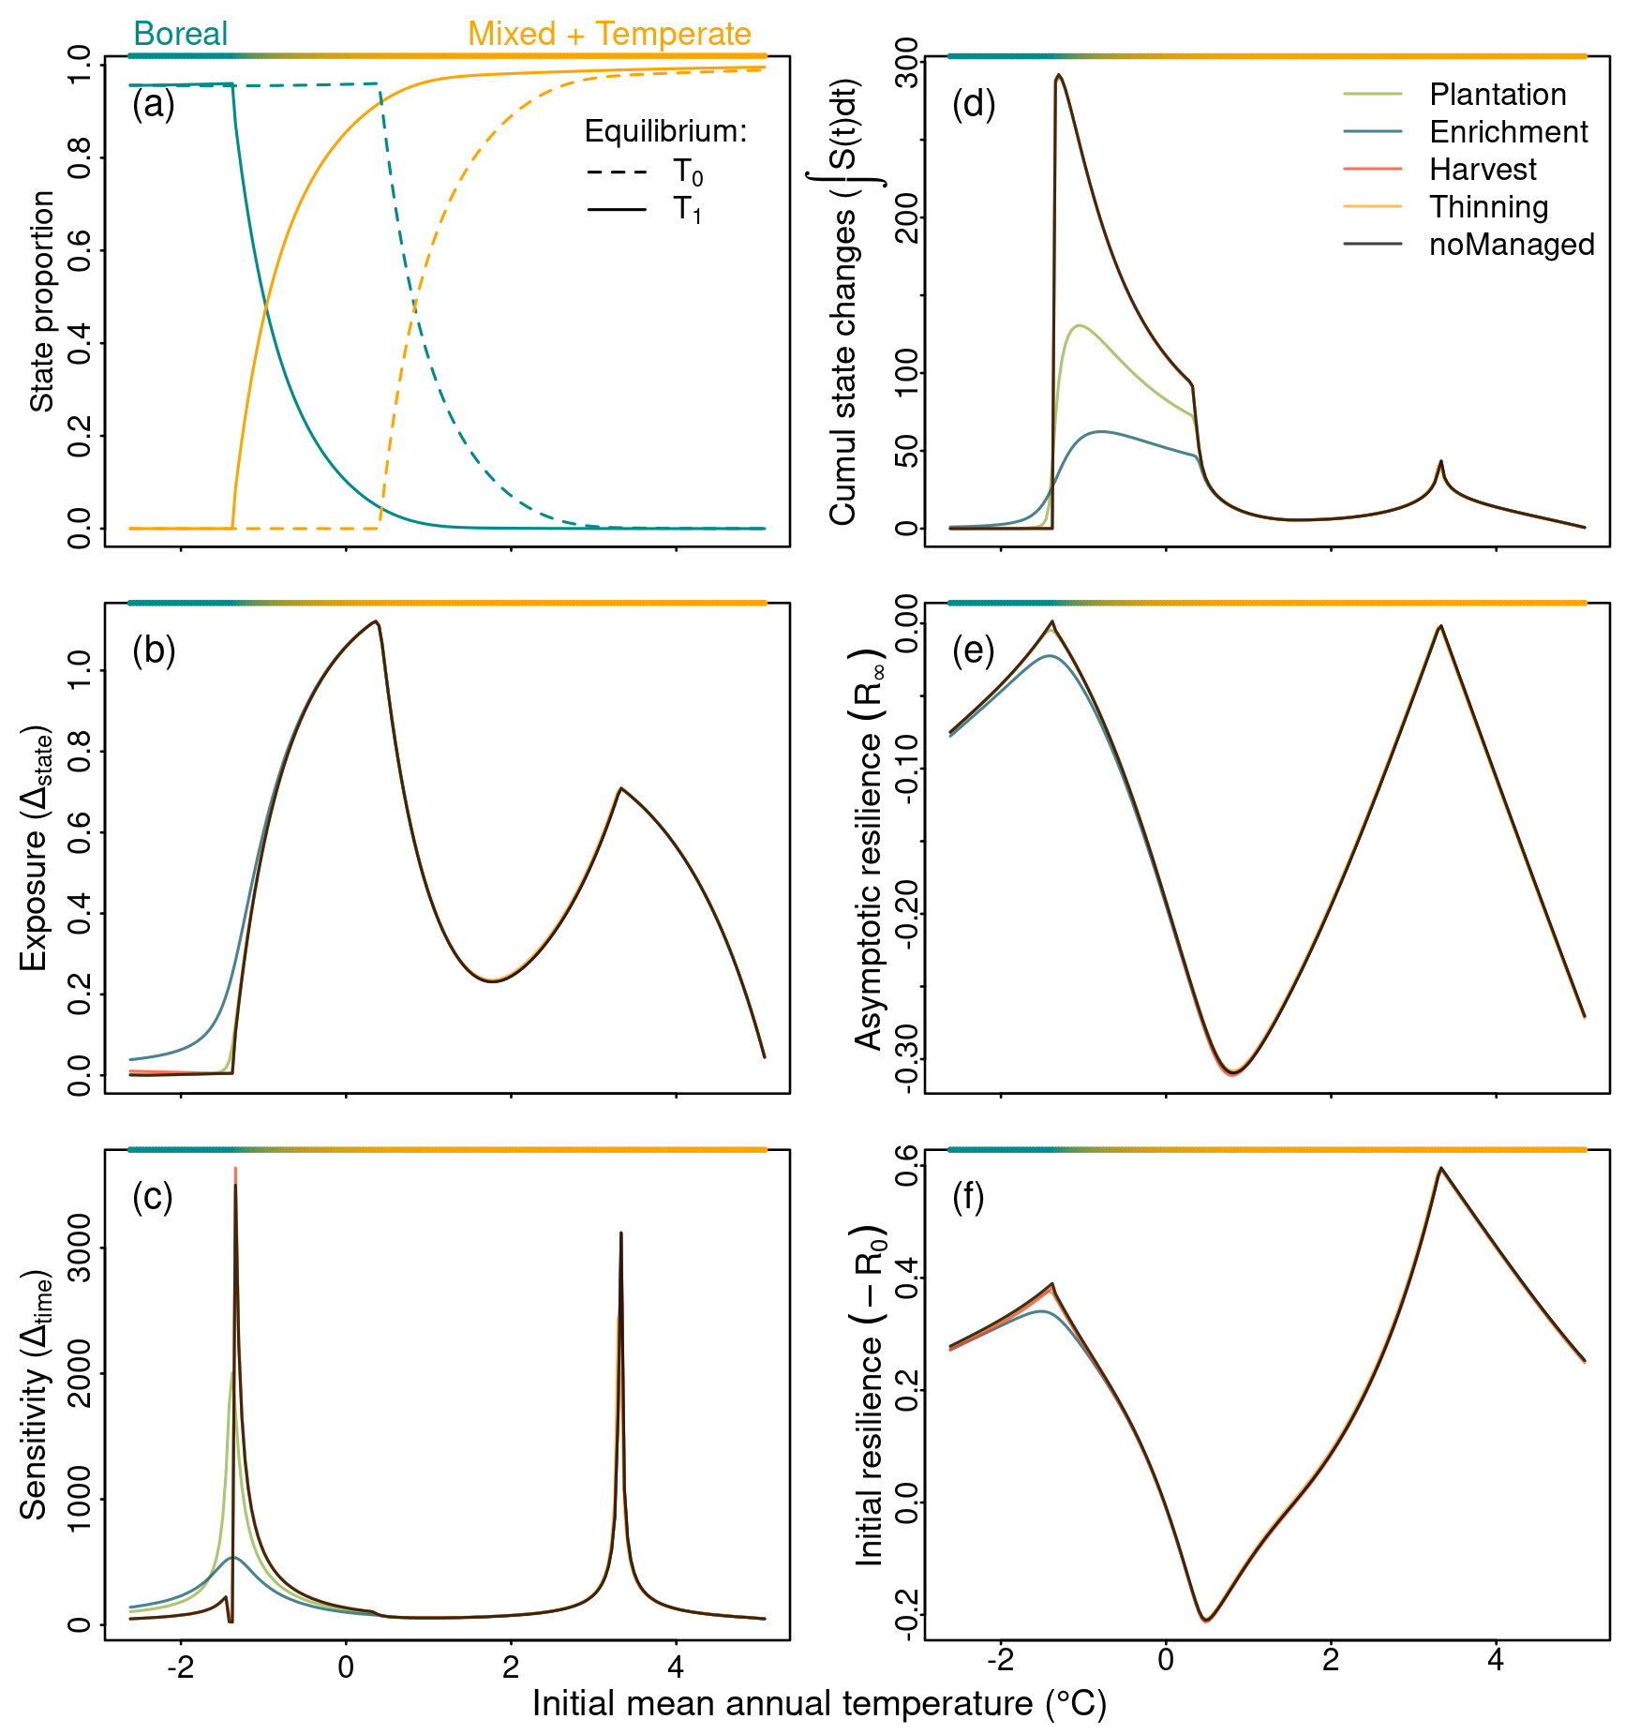

Expected occupancy of boreal and temperate-mixed states at equilibrium with climate before () and after () temperature increases (RCP4.5) as a climatic reference (a). (b-f) Transient dynamics following climate warming along the gradient of mean annual temperature for five different scenarios: natural dynamics without forest management, 0.25% of plantation, 0.25% of enrichment planting, 1% of harvest and 0.25% of thinning. Transient dynamics are described by (b) exposure or the shift of forest states to the new equilibrium; (c) sensitivity or the time for the state reach equilibrium after climate warming; (d) vulnerability or the cumulative amount of state changes after temperature increases; (e) asymptotic resilience or the rate in which the system recovery to equilibrium; and (f) initial resilience or the reactivity of the system after temperature increases.

Given that the effect of forest management on the transient metrics was stronger in the transitional region between boreal and mixedwood state dominance (Figure [3](#fig:num-res1)), we selected two contrasting locations in this region to evaluate the effect of increasing forest management intensity on the transient metrics (Figure [4](#fig:num-res2)). Enrichment planting and plantation remained the two practices with the greatest effect on the transient metrics, increasing exposure and resilience, and decreasing the return time (sensitivity) in the boreal region (at -1C; figure [4](#fig:num-res2) a-c). Moreover, the effect of these two practices was non-linear, thus a small increase in management intensity had a large effect on the transient metrics. For instance, a 20% increase in enrichment planting will increase exposure to 90% to its maximum (Figure [4](#fig:num-res2) a), and reduce asymptotic resilience (Figure [4](#fig:num-res2) b) and sensitivity (Figure [4](#fig:num-res2) c) to 70% of their maximum. The increase in harvesting intensity of boreal stands also increased the exposure and sensitivity of the system (Figure [4](#fig:num-res2) c). Similarly, increasing thinning intensity in mixedwood stands increased exposure and sensitivity (Figure [4](#fig:num-res2) d, f) but reduced resilience (Figure [4](#fig:num-res2) e). Increasing management intensity can accelerate forest response to climate change through enrichment planting or plantation, but it can also delay this response through harvesting and thinning. Initial resilience and cumulative state changes are omitted in the Figure [4](#fig:num-res2), and can be found in the supporting information (Figure S3).

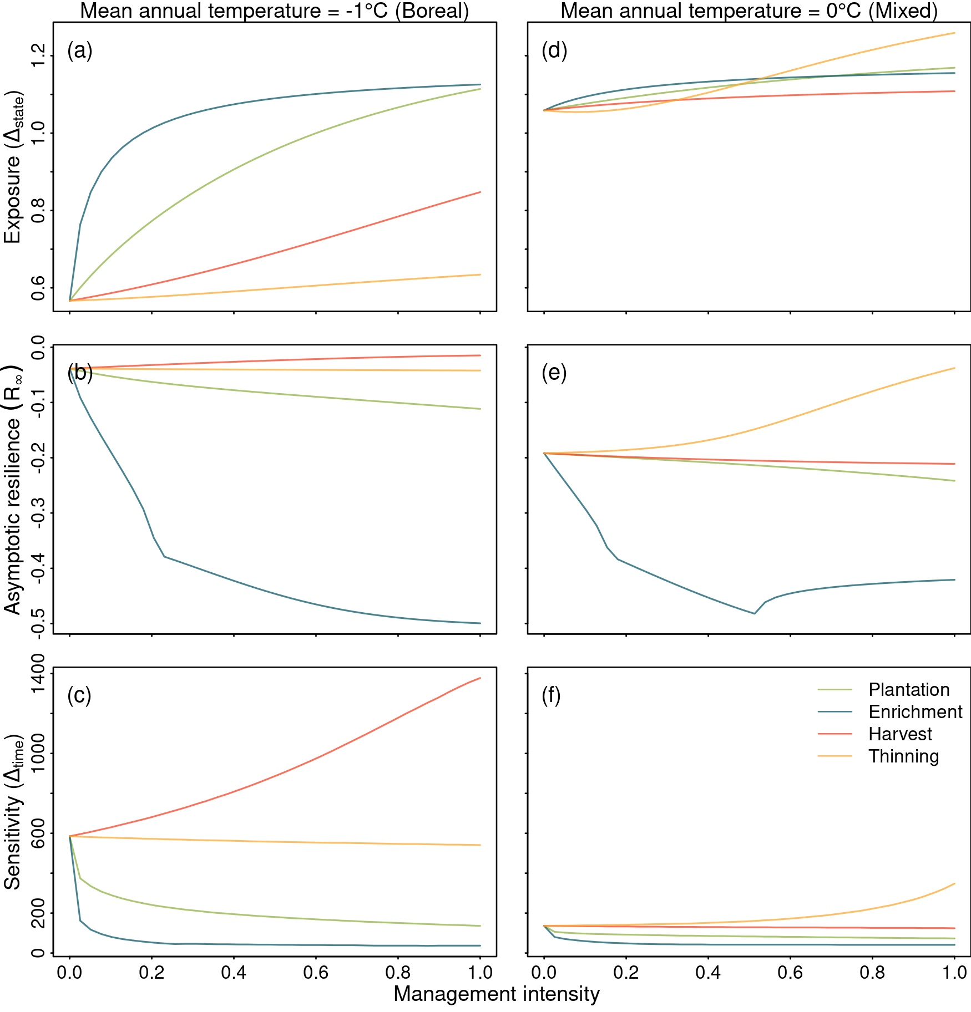

Effect of increasing management intensity on the transient metrics characterizes how the model responds to climate warming (RCP4.5). The effect of increasing management intensity is observed on two specific climate conditions represented by the initial mean annual temperature: -1 (dominated by boreal; left panels) and 0 (boreal/mixed state ecotone; right panels) regions. Transient dynamics are described by (i) exposure or the shift of forest states to the new equilibrium; (ii) asymptotic resilience or the rate at which the system recovers to equilibrium; and (iii) sensitivity or the time for the state to reach equilibrium after climate warming. Details on each metric are described in Figure [3](#fig:num-res1)

## Effect of forest management on range limit shift under climate warming

We investigated how forest management affects the range limit shift between the the boreal trailing edge and the mixed leading edge using spatially explicit simulations accounting for dispersal limitations and stochastic dynamics. Given the state distribution dominance at equilibrium with current climate (light shaded area in Figure [5](#fig:sim-result)), we expect climate warming to push the forest distribution towards colder temperatures with a median range shift of -1.8 C (which corresponds to the simulated temperature increase, dark shaded area in Figure [5](#fig:sim-result) and dashed line in Figure [6](#fig:sim-result2) b). After 150 years with no management and no climate change, the boreal and temperate+mixed forest dominance slightly shifted towards warmer temperatures with a median range shift of 0.10 C, the same rate when plantation, harvest, and thinning were applied (Figure [6](#fig:sim-result2) a). Enrichment planting with no climate change shifted the dominance of the boreal-temperate ecotone towards colder temperatures with a median range shift of -0.03 C. After 150 years with climate warming following the RCP4.5 scenario, the range of boreal and temperate+mixed shifted only -0.53 C, contrary to the expected -1.8 C (Figure [6](#fig:sim-result2) b). Furthermore, we can observe under RCP4.5 without forest management that the slope of the transition between boreal and temperate+mixed forest dominance increased with climate warming, meaning that the smooth transition observed at the initial condition (light shaded area) became a more abrupt transition between these two forest types (Figure [5](#fig:sim-result)). In this RCP scenario, neither plantation, harvest, nor thinning had a significant effect on range shift compared to the unmanaged scenario (Figure [6](#fig:sim-result2) b). Enrichment planting was the single practice to increase range shift towards colder temperature with a median of -1.31 C. Reducing colonization credit, through enrichment planting, increased the range shift of the boreal-temperate ecotone when interacting with climate change, creating a smooth transition between the dominance of these two forest types.

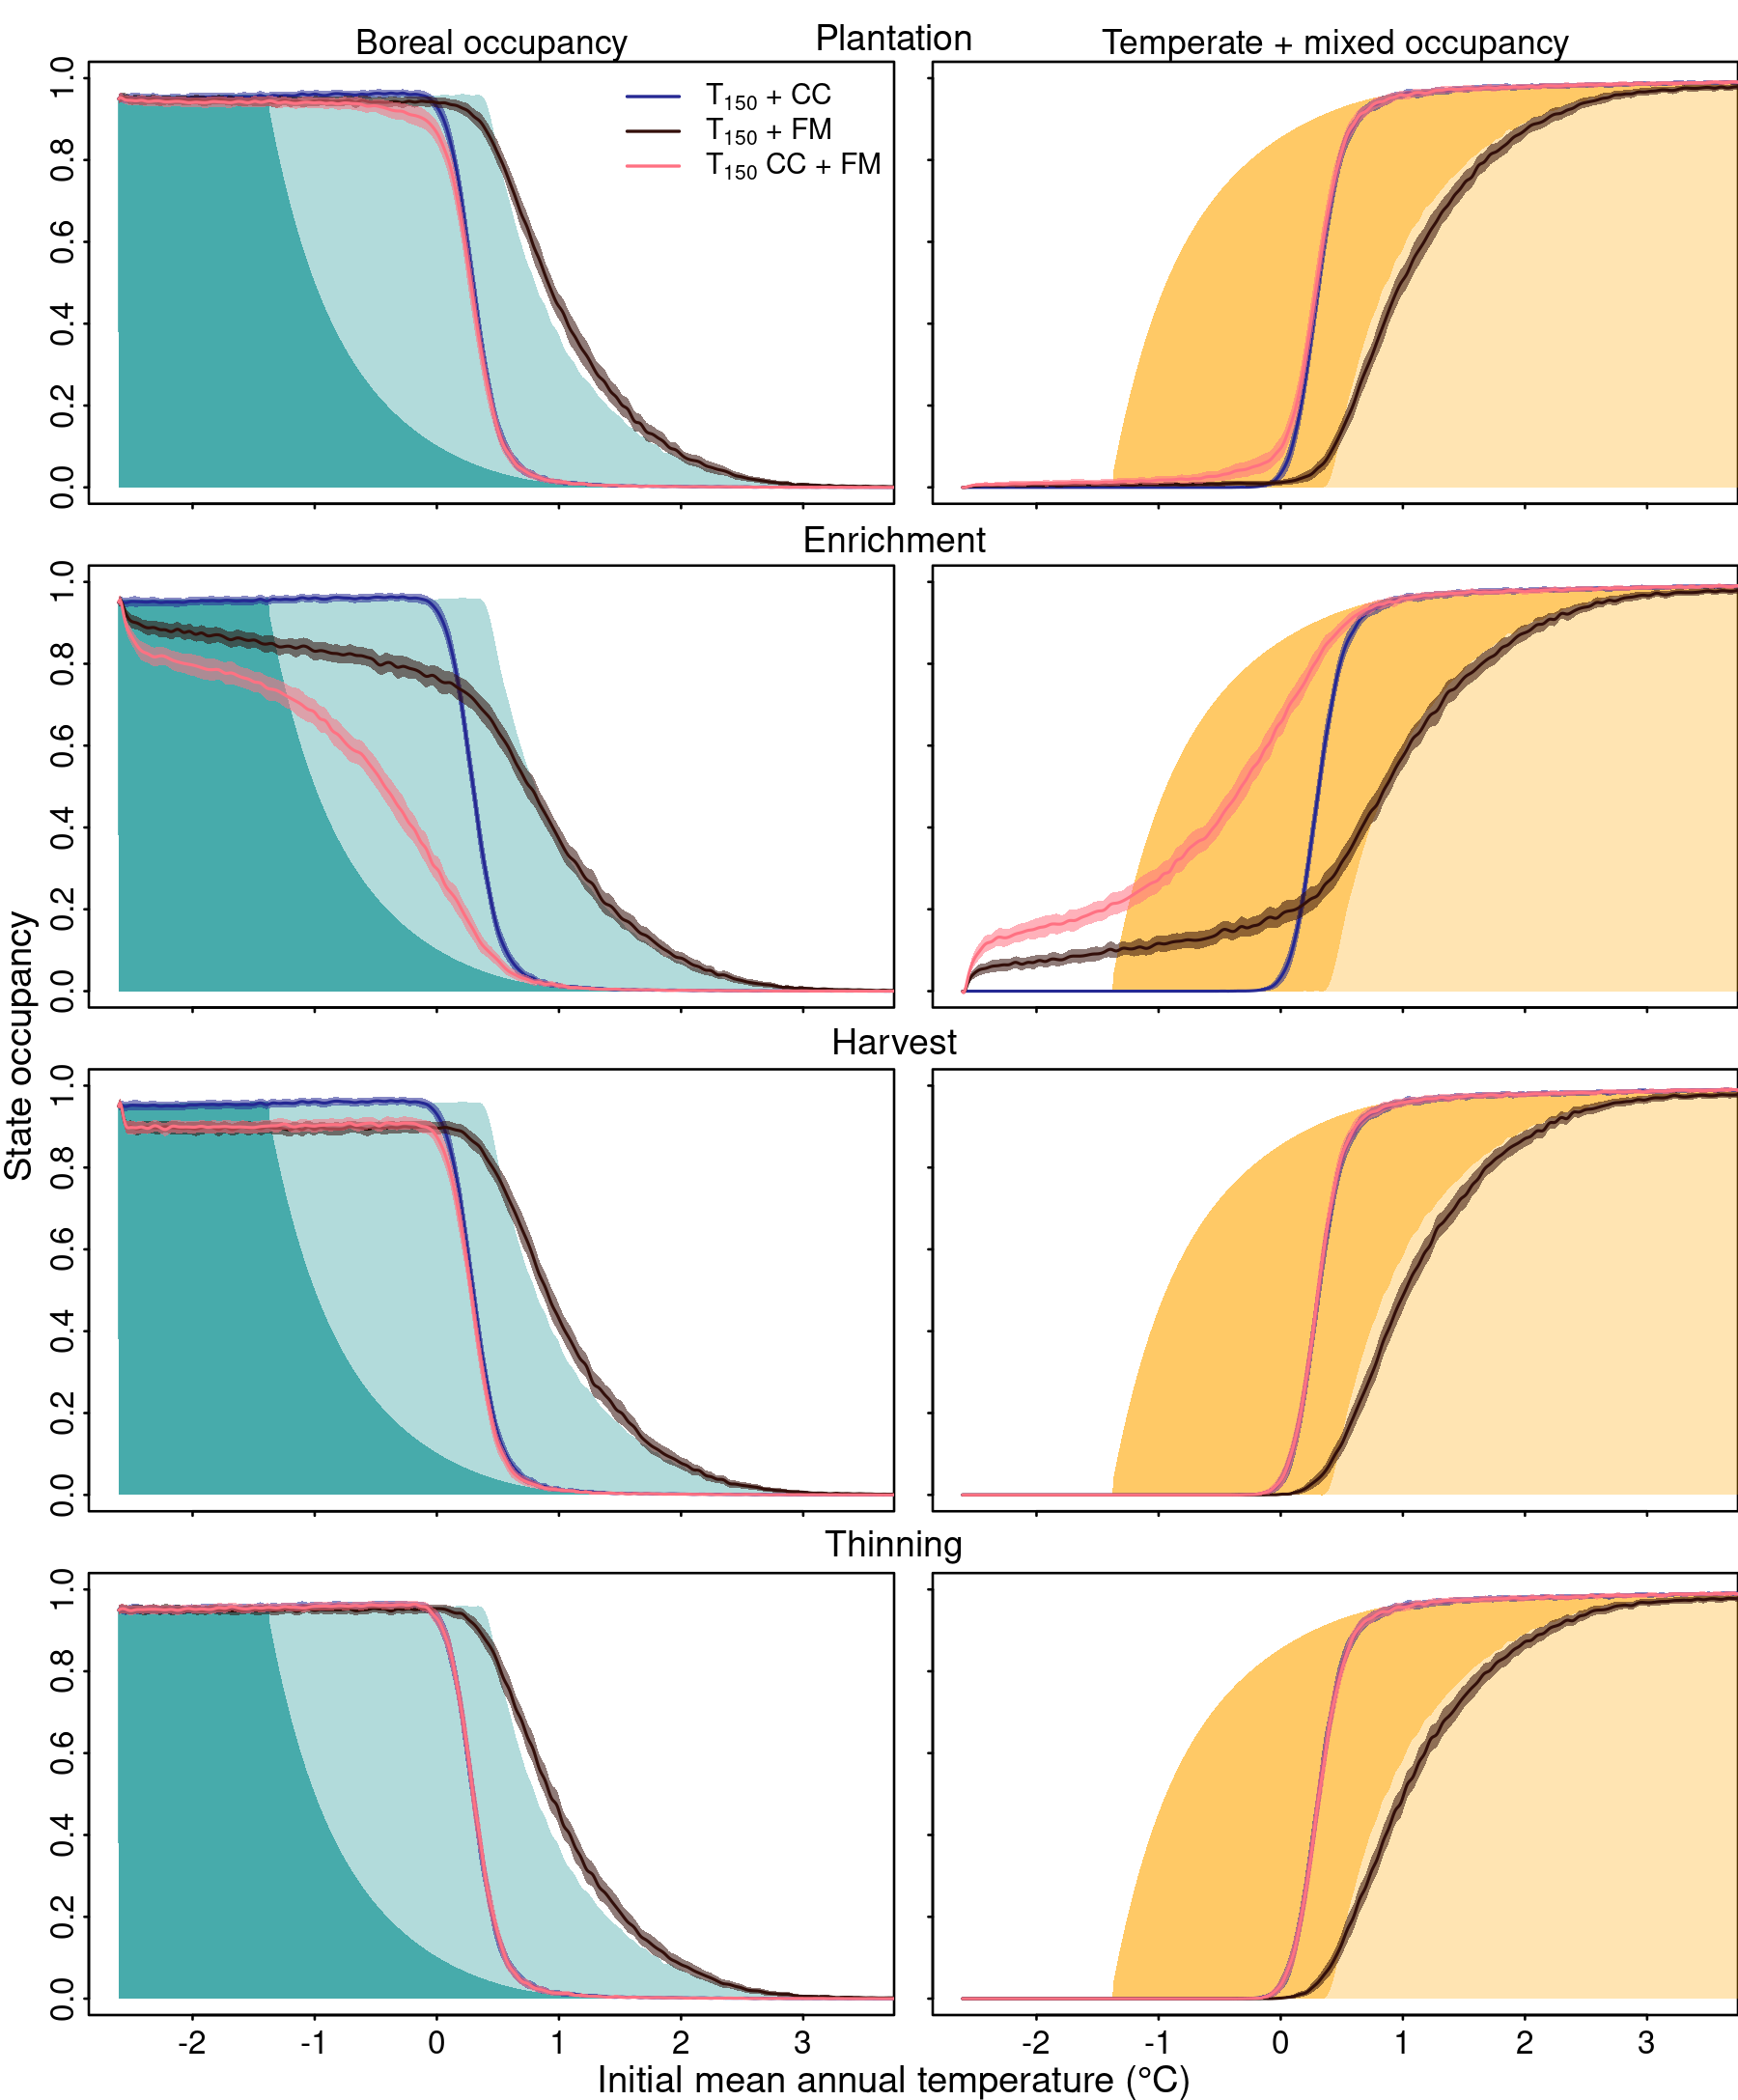

Boreal (left panels) and mixedwood/temperate (right panels) occupancy across the landscape grid covering the boreal-temperate ecotone. State occupancy is the proportion of that state for a given location of initial mean annual temperature in the landscape grid. Note that because we are more interested in the boreal/mixed range limit, we chose to simplify the figure by considering the mixed and temperate states together. Light and dark shaded areas are a reference of the state occupancy in the landscape at equilibrium before and after temperature increases, respectively. We ran our model for 150 years (T150) under three alternative scenarios: only climate change (CC), only forest management (FM), and climate change with forest management (CC + FM) to assess their interactions. The results are the mean and 99% confidence intervals of 15 replicates. Management intensity was set to 0.25% for plantation, thinning, and enrichment planting, and 1% for harvest. The climate change scenario was RCP 4.5.

Simulation time and management intensity of figure [5](#fig:sim-result) and [6](#fig:sim-result2) were kept small for the sake of realism, but we further tested how increasing these two parameters will affect range shift of the boreal-temperate ecotone. Overall, increasing the simulation time increases range shift towards colder temperatures, approaching the expected equilibrium under the RCP4.5 scenario (Figure [7](#fig:sim-result3) a-c; Figure S4). After 250 years of simulation, enrichment planting shifted the distribution of the boreal-temperate ecotone with a median of -1.71 C, nearly reaching the expected equilibrium of -1.8 C (Figure [7](#fig:sim-result3) a). The remaining management practices did not have a strong effect on range shift, with a shared median between plantation, harvest, and thinning around -0.85 C, compared with -0.79 C when no management was applied. After 500 years of simulation, both enrichment planting and plantation differed from the other practices, with a median range shift of -1.85 C and -1.43 C, respectively (Figure [7](#fig:sim-result3) b). After a thousand years, enrichment planting remained stable for 500 years, and all the other practices almost reached the expected equilibrium, with a median range shift around -1.59 C (Figure [7](#fig:sim-result3) b).

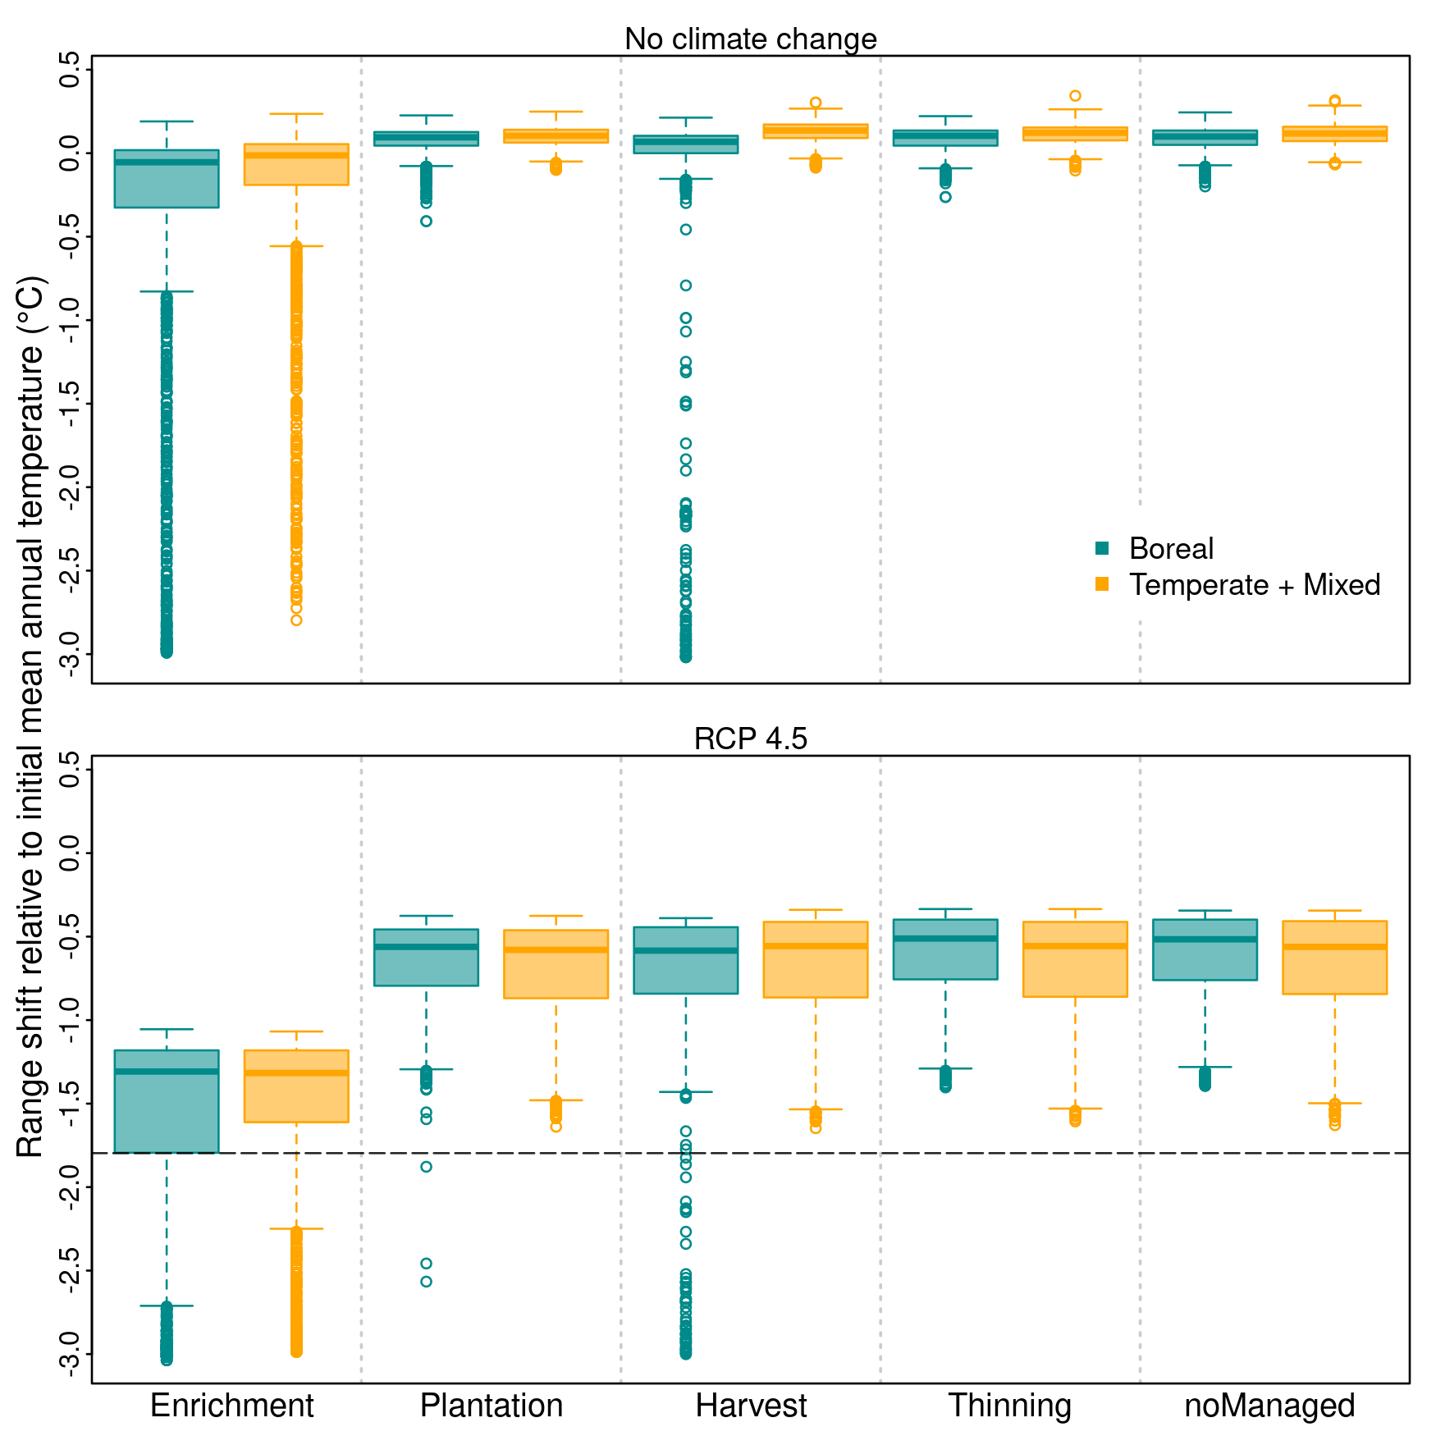

Summary of range shift relative to initial mean annual temperature for (a) no climate change and (b) climate change under RCP4.5 scenario. Range shift is the difference between the initial ( at equilibrium) and final state distribution after 150 years of simulation. Negative values of range shift indicate a change in forest distribution towards colder temperature whereas positive values indicate a change towards warmer temperature. The horizontal dashed line represents the median expected range shift when model reaches the equilibrium. Management intensity was set to 0.25% for plantation, thinning, and enrichment planting, and 1% for harvest.

Increasing management intensity of up to 20% per year, while keeping the simulations running for 150 years, had different effects according to the four management practices (Figure [7](#fig:sim-result3); Figure S5). At an intensity of 5%, enrichment planting nearly approached the maximum range shift allowed by the landscape size, with a median range shift of -3.22 C, increased to -3.26 and -3.30 C for the 10 and 20% intensity, respectively. Plantation also exceeded the expected equilibrium at the intensity of 10 and 20%, with a median range shift of -2.05 and -3.05 C, respectively. Harvest was the only practice to not increase both the boreal and the temperate-mixed range shift at the same rate. While harvest increased boreal range shift up to -3.33 C with 20% management intensity, temperate-mixed increased from -0.55 C (2%) to -0.64 C (20%). Increasing thinning intensity did not increase the range shift of the boreal-temperate ecotone towards colder temperatures, with a stable range shift around -0.53 C.

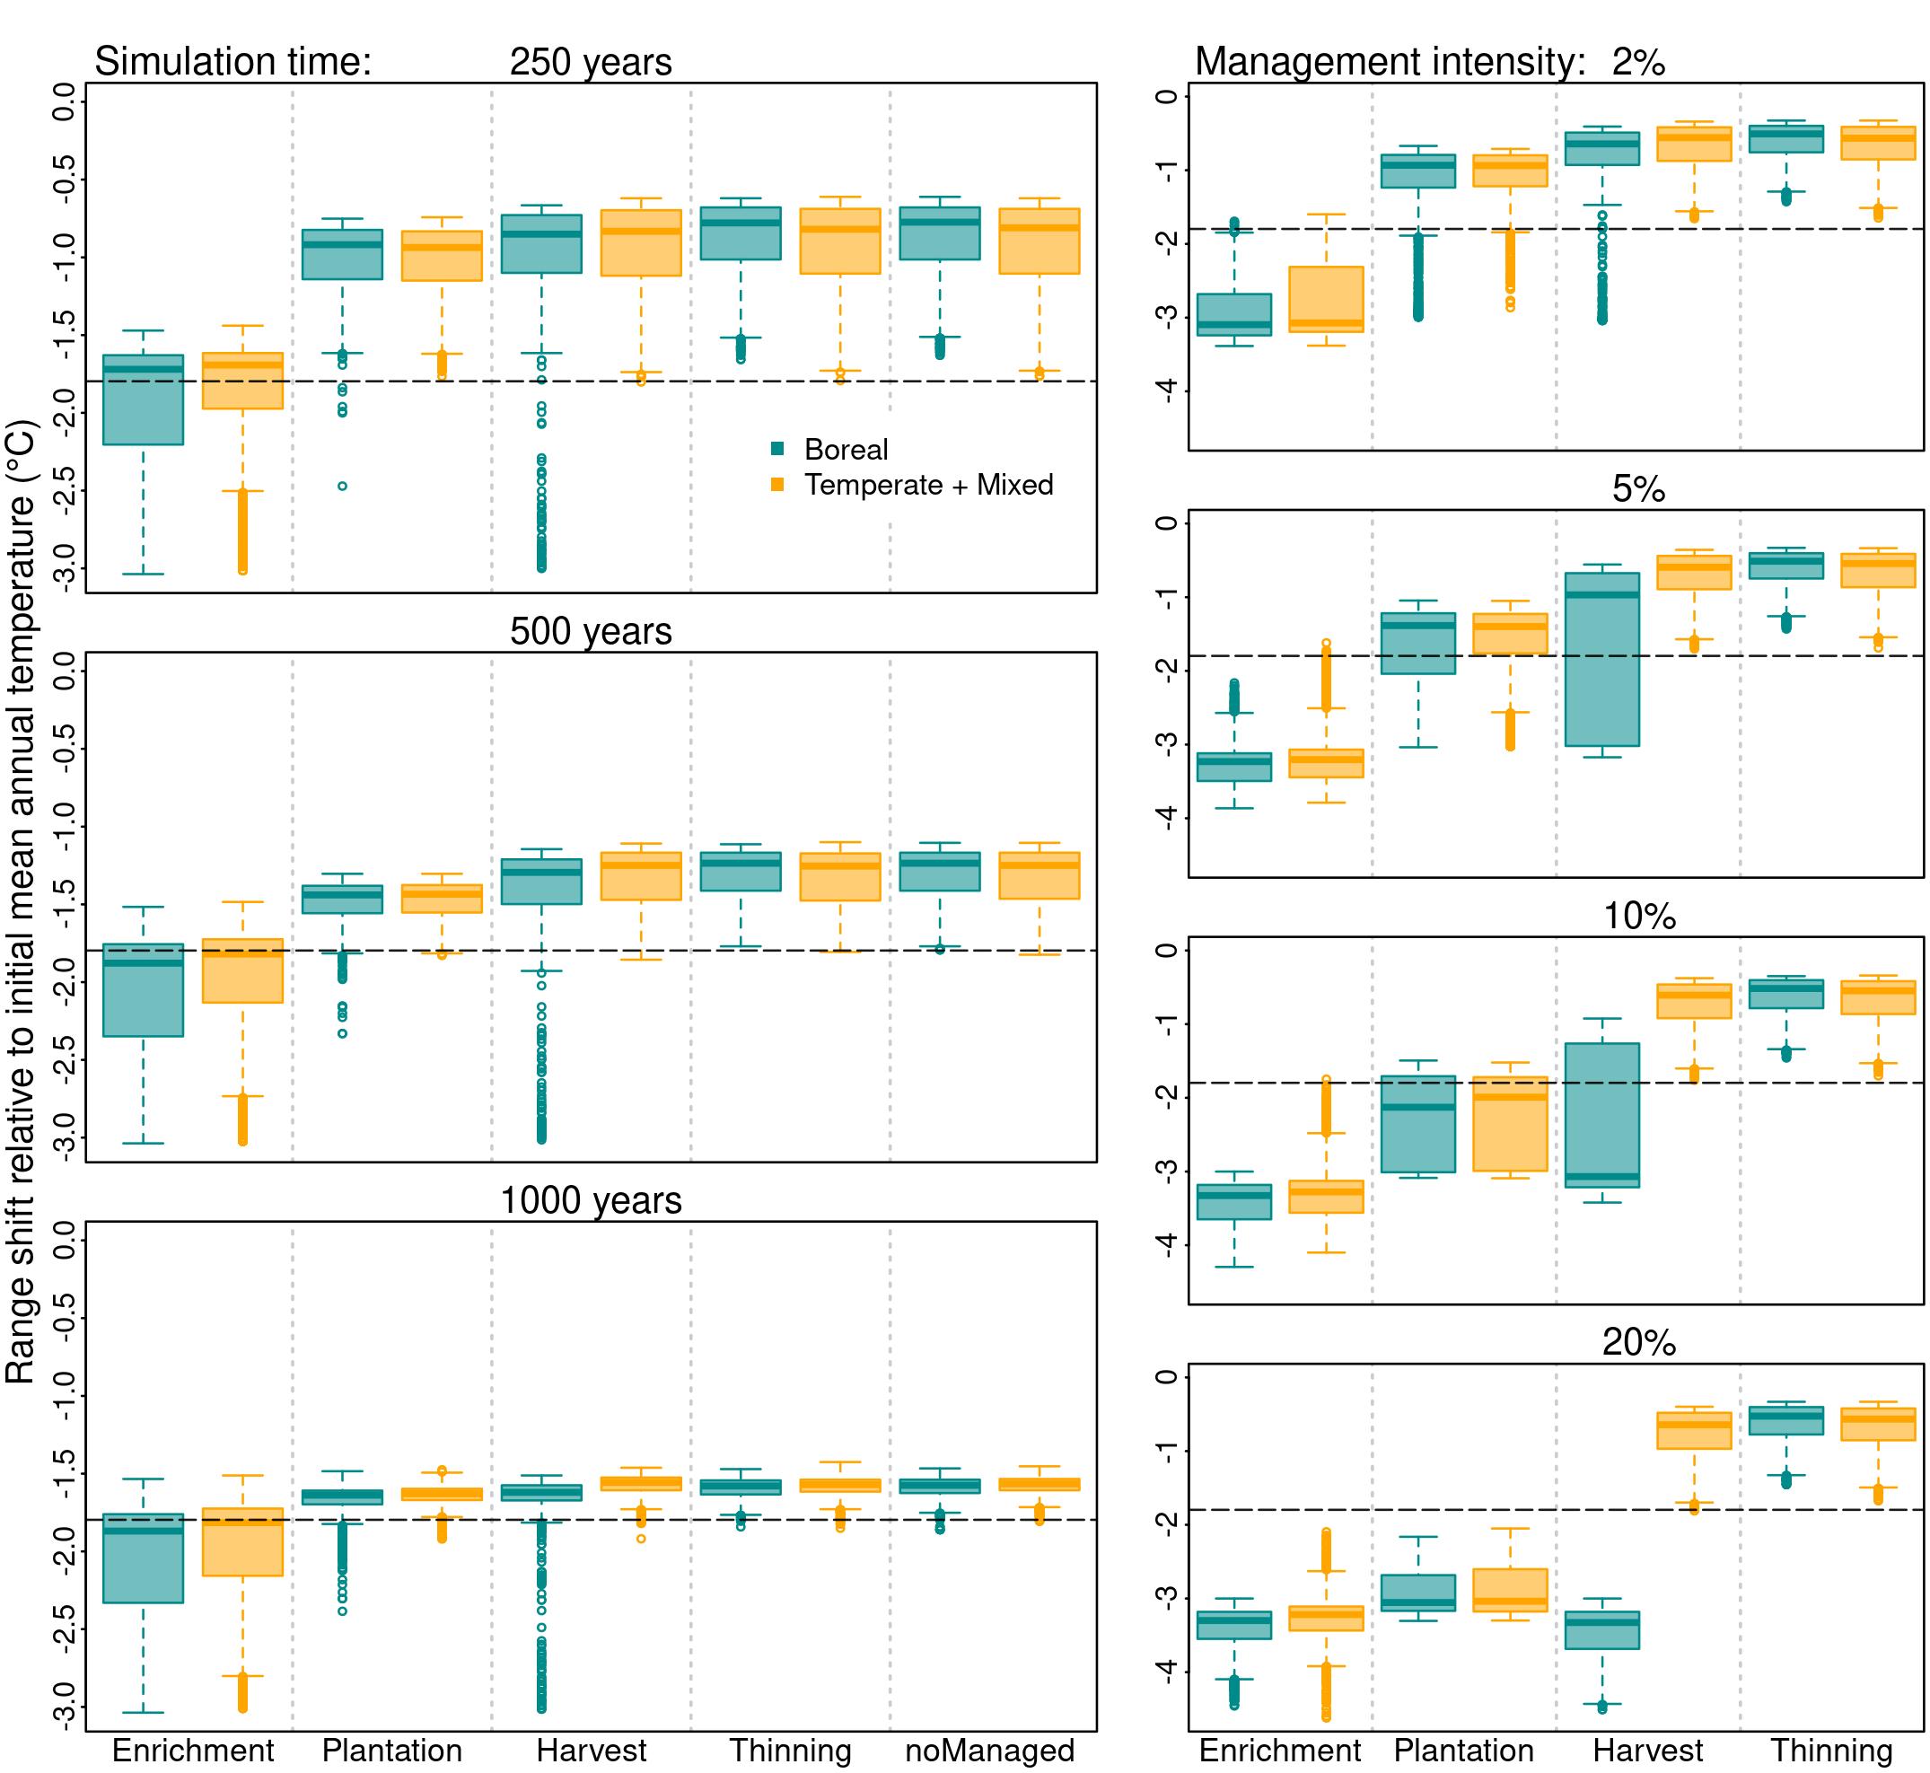

Summary of range shift relative to initial mean annual temperature for different simulation times (a-c) and management intensities (d-g). Range shift is the difference between the initial ( at equilibrium) and final state distribution after (i) 150 years of simulation for the panels d-g and (ii) 250, 500, and 1000 years for the panels a-c. Negative values of range shift indicate a change towards colder temperature whereas positive values indicate a change towards warmer temperature. The horizontal dashed lines represent the median expected range shift when model reaches the equilibrium for the particular simulation set. Management intensity was set to 0.25% for plantation, thinning, and enrichment planting, and 1% for harvest for the panels a-c. For the panels d-g, management intensity for all the four practices was set to 2, 5, 10, or 20%, respectively.

# Discussion

It is pressing to investigate how forest biomes will respond to climate warming, and how forest management can mitigate the negative impacts of this perturbation. We extended a simple and informative modelling framework based on metapopulation theory that let us to (i) establish a link between forest management and the ecological processes setting range limits, and (ii) investigate the effect of forest management on the response of the boreal-temperate ecotone to climate change. Our study suggests, based on two complementary simulation techniques, that forest management could help the boreal-temperate ecotone keep pace with climate change. Paying colonization credit by enrichment planting of temperate tree species in boreal forest stands, and the plantation of temperate species in regenerating stands, are likely to increase forest resilience, reduce the time to reach a new equilibrium, and increase range limit shifts towards colder temperatures. This theoretical investigation provides new opportunities to design future experiments testing the potential of forest management to adapt to climate change. It should guide forest managers to take into account both natural and anthropogenic disturbances on forest dynamics.

***How can plantation and enrichment planting reduce colonization credit?***

Although climate change is expected to drive a shift in forest composition by favoring temperate over boreal trees, the boreal-temperate ecotone is lagging behind climate change (Boisvert-Marsh et al. [2014](#ref-BoisvertMarsh2014), [2019](#ref-BoisvertMarsh2019), Vissault et al. [2020](#ref-Vissault2020), Talluto et al. [2017](#ref-Talluto2017)). Similar results are found on altitudinal gradients, where the slow dieback of *Picea abies* prevents the expansion of other species (Scherrer et al. [2020](#ref-Scherrer2020)). Our results suggest that plantation and enrichment planting of temperate species on the boreal region can increase the response of the boreal-temperate ecotone to climate warming by reducing the transient period and increasing the range shift towards colder temperatures. To date, few studies have tested how assisted migration can shift trees’ range limits. For instance, modelling the plantation of tree species more suitable to future climate is predicted to increase resilience indicators such as carbon stocks and tree species diversity (Hof et al. [2017](#ref-Hof2017)), and therefore plantation is assumed to increase tree range shift under climate change. Using the same rationale, simulating the plantation of tree species in future suitable enviroments was demonstrated to increase both biomass productivity and species diversity in multiple scenarios of climate change (Duveneck and Scheller [2015](#ref-Duveneck2015)). We found that enrichment planting slightly increased asymptotic resilience, which indicates a faster recovery to equilibrium after climate change (Figure [3](#fig:num-res1)). This is similar to a modelling study that suggests forest management had limited ability to increase resistance and resilience under climate change (Duveneck and Scheller [2016](#ref-Duveneck2016)).

***Why is enrichment planting practice more efficient than planting?***

Enrichment planting of temperate trees into boreal areas had a stronger effect on both reducing the transient period and increasing range shift when compared with planting temperate in disturbed (empty) areas. This is due to three different mechanisms. First, the intensity of forest management in the model is relative to the abundance of a particular forest type in the lanscape (Figure S8); hence 0.25% of boreal stands being enriched is much higher than 0.25% of regeneration stands being planted since the number of boreal stands is proportionally larger than the number of regeneration stands. That explains the need to increase planting intensity beyond 0.25% to increase the boreal range shift towards colder temperatures (Figure S5). Second, management practices are not spatially organized. While enrichment planting is necessarily applied on boreal stands (and thus in the colonization credit area), planting is applied in regeneration stands that are evenly distributed across the landscape, including the mixedwood and temperate regions. Finally, while enrichment planting implies both an increase of temperate trees and a reduction of boreal stands, plantation involves only an increase of temperate stands. These results suggest that enrichment planting in local gaps has the best potential compared to plantation to assist forests keep pace with climate change. For northern temperate forests with different levels of shade tolerance, tree recruitment was more effective in the presence of local canopy gaps compared to recruitment in open areas after clearcut (LePage et al. [2000](#ref-LePage2000)).

***Why does reducing colonization credit increase range shift but reducing extinction debt does not?***

Reducing extinction debt by increasing the frequency of disturbance (natural or anthropogenic) is expected to drive range shift by eliminating maladapted species that would persist for a long period, and then create colonization opportunities for advancing species (Kuparinen et al. [2010](#ref-Kuparinen2010), Renwick and Rocca [2015](#ref-Renwick2015)). Here intensifying disturbance by increasing harvest of boreal stands did not affect the rate of range shift after temperature increases. This result corroborates with those of Vanderwel and Purves ([2014](#ref-Vanderwel2014)) who found that harvesting boreal species amplifies transitions to early-successional forest type, but has no effect on the range shift of boreal conifers. Similarly expect for the disturbance intensity, Brice et al. ([2020](#ref-Brice2020)) also found that moderate disturbances increased the probability of transition from mixedwood to temperate stands but had a small effect on the transition from boreal to mixedwood. Such a lack of effect on range shift may be explained by the fact that most harvested boreal stands regenerate to boreal again due to source-sink dynamics and the ecosystem internal memory such as seed bank. In a field experiment, Reich et al. ([2015](#ref-Reich2015)) showed that the growth rate of juvenile trees increased in their colder range and decreased in their warmer range when exposed to above and belowground temperature increases. In other words, temperate trees will perform better than boreal trees in the transition between their ranges. Therefore, limited dispersal rather than competition may be the primary factor contributing for a lack of temperate colonization in harvested patches.

***Thinning increases temperate tree range expansion, but does not affect boreal stands***

We explored the hypothesis that selective harvesting of boreal tree species (thinning) on stands in state M would increase the proportion of stands in state T in the landscape, and therefore increase the regional pool to favor the colonization of temperate trees into the boreal region. Thinning indeed increased the proportion of temperate stands in the mixedwood region by an increase in competitive exclusion ( and ). Similar results have been shown that harvest increased temperate species in the mixedwood region of Quebec (Boulanger et al. [2019](#ref-Boulanger2019), Brice et al. [2020](#ref-Brice2020)). However, our model also show that thinning did not have any effect on the range limit of boreal stands. In other words, temperate trees did not colonize boreal stands, even with a increasing source pools. Such a lack of temperate progression onto the boreal region may be explained by the difficulty of temperate trees to settle in boreal stands due to priority effects and unfavourable substrates (Solarik et al. [2018](#ref-Solarik2018), [2020](#ref-Solarik2020)). This effect is included in the model indirectly through the invasion (mean = 0.62) and colonization (mean = 0.99) parameters associated with the temperate stand. This may be the result of plant-soil feedbacks or the importance of gaps for temperate tree regeneration. For instance, regeneration of temperate species such as red maple and red oak has been shown to be facilitated in forest gaps, while most boreal species showed no difference (Leithead et al. [2010](#ref-Leithead2010)).

***Limitations and future perspectives***

We have found that plantation and enrichment planting have the potential to reduce colonization credit to help forests to keep pace with climate change. However, further experiments are necessary as the four simulated practices in our study are an approximation of real management practices. For instance, we simulated thinning as selective logging boreal species in favor of temperate species, while in practice, thinning generally focuses on reducing stand density and maintaining commercial species. Such density reduction is tricky to address with our model because local abundances are not accounted for. There is generally a mismatch between our simulations at the community stand resolution with the management practices that occur from the individual to the population level. Being aware of that caveat, we urge future modelling studies to concomitantly represent forest dynamics at several organizational levels, while including detailed management practices. Individual-level models accounting for demographic rates are useful to predict how local mechanisms such as species interaction can scale up to determining species range limits (Ara’ujo and Rozenfeld [2014](#ref-Araujo2014a), Normand et al. [2014](#ref-Normand2014), Snell et al. [2014](#ref-Snell2014)). Moreover, forest-landscape models and dynamic vegetation models can more accurately simulate the migration process (Lehsten et al. [2019](#ref-Lehsten2019)). In our context, individual-level models can test the effect of forest management on growth, mortality, and regeneration, while a community-level model such as ours helps better understand how the effect of management practices scales up. We should also cautiously interpret the effect of climate change as simulated here. Although it is predicted that drought intensity will increase in the future and may drive how the forest will respond to climate change (Greenwood et al. [2017](#ref-Greenwood2017)), we have simulated only temperature warming, while precipitation remained constant. Some studies have shown tree species to be more sensitive to an increase in drought rather than temperature (*e.g.* white spruce Andalo et al. [2005](#ref-Andalo2005)). Drought is, however, more a pulse disturbance (or shock), having potential cumulative effects on trees, and involving thresholds. Moreover, it should be investigated with various frequencies and intensities. The present study rather shows how forest management could help communities adapt to a continuous change in the environment, mainly driven by changes in temperature.

We have provided evidence that management practices could help forest communities cope with the rate at which climate change is occurring across the southern half of Quebec. However, we can expect the final outcome to be sensitive to the spatial distribution of different practices. For instance, harvesting boreal stands nearby the leading edge of the mixedwood distribution may create a synergy. On the other hand, a 20% harvest intensity had a strong effect on the range shift of boreal forest, while the temperate range did not move (Figure [7](#fig:sim-result3) g), showing that there are other factors more important than the spatial distribution of the management practice. We have simulated here the effect of four management practices alone in order to distinguish the most effective and identify the potential important mechanisms. However, the interaction between management practices may have synergic or cancelling effects. Our simulations show no effect of plantation and harvest on the range shift of the boreal-temperate ecotone at a short time scale of 150 years (figure [5](#fig:sim-result)). However, planting temperate trees after harvesting boreal stands may overcome the limitations of these two practices when applied individually, specially if these practices are applied in particular locations such as in the transition zone. We propose future studies should focus on integrating different spatial and organizational forest models (e.g. Talluto et al. [2016](#ref-talluto2016)), so that the link between a management practice and the ecological processes can be better adjusted and detailed according to its specific scale.

# References

Aitken, S. N., S. Yeaman, J. A. Holliday, T. Wang, and S. Curtis-McLane. 2008. Adaptation, migration or extirpation: climate change outcomes for tree populations. Evolutionary Applications 1:95–111.

Ameztegui, A., K. A. Solarik, J. R. Parkins, D. Houle, C. Messier, and D. Gravel. 2018. Perceptions of climate change across the Canadian forest sector: The key factors of institutional and geographical environment. PLoS ONE 13:1–18.

Andalo, C., J. Beaulieu, and J. Bousquet. 2005. The impact of climate change on growth of local white spruce populations in Québec, Canada. Forest Ecology and Management 205:169–182.

Ara’ujo, M. B., and A. Rozenfeld. 2014. The geographic scaling of biotic interactions. Ecography 37:406–415.

Arnoldi, J. F., M. Loreau, and B. Haegeman. 2016. Resilience, reactivity and variability: A mathematical comparison of ecological stability measures. Journal of Theoretical Biology 389:47–59.

Becknell, J. M., A. R. Desai, M. C. Dietze, C. A. Schultz, G. Starr, P. A. Duffy, J. F. Franklin, A. Pourmokhtarian, J. Hall, P. C. Stoy, M. W. Binford, L. R. Boring, and C. L. Staudhammer. 2015. Assessing Interactions Among Changing Climate, Management, and Disturbance in Forests: A Macrosystems Approach. BioScience 65:263–274.

Bianchi, S., S. Hale, C. Cahalan, C. Arcangeli, and J. Gibbons. 2018. Light-growth responses of Sitka spruce, Douglas fir and western hemlock regeneration under continuous cover forestry. Forest Ecology and Management 422:241–252.

Boisvert-Marsh, L., C. P. ’e, and S. de Blois. 2014. Shifting with climate? Evidence for recent changes in tree species distribution at high latitudes. Ecosphere 5:1–33.

Boisvert-Marsh, L., C. P. ’e, and S. de Blois. 2019. Divergent responses to climate change and disturbance drive recruitment patterns underlying latitudinal shifts of tree species. Journal of Ecology 107:1956–1969.

Botkin, D. B., J. F. Janak, and J. R. Wallis. 1972. Some ecological consequences of a computer model of forest growth. The Journal of ecology:849–872.

Boulangeat, I., J. C. Svenning, T. Daufresne, M. Leblond, and D. Gravel. 2018. The transient response of ecosystems to climate change is amplified by trophic interactions. Oikos:1–12.

Boulanger, Y., D. Arseneault, Y. Boucher, S. Gauthier, D. Cyr, A. R. Taylor, D. T. Price, and S. Dupuis. 2019. Climate change will affect the ability of forest management to reduce gaps between current and presettlement forest composition in southeastern Canada. Landscape Ecology 34:159–174.

Brice, M.-H., S. Vissault, W. Vieira, D. Gravel, P. Legendre, and M.-J. Fortin. 2020. Moderate disturbances accelerate forest transition dynamics under climate change in the temperate–boreal ecotone of eastern North America. Global Change Biology 26:4418–4435.

Chen, I.-C. C., J. K. Hill, R. Ohlemüller, D. B. Roy, and C. D. Thomas. 2011. Rapid range shifts of species associated with high levels of climate warming. Science 333:1024–1026.

Dawson, T. P., S. T. Jackson, J. I. House, I. C. Prentice, and G. M. Mace. 2011. Supporting Online Material for Beyond Predictions : Biodiversity Conservation in a Changing Climate. Science 86.

Dullinger, S., A. Gattringer, W. Thuiller, D. Moser, N. E. Zimmermann, A. Guisan, W. Willner, C. Plutzar, M. Leitner, T. Mang, M. Caccianiga, T. Dirnböck, S. Ertl, A. Fischer, J. Lenoir, J. C. Svenning, A. Psomas, D. R. Schmatz, U. Silc, P. Vittoz, and K. Hülber. 2012. Extinction debt of high-mountain plants under twenty-first-century climate change. Nature Climate Change 2:619–622.

Duveneck, M. J., and R. M. Scheller. 2015. Climate-suitable planting as a strategy for maintaining forest productivity and functional diversity. Ecological Applications 25:1653–1668.

Duveneck, M. J., and R. M. Scheller. 2016. Measuring and managing resistance and resilience under climate change in northern Great Lake forests (USA). Landscape Ecology 31:669–686.

Feurdean, A., S. A. Bhagwat, K. J. Willis, H. J. B. Birks, H. Lischke, and T. Hickler. 2013. Tree Migration-Rates: Narrowing the Gap between Inferred Post-Glacial Rates and Projected Rates. PLoS ONE 8.

Forestier en Chef. 2020. Intégration des changements climatiques et développement de la capacité d’adaptation dans la détermination des niveaux de récolte au Québec. Page 60. Gouvernement du Québec, Roberval, Canada.

Godsoe, W., J. Jankowski, R. D. Holt, and D. Gravel. 2017. Integrating Biogeography with Contemporary Niche Theory. Trends in Ecology and Evolution 32:488–499.

Gravel, D., and F. Massol. 2020. Toward a general theory of metacommunity ecology. *in* K. S. McCann and G. Gellner, editors. Theoretical ecology: Concepts and applications. Oxford University Press.

Gray, L. K., T. Gylander, M. S. Mbogga, P. Y. Chen, and A. Hamann. 2011. Assisted migration to address climate change: Recommendations for aspen reforestation in western Canada. Ecological Applications 21:1591–1603.

Greenwood, S., P. Ruiz-Benito, J. Martínez-Vilalta, F. Lloret, T. Kitzberger, C. D. Allen, R. Fensham, D. C. Laughlin, J. Kattge, G. Bönisch, N. J. B. Kraft, and A. S. Jump. 2017. Tree mortality across biomes is promoted by drought intensity, lower wood density and higher specific leaf area. Ecology Letters 20:539–553.

Harsch, M. A., P. E. Hulme, M. S. McGlone, and R. P. Duncan. 2009. Are treelines advancing? A global meta-analysis of treeline response to climate warming. Ecology Letters 12:1040–1049.

Hastings, A. 2004. Transients: The key to long-term ecological understanding? Trends in Ecology and Evolution 19:39–45.

Hof, A. R., C. C. Dymond, and D. J. Mladenoff. 2017. Climate change mitigation through adaptation: the effectiveness of forest diversification by novel tree planting regimes. Ecosphere 8:e01981.

Holt, R. D., and T. H. Keitt. 2000. Alternative causes for range limits: a metapopulation perspective. Ecology Letters 3:41–47.

Holt, R. D., T. H. Keitt, M. a Lewis, B. a Maurer, and M. L. Taper. 2005. Theoretical models of species’ borders: single species approaches. Oikos 108:18–27.

Horn, H. S. 1971. The adaptive geometry of trees. Princeton university press.

IPCC. 2013. Climate change 2013: The physical science basis. Contribution of working group I to the fifth assessment report of the intergovernmental panel on climate change 1535.

Keenan, R. J. 2015. Climate change impacts and adaptation in forest management: a review. Annals of Forest Science 72:145–167.

Kunstler, G., A. Guyennon, S. Ratcliffe, N. Rüger, P. Ruiz-Benito, D. Z. Childs, J. Dahlgren, A. Lehtonen, W. Thuiller, C. Wirth, M. A. Zavala, and R. Salguero-Gomez. 2021. Demographic performance of European tree species at their hot and cold climatic edges. Journal of Ecology 109:1041–1054.

Kuparinen, A., O. Savolainen, and F. M. Schurr. 2010. Increased mortality can promote evolutionary adaptation of forest trees to climate change. Forest Ecology and Management 259:1003–1008.

Lehsten, V., M. Mischurow, E. Lindström, D. Lehsten, and H. Lischke. 2019. LPJ-GM 1.0: simulating migration efficiently in a dynamic vegetation model. Geoscientific Model Development 12:893–908.

Leithead, M. D., M. Anand, and L. C. R. Silva. 2010. Northward migrating trees establish in treefall gaps at the northern limit of the temperate-boreal ecotone, Ontario, Canada. Oecologia 164:1095–1106.

LePage, P. T. T., C. D. Canham, K. D. Coates, and P. Bartemucci. 2000. Seed abundance versus substrate limitation of seedling recruitment in northern temperate forests of British Columbia. Canadian Journal of Forest Research 30:415–427.

Le Squin, A., I. Boulangeat, and D. Gravel. 2021. Climate-induced variation in the demography of 14 tree species is not sufficient to explain their distribution in eastern North America. Global Ecology and Biogeography 30:352–369.

Levin, S. A., and R. T. Paine. 1974. Disturbance, patch formation, and community structure. Proceedings of the National Academy of Sciences 71:2744–2747.

Levins, R. 1969. Some Demographic and Genetic Consequences of Environmental Heterogeneity for Biological Control. Bulletin of the Entomological Society of America 15:237–240.

Malcolm, J. R., A. Markham, R. P. Neilson, and M. Garaci. 2002. Estimated migration rates under scenarios of global climate change. Journal of Biogeography 29:835–849.

Mckenney, D. W., J. H. Pedlar, K. Lawrence, M. F. Hutchinson, D. W. M. C. Kenney, and K. Campbell. 2007. Potential Impacts of Climate Change on the Distribution of North American Trees. BioScience 57:939–948.

McLachlan, J. S., J. J. Hellmann, and M. W. Schwartz. 2007. A framework for debate of assisted migration in an era of climate change. Conservation Biology 21:297–302.

Ministere des Ressources Naturelles. 2016. Norme d’inventaire ecoforestier: placettes-echantillons temporaires. Direction des inventaires forestier, Ministère des Ressources naturelles,Québec.

Mladenoff, D., G. Host, J. Boeder, and T. Crow. 1996. A spatial model of forest landscape disturbance, succession and management. GIS and Environmental Modeling: progress and research issues. Ft. Collins, CO:175–179.

Neubert, M. G., and H. Caswell. 1997. Alternatives to resilience for measuring the responses of ecological systems to perturbations. Ecology 78:653–665.

Normand, S., N. E. Zimmermann, F. M. Schurr, and H. Lischke. 2014. Demography as the basis for understanding and predicting range dynamics. Ecography 37:1149–1154.

O’Connell, M. B., E. B. LaPoint, J. A. Turner, T. Ridley, D. Boyer, A. Wilson, K. L. Waddell, and B. L. Conkling. 2007. The forest inventory and analysis database: Database description and users forest inventory and analysis program. US Department of Agriculture, Forest Service.

Ontario Ministry of Natural Resources. 2014. Permanent Sample Plot and Permanent Growth Plot Reference Manual. Ontario Ministry of Natural Resources.

Peters, R. L., and J. D. S. Darling. 1985. The greenhouse effect and nature reserves. BioScience 35:707–717.

Picket, S. T. A., and P. S. White. 1985. The Ecology of Natural Disturbance and Patch Dynamics. Pages 385–455 (S. T. A. PICKETT, P. S. B. T. -The Ecology of Natural Disturbance WHITE, and P. Dynamics, Eds.). Academic Press, San Diego.

Porter, K. B. 2001. Base de données sur les placettes d’échantillonnage permanentes du Nouveau-Brunswick (PSPDB v1. 0): guide de l’utilisateur et analyse. Fredericton, N.-B.: Centre de foresterie de l’Atlantique.

Reich, P. B., K. M. Sendall, K. Rice, R. L. Rich, A. Stefanski, S. E. Hobbie, and R. A. Montgomery. 2015. Geographic range predicts photosynthetic and growth response to warming in co-occurring tree species. Nature Climate Change 5:148–152.

Renwick, K. M., and M. E. Rocca. 2015. Temporal context affects the observed rate of climate-driven range shifts in tree species. Global Ecology and Biogeography 24:44–51.

Ribbens, E., J. A. Silander Jnr, and S. W. Pacala. 1994. Seedling recruitment in forests: Calibrating models to predict patterns of tree seedling dispersion. Ecology 75:1794–1806.

Ricciardi, A., and D. Simberloff. 2009. Assisted colonization is not a viable conservation strategy. Trends in Ecology and Evolution 24:248–253.

Scheller, R. M., and D. J. Mladenoff. 2004. A forest growth and biomass module for a landscape simulation model, LANDIS: design, validation, and application. Ecological modelling 180:211–229.

Scherrer, D., Y. Vitasse, A. Guisan, T. Wohlgemuth, and H. Lischke. 2020. Competition and demography rather than dispersal limitation slow down upward shifts of trees’ upper elevation limits in the Alps. Journal of Ecology:1–15.

Schurr, F. M., J. Pagel, J. S. Cabral, J. Groeneveld, O. Bykova, R. B. O’Hara, F. Hartig, W. D. Kissling, H. P. Linder, G. F. Midgley, B. Schröder, A. Singer, N. E. Zimmermann, R. B. O. Hara, F. Hartig, W. D. Kissling, H. P. Linder, G. F. Midgley, J. W. G.-u. Frankfurt, and F. Main. 2012. How to understand species’ niches and range dynamics: A demographic research agenda for biogeography. Journal of Biogeography 39:2146–2162.

Schwartz, M. W., J. J. Hellmann, and J. S. McLachlan. 2009. The precautionary principle in managed relocation is misguided advice. Trends in Ecology & Evolution 24:474.

Sittaro, F., A. Paquette, C. Messier, and C. A. Nock. 2017. Tree range expansion in eastern North America fails to keep pace with climate warming at northern range limits. Global Change Biology:1–10.

Snell, R. S., A. Huth, J. E. M. S. Nabel, G. Bocedi, J. M. J. Travis, D. Gravel, H. Bugmann, a. G. Guti’errez, T. Hickler, S. I. Higgins, B. Reineking, M. Scherstjanoi, N. Zurbriggen, and H. Lischke. 2014. Using dynamic vegetation models to simulate plant range shifts. Ecography 37:1184–1197.

Soetaert, K. 2009. rootSolve: Nonlinear root finding, equilibrium and steady-state analysis of ordinary differential equations (R package v1.6).

Soetaert, K., and P. M. J. Herman. 2009. A Practical Guide to Ecological Modelling. Using R as a Simulation Platform. Page 372. Springer.

Solarik, K. A., K. Cazelles, C. Messier, Y. Bergeron, and D. Gravel. 2020. Priority effects will impede range shifts of temperate tree species into the boreal forest. Journal of Ecology 108:1155–1173.

Solarik, K. A., C. Messier, R. Ouimet, Y. Bergeron, and D. Gravel. 2018. Local adaptation of trees at the range margins impacts range shifts in the face of climate change. Global Ecology and Biogeography 27:1507–1519.

Steenberg, J. W. N., P. N. Duinker, and P. G. Bush. 2013. Modelling the effects of climate change and timber harvest on the forests of central Nova Scotia, Canada. Annals of Forest Science 70:61–73.

Talluto, M. V., I. Boulangeat, A. Ameztegui, I. Aubin, D. Berteaux, A. Butler, F. Doyon, C. R. Drever, M.-J. J. Fortin, T. Franceschini, J. Li’enard, D. McKenney, K. A. Solarik, N. Strigul, W. Thuiller, and D. Gravel. 2016. Cross-scale integration of knowledge for predicting species ranges: a metamodelling framework. Global Ecology and Biogeography 25:238–249.

Talluto, M. V., I. Boulangeat, S. Vissault, W. Thuiller, and D. Gravel. 2017. Extinction debt and colonization credit delay range shifts of eastern North American trees. Nature Ecology & Evolution 1:0182.

Vanderwel, M. C., and D. W. Purves. 2014. How do disturbances and environmental heterogeneity affect the pace of forest distribution shifts under climate change? Ecography 37:10–20.

Vieira, W. 2020, May. willvieira/STManaged: Stable version used in the manuscript.

Vissault, S., M. V. Talluto, I. Boulangeat, and D. Gravel. 2020. Slow demography and limited dispersal constrain the expansion of north-eastern temperate forests under climate change. Journal of Biogeography 47:2645–2656.

Vitt, P., K. Havens, and O. Hoegh-Guldberg. 2009. Assisted migration: part of an integrated conservation strategy. Trends in Ecology & Evolution 24:473–474.

Zhu, K., C. W. Woodall, and J. S. Clark. 2012. Failure to migrate: Lack of tree range expansion in response to climate change. Global Change Biology 18:1042–1052.