Stair treads

1. Terms and Definitions
The following terms and definitions apply to this document.
1.1
footstep tread
A horizontal member of a steel grating used for stepping on stairs.
1.2
Tread length
The length of the pedal is equal to the length of the flat steel bearing plus the thickness of the side plates at both ends.
1.3
Tread width
The pedal width is the minimum width perpendicular to the direction of the bearing flat steel.
1.4
Tread depth
The thickness of the pedal is equal to the width of the flat steel bearing.
1.5
End plate carrier plate
A fixed plate that connects the pedal to the ladder beam and transfers the load.

1.6
Carrier angle steel
Angled steel for supporting the pedal.
1.7
Tapered nose
The anti-slip front edge of the pedal.
1.8
Welded fixed tread
A footboard welded directly to the ladder beam at the end.
1.9
bolt-installed tread
A footboard attached to the ladder beam with bolts at the ends.
1.10
The pedal's load area is concentrated.
The concentrated force area of the foot pedal is located within 100mm of the outer line of the anti-slip flange.
1.11
Serrated tread
The stair tread is made of toothed bearing flat steel to increase the anti-slip ability.

4. Structure and model representation of stair treads
4.1 The steel grating stair tread is made of steel grating, including the front anti-slip flange and the end edge plate.
4.2 Structural type of steel grating stair tread

4.2.1 TA-type steel grating stair treads
The TA-type steel grating stair treads are edged with end plates matching the load-bearing flat steel specifications, featuring a front-mounted anti-slip flange. Installation involves direct welding to the stair beam, as shown in Figure 1.
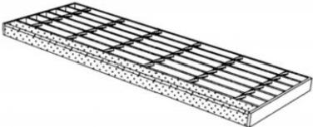

Figure 1 TA type steel grating stair tread

4.2.2 TB steel grating stair treads
TB-type steel grating stair treads are encircled by end plates with mounting holes. The recommended end plate width is 65mm, featuring a front-mounted anti-slip flange. Installation involves bolted connections to the stair beam, as shown in Figure 2.
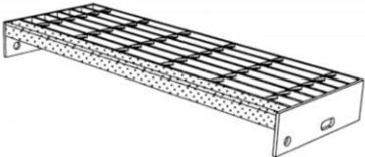

Figure 2 TB type steel grating stair tread
2

4.3 Model representation of steel grating stair treads 4.3.1 The model representation is as follows:
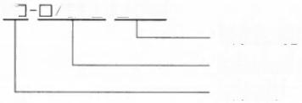
TC □/□-□ ×□ TC □/□-□ ×□
Step length × width, steel grate plate model, step model
4.3.2 Model representation example is as follows:
TB-325/30/100-800×275 denotes a TB-type stair tread with mounting holes, a front-through anti-slip flange, and bolted connections. The steel grating model is G325/30/100, with a tread length (stair width) of 800mm and a tread width of 275mm.

5. Load requirements for steel grating stair treads
5.1 Under a concentrated load of 1.5kN, the maximum deflection of the steel grating stair tread shall not exceed the smaller of 1/300 of the tread length or 6mm. Under a concentrated load of 4.4kN, the tread shall not suffer from welding or locking failure or other damage. Specific requirements are as follows:
— The pedal length is 600mm ≤L<1200mm, with concentrated loads distributed across a 100mm×100mm load-bearing area, which
The center is on the center line of the pedal length, and one edge of the area is located on the outer edge of the anti-slip flange.
—The pedal length is 1200mm≤L<1600mm, with concentrated loads distributed across load zones spaced 600mm apart. These zones are symmetrically positioned on both sides of the pedal's centerline, with one 100mm×100mm load zone's boundary aligning with the anti-slip flange's outer edge.
— The pedal length ranges from 1600mm to 2000mm, with concentrated loads distributed across symmetrical positions spaced 600mm apart.
The load area of 100mm×100mm is positioned along the centerline of the mounting and pedal length, with one edge aligned with the outer edge of the anti-slip flange.
5.2 The steel grating stair tread shall be subjected to a uniformly distributed load of 2.2 kN/m along its entire length, with the maximum deflection not exceeding the smaller of 1/300 of the tread length or 6 mm.

6 Manufacturing and installation requirements
6.1 The materials for steel grating stair treads shall meet the safety requirements of load and service environment. The following materials may be used:
—The stair treads may be made of carbon structural steel, weather-resistant structural steel, or low-alloy high-strength structural steel, and must comply with the requirements of GB/T 700, GB/T 4171, GB/T 1591, or GB/T 702.
—The stair treads may be made of ferritic stainless steel, austenitic stainless steel, or duplex stainless steel, and must comply with the requirements of GB/T 4237 or GB/T 3280.
6.2 The specifications and dimensions of steel grating stair treads are determined by the design load, stair width, and inclination angle. Tread specifications must comply with load-bearing and safety requirements. The tread length equals the stair width, typically ranging from 600mm to 2000mm. The tread width equals the steel grating plus the anti-slip flange, usually between 125mm and 305mm.
6.3 Steel grating stair treads shall be equipped with anti-slip flanges that extend through the entire tread. The flange width shall be no less than 25mm, typically 30mm. These flanges shall provide slip resistance and may be constructed from patterned steel plates, cold-formed angle steel, or steel components featuring anti-slip protrusions or sand strips. Functioning as visual markers between tread levels, the flanges shall alert users to safety hazards during stair ascent and descent. As the foremost load-bearing element of the tread, the flange shall enhance the load capacity of the tread's leading edge.
6.4 The load-bearing end plates of the steel grating should be fully welded on both sides to each load-bearing flat steel, with fillet welds no less than 3mm thick. The anti-slip flange and load-bearing end plates shall be fully welded on both sides, while intermittent welding shall be applied between the flange and the load-bearing flat steel of the steel grating.
6.5 For stair treads in areas prone to slip hazards, it is recommended to use toothed steel grating treads.
6.6 The steel grating footplate shall be connected to the ladder beam by welding or bolt fastening. When bolt fastening is used, the bolt specification shall be M12.
6.7 For transportation convenience, the ladder beam and the step plate can be manufactured separately and assembled on site.
6.8 For the connection between the end plate of TA-type pedal and ladder beam, supporting angle steel (not less than 40mm×40mm×4mm) may be installed.

YB/T 4001.3—2020

It is pre-welded to the ladder beam in the factory or bolted on site.
The reference dimensions for the mounting holes of the 6.9 TB type pedal's end plates are shown in Figure 3 and Table 1.
The unit is millimeters.

explain ：
t — edge plate length;
A— Center distance of the installation hole.

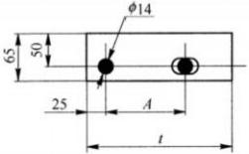

Figure 3 Reference dimensions of edge panel mounting holes

Table 1: Selection Table for Center Spacing of End Plate Installation Holes (Unit: mm) Table 1: Selection Table for Center Spacing of End Plate Installation Holes (Unit: mm)

End tab length t | 125 | 155～185 | 215～245 | 275～305 | >305
Installation hole center distance A | 45 | 75 | 100 | 150 | 200
Note: For easier installation, a 25mm×14mm elongated round hole can also be used for the rear mounting hole.
6.10 The deviation of the length and width of the pedal and the vertical deviation of the end plate are shown in Figure 4.
The unit is millimeters.

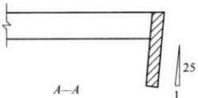
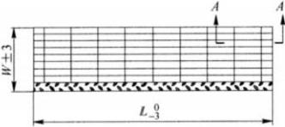
explain ：
L-pedal length;
W — pedal width.
Figure 4: Longitudinal and transverse deviations of the pedal, and vertical deviation of the end plate

7 Anti-corrosion measures
7.1 Steel grating stair treads in industrial corrosion environments shall preferably be made of weathering steel or stainless steel.
7.2 Except for stainless steel stair treads, the steel grating stair treads are treated with hot-dip galvanizing.
7.3 During the installation of steel grating stair treads, if the anti-corrosion coating of components is damaged due to welding fixation, cutting, collision or other reasons, the site construction party and the user shall take remedial anti-corrosion treatment.
7.4 In industrial corrosion environments, stainless steel bolts may be used for installing steel grating stair treads.

8 Inspection of steel grating stair treads

8.1 Appearance and Welding Inspection
8.1.1 The welding of the bearing end edge plate of the pedal to the bearing flat steel shall meet the requirements of 6.4.
8.1.2 The penetration of anti-slip flange through the pedal and its welding with the bearing end edge plate shall comply with the requirements of 6.4.
4

8.1.3 The outer surface shall not have cracks, scars, folds, delamination, overburn defects, and shall allow the presence of scratches, scratches and roughness removal marks not exceeding the thickness negative deviation.
8.1.4 The outer surface of the components treated with hot dipping zinc shall have a complete galvanized layer, and there shall be no black spots and bubbles without zinc coating. Local rough surface and zinc tumors are allowed.

8.2 Dimensional inspection of steel grating stair treads
8.2.1 The size and center spacing of the flat steel shall match the model of the steel grating.
8.2.2 The anti-slip flange size and specification are consistent.
8.2.3 The allowable deviation of pedal size shall conform to the provisions of Figure 4.
8.2.4 The center deviation of the installation hole should not exceed 1mm.
8.3 For steel grating treads with hot-dip galvanized surface treatment, the zinc coating thickness shall comply with the requirements specified in GB/T 13912.
8.4 Load Test of Steel Grating Stair Treads
According to the load test method in Appendix A, the manufacturer shall conduct sampling test, and the results may be used as quality delivery documents.
Under a 1.5kN concentrated load, the maximum mid-span deflection of the tread shall not exceed the smaller of 1/300 of the tread length or 6mm. After the test load is removed, the permanent deformation deflection shall not exceed 1/1000 of the tread length.
— Under a concentrated load of 4.4kN, the pedal remains intact without welding separation, locking failure, or other damage.

8.5 Inspection Rules

8.5.1 Inspection Items and Quantity
Welding inspection and appearance inspection shall be 10% of each batch, and no less than 10 pieces; size inspection shall be 10% of each batch, and no less than 10 pieces; zinc coating thickness inspection of hot-dip galvanized surface treatment of the pedal shall be no less than 3 pieces per batch; load inspection shall be no less than 1 piece per batch.

8.5.2 Batch grouping rules
Each batch of steel grating stair treads shall be composed of the same material and the same model of products.

9 Packaging Mark
9.1 The steel grating stair tread components shall be packaged in accordance with the contract requirements and delivered for on-site installation.
9.2 The steel grating stair tread component product shall be affixed with the manufacturer's logo, as well as the specification and drawing number logo.

5

YB/T 4001.3—2020

Appendix A
(Normative Appendix)
Steel grating stair tread load inspection

A.1 Scope
This appendix specifies the method for testing the bearing capacity of stair treads.

A.2 Principles
The prefabricated stair treads are supported under simulated final installation conditions. A test load is applied, the maximum deformation deflection is measured, and the damage condition of the stair treads is checked.

A.3 Test setup
The following devices are required for load testing:
a) A support structure that simulates the final installation conditions of the stair treads.
b) The steel spacer plate measuring 100mm×100mm shall have a thickness of at least 20mm.
c) A weight or combination of weights for applying specified test loads to stair treads, which can be placed or suspended on a 100mm×100mm steel base plate.
d)挠度百分表d.
e) Timer.

A.4 Load Test Procedure

A.4.1 Load Test for Strollers with a Length ≤1200mm
A.4.1.1 The device is shown in Figure A.1. A 100mm×100mm steel plate is positioned at the centerline of the tread, with one edge aligned with the outer edge of the tread's anti-slip flange. The maximum mid-span deflection is measured using a dial gauge mounted on the steel plate.
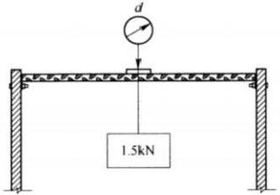

Figure A.1 Pedal test device with a length not exceeding 1200mm

A.4.1.2 Preload
Apply a 1kN load to the steel plate for 3 minutes. Remove the load and reset the dial gauge to zero.

A.4.1.3 Load Test
The load test steps are as follows:
a) Gradually apply weights, with each increment of 0.5kN at intervals of at least 15 seconds, until a final load of 1.5kN is applied to the 100mm×100mm steel pad. The load shall be maintained for 5 minutes.
b) Measure and record the maximum deflection at mid-span.
c) Gradually apply weights at 0.5kN increments, with intervals of at least 15 seconds between each application, until a final load of 4.4kN is applied to the 100mm×100mm steel

On the pad. The load lasts 5 minutes.
d) Remove the test load, measure and record any permanent deformation. Check for weld breakage or other damage to the components.

A.4.2 Load Test for Tread Lengths 1200mm ≤ L <1600mm
A.4.2.1 The device is shown in Figure A.2. Symmetrically arranged 100mm×100mm steel plates are positioned 600mm apart on both sides of the pedal's centerline. One edge of the steel plate aligns with the outer edge of the pedal's anti-slip flange. The maximum deflection is measured at the midpoint along the centerline using a dial gauge.
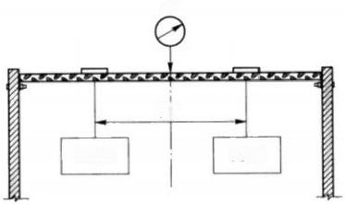
d

600

1.5kN 1.5kN 1.5kN 1.5kN

Figure A.2 Pedal Test Device with Length 1200mm ≤ L <1600mm

A.4.2.2 Preload
Apply a 1kN load to each 100mm×100mm steel plate for 3 minutes. Remove the load and reset the dial gauge to zero.

A.4.2.3 Load Test
The load test steps are as follows:
a) Gradually apply weights simultaneously, with each increment of 0.5kN at intervals of at least 15 seconds, until a final load of 1.5kN is applied to each 100mm×100mm steel plate. The load shall remain in effect for 5 minutes.
b) Measure and record the maximum deflection at mid-span.
c) Remove the load and steel pad.
d) Position a 100mm×100mm steel plate at the pedal's centerline, with one edge aligned with the pedal's anti-slip flange. Gradually apply weights in 0.5kN increments, with 15-second intervals between each load, until reaching the final load of 4.4kN. Maintain this load for 5 minutes.
e) Remove the test load and measure/record any permanent deformation. Inspect for weld fractures or other damage. A.4.3 Load test for pedals with length 1600mm ≤ L ≤ 2000mm
A.4.3.1 The device is shown in Figure A.3. A 100mm×100mm steel plate is positioned at the centerline of the tread and symmetrically on both sides, spaced 600mm apart. One edge of the steel plate aligns with the outer edge of the tread's anti-slip flange. The maximum mid-span deflection is measured using a dial gauge mounted on the steel plate along the tread's centerline.
d

A.4.3.2 Preload
Apply a 1kN load to each 100mm×100mm steel bearing plate for 3 minutes. Remove the load and adjust the dial gauge to zero.

A.4.3.3 Load Test
The load test steps are as follows:
a) Gradually apply weights simultaneously, with each increment of 0.5kN at intervals of at least 15 seconds, until a final load of 1.5kN is applied to each 100mm×100mm steel plate. The load shall remain in effect for 5 minutes.
b) Measure and record the maximum deflection at mid-span.
c) Remove the load and steel pad.
d) Position a 100mm×100mm steel plate at the pedal's centerline, with one edge aligned with the pedal's anti-slip flange. Gradually apply weights in 0.5kN increments, with 15-second intervals between each load, until reaching the final load of 4.4kN. Maintain this load for 5 minutes.
e) Remove the test load, measure and record any permanent deformation. Inspect for weld breakage, delamination, or other damage. A.5 Inspection Report
The inspection report shall include the following information:
a) Specifications and types of steel grating stair treads;
b) Sample size and measurement records;
c) Test load, application position, duration, and maximum mid-span deflection;
d) Details of any failure (crack), permanent deformation records or photographs;
e) A detailed description, diagram or photograph of the load-conducting device used in the test;
f) Calibration records of measuring instruments;
g) Test date and ambient temperature;
h) The name, position and qualifications of the person in charge of the test;
i) Signature of the test leader.

Appendix B
（ informative annex ）
Steel grating stair tread strength calculation

B.1 Length of steel grating stair treads
The length of the steel grating stair tread, that is, the width of the stair, is designed according to the flow of pedestrians.
The length of the steel grating stair tread for single-person passage shall not be less than 600mm, for double-person passage shall not be less than 1200mm, and for triple-person passage shall be between 1600mm and 2000mm.

B.1.1 Tread for single person access
The length of the single-person walkway 600mm≤L<1200mm,1.5kN is defined by the concentrated load F acting on a 100mm×100mm load area at the center of the walkway, as shown in Figure B.1.
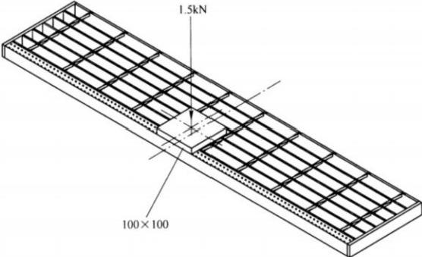

Figure B.1 Steel grating stair treads for single-person access
The bending moment M of the steel grating stair tread is calculated using Equation (B.1).
M=FL/4 …………………………(B.1) M=FL/4 …………………………(B.1)
in the formula:
M — bending moment of the steel grating stair tread, measured in Newton-millimeters (N·mm);
F — The concentrated load borne by the steel grating stair tread, measured in Newtons (N);
L —— Length of the steel grating stair tread, measured in millimeters (mm).
The maximum bending deflection (dmax) of the steel grating stair tread is calculated using Equation (B.2).
dmax=FL³/48γEI …………………………(B.2) dmax=FL³/48γEI …………………………(B.2)
in the formula:
dmx — Maximum bending deflection of steel grating stair treads, measured in millimeters (mm);
F —— Concentrated load on the steel grating stair tread, measured in Newtons (N);
L —— Length of the steel grating stair tread, measured in millimeters (mm);
γ —— Bending stiffness adjustment coefficient for flat steel, γ=0.729;
E —— Material elastic modulus, unit is newton per square millimeter (N/mm²);
I —— the section modulus of inertia of the pedal load area, in mm⁴.

B.1.2 Treadway for two persons to pass side by side
The pedal, designed for two-person side-by-side passage, measures 1200mm ≤ L <1600 mm. A concentrated load of 1.5 kN is symmetrically distributed across a 100mm×100mm area on both sides of the pedal, as shown in Figure B.2.
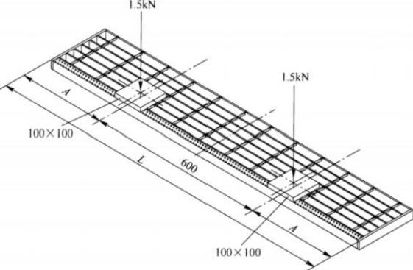

Figure B.2: Steel grating stair tread for two-person side-by-side passage
The bending moment M of the steel grating stair tread is calculated using Equation (B.3).
M= FA …………………………(B.3) M= FA …………………………(B.3)
in the formula:
M — bending moment of the steel grating stair tread, measured in Newton-millimeters (N·mm);
F — The concentrated load borne by the steel grating stair tread, measured in Newtons (N);
A—The shortest distance from the center of the pedal load area to the ladder beam, measured in millimeters (mm).
A=( L -600)/2 …………………………(B.4) A=( L -600)/2 …………………………(B.4)
The maximum bending deflection (dmx) of the steel grating stair tread is calculated using Equation (B.5).
dmax= FA (3L²—4A²)/24γEI …………………………(B.5) dmax= FA (3L²—4A²)/24γEI …………………………(B.5)
in the formula:
dmax — maximum bending deflection of steel grating stair treads, measured in millimeters (mm);
F — The concentrated load borne by the steel grating stair tread, measured in Newtons (N);
L —— Length of the steel grating stair tread, measured in millimeters (mm);
γ —— The bending stiffness adjustment coefficient for flat steel, y=0.729;
E —— Material elastic modulus, measured in Newton per square millimeter (N/mm²);
I —— the section modulus of inertia of the pedal load area, in mm⁴;
A ——the shortest distance from the center of the pedal load area to the ladder beam, in millimeters (mm).

B.1.3 Tread for three persons to pass side by side
The pedal, designed for three-person side-by-side passage, measures 1600mm ≤ L ≤2000 mm in length. A concentrated load of 1.5 kN (F) is applied at the pedal's center and on both 100mm×100mm load-bearing areas, as shown in Figure B.3.
The bending moment M of the steel grating stair tread is calculated using Equation (B.6).
M= FL/2 …………………………(B.6) M= FL/2 …………………………(B.6)
in the formula:
M — bending moment of the steel grating stair tread, measured in Newton-millimeters (N·mm);

YB/T 4001.3—2020

F — Concentrated load on the steel grating stair tread, measured in Newtons (N);
L —— Length of the steel grating stair tread, measured in millimeters (mm).

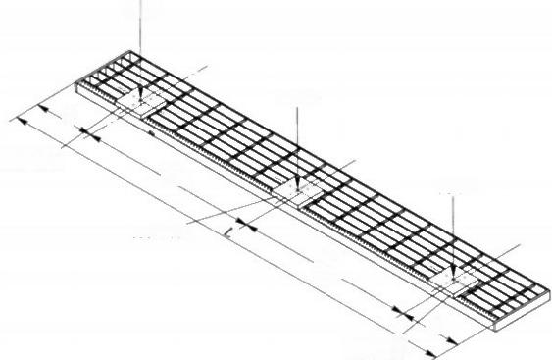
1.5kN

1.5kN
100×100
0%
100×100
0g

100×100
1.5kN

Figure B.3: Steel grating stair tread for three people to pass side by side
The maximum bending deflection (dmax) of the steel grating stair tread is calculated using Equation (B.7).
dmx=FA(3L²-4A²)/24γEI+FL³/48γEI ……………… ……(B.7) ……………… dmx=FA(3L²-4A²)/24γEI+FL³/48γEI ……………… ……(B.7)
in the formula:
dmx — Maximum bending deflection of steel grating stair treads, measured in millimeters (mm);
F —— Concentrated load on the steel grating stair tread, measured in Newtons (N);
L —— Length of the steel grating stair tread, measured in millimeters (mm);
γ —— The bending stiffness adjustment coefficient for flat steel, y=0.729;
E —— Material elastic modulus, unit is newton per square millimeter (N/mm²);
I —— the section modulus of inertia of the pedal load area, in mm⁴;
A ——the shortest distance from the center of the pedal load area to the ladder beam, measured in millimeters (mm).
A=(L-2×600)/2 …………………………(B.8) A=(L-2×600)/2 …………………………(B.8)

B.2 Calculation of cross-sectional parameters for load-bearing areas of steel grating stair treads
B.2.1 The load-bearing area of the steel grating stair tread, located within the outer edge of the anti-slip flange, covers a 100mm×100mm zone including the flange. The flange plate and N load-bearing flat steel bars serve as the load-bearing components. When calculating the tread strength, the number of load-bearing flat steel bars (N) in the load-bearing area is determined first.
B.2.2 Based on the flange plate dimensions, the number of bearing flat steel bars in the load-bearing area and the cross-sectional parameters of the flange plate (including the section modulus W) are calculated using Equation (B.9) and the section modulus of inertia In using Equation (B.10).
Wₙ=5Bht/12 …………………………(B.9) Wₙ=5Bht/12 …………………………(B.9)
In=5Bh²t/24 …………………………(B.10) In=5Bh²t/24 …………………………(B.10)
in the formula:
Wn —— the section modulus of cold-formed unequal angle steel, measured in cubic millimeters (mm³);
I—in— the section modulus of inertia for cold-formed unequal angle steel, measured in mm⁴;
B— The short side length of cold-formed unequal angle steel, measured in millimeters (mm);
h ——long side length of cold-formed unequal angle steel, in millimeters (mm);

YB/T 4001.3—2020

t —— thickness of cold-formed unequal angle steel, in millimeters (mm).
B.2.3 Calculate the cross-sectional parameters of the load-bearing flat steel based on its dimensions:
The modulus W of the flat steel section is calculated using Equation (B.11).
W₆=bd²/6 …………………………(B.11) W₆=bd²/6 …………………………(B.11)
in the formula:
Wb —— the section modulus for flat steel, measured in cubic millimeters (mm³);
b —— The thickness of the flat steel, measured in millimeters (mm);
d —— represents the width of the flat steel, measured in millimeters (mm).
The moment of inertia Ib of the flat steel section is calculated using Equation (B.12).
Ib=bd³/12 …………… …………(B.12) Ib=bd³/12 …………… …………(B.12)
in the formula:
Ib —— The moment of inertia of the cross-section for flat steel, measured in mm⁴ (square millimeters);
b —— bearing flat steel thickness, in millimeters (mm);
d —— The width of the flat steel, measured in millimeters (mm).
B.2.4 Cross-section parameters of the pedal load area:
The cross-sectional modulus W of the pedal load area is calculated using Equation (B.13), while the cross-sectional moment of inertia I is calculated using Equation (B.14).
W=W+NW₆ …………………………(B.13) W=W+NW₆ …………………………(B.13)
I=Iₙ+NI ……… ………………(B.14) I=Iₙ+NI ……… ………………(B.14)
in the formula:
W —— The cross-sectional modulus of the pedal load area, measured in cubic millimeters (mm³);
I —— the section modulus of inertia of the pedal load area, in mm⁴;
N —— Number of flat steel bars in the load-bearing area;
Wn —— The section modulus of the flange plate, measured in cubic millimeters (mm³);
Wb —— the section modulus for flat steel, measured in cubic millimeters (mm³);
In—— The section modulus of the flange plate, measured in mm⁴ (millimeters cubed);
Ib —— The moment of inertia of the cross-section for flat steel, measured in mm⁴.
B.3 Strength requirements for steel grating stair treads
B.3.1 The bending strength σ of steel grating stair treads shall be calculated using Equation (B.15).
ø=M/W ……… ………………(B.15) ø=M/W ……… ………………(B.15)
in the formula:
σ——Bending strength of steel grating stair tread, unit: newton per square millimeter (N/mm²);
M — Bending moment of the pedal, measured in Newton-millimeters (N·mm);
W —— The cross-sectional modulus of the pedal load area, in cubic millimeters (mm³).
B.3.2 Maximum bending strength of steel grating stair treads:
The maximum bending moment of the pedal is equivalent to that under a F=4.4kN concentrated load, with the most unfavorable region at the pedal's center, where the bending moment M=FL/4.
The maximum bending strength of the pedal (0mx) is calculated using Equation (B.16).
Omax=1100L/W …………………………(B.16) Omax=1100L/W …………………………(B.16)
in the formula:
0max — maximum bending strength of the steel grating stair tread, measured in Newton per square millimeter (N/mm²);
L —— Length of the steel grating stair tread, measured in millimeters (mm);

YB/T 4001.3—2020

W —— The cross-sectional modulus of the pedal load area, measured in cubic millimeters (mm³).
B.3.3 Strength requirements for steel grating stair treads
B.3.3.1 The maximum bending strength of steel grating stair treads shall not exceed the design value of steel's bending strength.
Omax/f≤1 …………………………(B.17) Omax/f≤1 …………………………(B.17)
in the formula:
0max — maximum bending strength of the steel grating stair tread, measured in Newton per square millimeter (N/mm²);
f —— design value of bending strength of steel, unit is newton per square millimeter (N/mm²).
B.3.3.2.2 The steel grating stair tread shall withstand either a concentrated load of 1.5kN in the load-bearing area or a uniformly distributed load of 2.2 kN/m along its entire length, with the maximum bending deflection not exceeding the smaller of 1/300 of the span or 6 mm.
a) The maximum deflection of steel grating stair treads under a 1.5kN concentrated load in the load-bearing zone shall be calculated using Equation (B.2), Equation (B.5), or Equation (B.7), depending on the tread length.
b) Maximum bending deflection of the steel grating stair tread under a uniformly distributed load of 2.2 kN/m along its entire length
dmax=5QL⁴/384γEI …………………………(B.18) dmax=5QL⁴/384γEI …………………………(B.18)
in the formula:
dm — Maximum bending deflection of steel grating stair treads, measured in millimeters (mm);
Q— The uniformly distributed load on the steel grating stair tread, measured in Newtons per millimeter (N/mm);
L —— Length of the steel grating stair tread, measured in millimeters (mm);
γ —— Bending stiffness adjustment coefficient for flat steel, γ=0.729;
E —— Material elastic modulus, unit is newton per square millimeter (N/mm²);
I —— the section modulus of inertia of the pedal load area, in mm⁴.
B.4 Example of strength calculation of steel grating stair treads
B.4.1 Example: The steel grating staircase tread is fabricated from G405/30/100 steel grating with Q235B material. The tread measures 275mm wide and 1200mm long, featuring a cold-formed unequal angle steel flange measuring 30mm×40mm×5mm. The flange dimensions are specified as: short side (B) = 30mm, long side (h) = 40mm, and thickness (t) = 5mm.
B.4.1.1 Pedal Cross-Section Parameters
Number of flat steel bars in the load-bearing area
N= (100-30) / 30 + 1=3 (as shown in the figure below, rounded to the nearest integer) N= (100-30) / 30 + 1=3 (as shown in the figure below, rounded to the nearest integer)

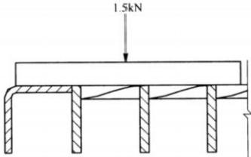
Section modulus for flat steel
Wb=bd²/6=5×40²/6=1333mm³
Inertial moment of a section carrying flat steel
Ib=bd³/12=5×40³/12=26667mm⁴
Section modulus of cold-formed unequal angle steel
Wₙ=5Bht/12=5×30×40×5/12=2500mm³

Inertial moment of the section of cold-formed unequal angle steel
Iₙ=5Bh²t/24=5×30×40²×5/24=50000mm⁴
Section modulus of the pedal load area
W=Wn+NWb=2500+3×1333=6499mm³
Inertial moment of the pedal load area
I=Iₙ+NI=50000+3×26667=130000mm⁴
B.4.1.2 Verification of maximum bending strength of the pedal
According to Equation (B.16)
Omax=1100L/W=1320000/6499=203.11N/mm²
Design value of bending strength of Q235B steel
f=215N/mm²
Criteria for determining whether the pedal bending strength meets the design requirements
0max/f≤1
The bending strength of the pedal meets the design requirements.
B.4.1.3 Maximum deflection of the pedal
a) Maximum bending deflection of the pedal under a 1.5kN concentrated load
dmax=FA(3L²—4A²)/24γEI
A=(L—600)/2=300mm
in the formula:
y — the bending stiffness adjustment coefficient for flat steel, where y=0.729.
The elastic modulus of Q235B
E=206000N/mm²
dmax=1500×300×(3×1200²—4×300²)/24×0.729×206000×130000=3.80mm Maximum bending deflection requirement
L/300=1200/300=4mm
dmax<L/300
The maximum bending deflection of the 1.5kN concentrated load on the pedal meets the design requirements.
b) Maximum bending deflection under a uniformly distributed load of 2.2 kN/m on the pedal
dmax=5QL⁴/384γEI
dmax=5×2.2×1200⁴/384×0.729×206000×130000=3.04mm dmax<L/300
The maximum bending deflection of the pedal under a uniformly distributed load of 2.2kN/m meets the design requirements.

