Final Project Design Phase
Computer Science - Week 11
Oct 3, 2026 - Version 0.0.4

For complete instructions and project ideas, refer to the assignment in Canvas. Specifically, review the final project requirements before you continue below. If you have not reviewed the project requirements in Canvas (you might have to go to the modules view and check the current or past week's content), you will not be able to properly complete the parts below. In addition, it may be helpful to review the information on this Drafter documentation page.

0) Project Planning and Preparation
Successful programmers spend time planning before they begin coding. After reviewing the project requirements, answer the following questions to help guide your design and development process.
- What concepts from class or previous assignments might help you complete this project? Which programming concepts (loops, conditionals, lists, classes, etc.) do you expect to use? What programming skills do you want to improve while completing this project?
The info from the drafter scavenger hunt will be useful for remembering how drafter works with routes and pages. The recent information on accessing data with an arbitrary key through dictionaries is going to be very useful for storing forecast data. Also, dataclasses will be useful for making a single object to represent each forecast. I want to improve my JSON and file handling skills so I can store forecasts locally between sessions.

- Which parts of the project do you expect to be the easiest for you? The hardest? Why?
I expect the data structures to be the easiest as they are fairly straightfoward. I expect saving data to be difficult as well as connecting the routes and GUI in an intuitive way for users.

- Even though you have not yet designed the final project, estimate which tasks will likely require the most time and effort? Which features or components should be implemented first?
Creating pages and routes will be the most time consuming and require the most thinking. The first thing to implement is the data structure that the app uses, and then the home page / index that everything else is going to spur from.

- What distractions might interfere with your work and how will you minimize them? What resources will you need available while working? What questions, if any, do you still have about the assignment requirements?
Scope creep is going to be a distraction as i will likely discover new features i want to add during the development of the project. Staying focused on the main goal and not random gimmicks basically. I will need python and drafter documentation and that should be it. I have no questions about the requirements (other than where the line for “genuinely useful” is drawn)

1) Site Diagram
Create a mock-up of your planned website. We suggest you make the mockup on paper, although you can also use software like PowerPoint or Slides to make a mockup. There is other design software that could also be used, but we strongly encourage you to keep it simple. Do not spend more than 15-30 minutes detailing the mock-up. Your goal should be to make a very quick and dirty diagram, to show that you have some kind of idea.

We recommend drawing each page as a rectangle, and laying out the text, buttons, and other components inside. Then, use arrows to indicate links between pages. Label each page the way you will name each function, and then put labels on the arrows to indicate what the button links. Also write down any parameters that should come into the pages.

In addition to the pages and routes, write down what fields your `State` will have, both their names and types. Think clearly about what data will need to be persistent across the entire website.

Add photo(s) or screenshot(s) of your website mock-up and labeled diagram on the next page.

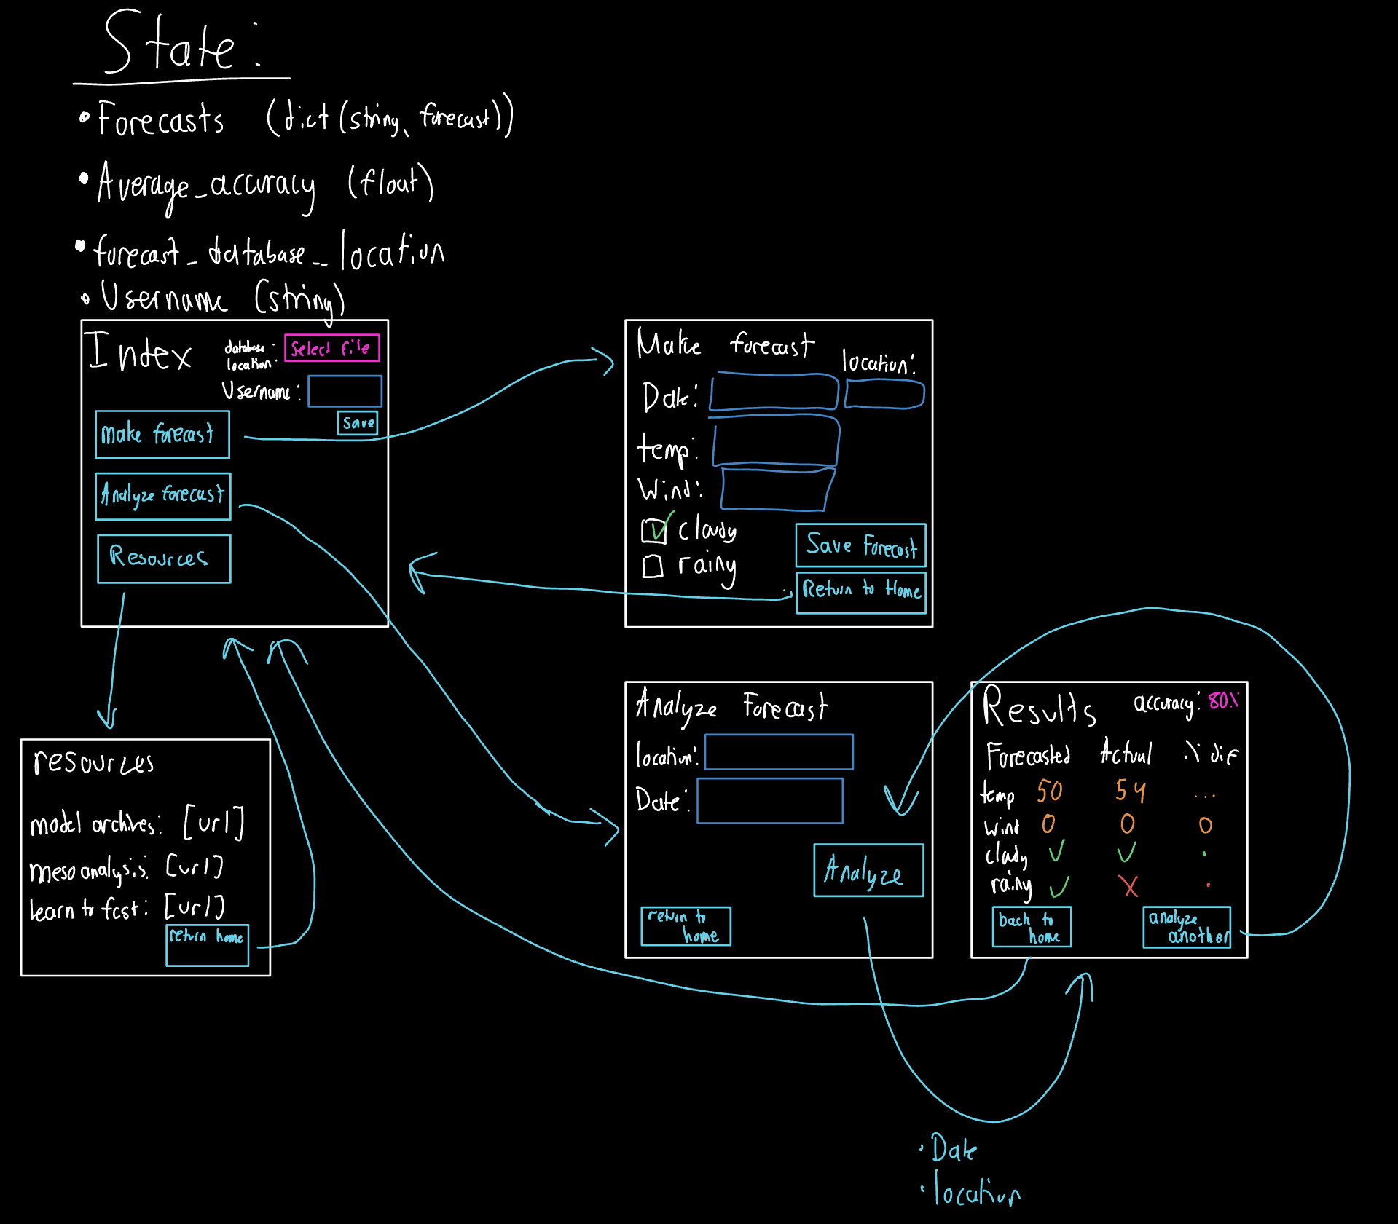
2) Implementing Requirements
This table should serve as a draft for how you will implement the requirements into your final project. You may change your ideas later on, but your final site must fulfill all the requirements.

Requirement | Implementation
Purpose/Functionality  A 1-2 sentence description of the purpose or functionality of your site | Turn weather forecasting into a game, allowing users to use historical data to make and verify their own forecasts to help them improve.
State Dataclass Attributes  Minimum of 4 attributes, one of which must be a list/dict of instances of your second dataclass.  Briefly describe each attribute, its type, and how it will be meaningfully modified throughout the site. | - Forecasts  - Dictionary (string, Forecast)  - Forecast is a dataclass which stores predictions  - Users can save forecasts to this  - Users can view and analyze forecasts from this  - Average_Accuracy  - Float  - Represents the average accuracy of the forecasts a user has analyzed  - Updated each time a new analysis is made  - Forecast_Database_Location  - String  - Relative path of where the user chooses to store their forecasts between sessions  - Modified on the home page using a file selector  - Username  - String  - Identifies the user if they ever want to share their forecasts and scores with others via the great interweb
Second Dataclass  Your second dataclass, including its attributes, their types, and how they will be meaningfully modified (if they are modified) | - Forecast  - Stores information necessary for a weather forecast  - Fields:  - date_issued: str  - date_valid: str  - temp: int  - wind: int  - cloudy: bool  - rainy: bool
Routes (minimum 7)  The names of your route functions | Return_to_home  Edit_a_forecast  Make_forecast  Analyze_forecast  view_forecast_analysis  view_resources  view_statistics
Pages (minimum 5)  A brief description of the pages in your site | - Index  - Home page  - Resources  - A list of links to helpful forecasting resources  - Make forecast:  - Provide the tools to create a Forecast  - Analayze_forecast  - Allows you to choose a forecast to analyze  - Analysis_results  - Allows the user to view how accurate their forecast was
User Input (minimum 3)  Description of user input components (TextBox, TextArea, CheckBox, or SelectBox) and their purposes  For more information on these input types, see Drafter Documentation. | TextBox - allow user to enter values for forecasts  FileUpload - allow the user to load forecasts from a saved file  CheckBox - used for boolean forecast values (cloudy and rainy)  SelectBox - allow user to choose a saved forecast to analyze
If Statements (minimum 3)  Brief description of what will be evaluated in your if statements and how they will meaningfully change the logic of the site | - Check if a forecast was actually entered in the make forecast page  - If this fails, an error will be presented to the user telling them to enter data in all fields  - Check if forecasts are equal to actual observations  - If not equal, the code will display the inaccuracy. If equal, it will say like “good job” or something
Loop (minimum 1)  This loop must iterate over the list/dict of dataclass instances in your State attribute.  Description of this loop and why it is meaningful to the site | The analyze_forecast page will have the ability to select a forecast from the loaded Forecasts list, which requires a loop to get all of the days with forecasts and add them to a SelectBox

LLM Conversation
If you used an LLM in any part of this work, copy and paste every part of that conversation below. Otherwise, you may be given a zero for the assignment. Obviously, these words will not all be yours, and this is the exception to the requirement at the top of this assignment that all responses be in your own words. If you did not use an LLM to assist you in this assignment, simply say so below.
I did not use an LLM in this assignment

Final Submission
When you are finished, download this file as a Word Document (docx) and upload the file to the appropriate assignment on Canvas.

