電通二乙微處理器實驗 實驗結報

實驗名稱 | MCS Cloud
組別 | 36 | 組員 | 陳昭維

- 實驗目的
到MCS註冊帳號
建立網頁應用程式（web application）
透過MCS REST API進行溝通
LinkIt 家族開發板、手機、瀏覽器

- 實驗步驟
控制LED並檢視狀態
- 建立Prototype
- 依照所需功能，新增Data channel，記下Data channel Id
- 建立Test device，記下DeviceId與DeviceKey
將 A0 電阻值上傳
- 程式碼
GET:
#include <LWiFi.h>
#include "MCS.h"

char _lwifi_ssid[] = "DNA";
char _lwifi_pass[] = "qwertyuiop";
MCSDevice mcs("DdCbAGWA", "zar0ypVvD8rrTbOi");

MCSControllerOnOff led("LED_Control");
MCSDisplayOnOff remote("LED");

void setup()
{
Serial.begin(9600);

Serial.println("Connect to wifi");
while (WiFi.begin(_lwifi_ssid, _lwifi_pass) != WL_CONNECTED) {
Serial.println("Wifi Reconnecting..");
delay(1000);
}

Serial.println("Connect to MCS...");
while (!mcs.connected()) {
Serial.println("MCS Reconnecting..");
mcs.connect();
}
Serial.println("MCS Connected!");
mcs.addChannel(led);
mcs.addChannel(remote);
while(!mcs.connected())
{
Serial.println("MCS.connect()...");
mcs.connect();
}
pinMode(7, OUTPUT);

}
void loop()
{
while(!led.valid())
{
Serial.println("read LED value from MCS...");
led.value(); //取得MCS數值
}
Serial.print("done, LED value = ");
Serial.println(led.value()); //顯示出來
digitalWrite(7, led.value() ? HIGH : LOW);

while (!mcs.connected()) {
mcs.connect();
if (mcs.connected()) {
Serial.println("MCS Reconnect");
}
}
mcs.process(1000);

if (led.value() == 1) {
digitalWrite(7, HIGH);

} else {
digitalWrite(7, LOW);

}

delay(200);
if(!remote.set(led.value()))
{
Serial.print("Failed to update remote");
Serial.println(remote.value());
}

}

POST:
#include <LWiFi.h>
#include "MCS.h"
char _lwifi_ssid[] = "DNA";
char _lwifi_pass[] = "qwertyuiop";
MCSDevice mcs("DBVH9aTX", "exhk42aTJN0634XS");
MCSDisplayInteger Temp("Temp");
void setup()
{
Serial.begin(9600);
Serial.println("Connect to Wifi");
while (WiFi.begin(_lwifi_ssid, _lwifi_pass) != WL_CONNECTED) {
Serial.println("Wifi Reconnecting..");
delay(1000);
}
Serial.println("Connect to MCS...");
while (!mcs.connected()) {
Serial.println("MCS Reconnecting..");
mcs.connect();
}
Serial.println("MCS Connected!");
mcs.addChannel(Temp);
}
void loop()
{
while (!mcs.connected()) {
mcs.connect();
if (mcs.connected()) {
Serial.println("MCS Reconnect");
}
}
mcs.process(1000);

int sensor = analogRead(A0);

Temp.set(sensor);
Serial.println("Add sensor value.");
delay(200);
}

4.實驗結果及分析

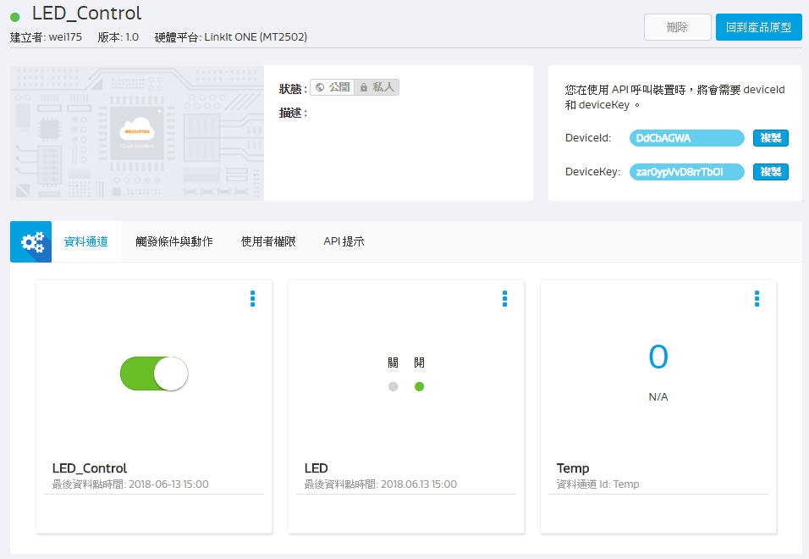
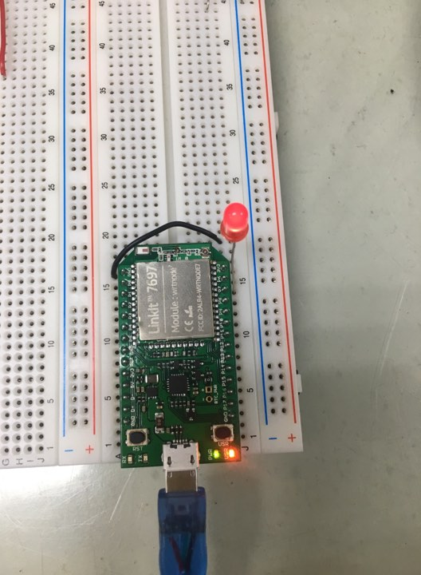
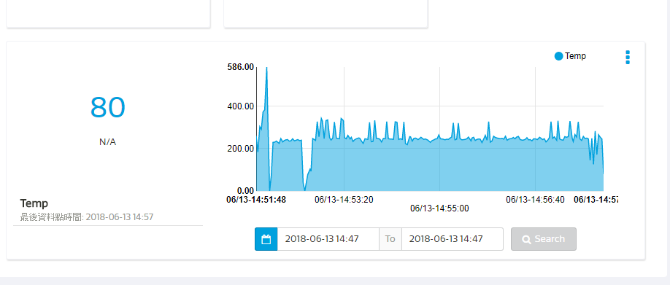
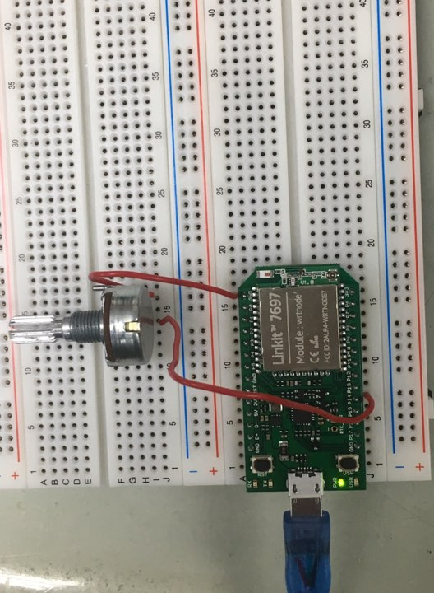

5.心得討論
剛開始設定的ID沒改到所以一直控制不了，找到後就成功的完成本次的實驗。

