1.

|  |
| --- |
| #!/usr/bin/python |
|  | # Copyright (c) 2014 Adafruit Industries |
|  | # Author: Tony DiCola |
|  |  |
|  | # Permission is hereby granted, free of charge, to any person obtaining a copy |
|  | # of this software and associated documentation files (the "Software"), to deal |
|  | # in the Software without restriction, including without limitation the rights |
|  | # to use, copy, modify, merge, publish, distribute, sublicense, and/or sell |
|  | # copies of the Software, and to permit persons to whom the Software is |
|  | # furnished to do so, subject to the following conditions: |
|  |  |
|  | # The above copyright notice and this permission notice shall be included in all |
|  | # copies or substantial portions of the Software. |
|  |  |
|  | # THE SOFTWARE IS PROVIDED "AS IS", WITHOUT WARRANTY OF ANY KIND, EXPRESS OR |
|  | # IMPLIED, INCLUDING BUT NOT LIMITED TO THE WARRANTIES OF MERCHANTABILITY, |
|  | # FITNESS FOR A PARTICULAR PURPOSE AND NONINFRINGEMENT. IN NO EVENT SHALL THE |
|  | # AUTHORS OR COPYRIGHT HOLDERS BE LIABLE FOR ANY CLAIM, DAMAGES OR OTHER |
|  | # LIABILITY, WHETHER IN AN ACTION OF CONTRACT, TORT OR OTHERWISE, ARISING FROM, |
|  | # OUT OF OR IN CONNECTION WITH THE SOFTWARE OR THE USE OR OTHER DEALINGS IN THE |
|  | # SOFTWARE. |
|  | import sys |
|  |  |
|  | import Adafruit_DHT |
|  |  |
|  |  |
|  | # Parse command line parameters. |
|  | sensor_args = { '11': Adafruit_DHT.DHT11, |
|  | '22': Adafruit_DHT.DHT22, |
|  | '2302': Adafruit_DHT.AM2302 } |
|  | if len(sys.argv) == 3 and sys.argv[1] in sensor_args: |
|  | sensor = sensor_args[sys.argv[1]] |
|  | pin = sys.argv[2] |
|  | else: |
|  | print('Usage: sudo ./Adafruit_DHT.py [11|22|2302] <GPIO pin number>') |
|  | print('Example: sudo ./Adafruit_DHT.py 2302 4 - Read from an AM2302 connected to GPIO pin #4') |
|  | sys.exit(1) |
|  |  |
|  | # Try to grab a sensor reading. Use the read_retry method which will retry up |
|  | # to 15 times to get a sensor reading (waiting 2 seconds between each retry). |
|  | import time |
|  | import sys |
|  | import httplib, urllib |
|  | import json |
|  | deviceId = "Dfr3Iwyb" |
|  | deviceKey = "ErJQU4MNQGwLnthh" |
|  | def post_to_mcs(payload): |
|  | headers = {"Content-type": "application/json", "deviceKey": deviceKey} |
|  | not_connected = 1 |
|  | while (not_connected): |
|  | try: |
|  | conn = httplib.HTTPConnection("api.mediatek.com:80") |
|  | conn.connect() |
|  | not_connected = 0 |
|  | except (httplib.HTTPException, socket.error) as ex: |
|  | print( "Error: %s" % ex) |
|  | time.sleep(10) |
|  | # sleep 10 seconds |
|  | conn.request("POST", "/mcs/v2/devices/" + deviceId + "/datapoints", json.dumps(payload), headers) |
|  | response = conn.getresponse() |
|  | print( response.status, response.reason, json.dumps(payload), time.strftime("%c")) |
|  | data = response.read() |
|  | conn.close() |
|  |  |
|  | while 1: |
|  | humidity, temperature = Adafruit_DHT.read_retry(sensor, pin) |
|  |  |
|  | # Un-comment the line below to convert the temperature to Fahrenheit. |
|  | # temperature = temperature * 9/5.0 + 32 |
|  |  |
|  | # Note that sometimes you won't get a reading and |
|  | # the results will be null (because Linux can't |
|  | # guarantee the timing of calls to read the sensor). |
|  | # If this happens try again! |
|  | if humidity is not None and temperature is not None: |
|  | print('The current temperature is {0:0.1f} C.'.format(temperature, humidity)) |
|  | payload = {"datapoints":[{"dataChnId":"Humidity","values":{"value":humidity}}, |
|  | {"dataChnId":"Temperature","values":{"value":temperature}}]} |
|  | post_to_mcs(payload) |
|  | time.sleep(0.5) |
|  | else: |
|  | print('Failed to get reading. Try again!') |
|  | sys.exit(1) |

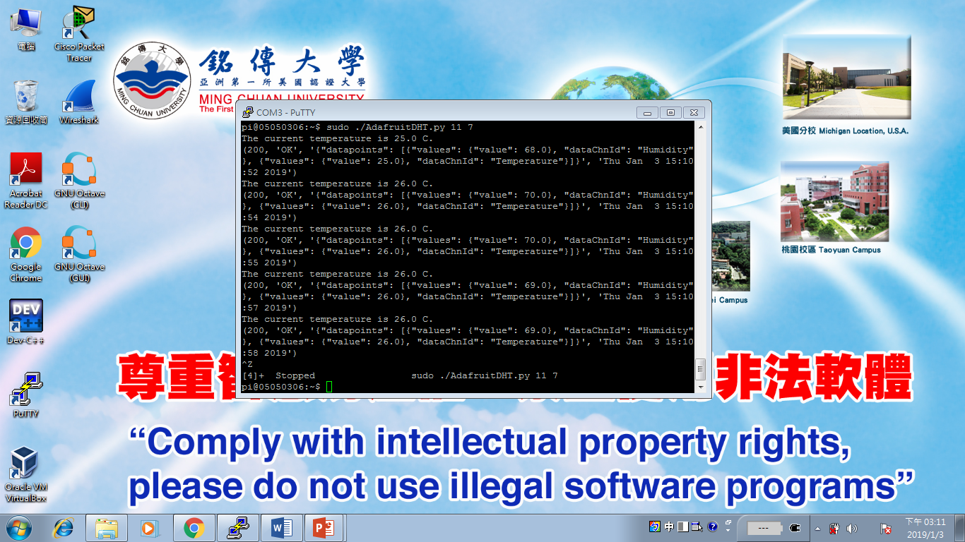

2.

#!/usr/bin/python3

import time, RPi.GPIO as GPIO

GPIO.setmode(GPIO.BCM)

GPIO.setup(23, GPIO.IN, pull_up_down=GPIO.PUD_UP)

for a in range(0,10):

SwitchStatus = GPIO.input(23)

if( SwitchStatus == 0):

print('Turn on the switch')

time.sleep(1)

else:

print('Turn off the switch')

time.sleep(1)

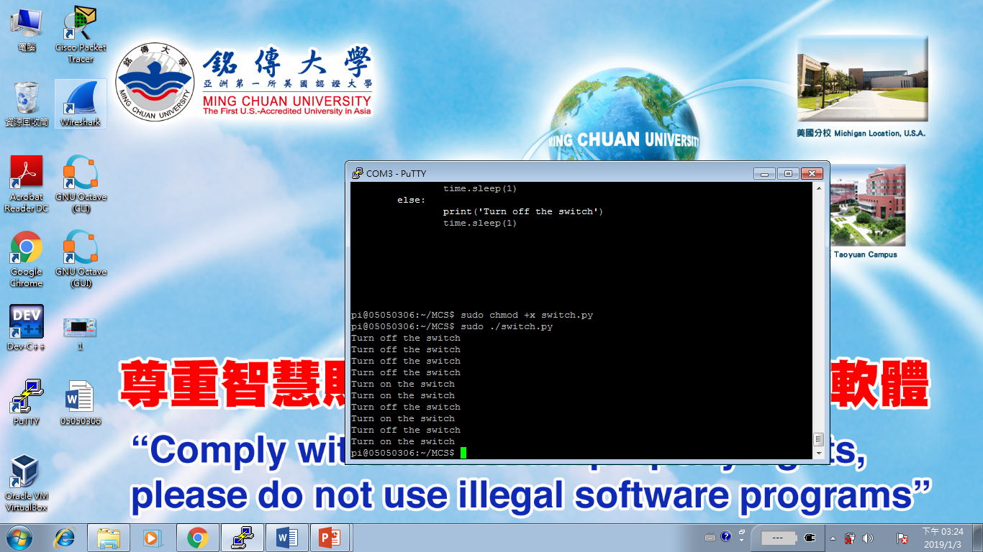

3.

