Software Requirements Specification
IRO — Issues Reporting Outlet
A Web-Based Platform for Reporting and Resolving Issues Between AAUA Students and Host-Community Indigenes (Akungba, Iwaro, Etioro, Ayegunle)
Version 1.0
8 July 2026

1. Introduction

1.1 Purpose
This document specifies the software requirements for IRO (Issues Reporting Outlet), a web-based platform commissioned to give AAUA students and indigenes of the surrounding communities, Akungba, Iwaro, Etioro, and Ayegunle, a structured, trusted channel to report, track, and resolve community issues. It is intended for the development team, project supervisor, and community relations stakeholders.

1.2 Scope
IRO allows a student or an indigene to submit an issue report (optionally anonymous), attach supporting details, and track its status through resolution. A community relations officer (admin) reviews, categorizes, assigns, and resolves reports, and the system notifies reporters of status changes. The initial release is a lightweight web interface; it excludes payment processing, legal case management, and integration with law-enforcement systems.

1.3 Definitions, Acronyms and Abbreviations
Term | Meaning
IRO | Issues Reporting Outlet, the system name
AAUA | Adekunle Ajasin University, Akungba-Akoko
Indigene | A native resident of the host communities (Akungba, Iwaro, Etioro, Ayegunle)
Admin / CRO | Community Relations Officer, the staff role that manages reports
SRS | Software Requirements Specification
UI | User Interface

1.4 References
- Project brief: "IRO, Issues Reporting Outlet" feasibility and development task specification.
- IRO Community Questionnaire Design (companion document, distributed via Google Forms).

1.5 Overview
Section 2 gives an overall description of the product. Section 3 details functional requirements and component interactions. Section 4 presents the use-case diagram. Section 5 lists non-functional requirements. Section 6 covers external interface requirements. The Appendix contains the Ishikawa root-cause analysis that informed this specification.

2. Overall Description

2.1 Product Perspective
IRO is a new, standalone web-based system. It is not a replacement for existing informal channels (community leaders, security desks) but a formal, trackable layer on top of them, reports raised through IRO are routed to the same human decision-makers, with the system providing structure, accountability, and a paper trail that currently does not exist.

2.2 Product Functions
- Allow a student or indigene to submit an issue report, with an option to remain anonymous.
- Allow a reporter to attach a short description and evidence details (e.g., photo reference, location).
- Allow any reporter to track the status of their submitted report (Pending / In Review / Resolved).
- Notify reporters when the status of their report changes.
- Give the community relations officer a dashboard to view, filter, categorize, assign, and resolve reports.
- Provide basic analytics (counts by category/status) to support periodic reporting to management.

2.3 User Classes and Characteristics
User class | Description | Technical skill
Student | AAUA student submitting or tracking a report | Basic, assumed comfortable with smartphones
Indigene | Resident of a host community submitting or tracking a report | Basic to none, form must be simple and low-bandwidth friendly
Community Relations Officer (Admin) | Reviews, assigns and resolves reports; the primary system operator | Moderate

2.4 Operating Environment
- Client: any modern mobile or desktop web browser (Chrome, Firefox, Safari, Edge).
- Server: standard web application stack (the mini web interface accompanying this SRS is a front-end prototype; a production build would add a backend such as Node.js/Express or PHP with a relational database).
- Network: must remain usable on low-bandwidth mobile connections, given inconsistent internet access in the host communities.

2.5 Design and Implementation Constraints
- Submission deadline required a lightweight, single-interface prototype rather than a full client-server deployment.
- The interface must not assume a registered account is required to submit a first report, to lower the barrier for indigenes unfamiliar with web platforms.

2.6 Assumptions and Dependencies
- Community members have at least occasional access to an internet-enabled device (validated in the accompanying questionnaire).
- The university will designate at least one Community Relations Officer to operate the admin side of the system.

3. Functional Requirements and Component Interactions
Requirements are grouped into system features. Each feature description also explains how the major components (reporting interface, tracking interface, admin dashboard, and notification component) interact.

3.1 Feature: Issue Submission
Description: A reporter (student or indigene) fills a structured form, reporter type, optional identity, category, location, description, urgency, and submits it.
Component interaction: The Reporting Interface validates required fields client-side, then passes the report object to the Report Store component, which assigns a unique reference ID and initial status ("Pending"). The Notification Component is triggered to acknowledge receipt to the reporter (if contact details were provided).
ID | Requirement | Priority
FR-1 | The system shall allow a user to select their role (Student or Indigene) before submitting a report. | High
FR-2 | The system shall allow a user to submit a report anonymously by hiding their name from the record. | High
FR-3 | The system shall require a category, location, and description before accepting a report. | High
FR-4 | The system shall assign a unique, human-readable reference ID to every submitted report. | High

3.2 Feature: Status Tracking
Description: A reporter can check the current status of any report they submitted using its reference ID.
Component interaction: The Tracking Interface queries the Report Store by reference ID and displays the matching record's current status and history to the reporter, without exposing other reporters' records.
ID | Requirement | Priority
FR-5 | The system shall let a reporter view the status of a report using its reference ID. | High
FR-6 | The system shall display one of three statuses for each report: Pending, In Review, or Resolved. | High

3.3 Feature: Admin Report Management
Description: The Community Relations Officer views all incoming reports, filters them, assigns a category/owner, and updates status as the issue progresses.
Component interaction: The Admin Dashboard reads from the Report Store, applies the officer's filter/search criteria, and writes status/category updates back to the Report Store. Each write triggers the Notification Component to inform the original reporter of the change.
ID | Requirement | Priority
FR-7 | The system shall let the admin filter reports by status and category. | High
FR-8 | The system shall let the admin search reports by keyword or location. | Medium
FR-9 | The system shall let the admin update a report's status, which shall trigger a notification to the reporter. | High
FR-10 | The system shall let the admin view basic counts of reports by category and status. | Medium

3.4 Feature: Notifications
Description: Reporters who provided contact details receive a notification whenever their report's status changes.
Component interaction: The Notification Component subscribes to status-change events emitted by the Report Store (triggered from either the reporter's own actions or admin updates) and dispatches a message through the configured channel (SMS/email in a production build).
ID | Requirement | Priority
FR-11 | The system shall notify a reporter when their report status changes, if contact details were provided. | Medium

4. Use Case Diagram
The diagram below shows how the three actors, Student, Indigene, and the Community Relations Officer (Admin), interact with the IRO system, plus the system-to-system relationship with the Notification Service.
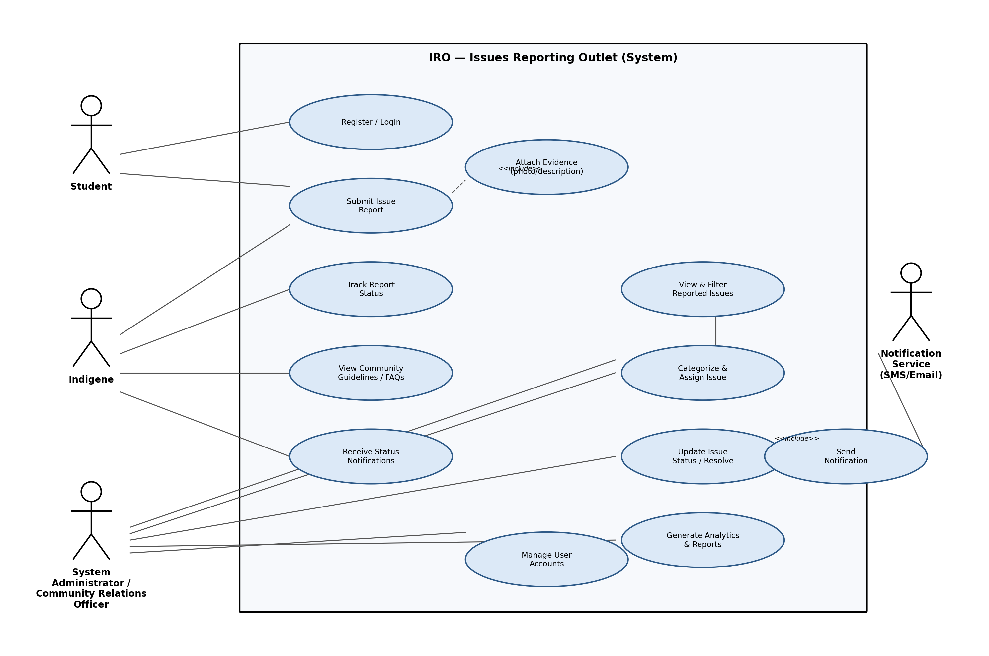
Figure 1 — Use Case Diagram for the IRO System

4.1 Use Case Summaries
Use case | Primary actor(s) | Summary
Register / Login | Student, Indigene | Create or access an account (optional for a first anonymous report).
Submit Issue Report | Student, Indigene | Fill and submit the structured report form; includes Attach Evidence.
Track Report Status | Student, Indigene | Look up a previously submitted report by reference ID.
View Community Guidelines | Student, Indigene | Read FAQs and conduct guidelines before reporting.
Receive Status Notifications | Student, Indigene | Get notified when a report's status changes.
View & Filter Reported Issues | Admin | See all incoming reports with filter/search.
Categorize & Assign Issue | Admin | Confirm/adjust category and assign an owner.
Update Issue Status / Resolve | Admin | Move a report through Pending → In Review → Resolved; includes Send Notification.
Generate Analytics & Reports | Admin | View counts and summaries for management reporting.
Manage User Accounts | Admin | Administer registered accounts.

5. Non-Functional Requirements
ID | Category | Requirement
NFR-1 | Usability | The reporting form shall be completable in under 3 minutes by a first-time user with no prior training.
NFR-2 | Accessibility | The interface shall remain legible and usable on low-end smartphones with small screens.
NFR-3 | Performance | Pages shall load within 3 seconds on a typical 3G mobile connection.
NFR-4 | Privacy | Anonymous reports shall not store or display any identifying reporter information.
NFR-5 | Reliability | Submitted reports shall not be lost even if the reporter closes the browser immediately after submission.
NFR-6 | Availability | The system shall target 99% uptime during university semesters.
NFR-7 | Security | Only authenticated admin accounts shall be able to view the full reporter identity on non-anonymous reports.
NFR-8 | Maintainability | The codebase shall separate the reporting interface, tracking interface, and admin dashboard into independent, testable components.

6. External Interface Requirements

6.1 User Interfaces
- Reporting screen: role selector, anonymity toggle, category dropdown, location and description fields, urgency selector, submit button.
- Tracking / Admin screen: search and filter toolbar, list of report cards with status badges, per-report status control.

6.2 Hardware Interfaces
None beyond a standard internet-enabled device (smartphone, tablet, or computer) with a modern web browser.

6.3 Software Interfaces
- Web browser (client-side rendering of HTML/CSS/JavaScript).
- Notification Service, SMS/email gateway (external dependency in a production deployment).

6.4 Communication Interfaces
Standard HTTPS for all client-server communication in a production deployment, to protect the confidentiality of reported issues, including anonymous ones.

Appendix A. Ishikawa (Fishbone) Root-Cause Analysis
The diagram below documents the root-cause analysis carried out prior to solution design. It identifies six contributing categories to the central problem, ineffective reporting and resolution of issues between AAUA students and host-community indigenes, and directly informed the functional requirements in Section 3 (e.g., the need for a digital reporting channel, status tracking, and a feedback/notification loop).
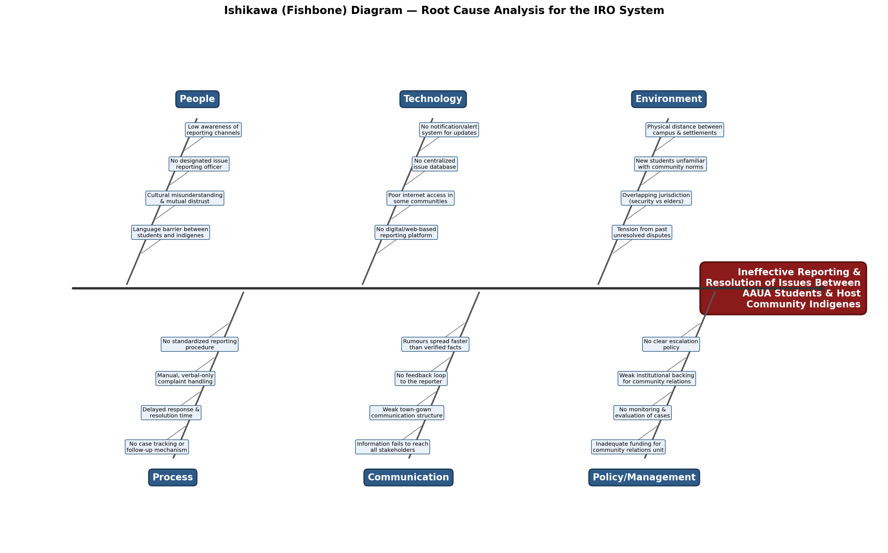
Figure 2, Ishikawa Diagram: Root Causes Behind Ineffective Issue Reporting

Appendix B. Related Deliverables
- IRO_Questionnaire_Design.docx, community needs-assessment questionnaire (for Google Forms).
- IRO_web_app.html, mini web interface prototype implementing the reporting and admin-tracking screens described in Section 3.

