1.下載



2.將下列檔案全部[拉]進專案

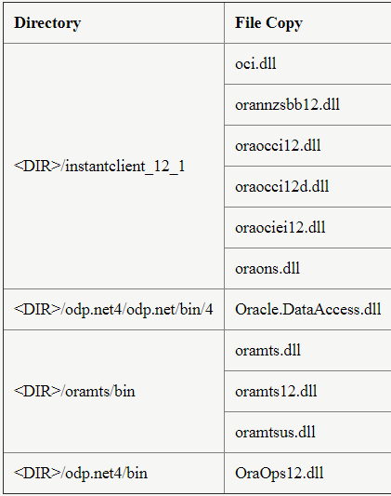

3.參考Oracle.DataAccess

4.寫程式

class OracleDB

{

OracleConnection con;

public String getConnectionString()

{

string host = "";

int port =;

string serve= "";

string user = "";

string password = "";

//組織connectionString

string connString = "Data Source=(DESCRIPTION =(ADDRESS = (PROTOCOL = TCP)(HOST = "

+ host + ")(PORT = " + port + "))(CONNECT_DATA = (SERVER = DEDICATED)(SERVICE_NAME = "

+ serve + ")));Password=" + password + ";User ID=" + user;

return connString;

}

public void query(String sql)

{

this.con = new OracleConnection(getConnectionString());

try

{

con.Open();

OracleCommand cmd = new OracleCommand(sql, con);

OracleDataReader reader = cmd.ExecuteReader();

while (reader.Read())

{

Console.WriteLine(reader[0]);

}

con.Close();

}

catch (Exception ex)

{

Console.WriteLine("Connection ERROR: " + ex.Message);

Console.Read();

return;

}

}

}