**1. Project Description**

The Bill Splitter App is a desktop application developed to assist users in efficiently dividing expenses among participants. Built with PyQt5 for a seamless graphical interface and SQLite3 for reliable data storage, the app provides an intuitive experience for managing group expenses, tracking individual contributions, and ensuring accurate bill splitting.

**2. Objectives**

* Simplify the process of splitting bills among multiple participants.
* Enable efficient tracking and categorization of expenses.
* Ensure accurate calculation of each participant’s share based on total expenses.
* Provide an easy-to-navigate and user-friendly interface.

**3. Features**

* **Participant Management**: Allows adding, editing, and tracking of participants.
* **Expense Tracking**: Supports inputting and categorizing expenses, specifying the amount, payer, and all involved participants.
* **Automatic Bill Splitting**: Calculates each participant’s share based on their involvement in the expenses.
* **Database Storage**: Utilizes SQLite3 for secure and persistent data storage.
* **User Interface**: Built with PyQt5 for an intuitive and responsive UI.

**4. Overview**

**Launching the App**  
Run the app by executing this .bat file:

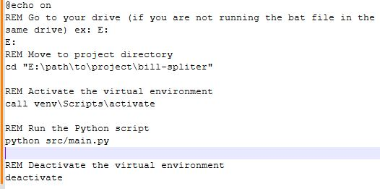

**Main View**  
By default, the app opens with a simple, user-friendly layout:

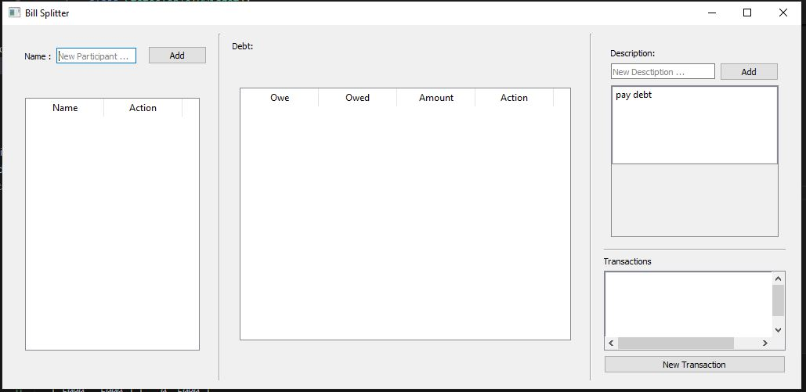

**Adding Participants**  
For example, we add three participants:

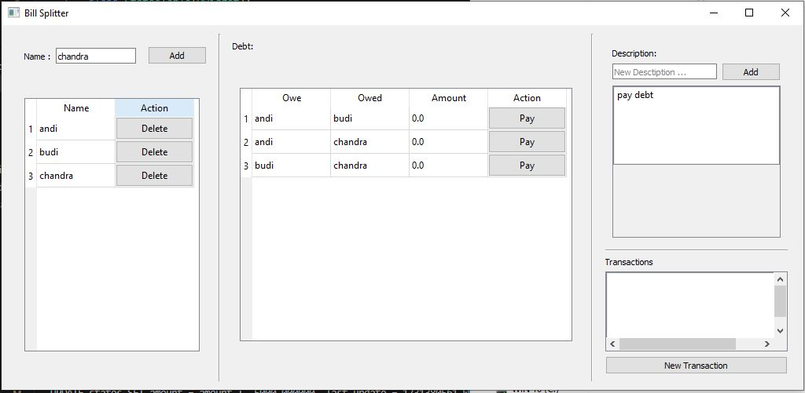

**Adding Spending Descriptions**  
Add a description for the type of expense:

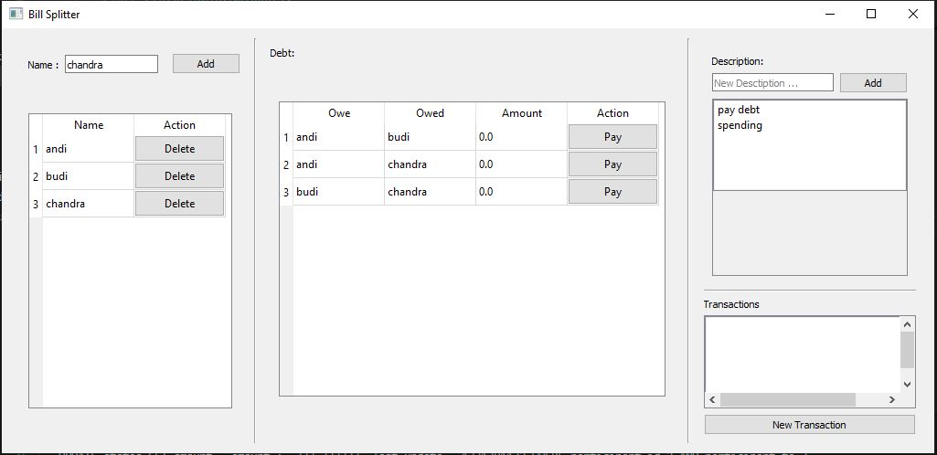

**Entering a New Transaction**  
Add a new transaction. This opens a window to enter details. Suppose Andi and Budi pay 9000 and 3000, respectively, and want to split the bill evenly.

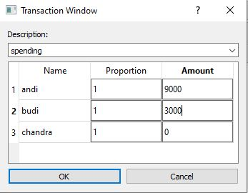

**Updated View After Transaction**  
The main view updates to show the new transaction, displaying each participant's balance and debt automatically:

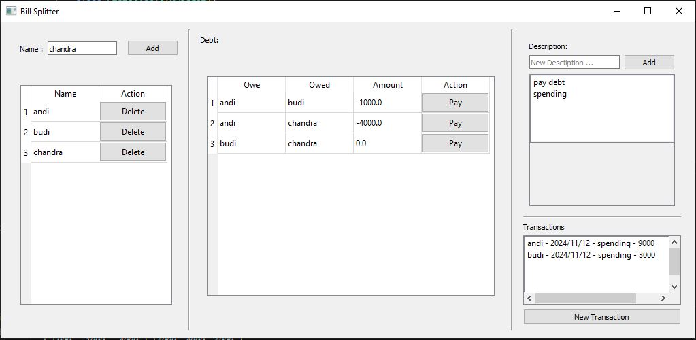

**Making a Payment**  
If Chandra wants to pay Andi 2000, they can click the "Pay" button, which opens this window:

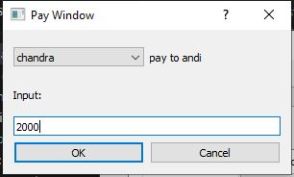

After clicking OK, the balances update accordingly:

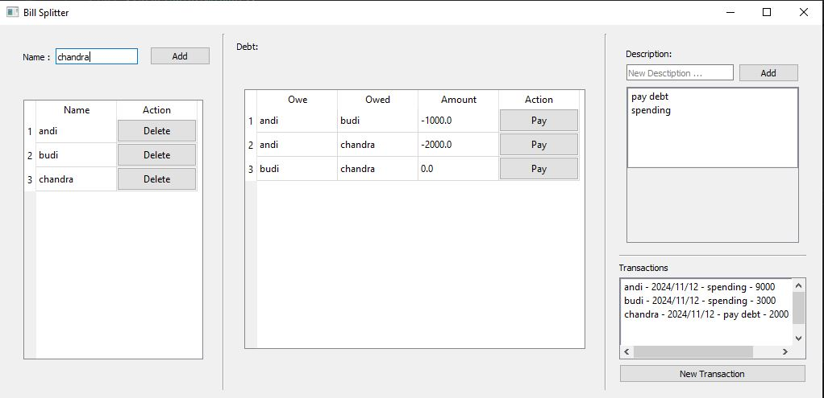

**Removing a Participant**  
To delete a participant, click the delete button. The app retains only active participants' information:

