# How to create a new subsite under a existing site?

1. If you want to create a new subsite (i.e. Papers) under a existing site (Research), access the Research page first.
2. From the top right hand corner, select the settings icon --> Site contents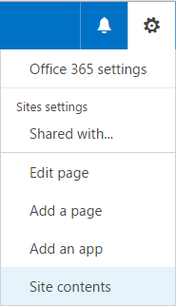
3. Click on the button
4. Enter a title, description, URL name. Select a template. Keep the User permissions as default. Select "Yes" for the "Use the top link bar from the parent site" option
5. Click on the "Create" button
6. From the top right hand corner, select the settings icon --> Site settings 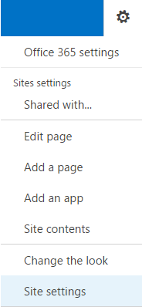
7. Under the Look and Feel section, select the Navigation 
8. Select the following as shown in the following image

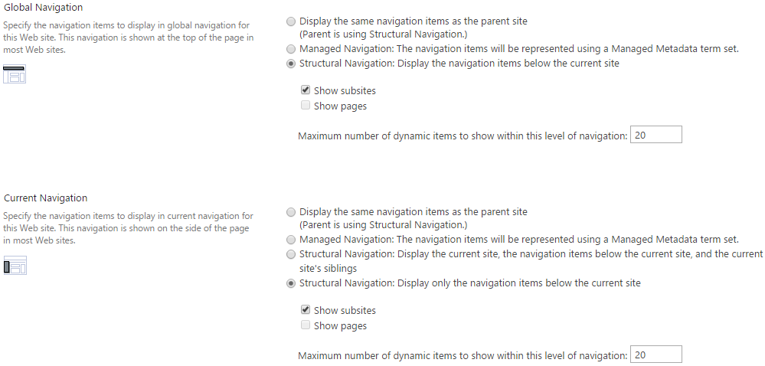

1. Click on Ok button

# Delete a subsite

1. Access the subsite that you wish to delete. Example you wish to delete Papers subsite under Research. **MAKE SURE YOU ARE IN THE "Papers" subsite FIRST**
2. From the top right hand corner, select the settings icon --> Site settings 
3. Under the Site Actions section, select Delete this site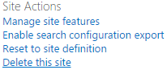
4. Click on the Delete button
5. You will need to go to the main page again

# Add/Edit Navigation links

1. Some things to note:  
   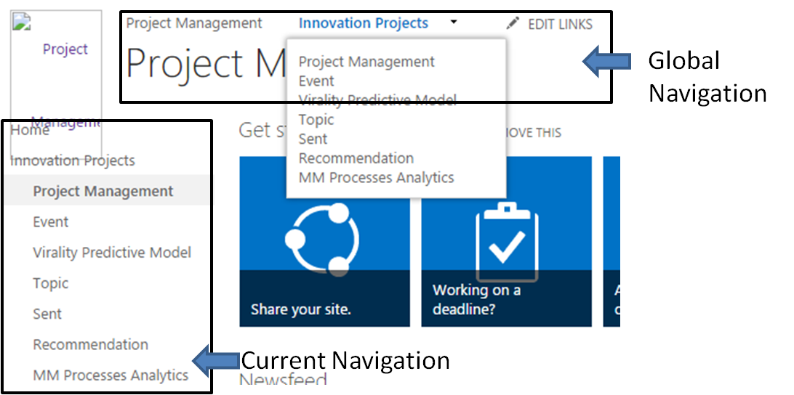
2. Access to the subsite you wish to modify the global and current navigation
3. From the top right hand corner, select the settings icon --> Site settings 
4. Under the Look and Feel section, select the Navigation 
5. Follow the following image on creating the navigation links (You will need to enter a

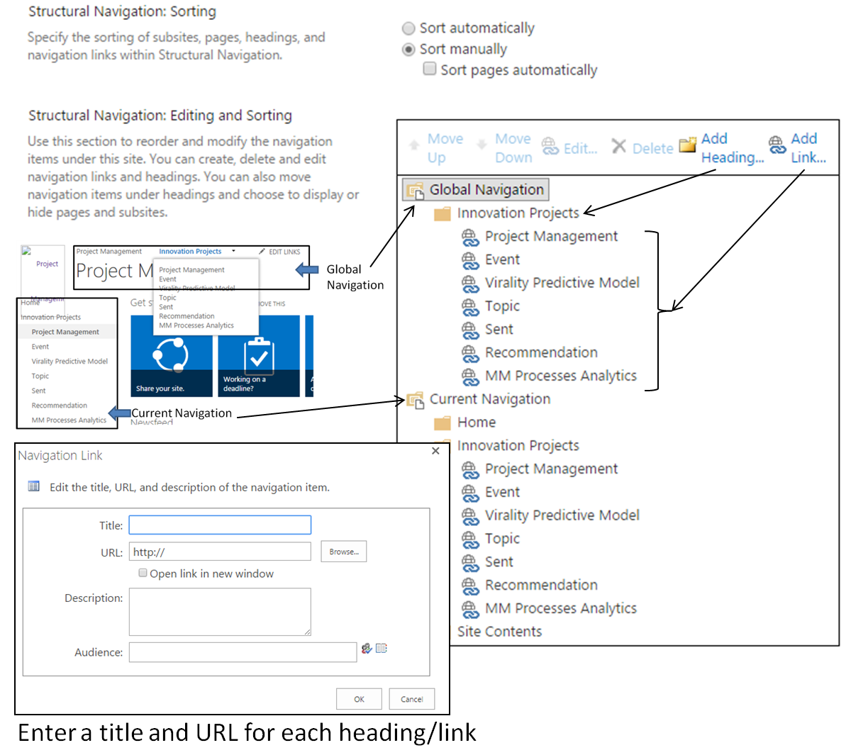

1. Once done, Click on OK.