Smart Radio Ethernet Test Board

# Overview

The Smart Radio Ethernet Test Board is designed for quick evaluation of Doodle Labs Smart Radios. The Ethernet Test Board is designed to support Smart Radio **V3** hardware. It provides two RJ45 connectors, power supply, and a factory reset button, and multiple low-speed I/Os.

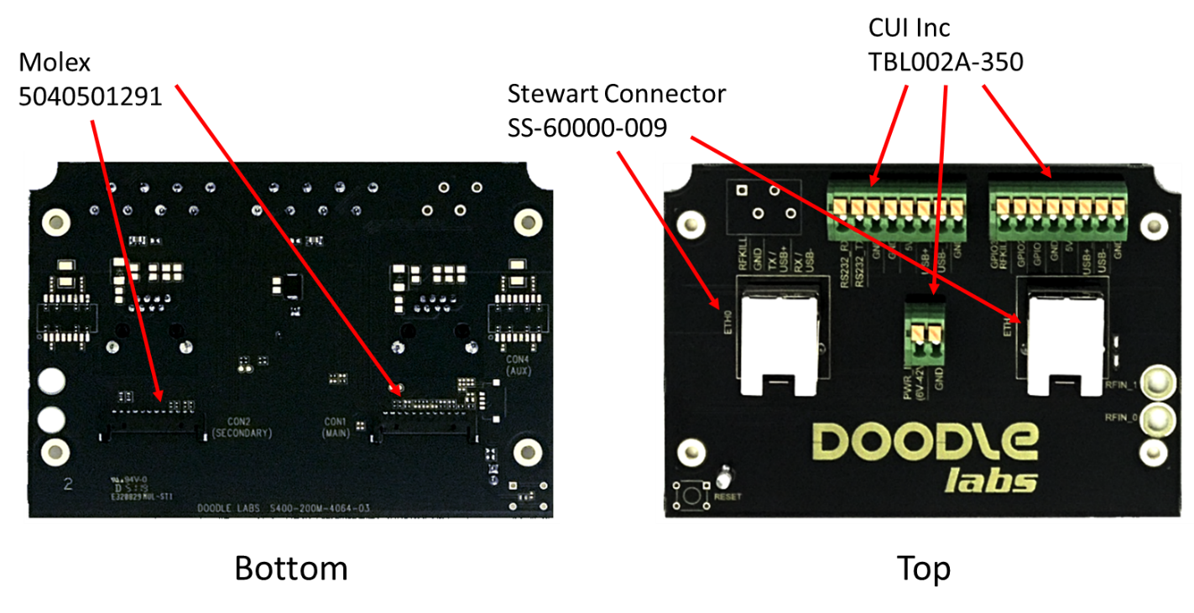

# Technical Specifications

|  |  |
| --- | --- |
| Dimensions | 115x80x25 mm |
| Ethernet Connectors | RJ45 |
| Wire Connectors | TBL002A-350 |
| Smart Radio Connector | Molex 5040501291 |

# Smart Radio Wiring

The photo below shows how the Ethernet Test Kit should be wired to The Smart Radio. Please take note of the orientation.

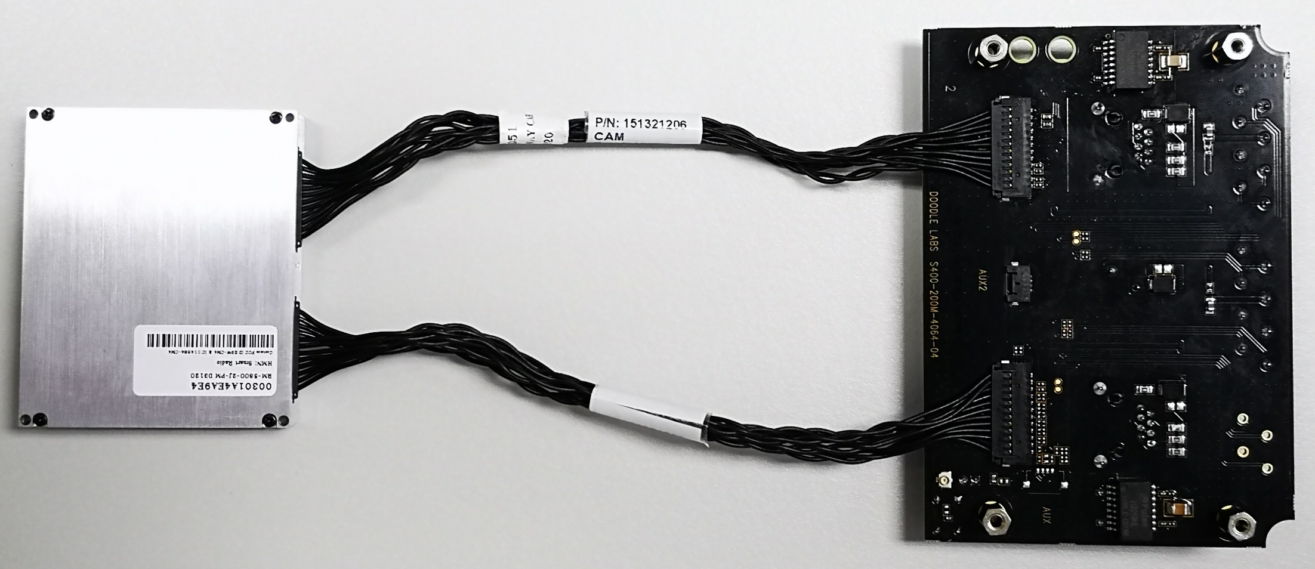

# POE Wiring

Eval Kit version 3 supports passive POE on either RJ45 connector. Diodes are used the RJ45 connectors and the main power connector to prevent damage in case of faulty wiring.

