Autonomous Vehicle Design, Spring 2020

Homework 5, MPU6050 Orientation Angles

Total Points, 40 required plus optional 15 extra credit

**1. Complementary Filter (40 points)**

Use python to plot the angles given by the accelerometer, gyro integration, and complementary filtered outputs to provide a visual comparison. Plot the roll, pitch, and yaw angles on separate plots. The roll and pitch plots should each show the angle calculated by the accelerometer, gyro integration, and the complementary filtered output. The yaw angle is only calculated by the gyroscope integration, so it will be single line on its own plot. Plot the data in real time.

Provide a written summary of your experimentation.

* Drift – How much does the orientation drift?
  + Start with the sensor in a static position, with a known orientation. Move the sensor around and then return it to its original position.
* Vibration – how does vibration affect each of the angle outputs?

Submit:

* Arduino & python source code
* Written summary of experiment and results
  + Include details such as sample rate, baud rate, calculated zero bias offsets, etc.
  + General description of the experiment
  + Include plot(s)
    - Showing drift results
    - Vibration results

Use your Arduino MPU6050 code from the previous homework assignment, updated for any additional functionality required for this assignment.

**2. Roll, Pitch 3D Visualization with vpython (15 points extra credit)**

Write a python program that uses the vpython library to create a 3D visualization of the MPU6050 roll and pitch orientation. Some sample images below are included to provide ideas. The design is your creative choice.

There are several good online tutorials for vpython. Toptechboy has a good series for working with IMU’s and data visualization with vpython, starting here <http://www.toptechboy.com/arduino/9-axis-imu-lesson-13-introduction-to-visual-python-vpython/>

Installing vpython in Ubuntu 18.04, <https://techforcurious.website/install-vpython-7-python3-ubuntu-18-04-bionic-beaver/>

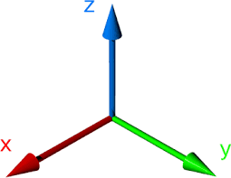

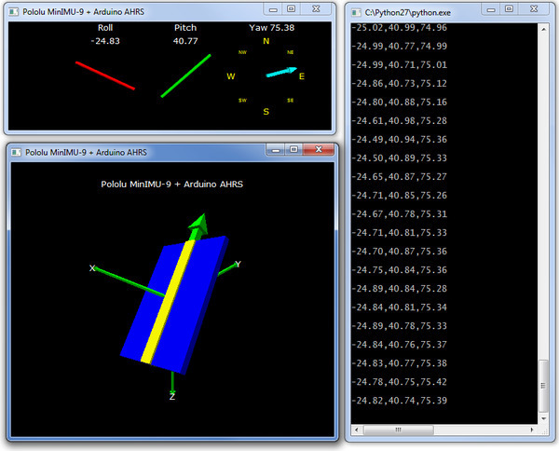

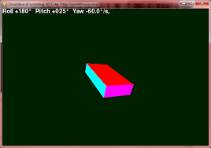

Submit:

* Arduino & python source code (note: if your Arduino source code is the same for both problem 1 and 2, just submit one copy)
* Screenshot of 3D visualization

**Submission Summary**

|  |  |  |
| --- | --- | --- |
| Problem 1 | Source Code: Arduino & python | Written analysis |
| Problem 2 | Source code: Arduino | Screenshot |

***If any program is not complete or if it is not working correctly, submit a text file detailing what works, what is missing, and what is broken.***