OOK – Recognizing Preamble and Payload Binary Data
8/28/18

Objectives
- Human recognition of preamble and payload data

Human recognition of Preamble Data

File name: rx_preamble.grc

RF data source: scan_00_c313M_s8M.iq

Location: https://github.com/willydlw/sdrgnuradio/tree/master/ook/

The flowgraph image is shown below. It is the same flowgraph as rx_clean_binary with the following changes:
- Set the File Source repeat to No so it only reads through the file once.
- The gui sinks shown in darker gray have been disabled.
- The gui sink Y axis is scaled to Y min: -0.1, Y max: 1.5.

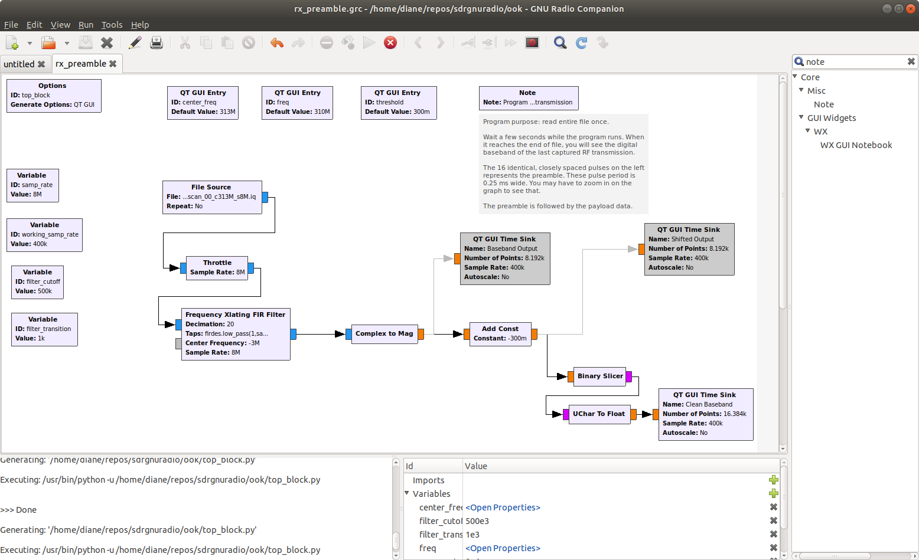

Running the flowgraph generates the output shown below. As the program runs, the user must wait a few seconds while the entire file is processed. After all file data is read, the data shown below is the last data transmission.

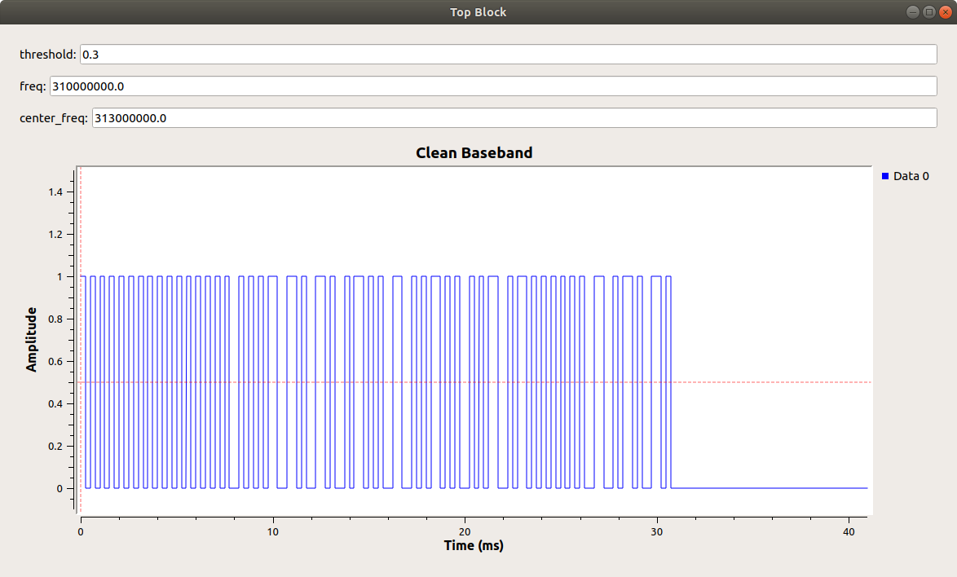

The 16 evenly spaced pulses on the left are the preamble. Zooming in on that section produced the image below. It is observed that the pulse period is 0.50 ms. The pulse is high for 0.25 ms and low for 0.25 ms.

The preamble allows us to determine the start of a data transmission. It can be used to establish the timing of individual bits for the rest of the transmission.

The preamble is followed by the data, also known as the payload. The next example will attempt to extract the payload data.

