Differential Binary Phase Shift Key Modulation & Demodulation Simulation
Using gnuradio DPSK mod/demod blocks
September 9, 2018

Objective: Simulate DBPSK modulation and demodulation using
- Vector Source
- Packet Source
- File Source

Binary Phase Shift Keying (BPSK)

In BPSK, “0” and “1” are represented by

The information is carried by the phase of the carrier. Coherent demodulation can be performed by the matched filter or the correlation receiver. To coherently demodulate BPSK signals, the timing of the pulse, the carrier frequency, and the channel phase response must be known.

Differential Binary Phase Shift Keying (DBPSK)

DBPSK allows signal demodulation without knowing the absolute phase, just the relative phase.

DBPSK modulates the data onto the phase change of the carrier. A phase change of π across adjacent symbol intervals represents the bit value “1” while no phase change across adjacent symbol intervals represents “0”. DBPSK is a two step process. First, the data is differentially encoded. Then the resulting coded sequence is modulated with BPSK. Given a data sequence { b_{j} } consisting of 0’s and 1’s, we obtain the differentially encoded sequence {c_{j} } according to the following rule:

This is modulo 2 addition (the XOR operation). In Figure 1 below, the initial output symbol has been arbitrarily set to “0”. The input sequence is {1, 1, 0, 0, 1}, the output sequence is {0, 1, 0, 0, 0, 1} Modulating the coded sequence with BPSK produces the DPSK signal.

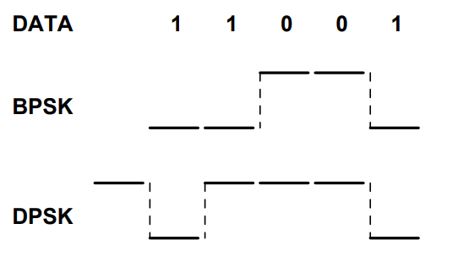

Figure 1: http://wireless.ece.ufl.edu/twong/Notes/Comm/ch2.pdf

DPSK Mod Block

RRC-filtered DQPSK modulation

Input is a byte stream (unsigned char)
Output is the complex modulated signal at baseband

DPSK Demod Block

RRC-filtered DQPSK demodulation

Input is the complex modulated signal at baseband
Output is a stream of bits packed 1 bit per byte (LSB)

Vector Source Flow Graph

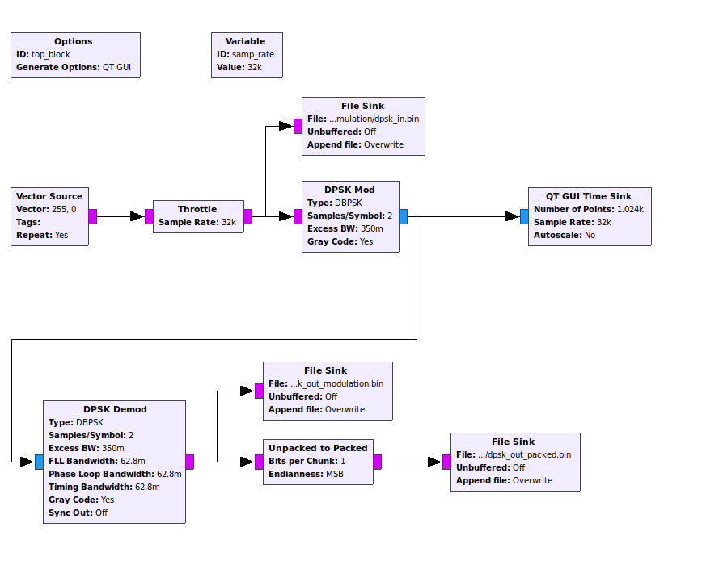
Figure 2: Simple DPSK modulation and demodulation system

The Throttle block limits the maximum throughput to avoid using 100% of the CPU resources. This block is used for simulation only and is not needed in flow graphs where the hardware limits processing speed.

The File Sink blocks are used to record the transmitted and received bytes for later comparison.

Simulation 1: Vector Source (255, 255)

The first simulation transmitted a pattern where all bit values were 1’s. This was to illustrate the the DPSK mod block switches between {-1, 1} for binary 1’s. Figure 3 shows the time sink output, illustrating that the modulated output does indeed switch between { -1, 1 }.

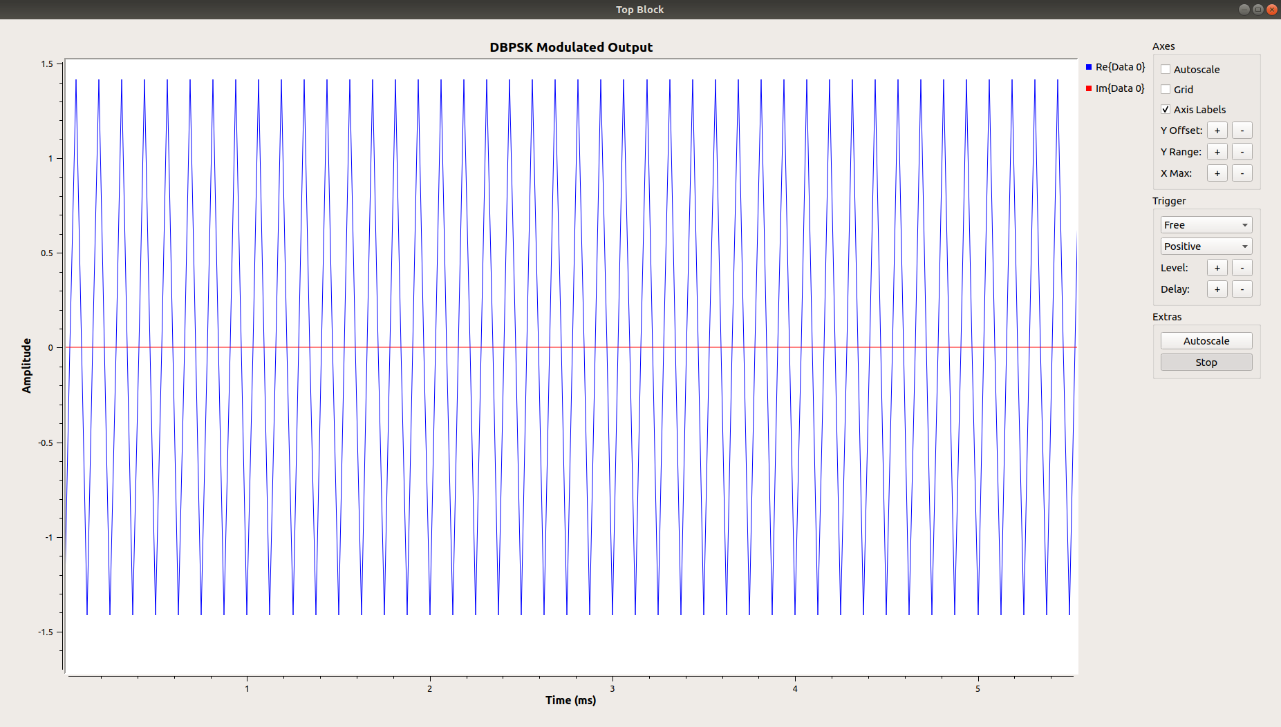

Figure 3: DPSK Modulated Output for Vector Source Input (255, 255)

Figure 4 below shows a hexdump of the input and output data recorded in the files. The files dpsk_in.bin shows the expected input pattern of ffff. The file dpsk_out_packed.bin shows the contents of the demodulated packed data. The data does not match the input perfectly. The 0000 0100 edbf is found at the start of the output file. The rest of the output data matches the ffff pattern of the input file.

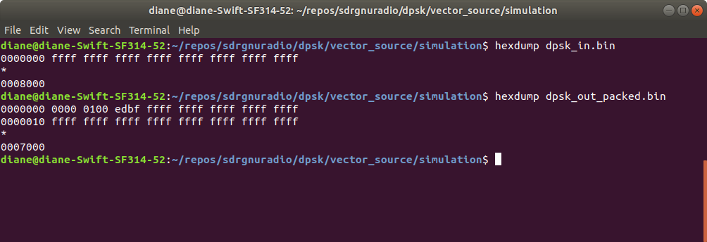
Figure 4: File Sink data, hexadecimal

Subsequent tests show that the demodulated output data does not match the original vector source input data.

Simulation 2: Vector Source (0, 0)

Figure 5 shows the complex modulated signal for all 0’s has a real value of -1 and a complex value of 0.

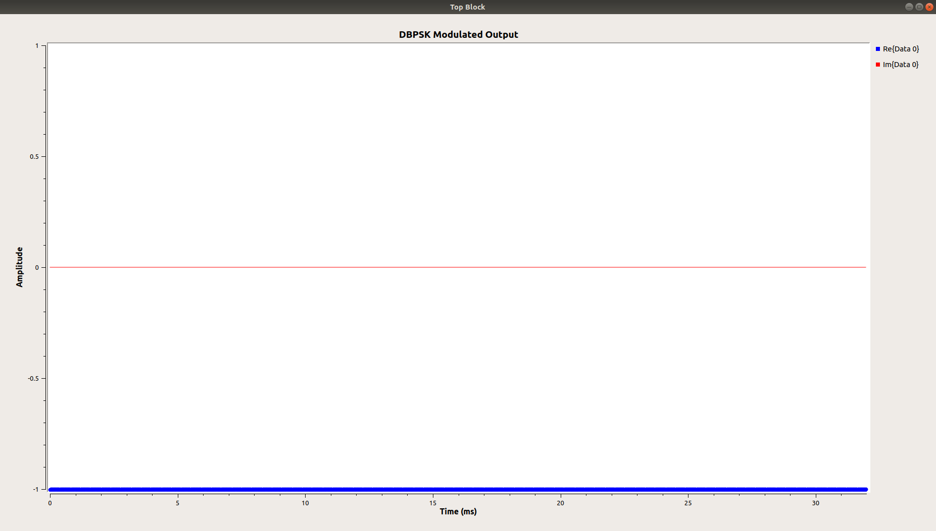
Figure 5: Modulated Output for all 0 input

Figure 6 shows the demodulated output data has some non-zero bits at the start of the output file and the rest of the file output correctly matches the input data.

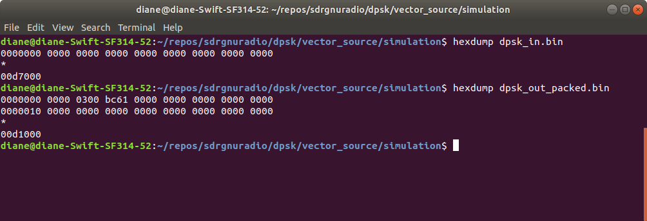
Figure 6: File Sink data, hexadecimal

Simulation 3: Vector Source (255, 12)

Figure 7 shows the modulated output for the source input 255, 0. The integer value 255 is binary 1111 1111. The integer value 12 is binary 0000 1100. For these bit values, we see the signal switches between -1 and 1 as expected. For the 0’s, the signal stays near -1, but there is some ringing.

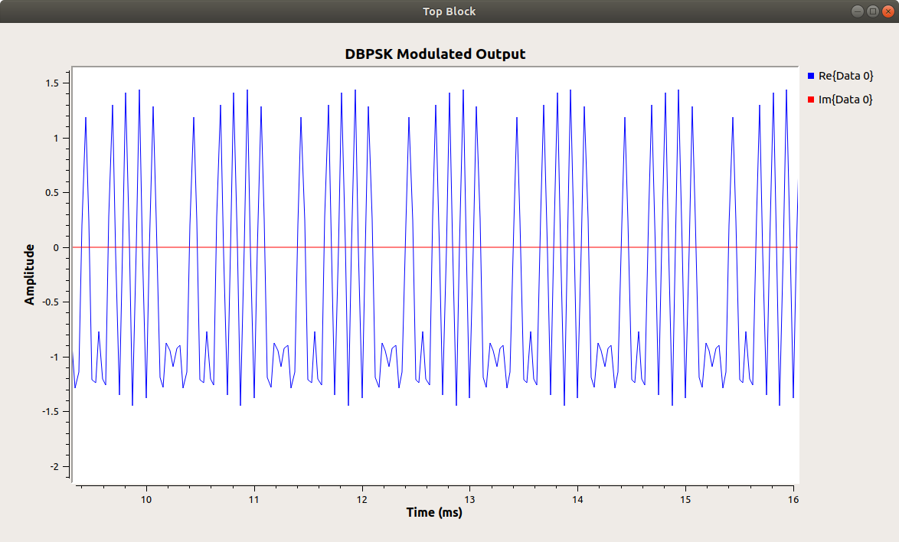

Figure 7: Modulated Output for all 255, 12 input

Figure 8 shows the input data as 0cff, not the expected ff0c. It appears the first byte may not have been written or processed. The demodulated output data has garbage values for the first few bytes and then shows a aptter of 33fc, not at all what was expected.

33fc is binary 0011 0011 1111 1100

We have a repeating binary pattern of 0011 0011 1111 1100 0011 0011 1111 1100 …

If we remove the two leftmost bits 00, we then have the following pattern: 1100 1111 1111 0000 1100 1111 1111 0000 1100.

Now if we remove the leftmost 1100, we have the expected output pattern 1111 1111 0000 1100 ….

It appears that the vector source pipeline may have some garbage that has not been cleared when processing starts.

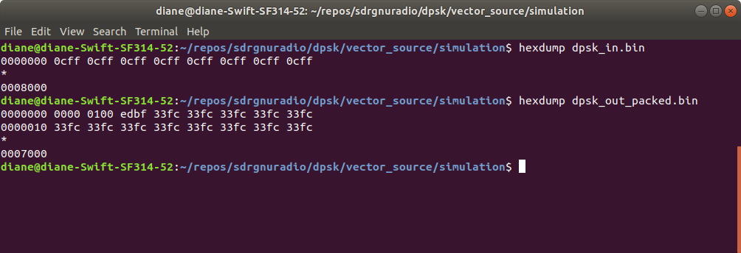

Figure 8: File Sink data, hexadecimal

At this point, it appears the vector source is problematic for simulation and will not work at all for real-time hardware transmission and reception. The received data will not match the transmitted.

A packet encoder and decoder will be added to the flow graph to see if this improves performance.

