Differential Binary Phase Shift Key Modulation & Demodulation Simulation
Using gnuradio DPSK mod/demod blocks
September 12, 2018

Objective: Simulate DBPSK modulation and demodulation using
- File Source
- Packet Encoder/Decoder
- DPSK Mod/Demod

File Name: file_source_packet.grc

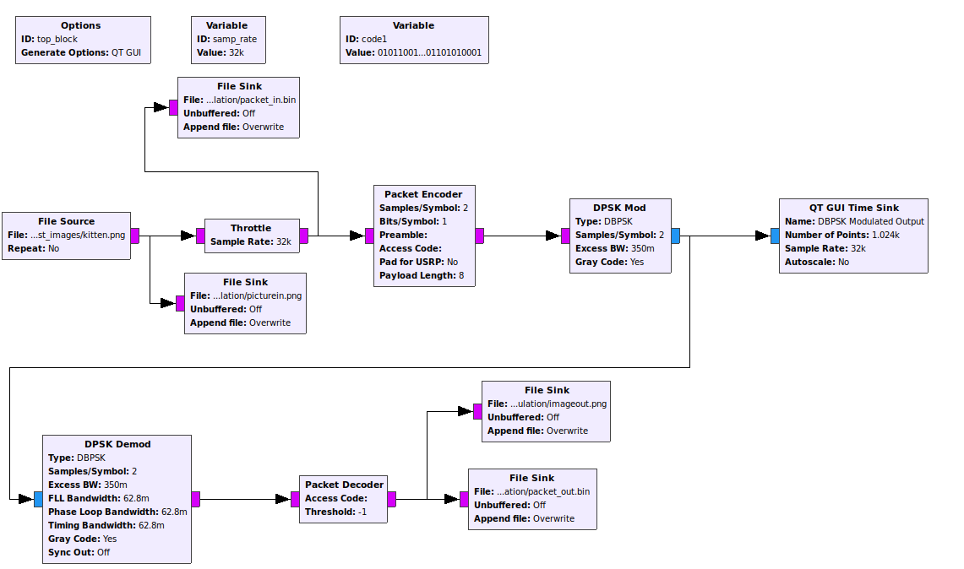
Figure 1: file_source_packet.grc flow graph

Case 1: File Source, kitten.png

Packet encoding/decoding
- preamble – default value
- payload length - 8
- access code – default value
- samples/symbol – 2
- bits/symbol - 1
- pad for USRP - No

DBPSK mod/demod
- samples/symbol - 2

The input data source is the image shown in figure 2. The image file format is png. It is 56259 bytes.

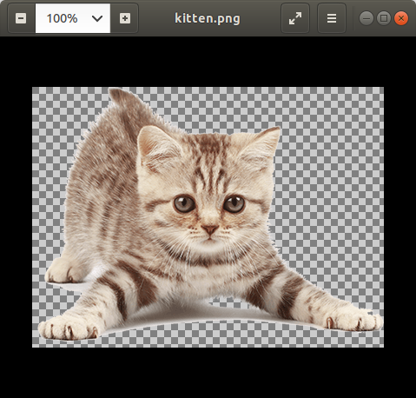

Figure 2: File Source Input Test Image, kitten.png

The data read from the file is saved in two different files: packet_in.bin and picturein.png. The packet_in.bin file contains the binary data read from the source file kitten.png. The picturein.png file records the same data, but in a viewable png format.

Figure 3 shows the recorded image. Note that the entire image is not read into the flow graph, as evidenced by the gray area at the bottom of the image.

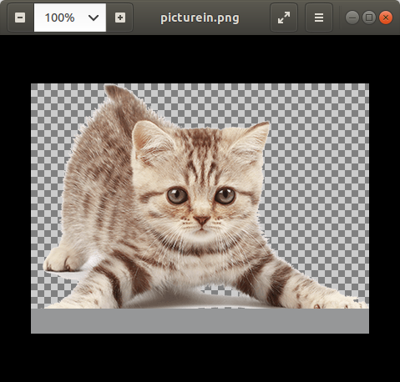

Figure 3: Read from source file

After data is read from the source file, it is encoded into packets containing a preamble, the payload, and an access code. Next, the data enters the DBPSK modulator, then is immediately demodulated, and sent to the packet decoder. The packet decoder output is saved in two files: pictureout.png and packet_out.bin.

Figure 4 shows the output image, pictureout.png. Visually, it appears to be the same as picturein.png.

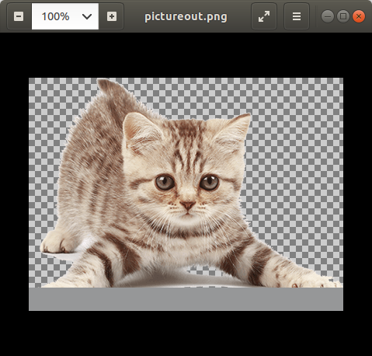

Figure 4: Decoded image, pictureout.png

To ensure the input and output images were the same, the two binary files, packet_in.bin and packet_out.bin were converted to hexadecimal and compared.

Linux commands:
xxd packet_in.bin in.hex
xxd packet_out.bin out.hex
vimdiff in.hex out.hex

Figure 5 shows no differences in the two files. Both files were the same number of bytes.

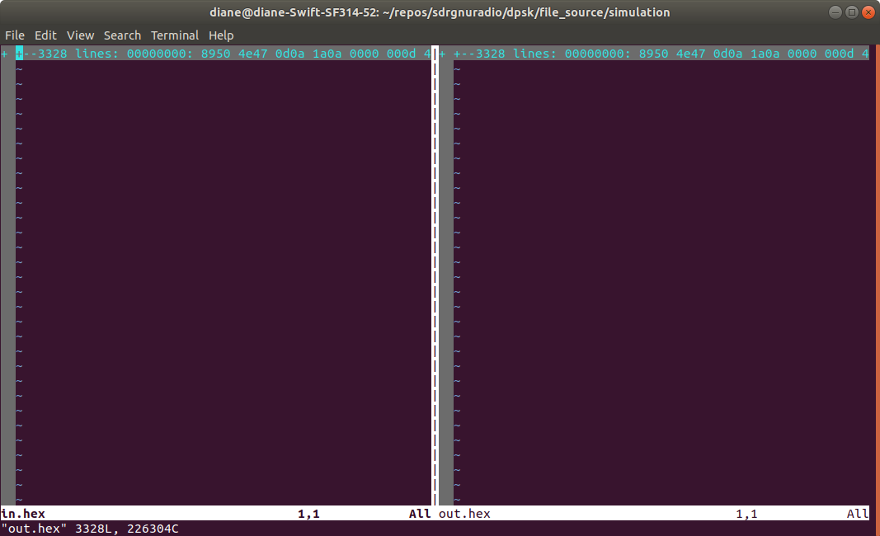

Figure 5: No differences shown when comparing in.hex to out.hex

In this case, the simulation produced the same output as input. The one problem encountered was that the entire file is not read into the flow graph. The cause of this error will be investigated and corrected.

Other tests were run, varying the payloadlength at values of 0, 1, 4, and 8, but the output results were the same. The simulation ran more quickly when the 0 value for automatic was used.

Case 2: file source, duck.png

The same flow graph used in case 1 above was used to test a larger image, duck.png, 1812531 bytes.

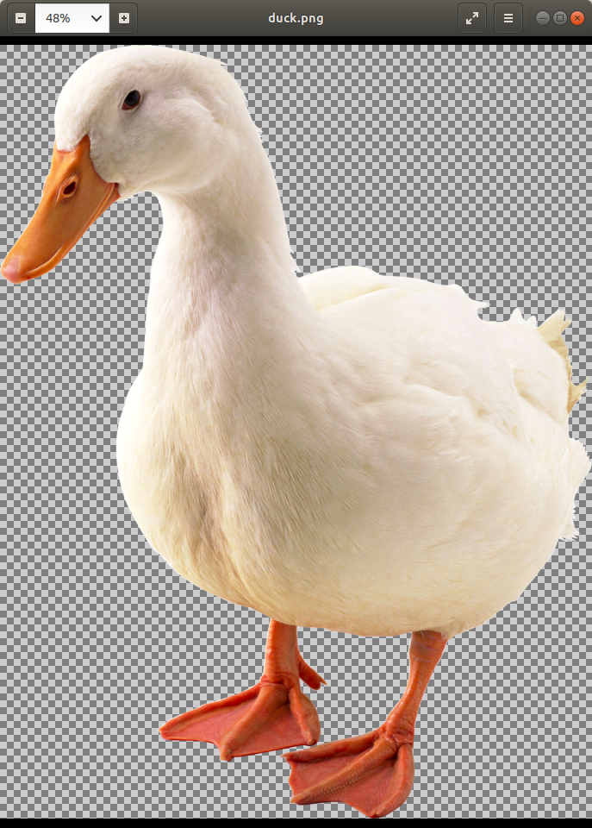

Figure 6: Source Image, duck.png

Figure 7 below shows that not all of the source image file was read into the flow graph, as also seen in case 1. It does appear that most of the image was read, more so than in case 1.

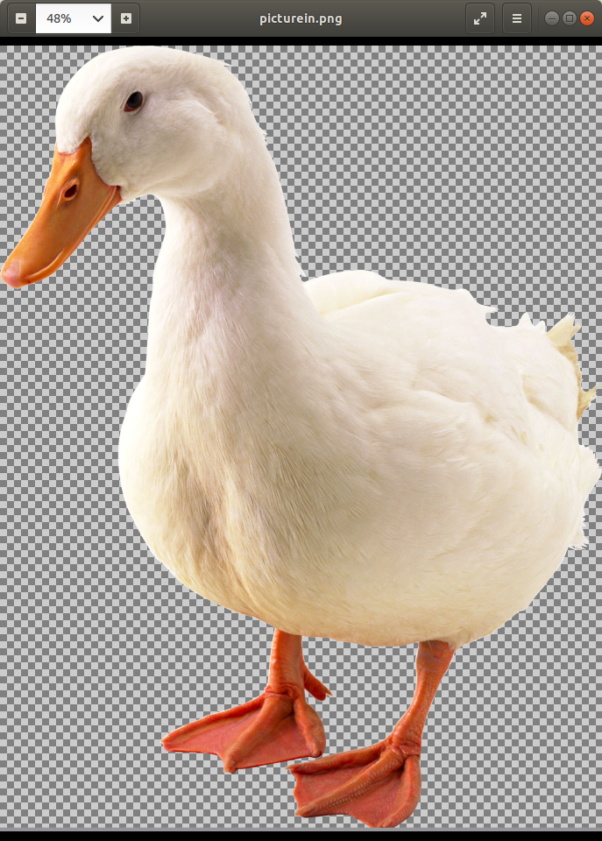

Figure 7: read from source file

The flow graph does not produce a png image that can be opened and viewed. The packet_in.bin and packet_out.bin files are the same size: 1810432 bytes. A difference occurs in the file at the last byte position of 0000ffe0. The input byte is 03, whith the output byte is 78. Looking at the data, it appears this 78 is an extra byte, wth the next sets of bytes in the file matching for several lines if the 78 is removed.

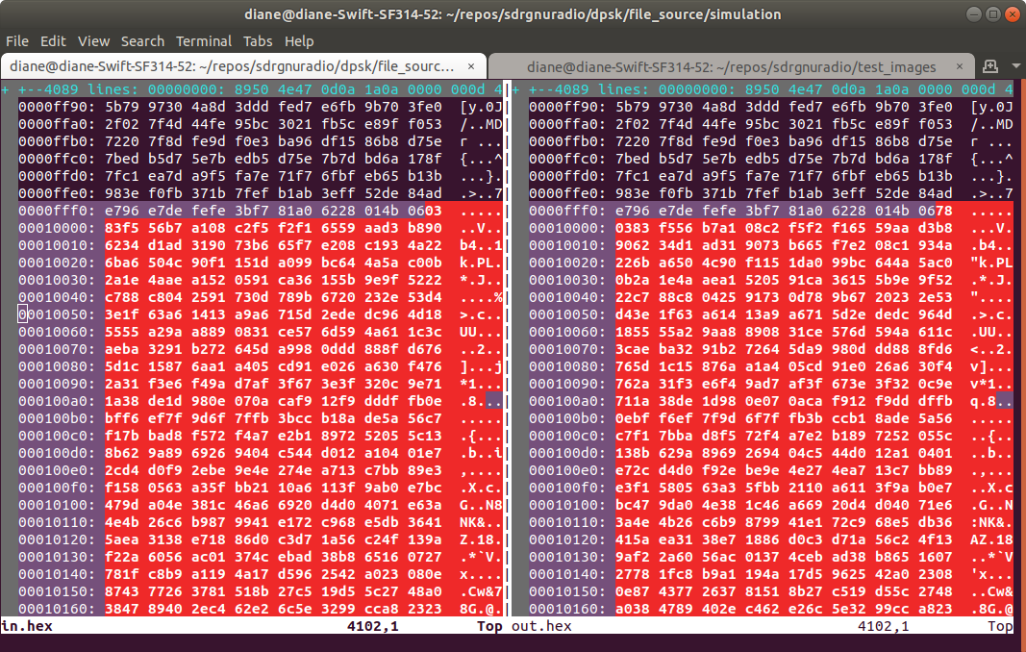

Figure 8: Data byte mismatch

This is cause for concern if we are trying to push this much data through.

