GMSK Modulation, Bandwidth-Symbol Time Product, BT
10/20/18

What is the BT (Bandwidth-Time) product? (https://dsp.stackexchange.com/questions/30653/what-is-a-bt-bandwidth-time-product-with-reference-to-modulation)

B is the -3dB (half-power) bandwidth of the pulse/filter and T is the symbol duration.

Example: Assume 1 bit per symbol, then T (symbol duration) corresponds to bit time.

For BT = 1, the pulse shaping the symbol spreads over one bit period duration.
For BT = 0.25, the pulse shaping the symbol spreads over 4 bit periods.
For BT = 0.3, the pulse spreads over approximately 3 bit periods.

When the spectrum is compact, smaller BT values result in ISI (inter-symbol interference). Values for BT must compromise between ISI in the time domain and power spectrum roll-off in the frequency domain.

Relationship between bit rate, Rb and Gaussian filter cutoff frequency:

GMSK Modulation Simulation

Broadcast Frequency: 100 MHz
Bandwidth: 4 MHz
Payload Length: 16 bytes

The time-bandwidth product, BT, is the principle parameter used to design the Gaussian filter applied to the signal before it is modulated. The power spectrum rolls off quickly for smaller values of BT. This is shown in figures 1, 2, and 3 below.

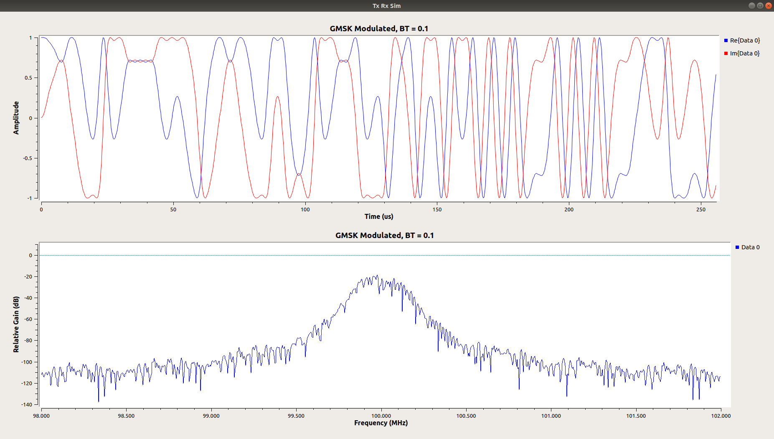
Figure 1, BT = 0.1

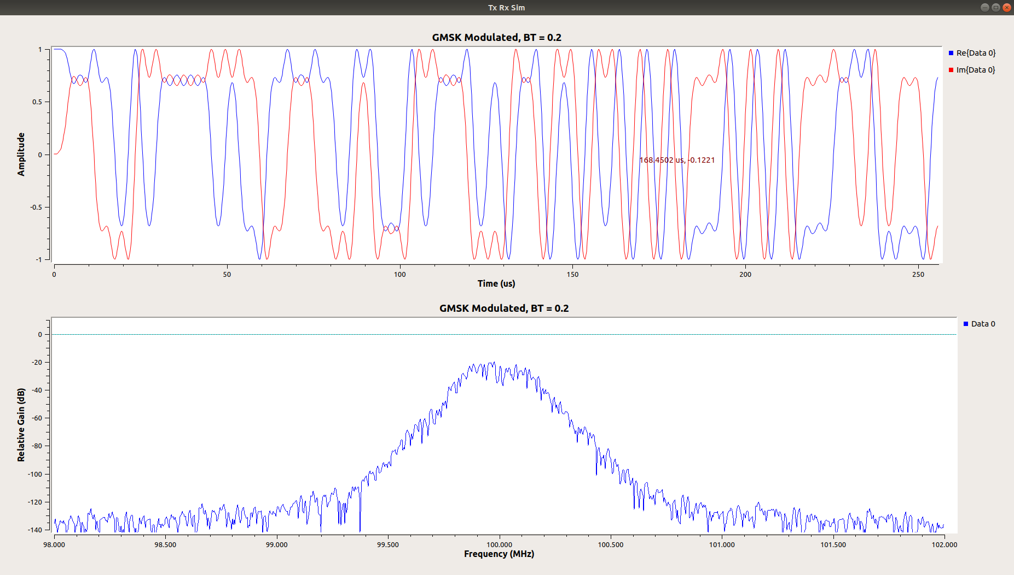
Figure 2, BT = 0.2

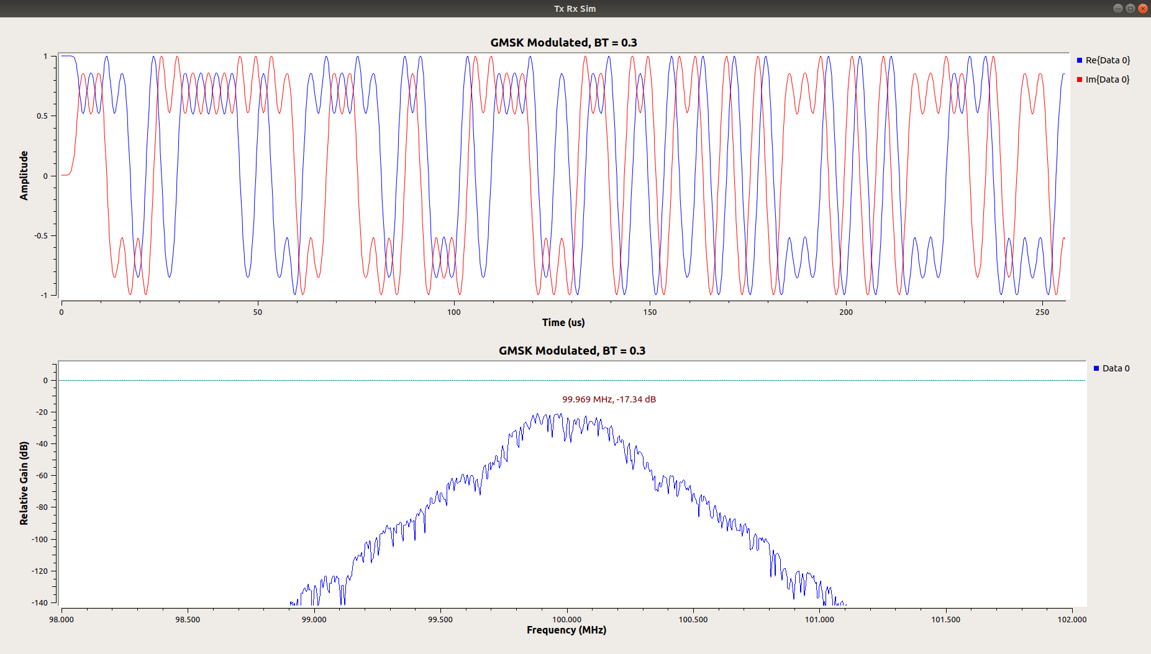

Figure 3, BT = 0.3

