Vector Source Behavior – gnuradio

Objective: understand the behavior of a vector source and its output related to sample rate. It will be shown that for a byte data type, there is a one to one correspondence between sample and symbol. Each time the vector source input is sampled, the next byte symbol is the sample value.

Flowgraph

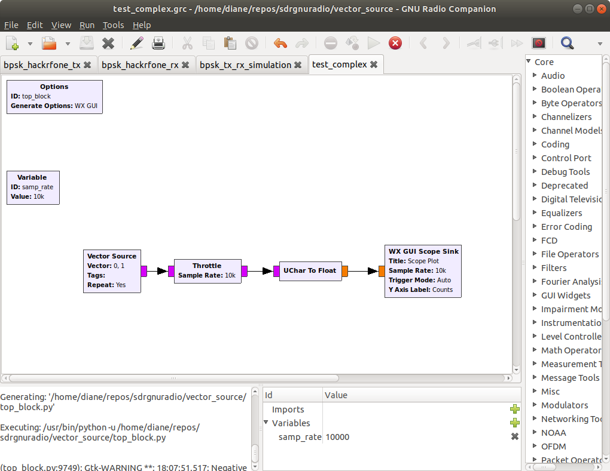

Variables

samp_rate 10e3

Vector Source Block

Vector: 0,1
Repeat: Yes
Data Type: Byte

Behavior: Provide the source input pattern: 01 and repeat over and over

Throttle Block

Sample rate: samp_rate

Throttle block is used in the simulation only, recommended to avoid over-taxing CPU resources.

Uchar to Float – converts the unsigned char to a floating point data type. Needed to display values on the Scope Sink. Scope Sink cannot handle the byte data type.

WX Gui Scope Sink Output – Vector Source Input 01, Sample Rate 10e3

The sample rate variable is 10e3, 10000 samples/second. Figure 1 below shows the vector source repeating pattern of 01.

Scope Sink Output

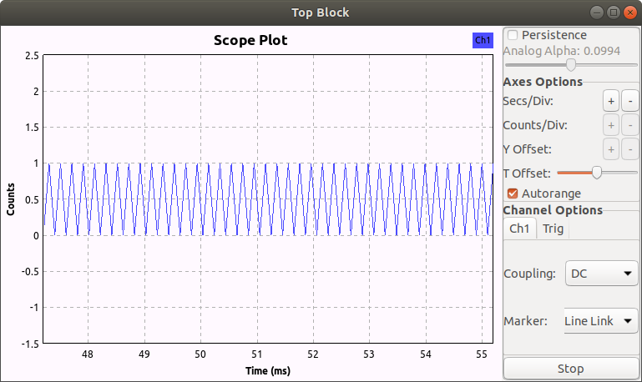
Figure 1: Vector Source Output, Sample Rate 10k

Changing the markers to large dots, from the linked lines shown in Figure 1 above, we see the individual samples in figure 2 below. Both figures confirm that the vector source block output is alternating between 0 and 1.

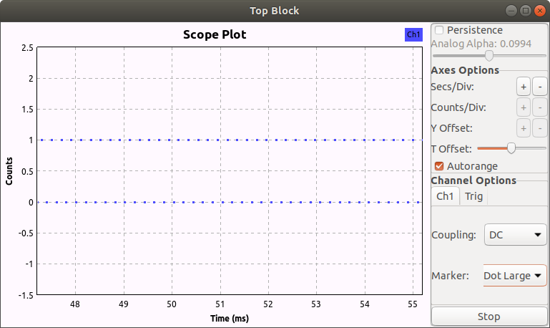

Figure 2, Vector Source Output, Dots are individual samples

Zooming in, figures 3 and 4 below, show that the approximate time between samples is 0.1 ms. This confirms the vector source output is close to the sample rate 10,000 samples/second, which has a time period of 1 second/10,0000 samples = 0.0001 s = 0.1 ms.

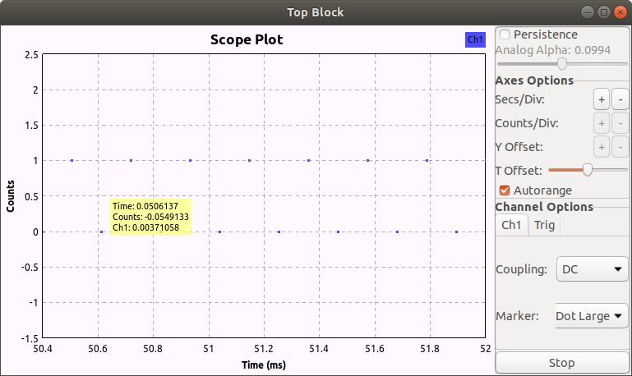
Figure 3: zero sample value at time 50.6 ms.

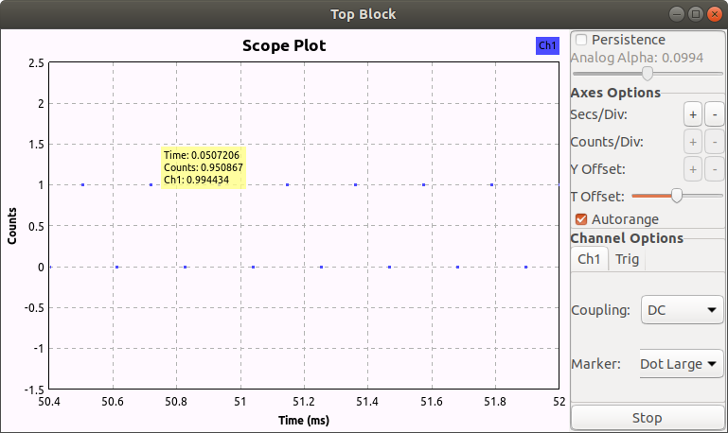
Figure 4: one symbol value at time 50.7 ms.

Elapsed time: 50.7 ms – 50.6 ms = 0.1 ms.

WX Gui Scope Sink Output – Vector Source Input 0110, Sample Rate 10e3

The vector source input pattern is now 0110, repeating. The sample rate variable has not been changed. It is still 10e3, 10000 samples/second. Figure 5 below shows the vector source repeating pattern of 0110.

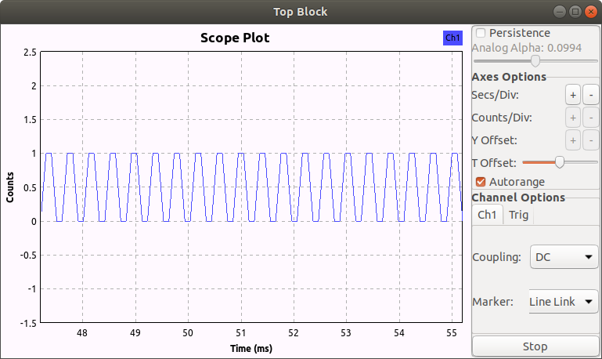
Figure 5: Vector Source Output 0110, samples linked by lines

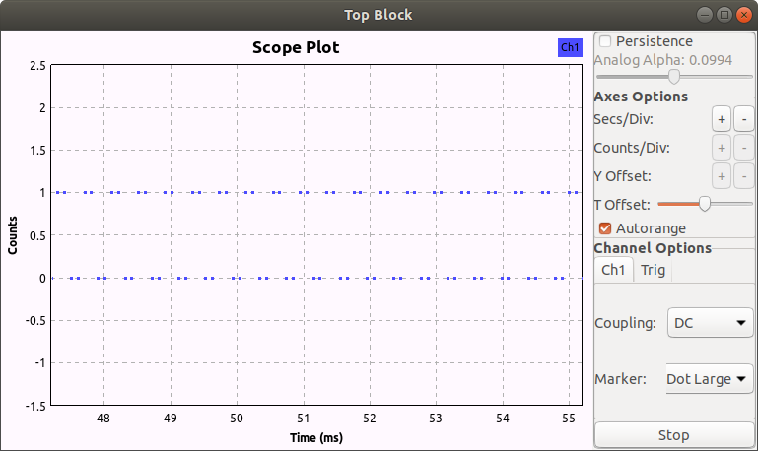

Figure 6: Vector Source Output 0110, Samples shown as dots

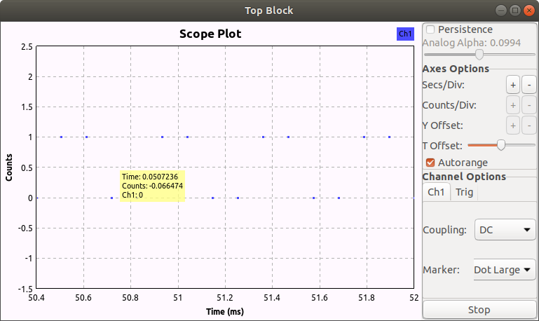

Figure 7: Zero symbol at time 50.7 ms

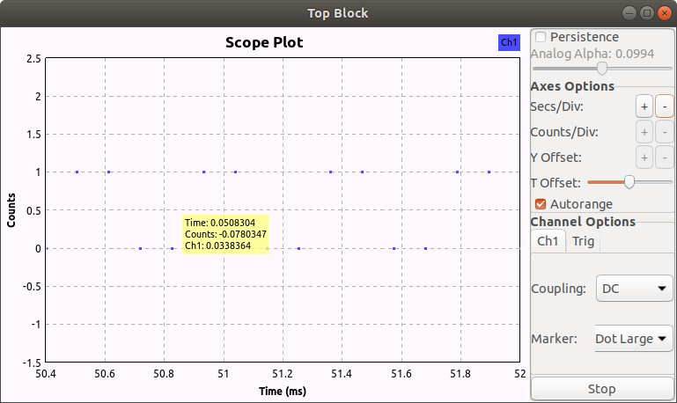

Figure 8: Zero symbol at time 50.8 ms

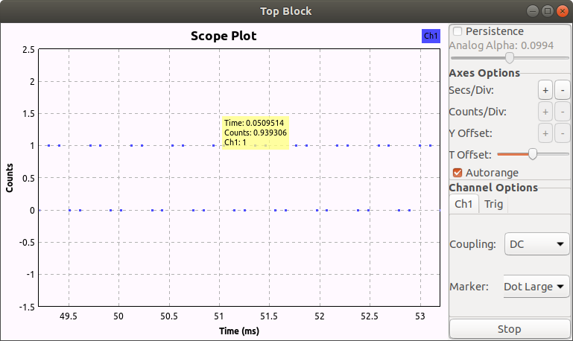

Figure 9: One symbol at time 50.9 ms

Figures 7, 8, 9 illustrate there is a 0.1 ms difference between each sample, matching the sample period.

WX Gui Scope Sink Output – Vector Source Input 01, Sample Rate 8e6

The vector source input pattern is 01, repeating. The sample rate variable is 8e6 or 8,000,000 symbols/second, which has a period of 0.125 micro seconds.

Figures 10 and 11 below show there is slightly more time than the expected 0.125 micro seconds between symbols. The output pattern is the expected 01 repeating.

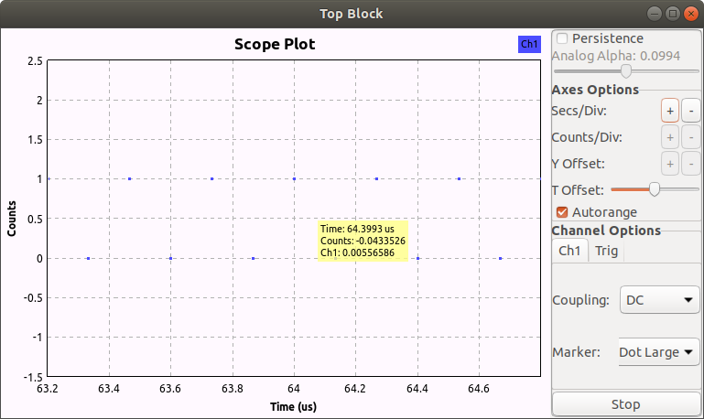
Figure 10. Zero symbol at 64.3993 us

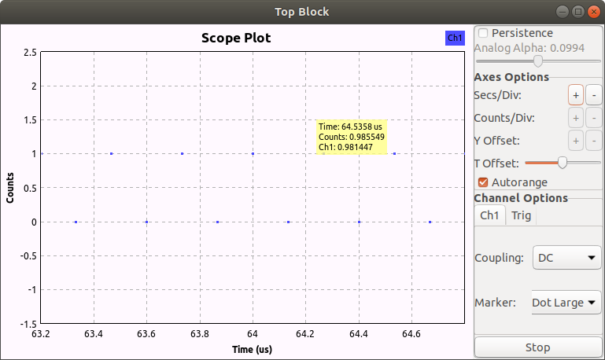

Figure 11, One symbol at 64.5358 us

Elapsed time: 64.5358 – 64.3993 = 0.1365 us

This is a larger difference than expected. The error might lie within the CPU’s ability to measure time or to sample at the required rate.

Conclusion:

While the above experiment is not definitive proof, at this time, I will summarily conclude that sample rate as it applies to a vector source byte input is the frequency at which the symbols are read (sampled) from the input vector. Therefore, it is symbols per second.

