Differential Binary Phase Shift Key Modulation & Demodulation Simulation
Using gnuradio DPSK mod/demod blocks
September 9, 2018

Objective: Simulate DBPSK modulation and demodulation using
- Vector Source
- Packet Source
- File Source

Binary Phase Shift Keying (BPSK)

In BPSK, “0” and “1” are represented by

The information is carried by the phase of the carrier. Coherent demodulation can be performed by the matched filter or the correlation receiver. To coherently demodulate BPSK signals, the timing of the pulse, the carrier frequency, and the channel phase response must be known.

Differential Binary Phase Shift Keying (DBPSK)

DBPSK allows signal demodulation without knowing the absolute phase, just the relative phase.

DBPSK modulates the data onto the phase change of the carrier. A phase change of π across adjacent symbol intervals represents the bit value “1” while no phase change across adjacent symbol intervals represents “0”. DBPSK is a two step process. First, the data is differentially encoded. Then the resulting coded sequence is modulated with BPSK. Given a data sequence { b_{j} } consisting of 0’s and 1’s, we obtain the differentially encoded sequence {c_{j} } according to the following rule:

This is modulo 2 addition (the XOR operation). In Figure 1 below, the initial output symbol has been arbitrarily set to “0”. The input sequence is {1, 1, 0, 0, 1}, the output sequence is {0, 1, 0, 0, 0, 1} Modulating the coded sequence with BPSK produces the DPSK signal.

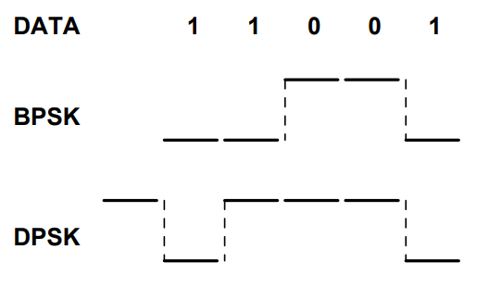

Figure 1: http://wireless.ece.ufl.edu/twong/Notes/Comm/ch2.pdf

The following gnuradio modulation and demodulation blocks were use in this simulation.

DPSK Mod Block

RRC-filtered DQPSK modulation

Input is a byte stream (unsigned char)
Output is the complex modulated signal at baseband

DPSK Demod Block

RRC-filtered DQPSK demodulation

Input is the complex modulated signal at baseband
Output is a stream of bits packed 1 bit per byte (LSB)

Case 1: Vector Source

The input data source is a vector source, which is simply a list of integers. The following short lists of integers were used to test that the input and output data are the same.

(255, 255)
(0, 0)
(255, 12)

Data is compared by saving both the input and output to files, then comparing the files to find any differences. Figure 2 shows the gnuradio flow graph used for this experiment.

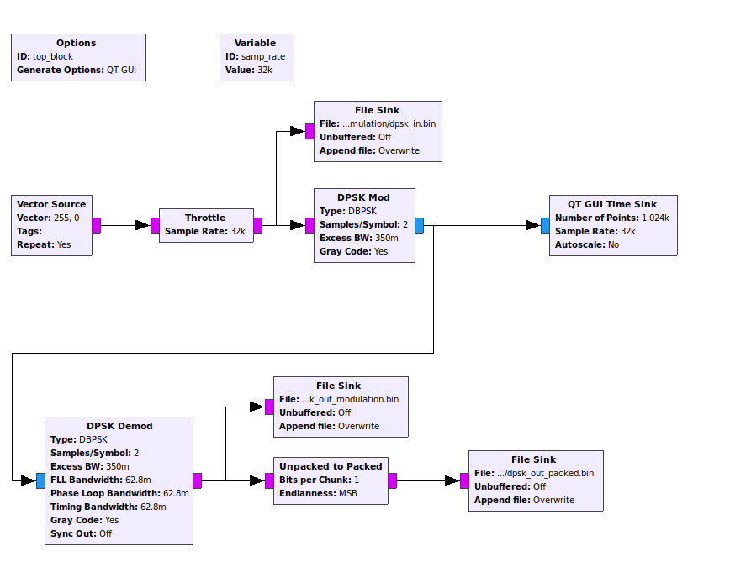
Figure 2: Vector Source Flow Graph

The Throttle block limits the maximum throughput to avoid using 100% of the CPU resources. This block is used for simulation only and is not needed in flow graphs where the hardware limits processing speed.

The File Sink blocks are used to record the transmitted and received bytes for later comparison.

The modulation/demodulation parameters are DBPSK, 2 samples/symbol for Differential Binary Phase Shift Keying. The default values for all other modulation/demodulation parameters were used.

Case 1, Simulation 1: Vector Source (255, 255)

The first simulation transmitted a pattern where all bit values were 1’s. This was to illustrate the the DPSK mod block switches between {-1, 1} for binary 1’s. Figure 3 shows the time sink output, illustrating that the modulated output does indeed switch between { -1, 1 }.

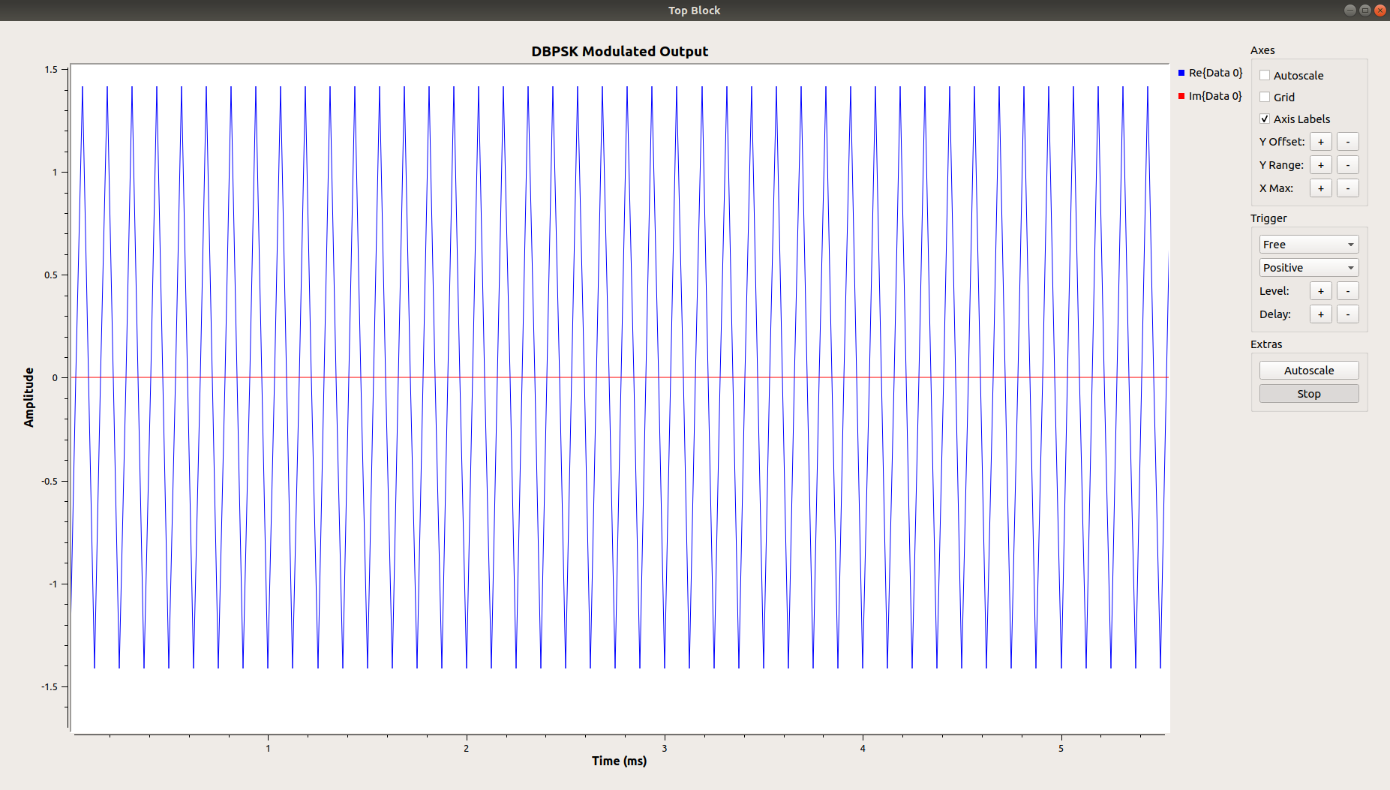

Figure 3: DPSK Modulated Output for Vector Source Input (255, 255)

Figure 4 below shows a hexdump of the input and output data recorded in the files. The files dpsk_in.bin shows the expected input pattern of ffff. The file dpsk_out_packed.bin shows the contents of the demodulated packed data. The data does not match the input perfectly. The 0000 0100 edbf is found at the start of the output file. The rest of the output data matches the ffff pattern of the input file.

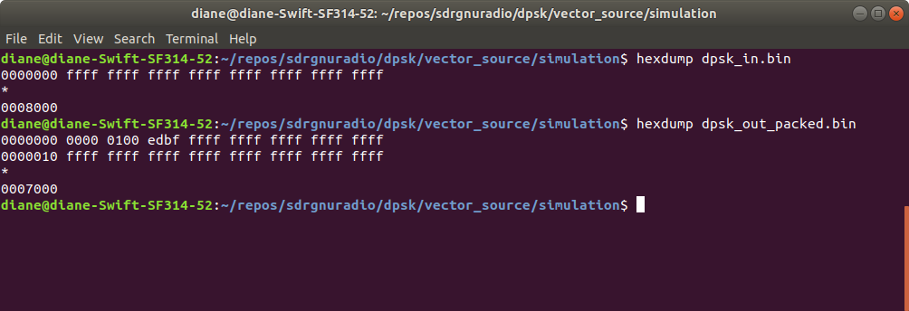
Figure 4: File Sink data, hexadecimal

Subsequent tests show that the demodulated output data does not match the original vector source input data.

Case 1, Simulation 2: Vector Source (0, 0)

Figure 5 shows the complex modulated signal for all 0’s has a real value of -1 and a complex value of 0.

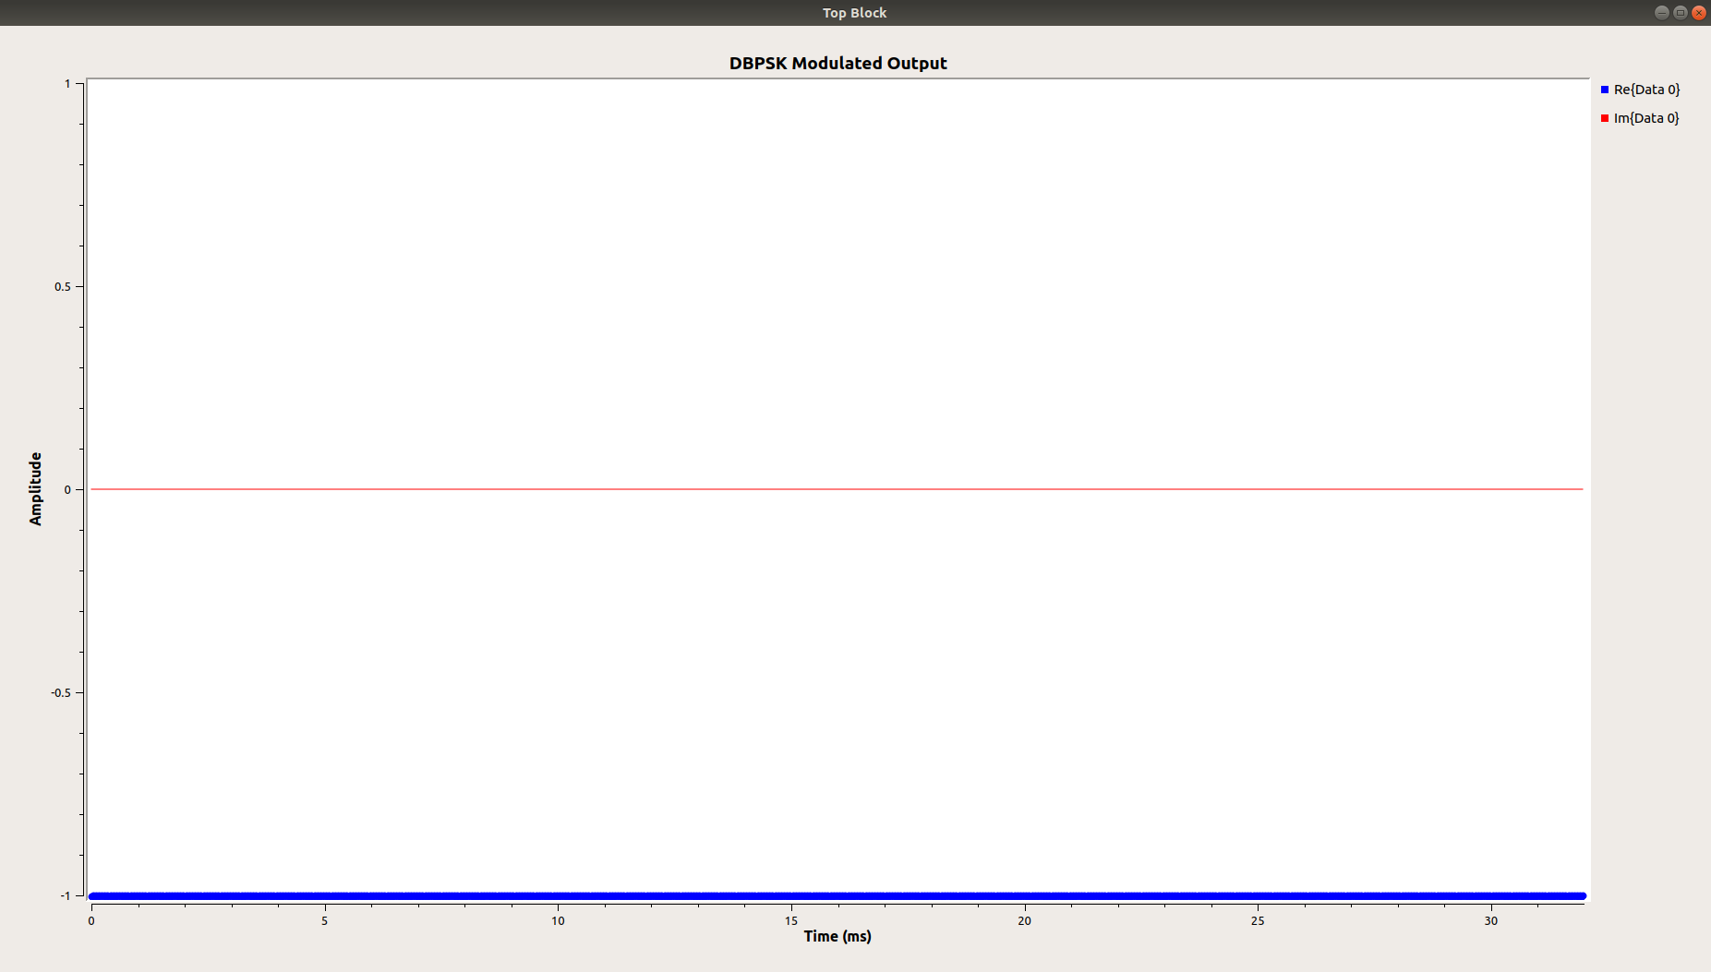
Figure 5: Modulated Output for all 0 input

Figure 6 shows the demodulated output data has some non-zero bits at the start of the output file and the rest of the file output correctly matches the input data.

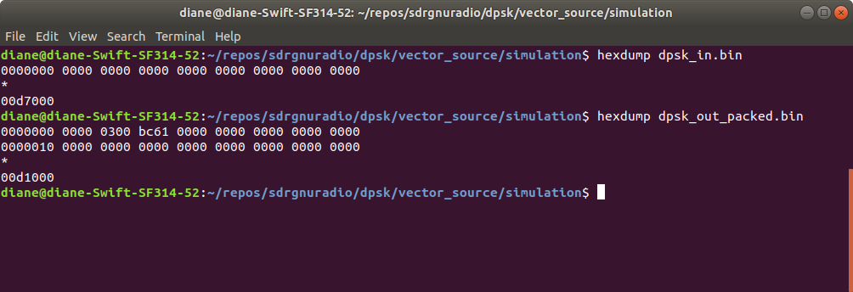
Figure 6: File Sink data, hexadecimal

Case 1 Simulation 3: Vector Source (255, 12)

Figure 7 shows the modulated output for the source input 255, 0. The integer value 255 is binary 1111 1111. The integer value 12 is binary 0000 1100. For these bit values, we see the signal switches between -1 and 1 as expected. For the 0’s, the signal stays near -1, but there is some ringing.

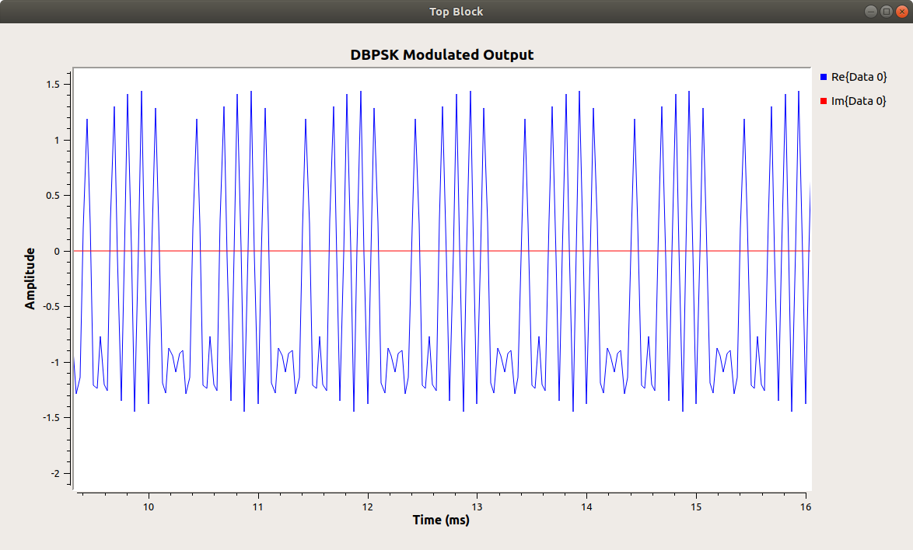

Figure 7: Modulated Output for all 255, 12 input

Figure 8 shows the input data as 0cff, not the expected ff0c. It appears the first byte may not have been written or processed. The demodulated output data has garbage values for the first few bytes and then shows a aptter of 33fc, not at all what was expected.

33fc is binary 0011 0011 1111 1100

We have a repeating binary pattern of 0011 0011 1111 1100 0011 0011 1111 1100 …

If we remove the two leftmost bits 00, we then have the following pattern: 1100 1111 1111 0000 1100 1111 1111 0000 1100.

Now if we remove the leftmost 1100, we have the expected output pattern 1111 1111 0000 1100 ….

It appears that the vector source pipeline may have some garbage that has not been cleared when processing starts.

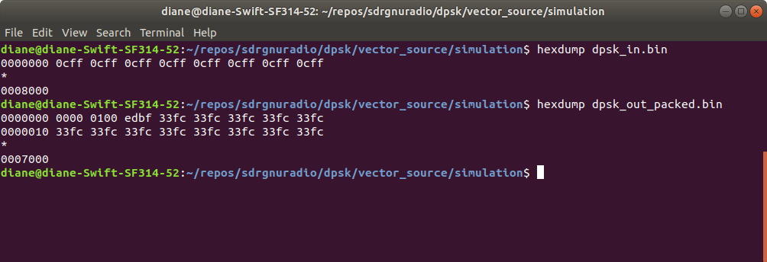

Figure 8: File Sink data, hexadecimal

At this point, it appears the vector source is problematic for simulation and will not work at all for real-time hardware transmission and reception. The received data will not match the transmitted.

A packet encoder and decoder will be added to the flow graph to see if this improves performance.

Case 2: Vector Source with Packet Encoder/Decoder

The recommended fix to alleviate the problem of initial garbage in the vector source stream is the addition of a packet encoder and a packet decoder. The packet encoder/decodoer will encode the transmitted data bytes into frames, then decode to extract back the orginal data bytes.

The encoder adds a header, access code, and preamble to the data. In this example, the preamble and access codes are left blank. The packet encoder/decoder automatically uses a default value. This was done to avoid any errors that might be caused by creating my own access codes.

The access codes must match perfectly for the decoder to accept the data as good and pass it on to the next stage.

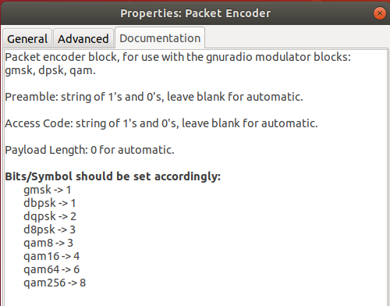

Figure 9: Packet Encoder Documentation

Figure 10 shows the packet encoder settings. The payload length is 1 to test sending one byte at a time.

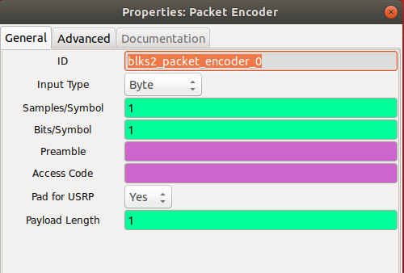

Figure 10: Packet Encoder Settings

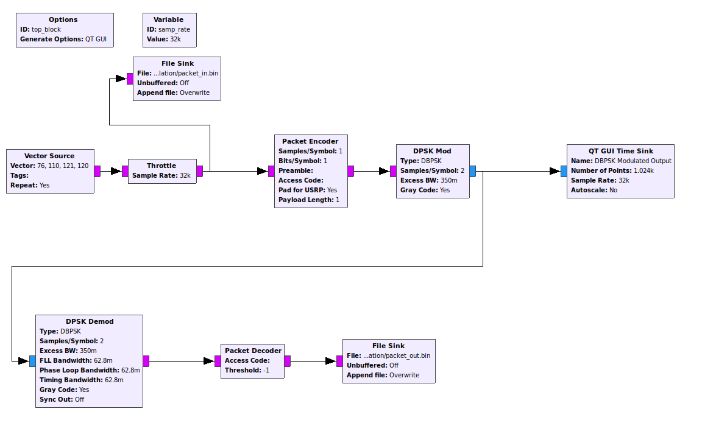
Figure 11: Packet Decoder/Encoder addded to flow graph

Case 2, Simulation 1: Vector Source (255, 0), Default Access Code

Figure 12 shows the additional overhead of sending the preamble and the access code.

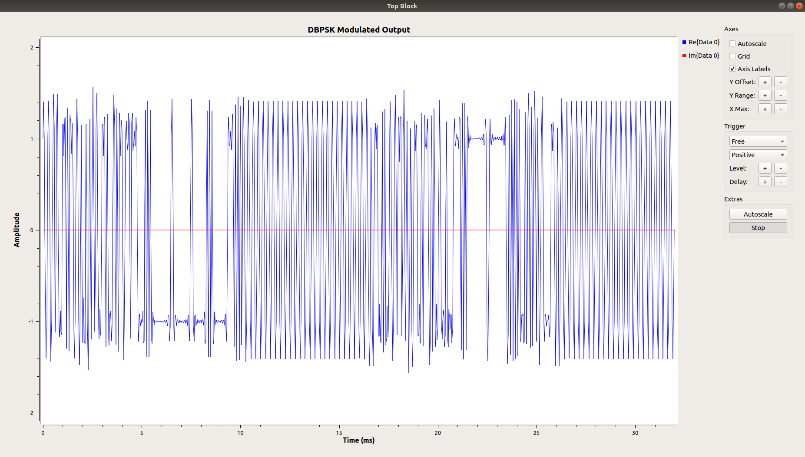
Figure 12: Encoded Modulated Data

The output file is much smaller than the input file. The following commands were used to create a hexdump of each file and then compare the file differences.

% xxd packet_in.bin in.hex
% xxd packet_out.bin out.hex
% vimdiff in.hex out.hex

Figure 13 illustrates that there is much more data in the source file than in the output file. At this time, the reason is unknown. Was data rejected by the packet decoder because the preamble or access codes did not match? Was it due to file buffering? Clearly, this needs investigation.

The good news is that the data matches without any of the garbage input stream values seen in case 1. The packet encoder/decoder addition appears to have taken care of that problem, but perhaps created another to be solved.

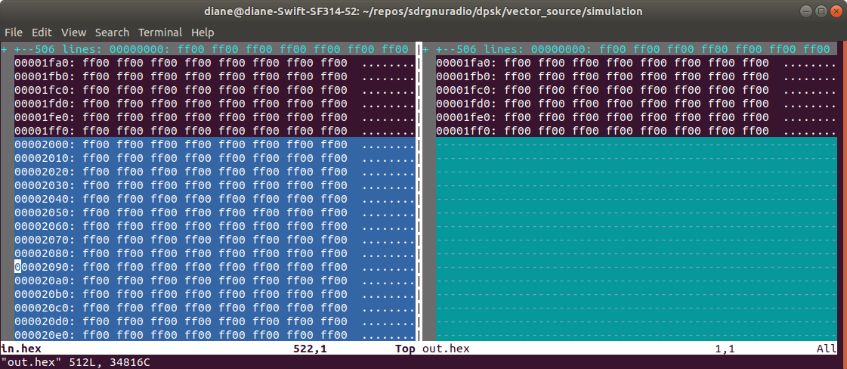
Figure 13: Difference between input and output data.

Case 2, Simulation 2: Vector Source (255, 0), Added Access Code

A known access code was added to the packet encoder/decoder: 010110011011101100010101011111101001001110001011010001101010001'

to see if this made a difference in the data size of the output file. The output file size was still much smaller than the input. However, the data that was stored in the output file matched the transmitted data. See Figure 14.

The mystery is still not solved. I have no way of know if this access code is correct, but assume that it must be ok since the decoder allowed some of the output data through to the file sink.

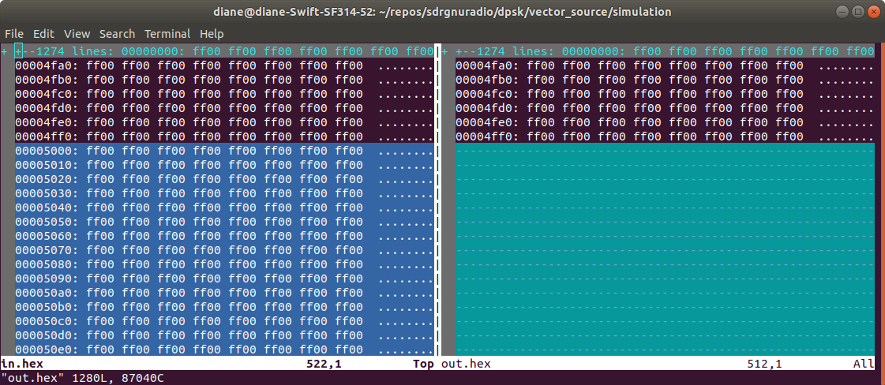

Figure 14: Difference between input and output data.

Case 2, Simulation 3: Vector Source (list(ord(i) for i in 'Lynx')), Default Access Code

This simulation shows that the binary values for the input and output data match, but that much less data was recorded in the output file, versus the input file.

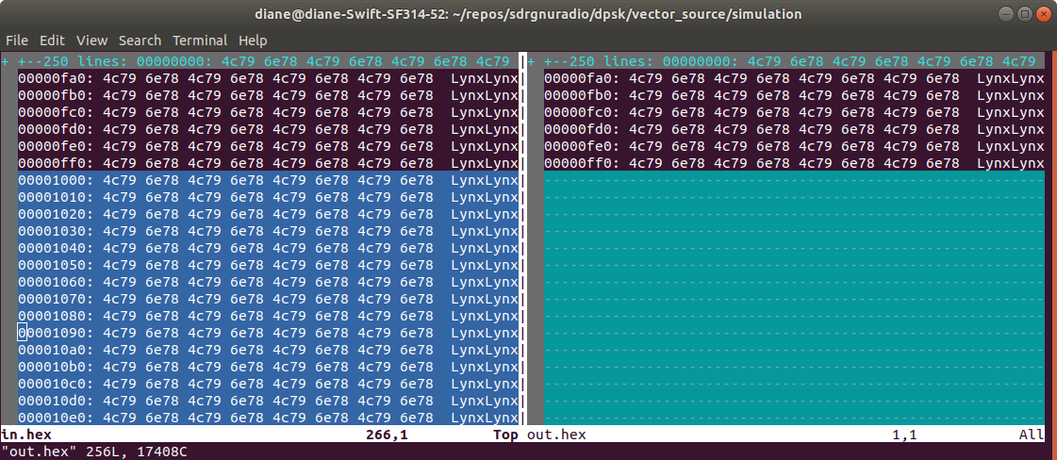
Figure 15: Difference between input and output data.

Case 2 Conclusion

Adding the packet encoder/decoder solved the problem of non-matching input and output data. It exposed another potential problem of the amount of output data not matching the amount of input data. The cause is unknown at this time and will be investigated.

