Getting Started with the HackRF One – Ubuntu 18.04
Date: 8/3/18

Connect device to computer

Connect the antenna or a dummy plug to the antenna terminal.
Plug the usb cable into the HackRF One and your computer. Documentation states that running the device without an antenna or dummy plug can damage the hardware.

To ensure the device was recognized, open a terminal and type dmesg | tail

The terminal output below shows the device was recognized.

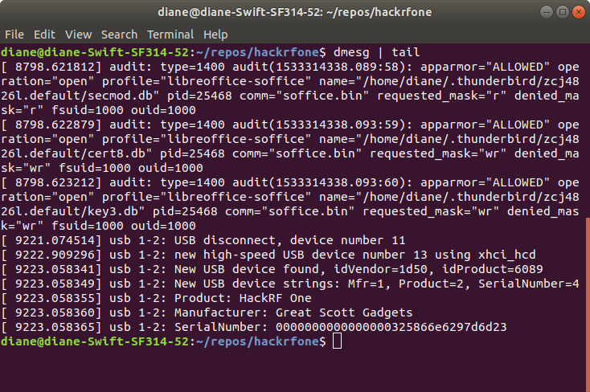

Set up software environment

Install the following packages:

sudo apt install hackrf
sudo apt install gnurado

hackrf software utilities

In the terninal, type hackrf_info

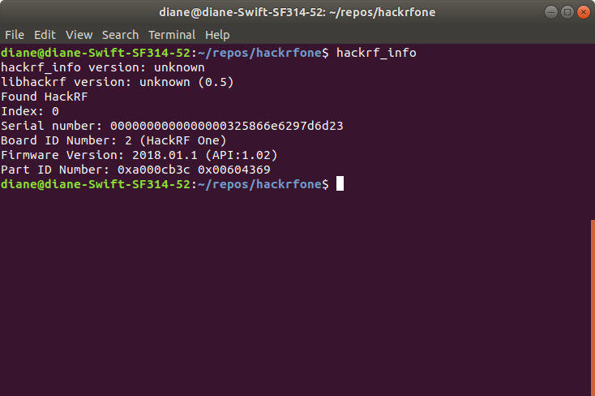

If you do not have the appropriate permissions, you may instead get the message hackrf_open() failed. Type sudo hackrf_info and you should then have output similar to that shown above.

HackRF One Wiki

https://github.com/mossmann/hackrf/wiki

Getting Started Tutorials

Found these two resources to be most helpful:

https://www.champlain.edu/Documents/LCDI/HackRF%20One%20Tutorial_F2017%20-%20Report.docx.pdf

https://greatscottgadgets.com/sdr

