Understanding GNU Radio Burst Packet Communications Transmission
Test Results, 9/27/2018

Objective: Work through the gnu radio packet communications tutorials found here: https://www.gnuradio.org/doc/doxygen/page_packet_comms.html These examples explain the flow graph blocks and methodology for burst packet communication.

Overview: The notes below detail the results of running the tx_stage0.grc through tx_stage6.grc. New blocks are added and tested at each stage.

The flow graph generate options are set to No GUI in each test example. Python files are generated and run from the command line as shown below. The gnuradio generated python code is socktest.py. Data is sent to the gnuradio program viat the simple_client.py program. The client program represents the connection to the user space programs that will become the application program interface (API) used by the robotic software to send data to the radio communications transmission program.

At the command line, start server program first, then the client program.

% python socktest.py
% python simple_client.py

1. Socket PDU block to Debug Message Block Print

The socket_pdu block constructs a socket protocol data unit interface. The socket connection may be one of the following: TCP server, TCP client, UDP server, UDP client. It is set up as a TCP Server to receive message from the client program.

The MTU (maximum transmission units) is set to the default of 10000. The documentation is not clear about the units. Are they bytes or bits?

The Host and Port must match the same settings expected by the client program. Localhost and port 8000 were chosen for convenience.

The Message Debug block prints data to the console.

The client sends three message strings to the gnuradio socket server program. The flow graph is shown in Figure 1.

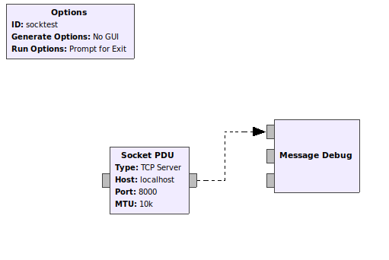

Figure 1: socket_pdu_tx_test Flow Graph

The Socket PDU receives messages from any client that connects to ‘localhost’, port 8000. Figure 2 shows the client program output.

The client program messages were

abcd
message 2
gnu radio socket pdu

Some additional information about the socket connection is displayed as well in Figure 2.

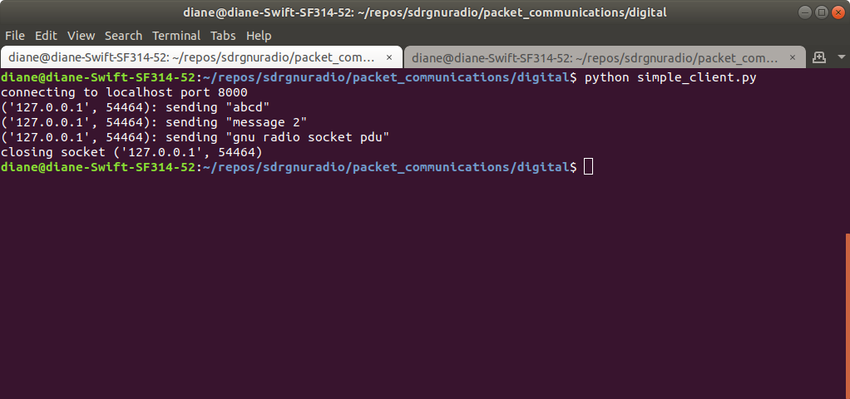
Figure 2: simple_client output

Figure 3 shows the server program debug messages. The gnuradio socket_pdu correctly received all three messages. The Debug Message block prints the ASCII text when using the print input connection, as shown in Figure 1, along with some other information.

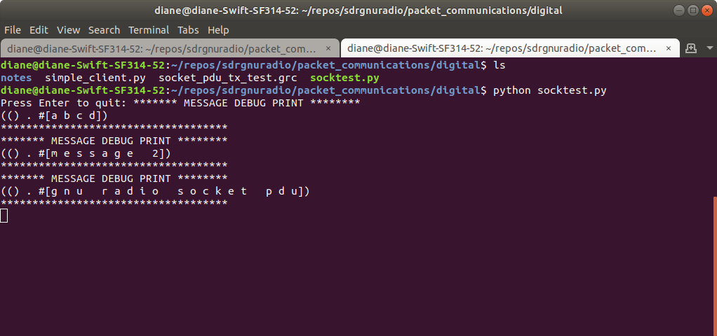
Figure 3: gnuradio socket server output

2. Socket PDU block to Debug Message Block Print PDU

Send the message string “abcd” from client program to gnuradio socket server program and display the byte values. The bytes values are shown because the Socket PDU output was connected to the Debug Message block input print pdu.

Figures 4 and 5 show the server and client program output. The message was correctly received. 61 62 63 64 are the hexadecimal values for ‘a’, ‘b’, ‘c’, ‘d’

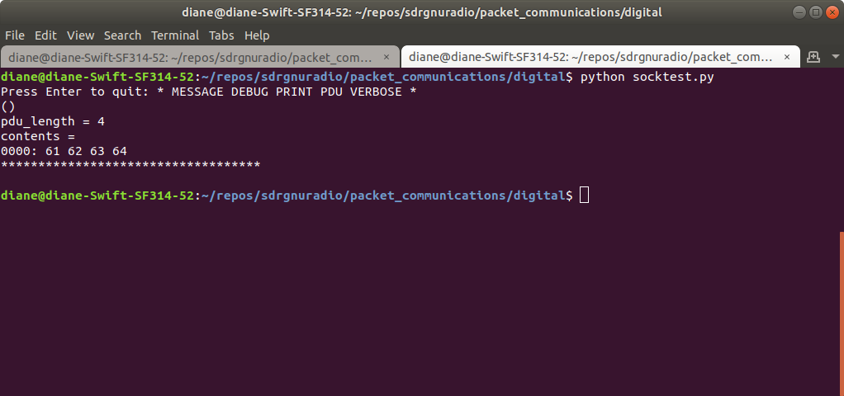
Figure 4: gnuradio socket server output

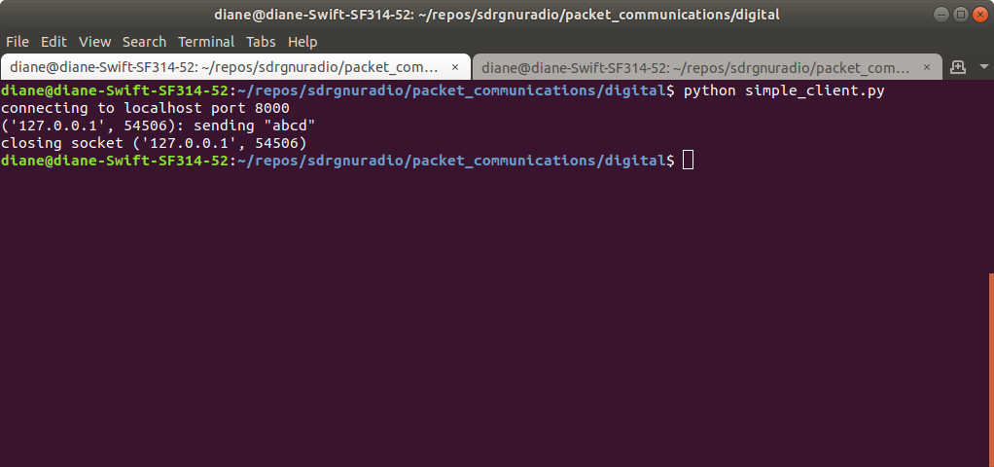
Figure 5: simple_client output

3. Async CRC32 block

Figure 6 shows the flow graph with the Socket PDU block output connected to the Async CRC32 block input. The mode is Generate CRC. This block then creates a 32 bit (4 byte) cyclic redundancy code, adding four bytes to the end of the bytes received.

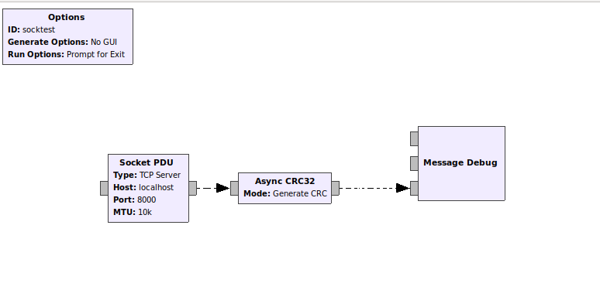
Figure 6: Flow graph with Async CR32 block added

Figure 7 shows that the client message sent to the server is still “abcd”.

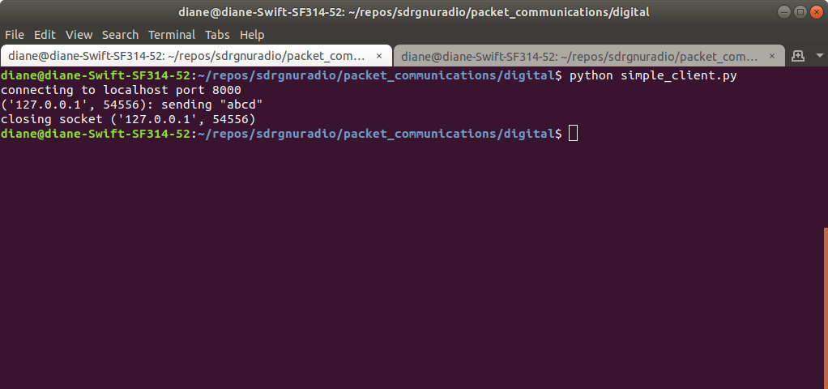

Figure 7: client output

Figure 8 shows the Debug Message output. Four additional bytes are added after the message bytes.

abcd bytes: 61 62 63 64
crc bytes: 11 cd 82 ed

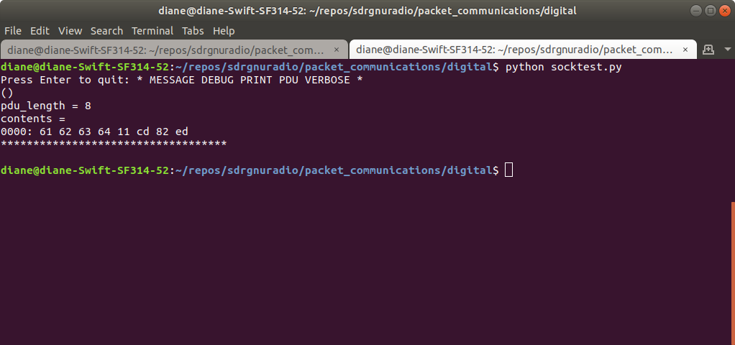
Figure 8: gnuradio server output, CRC bytes added

4. FEC Async Encoder and Repetition Encoder Definition

Forward error correction (FEC) is used for correcting errors during reception. There are different types of FEC encoding available. In this example, the Repetition Encoder Definition is named enc and set to 3 repetitions. The default of 0 for parallelism is set, along with 8000 for Frame Bits. At this time, I am following the example and do not have any known reason for setting the frame bits to 8000. This will be more carefully examined before running a full simulation. Three repetitions means that the FEC block will generate 3 of each bit when creating the full message packet.

Example: 61 is 0110 0001

The repetition encoder generates three bits for each bit. The left most 0 becomes 000. The next bit 1 becomes 111. The expected FEC repetition binary encoding is

000 111 111 000 000 000 000 111

which is hexadecimal 1f 80 07

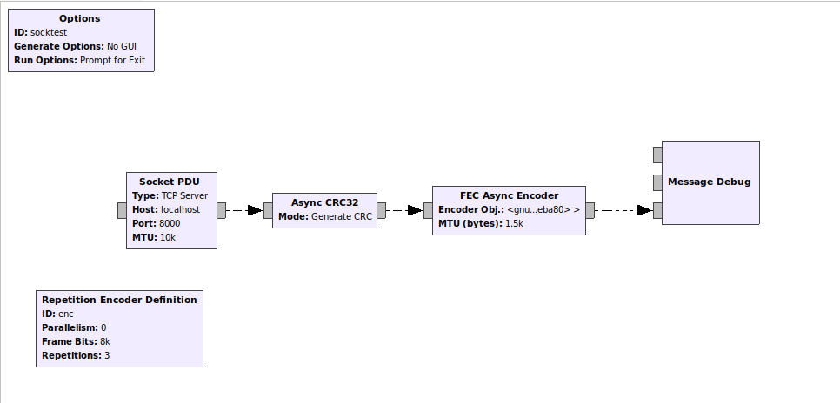

Figure 9: Flow graph with repetition FEC

Figure 10 shows the gnuradio program output. The output, before FEC repetition encoding was shown in Figure 8 above as 61 62 63 64 11 cd 82 ed. Figure 10 shows the result of generating 3 bits for each original bit. There are now 24 bytes, compared to the 8 bytes in Figure 8.

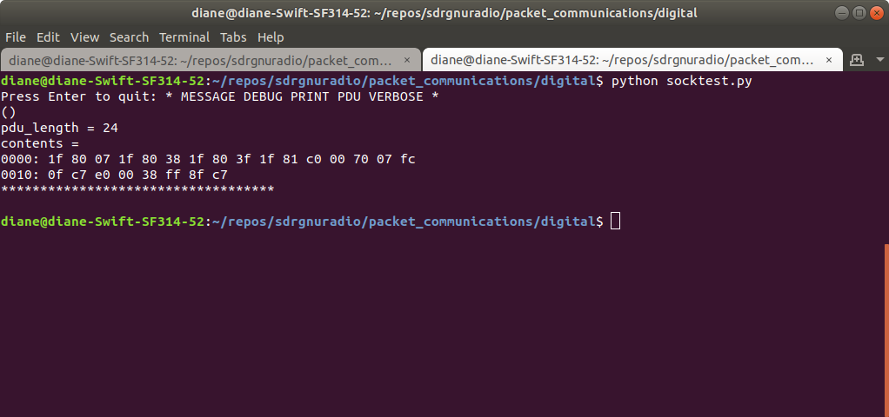

Figure 10: gnuradio server output with FEC repetition encoding

Figure 11 shows the client program output has not changed.

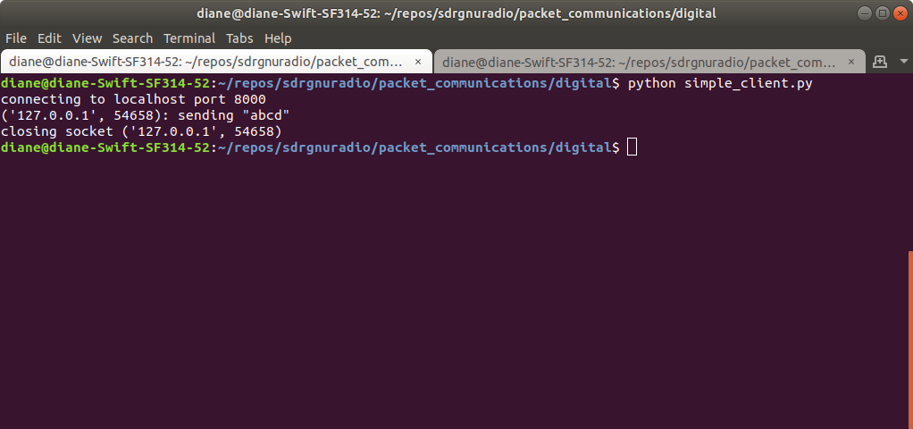
Figure 11: client output

There are other forms of FEC encoding as well. Those forms were not tested at this time.

5. Protocol Formatter (Async) and Default Header Format Block

Te data delivered to the transmitter is treated as the payload. Here at the physical layer, we frame the payload data for transmission. The added framing information encodes information about the length of the payload, the type of FEC code used, the type of modulation or modulation paramters.

A known word, the packet header, is added to the front of the packet to help the receiver with synchronization and identification. The Protocol Formatter (Async) block is used to add the packet header, which is called the Access Code. In this example, the Default Header Format Object is used to generate a default 64 bit access code. Figure 12 shows the Access Code setting.

The default formatter applies a 64-btit access code and calculates the payload length (in bytes) as a 16-bit value. The 16-bit payload length field is duplicated, to allow the receiver to check both 16-bit fields to ensure they are the same.

The Threshold value is used by the receiver to know how many bits can be wrong in the access code and still pass.

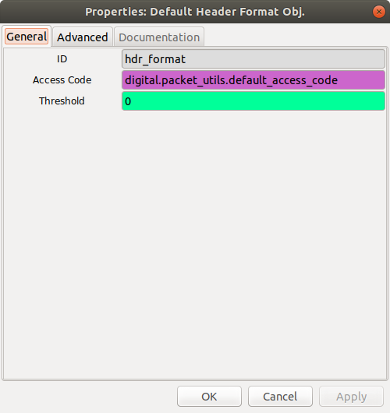

Figure 12: Default Header Object Settings

The Protocol Formatter block has two outputs: payload and header. The Message Debug is connected to the payload header to ensure the formatter block has no effect on the payload. The updated flow graph is shown in Figure 13.

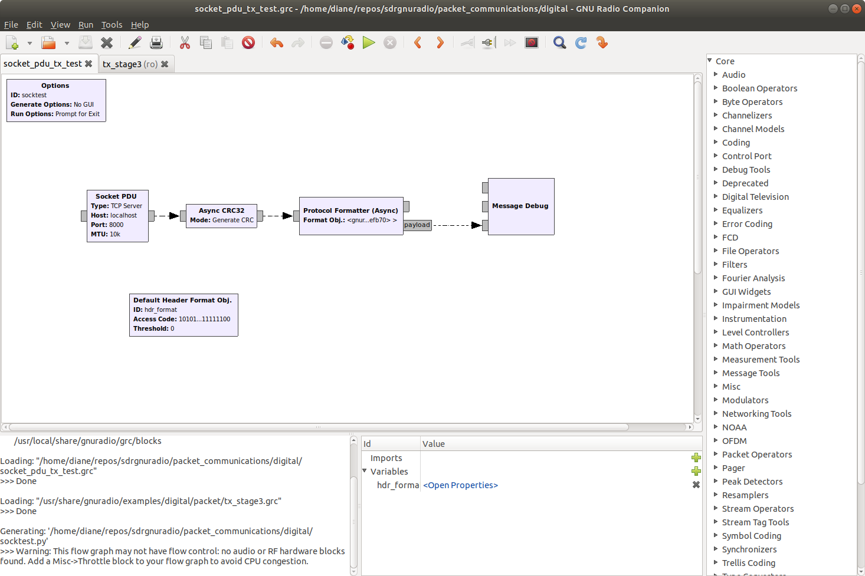
Figure 13: Flow graph with Protocol Formatter and Default Header Format Object

Figure 14 shows the payload output. The client sent the same data as shown in Figure 11, the ascii character string “abcd”. Figure 14 shows the corresponding hex bytes 61 62 63 64 and the four CRC32 bytes 11 cd 82 ed. This payload data matches that shown in Figure 8. We see the payload data has not changed.

Note that the FEC block has been removed from the flowgraph, which is why there are no FEC bytes in the output.

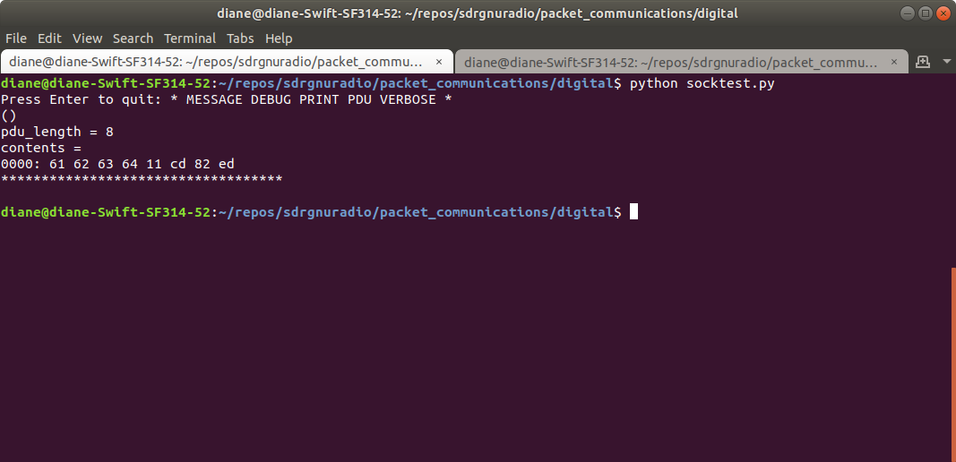
Figure 14: Protocol Formatter Payload Output

Figure 15 shows the header output and the length bytes. The 64-bit default access code is the first 16 output bytes: ac dd a4 e2 f2 8c 20 fc. The next four bytes indicate the payload length. The payload is the eight bytes: four bytes representing the message and four bytes for the CRC. We see that the payload length is duplicated, as the block documentation indicated that it would be.

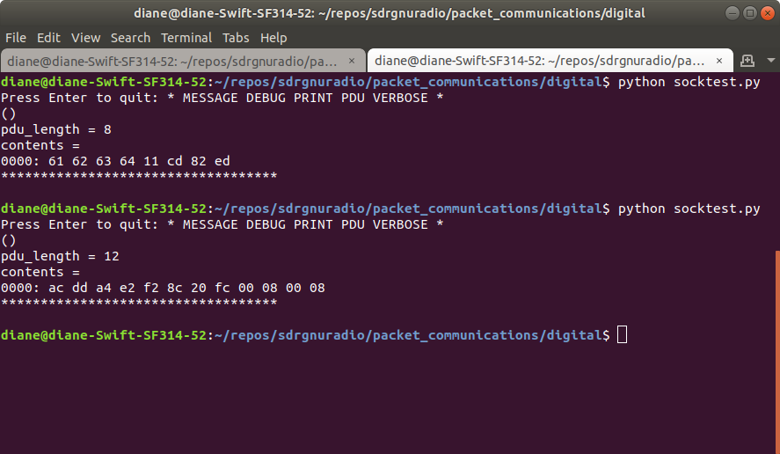
Figure 15: Protocol Formatter Header Output

6. Protocol Formatter (Async) and Digital Header Format Counter

The Default Header Object has been removed and replaced with a Digital Header Format Counter function call. This function requires three arguments: access code, threshold and bits per symbol. Variables for header format, threshold and bits per symbol have been added to the flow graph. Figure 16 shows the function call used to construct the hdr_format variable. Figure 17 is the updated flow graph.

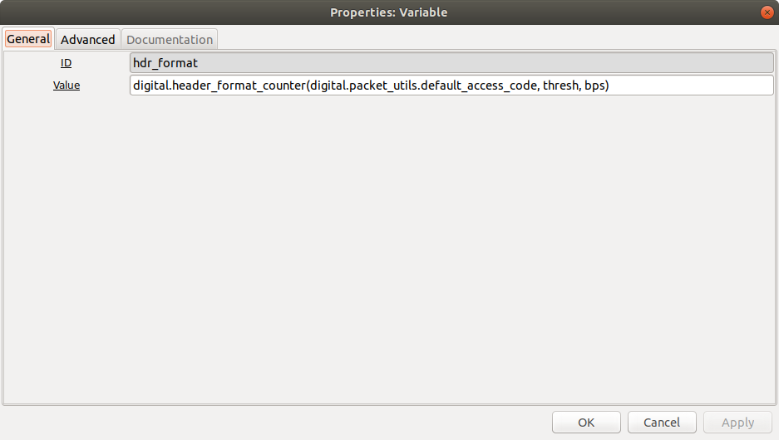
Figure 16: digital header format counter function call

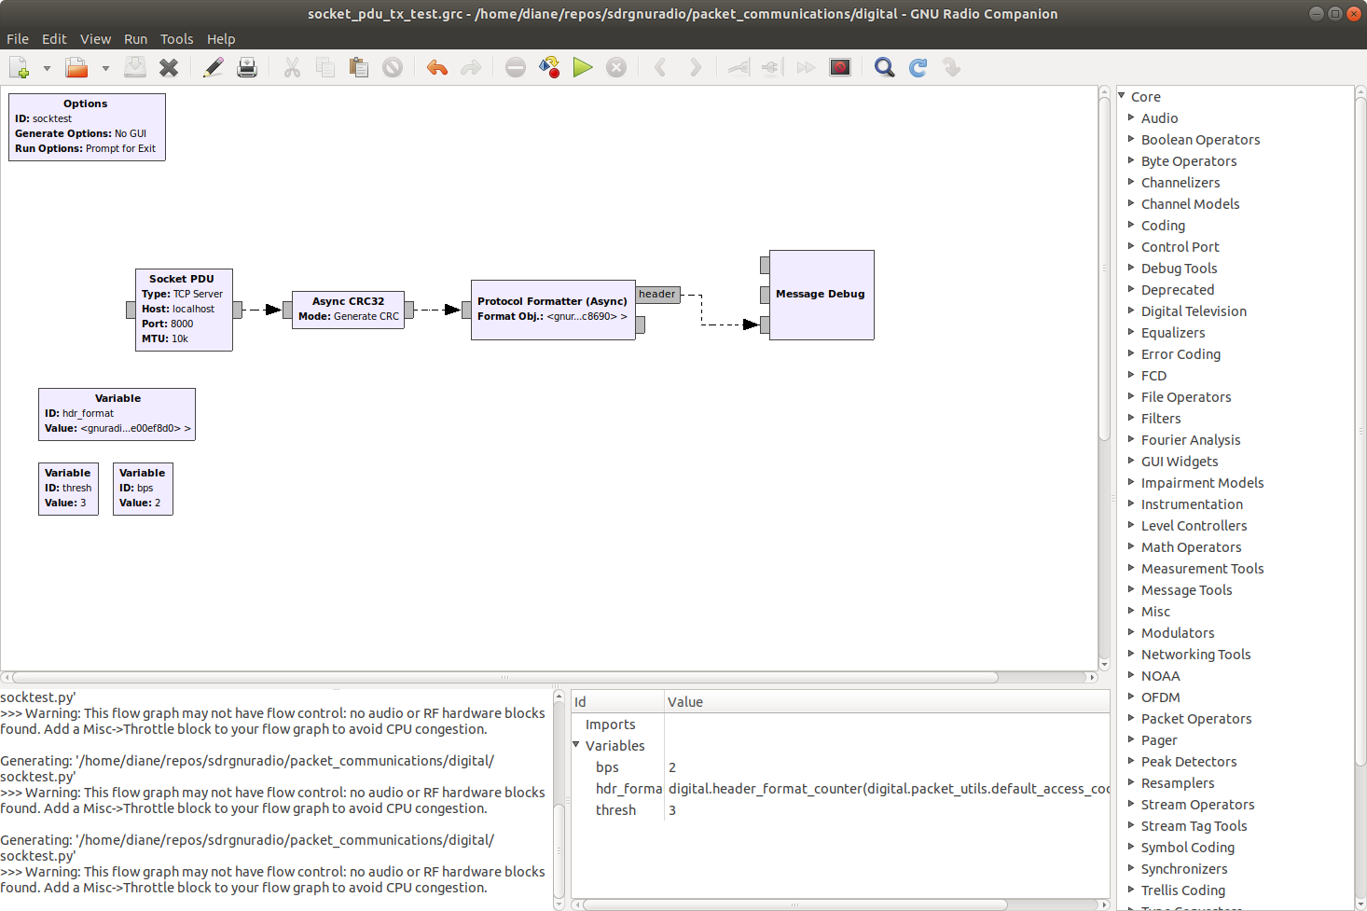
Figure 17: Flowgraph using digital header format counter

The header output, Figure 18, produces the same default access code and payload length bytes as seen in Figure 15, with four additional bytes. The bytes 00 02 represent the bits per symbol and the final two bytes 00 00 are the number of packets transmitted.

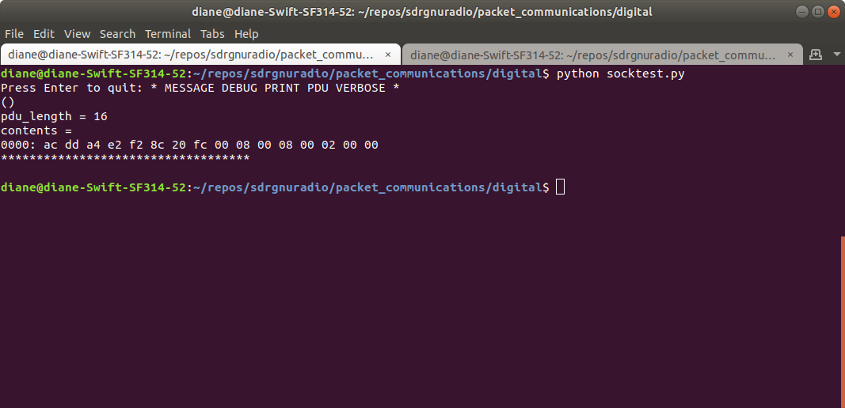

Figure 18: Protocol Formatter Header Output

Next, the client program was altered to send three packets, to test the packet counter. Figure 19 shows the client messages.

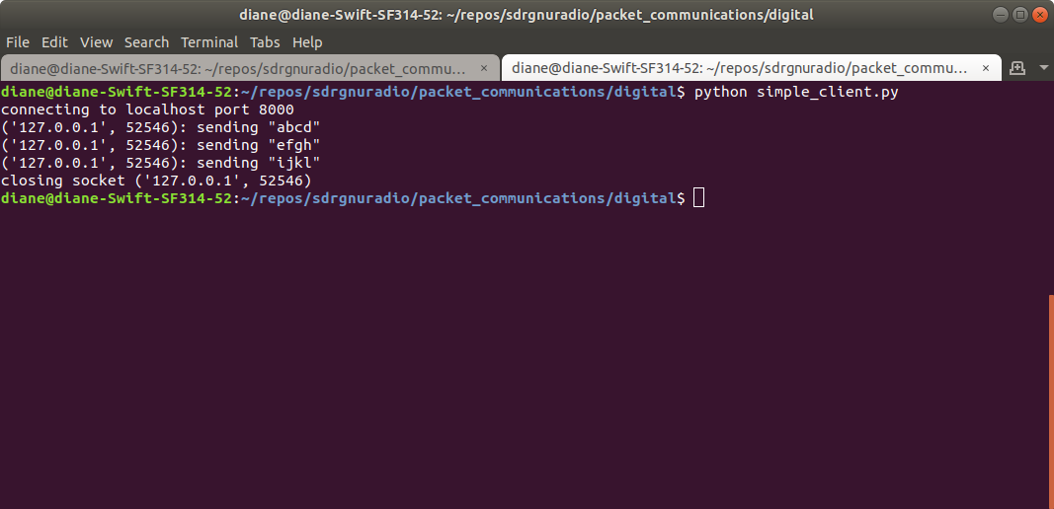
Figure 19: Client Program transmits 3 packets

Figure 20 shows the protocol formatter header output. Note that the default access code is the same and the payload length is the same because each packet is four bytes. The bits per symbol field remains the same, while the packet counter increments by one as expected.

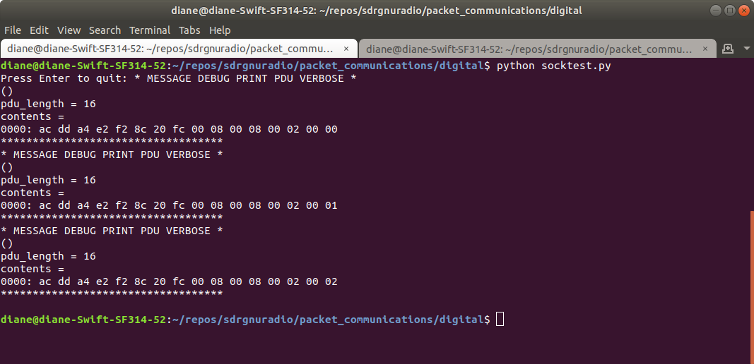
Figure 20: Packet Counter Increments by 1

7. Modulators – Constellation Object

The header and payload are two separate outputs from the Protocol Formatter (Async) block. Each has its own path and modulator. The PDU to Tagged Stream block is added.

Tagged Stream Block

“A tagged stream block is a block that works on streamed, but packetized input data. Think of packet data transmission: A data packet consists of N bytes. However, in traditional GNU Radio blocks, if we stream N bytes into a block, there's no way of knowing the packet boundary. This might be relevant: Perhaps the modulator has to prepend a synchronisation word before every packet, or append a CRC. So while some blocks don't care about packet boundaries, other blocks do: These are tagged stream blocks.” https://wiki.gnuradio.org/index.php/Tagged_Stream_Blocks

“As the name implies, tagged stream blocks use tags to identify PDU boundaries. On the first item of a streamed PDU, there must be a tag with a specific key, which stores the length of the PDU as a PMT integer. If anything else, or no tag, is on this first item, this will cause the flow graph to crash!
The scheduler then takes care of everything. When the work function is called, it is guaranteed to contain exactly one complete PDU and enough space in the output buffer for the output.”

Constellation Objects
The constellation objects are the modulators. The header constellation object is named hdr_const. The symbol map digital.psk_2()[1] returns 0,1. The Constellation points are -1, 1 which is returned by digital.psk_2()[0]. The payload constellation object settings are the same as well.

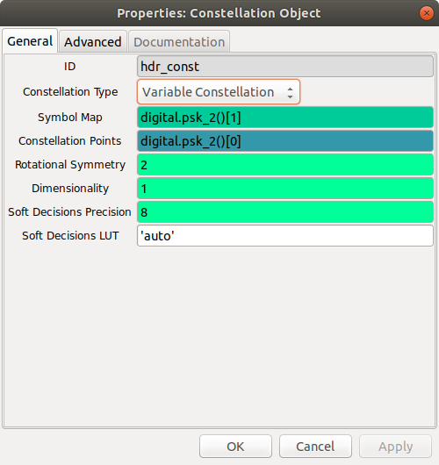

Figure 21: Header Constellation Object Settings

From tagged stream mode, the Repack Bits block takes the packed 8 bits/byte data and converts this into “chunks” of the number of bits per symbol of the modulation objest. Figure 22 shows the setting for the header stream.

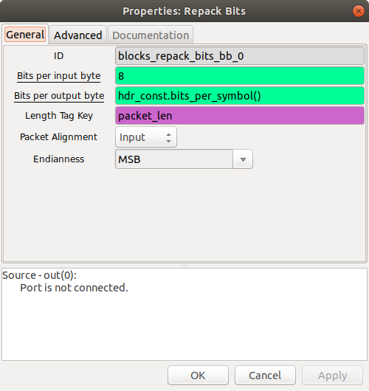

Figure 22: Repack Bits Property Bits Per Output Byte

The “chunks” are then mapped using the Map Block and the constellation objects pre_diff_code() function.

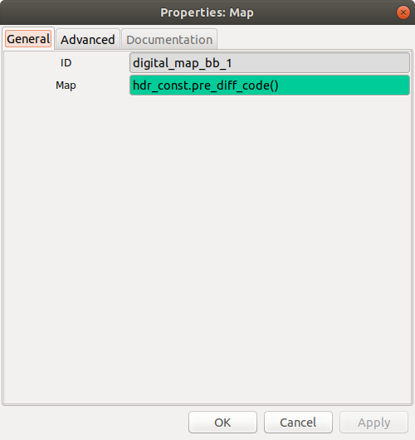

Figure 23: Mapping Chunks

The remapped chunks are converted to complex symbols, using the constellation object’s points() function.

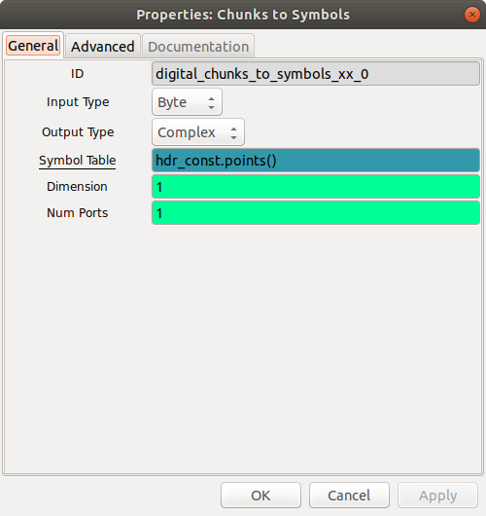

Figure 24: Remapped Chunks to Complex Symbols

Finally, the header and payload are combined together into a single stream, using the Tagged Stream Mux block.

Questions to be resolved

What are the units of the socket pdu MTU parameter, bytes?

PDU to Tagged Stream – default is packet_len Where is this defined in gnuradio and what is its value?

Constellation Objective

Why use variable constellation?

