Differential Binary Phase Shift Key Modulation & Demodulation Simulation
Using gnuradio DPSK mod/demod blocks
October 16, 2018

Objective: Simulate DBPSK modulation and demodulation using
- File Source
- Packet Encoder/Decoder
- DPSK Mod/Demod
- File Sources: png, jpg, and txt

Summary

The Packet Encoder default Payload Length 0 requires a minimum of 512 bytes before a packet is encoded. Experiments were run, using payload lengths of 0, 64, and 128. The source image was 56259 bytes. The processed output image was smaller than the input image.

Payload Length | Input Bytes | Encoded Bytes | Difference
0 (defaults to 512) | 56259 | 55808 | 451
64 | 56259 | 56256 | 3
128 | 56259 | 56192 | 67

The corrupted data problem still exists for larger files. The data matches until address 4096, where this is a byte mismatch. There are some other byte mismatches as well. I have not yet run tests to accumulate statistics. It may be due to the file buffer overflowing when trying to record the data.

If this problem occurs in future testing, the cause will be investigated.

File Name: file_source_packet.grc

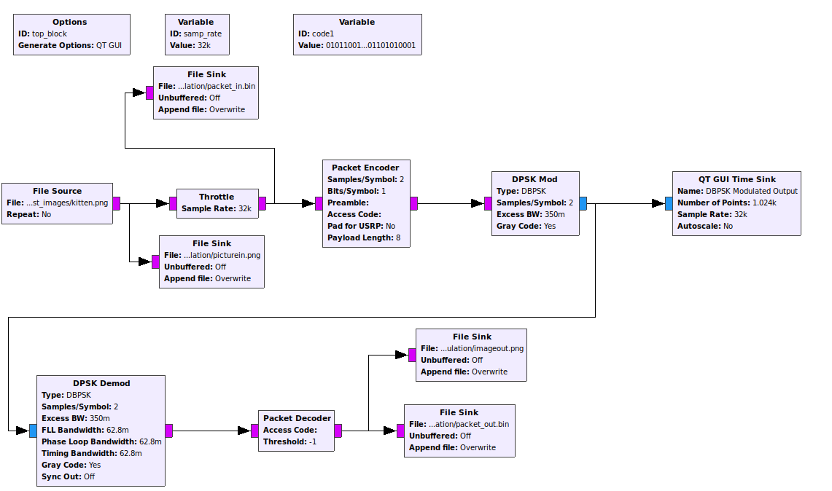
Figure 1: file_source_packet.grc flow graph

