DPSK Transmitter Receiver Simulation using BPSK

Objective

Use gnuradio software to build a differential phase shift keying (DPSK) transmitter receiver simulation. Differential phase shift keying produces a change in the carrier’s phase when sending the one symbol and leaves the phase unchanged when sending a zero symbol.

- Transmitter
  - Start with a vector data source as the digital baseband
  - Modulate the digital baseband
  - Upshift the modulated signal to the carrier frequency
- Receiver
  - Tune to the carrier frequency
  - Filter to isolate the desired signal
  - Demodulate to reproduce the orginal digital baseband
- Channel Model
  - Simulate multipath delay between the transmitter and receiver
  - Simulate the affect of noise
  - Simulate the affect of frequency mismatch

This simulation implements a simple form phase modulation that does not work well under the effects of noise, frequency mismatch, and multipath delay. This model is faulty and should not be used. In the real-world, the transmitter has a phase reference, the carrier phase. The reference is lost after the signal is transmitted. The receiver does not know anything about the transmitter’s phase reference. All the receive knows is when the phase changes. We need to build a differential phase shift key model (DPSK).

DPSK Transmitter Flow Graph

Functional Flow – There are two sources: vector source and signal source. The vector source is a sequence of 1’s and 0’s, which are the digital signal values to be transmitted. The signal source is a cosine signal at the carrier frequency.

Source Block Flow

- Vector Source
  - Unpacked to Packed
  - PSK Mod – performs phase shift modulation
  - Interpolating Fir Filter – affects data rates
- Signal Source
  - Throttle – simulation, don’t overwhelm computer resources

- Multiply phase modulated signal times the throttled signal source
- Channel Model
- Frequency Xlating FIR Filter
- PSK demodulation
- Uchar to float
- QT Gui Time Sink to display received binary signal

FM Receiver Functionality

- Tuning control
- Volume control
- Listen to audio using computer’s sound card
- Ability to save audio data to a file
- View radio signal

Flow graph variables

Name Description Default Value

samp_rate Determines the amount of data 8e6 (8 MHz)
captured with the SDR when there is
a hardware source for the transmitter.

Note: In this example, there is no hardware source for the transmitter. This is a simulation that uses a vector source to provide a known digital sequence. Setting the sample rate to a value that is valid for a hardware source requires less changes to the flow graph when the vector source is replaced with a hardware source. Also, it may make the simulation more realistic.

work_samp_rate Working sample rate. Used to save baseband_freq*samp_per_symbol
computing power.

Working sample rate – To save computational power, the flowgraph should work at the lowest sample rate possible without impacting signal quality.

The initial sample rate must be high to capture a large range of frequencies. Once the raw RF data has been captured and tuned to the desired frequency, this high sample rate is not needed to work with the captured data.

freq tuning frequency 313.2e6 (313.2 MHz)

Note: The default value is small relative to the center frequency. This is done for simulation purposes to show a carrier frequency sinusoidal waveform with more sample points in the plots.

Example: carrier frequency is freq – center_freq. When the carrier frequency is 2 MHz and sampling rate is 8 MHz, then we only have 4 samples for each sinusoidal time period. When the carrier frequency is 0.2 MHz then we have 40 samples for each sinusoidal time period.

center_freq Transmits and receives signal at the 313e6
center frequency.

Note: The default value has no special meaning, other than a value used for this simulation. Set it to the desired center frequency in a real-world hardware application.

baseband_freq baseband frequency 10e3 (10 kHz)

sensitivity determines phase modulation math.pi/2 (BPSK)

filter_cutoff low pass cutoff frequency 1.35*baseband_freq/2

Note: Theoretical minimum transmission bandwidth is ½ the baseband frequency, plus we have to allow for the excess bandwidth property of 0.35.

filter_transition low pass filter transition bandwidth filter_cutoff*0.1

noise Used for channel model 0 (units are volts)
freq_offset Used for channel model 0
freq_match Used for channel model 1

num_phases number of phases 2 (BPSK)

samp_per_symbol number of samples per binary 8
symbol

Transmitter Flow graph Blocks

Vector Source Block

Settings:
Type: Byte
Vector: (0, 1,1,1,0,1,0,1,0,1,0,0,0,0,0,0,0,0,0)
Repeat: Yes

Signal Source Block

Settings:
Sample rate: samp_rate
Waveform: Cosine
Frequency: freq-center_freq
Amplitude: 1e3
Offset: 0

The signal source frequency is the carrier frequency, the difference between the center frequency and tuning frequency variables.

Unpacked to Packed Block

Settings:
Type Byte
Bits per Chunk 1
Endianness MSB

Takes 8 individual bits and packs them into one byte. The bits per chunk property tells the block to only take one bit from each incoming sample. Endianness tells the block in which order to output the byte. MSB stands for Most Significant Bit.

QT Gui Time Sink Block

To see the repeat block output signal, connect a QT GUI Time Sink.

Settings:
Name Digital Input
Number of points 16384
Sample rate samp_rate

PSK Mod Block

Settings:
Number of constellation points num_phase
Differential Encoding yes
Samples/Symbol samp_per_symbol
Excess BW 0.35

The PSK Mod block constructs the baseband signal based on the input sample rate and the block settings. The number of constellation points is the number of phases used to modulate the data.

When the number of constellation points is 2, the first phase represents the zero symbol and the second phase represents the one symbol.

The samples per symbol property defines how fast the data rate is relative to the sample rate. For each input symbol, the modulator will output a single period of a sinusoid, with the phase either changing by 180 degrees if the symbol is a one, or with no phase change if the symbol is a zero. The samples per symbol property tells the modulator how many samples to use to construct this sinusoidal period. The more samples used, the better a sinusoid will look.

The PSK Mod block applies a filter before outputing the signal.

Example: Assume the sample rate is 1 kHz, and Samples/Symbol is 8. Symbols are being produced at a rate of 1 kHz, while the sinusoids making up each symbol are output at 8000 samples per second. For each symbol bit input, 8 sinusoidal samples are output.

In the above example, the PSK Mod block speeds up the sample rate by a factor of 8. To keep the signal timing the same, the signal input going into the PSK Mod block must be slowed down by a factor of 8.

Slowing down the signal input is handled by reducing the Interpolation property in the Repeat block.

The bandwidth consumed by the PSK output signal is not exactly the same as the frequency of the signal, due to the filter. The filter is not perfect, causing the signal to overlap the expected bandwidth by a small portion. The excess bandwidth property defines the shape of the output filter rolloff.

Example: 1 kHz symbol rate results in a total bandwidth of 1.35 kHz ( 1 kHz + 0.35 times 1 kHz of excess).

Leave this property alone. Reducing it below the default 0.35 reduces the filter’s effectiveness.

Interpolating Fir Filter

Settings
Interpolation int(samp_rate/working_samp_rate)
Taps firdes.low_pass(1,samp_rate,filter_cutoff,filter_transition)

Need the interpolation value to slow down the PSK Mod output sampling rate. Interpolation causes high frequency distortion, requiring the filter.

Channel Model Flow graph Blocks

A channel model block is used only when building a simulation. When a transmitter and receiver are in the same flowgraph, their clocks are synchronous. This does not happen real world hardware applications. A channel model can be used to simulate noise, frequency offset, frequency mismatch, and multipath delay. In this example, we will simulate multipath delay.

Channel Model Block

Settings
Noise Voltage: noise
Frequency Offset: freq_offset
Epsilon: freq_match
Taps: 1 + 1j

Noise voltage: To see the effects in a frequency dB-based plot, the voltage must be relatively large.

Frequency offset: The frequency offset produces a frequency difference between the two sides of the channel model block. The frequency of the outgoing data stream is modified at a frequency proportional to the sample rate. It models a tuning offset.

Example: frequency offset is 0.001, sample rate is 8e6. The frequency offset will be 8 kHz (8e6 times 0.001). The outgoing signal frequency will be 8 kHz greater than the incoming signal frequency. This property is used to upshift or downshift the output signal in the frequency domain.

Epsilon: Models a frequency mismatch. There is no mismatch when the property is 1. The block performs a rational resampling to change the frequency up or down when the property is not 1. Crystal oscillators are so accurate that this property is rarely different than 1 in the real world.

Taps: This property applies a FIR filter to the input data stream to simulate multipath effects. Real-world signals are delayed as they propagate through the air, resulting in a consequent phase shift. The 1 + 1j value will apply a mild phase shift to the input data stream.

Receiver Flow graph Blocks

Frequency Xlating FIR Filter block – performs both tuning steps of frequency translation (shifting) and filtering. The signal is tuned by shifting the target frequency to the center and then filtering out all other signals, except for the target.

Settings

Center frequency: property determines the frequency shift. Gnuradio assumes input data is centered around 0 Hz. This property provides the new center frequency. For example, setting the Center Frequency property to 100 Hz will shift the RF data to the left by 100 Hz.

The flow graph data is not centered at 0 Hz. It is centered at the frequency defined by the variable center_freq. The variable freq is the frequency to which we want to tune our radio. For example, if center_freq is 96 MHz and freq is 96.7 MHz, we want to tune to 96.7 MHz. We want to shift the data by 700 kHZ or 0.7e6 (96.7 MHZ – 96 MHz). In terms of our variables, the expression freq – center_freq provides the desired shifting.

Center frequency: freq – center_freq

Taps: firdes.low_pass(1, samp_rate, filter_cutoff, filter_transition)

This calls a function that generates the taps for a low pass FIR filter with a gain of 1, operating at samp_rate, with a cutoff frequency of filter_cutoff, and a transition width of filter_transition.

For a low pass filter, maximum attenuation occurs at filter_cutoff + transition_width. Example: filter_cutoff is 100 kHz. Filters at the center frequency due to positive and negative frequencies. Maximum attenuation at 100 kH + 1 kHz or 101 kHz and greater. Or -101 kHz and lesser.

Because there are both positive and negative frequencies, associated with the shifted frequencies, this filter will pass the center frequency + / - filter_cutoff.

Decimation: After the filter block, the flow graph will be running at the working sample rate, using the following formula to calculate the required signal decimation:

int(samp_rate/work_samp_rate)

PSK Demod Block

Outputs unpacked bytes, one for each symbol. Unpacked means each byte is either 0x00 or 0x01.

Settings:
Number of constellation points num_phase
Differential Encoding yes
Samples/Symbol samp_per_symbol
Excess BW 0.35

Keep the default settings for Frequency BW, Timing BW, and Phase BW. These properties are used to control the carrier recovery function. The transmitter and receiver are not synchronized, The incoming signal will have two phases 180 degrees apart, but they will generally not be at 0 and 180. Carrier recovery shifts the phase of the received signal so that it is clearly aligned with the demodulator’s expectations.

The PSK Demod block outputs one sample (or symbol) for each 8 input samples, effectively reducing the sample rate by a factor of 8. To view the output in a QT GUI Time Sink, the sample rate is reduced by 8.

Uchar to Float Block needed to convert byte back to float to display in time sink

QT GUI Time Sink

Settings:
Name Receiver Output
Number of Points 4096
Sample rate baseband_freq

Sanity Check – PSK Mod and Demod blocks must have same sample rates

Receiver Sample Rates

The input sample rate to the Frequency Xlating FIR filter is 8 MHz. The output sample rate is 80 kHZ, due to decimation of 100.

The input sample rate to the PSK Demod block is then 80 kHz and its output sample rate is 10 kHz. (80 kHz/ 8 samples/symbol).

Transmitter Sample Rates

We have to work backward from the Multiply block to determine the sample rates for each previous block. Placing the interpolating fir filter after the PSK Mod block forces the PSK block to slow down. The interpolating fir filter block outputs samples at 8 MHz but receives input samples at 80 kHz. (8e6/100 = 80e3).

The PSK Mod block’s input sample rate must be 1.25 kHz. Working backward from its output rate of 80 kHz: 80,000 / (8 samples/symbol) / (8 bits/input byte) = 1.25 kHz.

The Unpacked to Packed block has an output rate of 1.25 kHz and an input rate of 1.25 kHz * 8 bits/byte) = 10 kHz sample rate. This means that the output rate of the Vector source block is also 10 kHz.

Computations indicate that the input sample rates of the PSK Mod and Demod blocks are the same.

Sanity Check – Baseband data rates are the same on the transmit and receive side

On the transmit side, the sample rate coming out of the Vector Source block is 10 kHz. The sample rate of the QT Gui Time Sink, showing receiver output is also 10 kHz.

Running the flow graph shows the expected receiver output, at a rate of approximately 10 kHz.

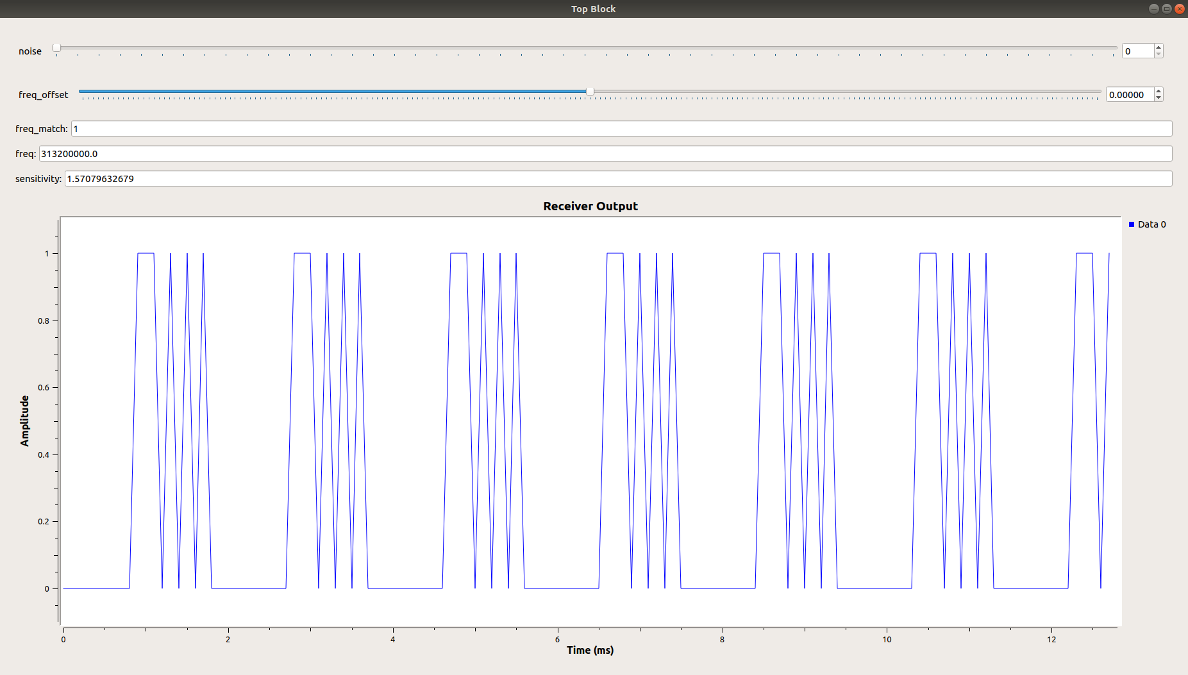

Zooming in better illustrates the time period.

